2. Assessment of the Pacific Cod Stock in the Eastern Bering Sea

Steven J. Barbeaux, Lewis Barnett, Madison Hall, Pete Hulson, Julie Nielson, S. Kalei Shotwell, Elizabeth Siddon, and Ingrid Spies

Alaska Fisheries Science Center, National Marine Fisheries Service

National Oceanic and Atmospheric Administration

7600 Sand Point Way NE., Seattle, WA 98115-6349

November 04, 2023

[](https://afsc-assessments.github.io/EBS_PCOD/2023_ASSESSMENT/NOVEMBER_MODELS/)

*With contributions from:*

Caitlin Allen-Akselrud, Kerim Aydin, Mathew Callahan, Curry Cunningham, Lucas DeFilippo, Bridget Ferriss, Ben Fissel, Madison Hall, Kirstin Holsman, Tom Hurst, Kelly Kearney, Ben Laurel, Cecilia A. O’Leary, Beth Matta, Susanne McDermott, Sandi Neidetcher, Jens Nielsen, Kimberly Rand, Patrick Ressler, Heather Renner, Sean Rohan, Katie Sweeney, James Thorson, Jordan Watson, Sarah Wise, and Stephani Zador

# EXECUTIVE SUMMARY

## Summary of Changes in Assessment Inputs

Relative to the November edition of last year’s BSAI SAFE report, the following substantive changes have been made in the eastern Bering Sea (EBS) Pacific cod stock assessment.

### Changes in the Input Data

* Catches for 1991-2022 were updated, and a preliminary catch estimate for 2023 was incorporated.
* Commercial fishery size compositions for 1991-2022 were updated, and a preliminary size composition from the 2023 commercial fishery was incorporated.
* The VAST approach for the AFSC Bering Sea bottom trawl was updated for 2023.
* The size composition from the 2023 EBS+NBS survey was incorporated
* The VAST approach was used to estimate the age compositions from the combined EBS+NBS survey time series through 2022.
* Conditional age-at-length data for 1990- 2022 from the bottom trawl survey were included in one model exploration.

### Changes in the Assessment Methodology

The ensemble of models presented and accepted for use in 2022 were re-run with the updated data as parameterized in last year’s assessment. In addition, three alternative models were developed from those described in the September update ([Appendix 2.1](https://meetings.npfmc.org/CommentReview/DownloadFile?p=25dc55f0-b10e-48de-af96-72c8fa85159c.pdf&fileName=EBS%20Pacific%20cod%20model%20explorations_Sept%202023.pdf)). Model 23.1.0.a is a simplified version of Model 22.2 with no annually varying parameters and use of the simple multinomial for size and age composition data instead of the Dirichlet Multinomial used in the 2022 ensemble models. Model 23.1.0.d is Model 23.1.0.a with fixed natural mortality, annually varying parameters on growth and survey selectivity. Model 23.2 is Model 23.1.0.d with conditional age at length data included. For all of the 2023 models the input sample sizes for the size and age composition data use a bootstrap approach developed by Hulson et al. (2023). Model 23.1.0.d is recommended as a single model replacement for the 2022 ensemble.

## Summary of Results

The principal results of the present assessment, **based on Model 23.1.0.d**, are listed in the table below (biomass and catch figures are in units of t) and compared with the corresponding quantities as specified last year by the SSC:

|  |  |  |  |  |  |  |
| --- | --- | --- | --- | --- | --- | --- |
| **Quantity** | As estimated or  *specified last* year for: | | | As estimated or  *recommended this* year for: | | |
| 2023 | | 2024 | 2024* | | 2025* |
| *M* (natural mortality rate) | 0.34 | 0.34 | | 0.386 | 0.386 | |
| Tier | 3b | 3b | | 3b | 3b | |
| Projected total (age 0+) biomass (t) | 844,578 | 831,566 | | 808,203 | 787,837 | |
| Projected female spawning biomass (t) | 245,594 | 242,911 | | 223,107 | 211,131 | |
| *B100%* | 668,477 | | | 567,465 | | |
| *B40%* | 267,391 | | | 226,986 | | |
| *B35%* | 233,467 | | | 198,612 | | |
| *FOFL* | 0.36 | 0.35 | | 0.46 | 0.43 | |
| *maxFABC* | 0.29 | 0.29 | | 0.37 | 0.35 | |
| *FABC* | 0.29 | 0.29 | | 0.37 | 0.35 | |
| OFL (t) | 172,495 | 166,814 | | 200,995 | 180,798 | |
| maxABC (t) | 144,834 | 140,159 | | 167,952 | 150,876 | |
| ABC (t) | 144,834 | 140,159 | | 167,952 | 150,876 | |
| **Status** | As determined *this* year for: | | |  | | |
| 2021 | | 2022 | 2022 | | 2023 |
| Overfishing | No | | n/a | No | | n/a |
| Overfished | n/a | | No | n/a | | No |
| Approaching overfished | n/a | | No | n/a | | No |

*Projections are based on assumed catches of 142,945 t, and 167,952 t in 2023 and 2024, respectively.

Note that the recommended 2024 and 2025 *FABC* and ABC values listed above may be subject to modification following consideration by the Plan Team and SSC. The summarized results of the risk analysis (see subsection in the “Harvest Recommendations” section) are shown below:

|  |  |  |  |
| --- | --- | --- | --- |
| *Assessment-related considerations* | *Population dynamics considerations* | *Environmental/ ecosystem considerations* | *Fishery Performance considerations* |
| Level 1: No Concern | Level 1: No Concern | Level 1: No Concern | Level 1: No Concern |

In the event that the 2024 *FABC* or ABC values are changed from those shown above, projected 2025 values of other non-constant quantities would need to change in response and would be reflected in the harvest specification tables.

## Responses to SSC and Plan Team Comments on Assessments in General

December 2022 SSC

*The SSC supports the JGPT recommendation to make reporting of fish condition routine and standardized across assessments.*

Standardized fish condition for Bering Sea Pacific cod is reported in the ESR.

*The SSC reiterates its previous recommendation that the number of levels should be collapsed from four to three to make the choices easier for the authors.*

As Bering Sea Pacific cod rating on all risk table categories is 1 Normal, this had no impact this year on this assessment.

## Responses to SSC and Plan Team Comments Specific to this Assessment

December 2022 SSC

*The SSC requests the authors include a simple catch/biomass or OFL/biomass plot to complement the standard apical F and phase-plane plots in future assessments.*

See Figure 2.50 for a figure showing catch by spawning biomass for the 2022 Ensemble and 2023 explored models.

*Given recent evidence for Pacific cod movement in and out of the EBS+NBS regions and stock structure considerations, the SSC encourages collaboration with other Pacific cod assessment authors to explore the feasibility and utility of a more spatially comprehensive assessment model for Alaska that considers connectivity with the GOA.*

All three of the Pacific cod stock assessment authors have been working together closely this year and although a more spatially comprehensive assessment model is being considered it is not yet in production. It is hoped that analysis of the PSAT data collected over the last year will better inform our choices on development of the model and we await the results of that research.

September 2023 Plan Team

*The Team supported the current path of development and recommended a model similar to M23.1.0.d with the following changes: 1) use conditional age-at-length data (CAAL) from the survey, remove marginal age comps for the years with CAAL, and include all length composition data, 2) fix M at 0.3866 based on a maximum age of 14, and 3) potentially estimate growth CVs (authors' discretion which growth CVs to estimate).*

Model 23.2 presented in this document adds CAAL to Model 23.1.0.d. Both models have fixed M at 0.3866. Although we explored estimating the growth CVs we did not propose a model this year with this feature.

*The Team is also interested in exploring uncertainty related to alternative values of M, and supports the authors' suggestion to profile over different values of the CV on a prior for M, sequentially reducing the uncertainty of the prior to examine the effect of estimating or fixing growth on assessment outputs including reference points.*

A profile over the CV of the prior of natural mortality is explored in this document. As expected the M moves away from the prior to a lower value and the value of catchability increases. See Figure 2.37, Figure 2.38, and Figure 2.39.

*The authors indicated that they will run M23.1.0.a with updated data, and the Team recommended that this updated model be brought forward in November as a sensitivity to better understand uncertainty.*

Model 23.1.0.a is brought forward in this document as a sensitivity run.

October 2023 SSC

*The SSC agrees with the author and BSAI GPT to not pursue the ensemble modeling approach at this point due to the model performance issues noted.*

The authors concur and recommend a single model approach in this document.

*The SSC also concurs with the BSAI GPT recommendation that the authors bring forward the status quo ensemble model, Model 23.1.0.a as a sensitivity to better understand uncertainty, Model 23.1.0.d (not included in BSAI-GPT recommendation) and model 23.1.0.d with the following changes: use CAAL data from the survey, remove marginal age compositions for the years with CAAL, and include all length composition data, fix M at 0.3866 based on a maximum age of 14, and at the discretion of the author estimate growth CVs*.

The authors present the base ensemble model, Model 23.1.0.a as presented in September as a sensitivity model, Model 23.1.0.d with fixed natural mortality, and Model 23.2 which adds CAAL to Model 23.1.0.d, removes marginal age composition for years with CAAL and includes all length composition data. Both Model 23.1.0.d and Model 23.2 have fixed M at 0.3866. Although we did explore estimating the growth CVs, we did not propose a model this year with this feature.

# INTRODUCTION

Pacific cod (*Gadus macrocephalus*) is a transoceanic species, ranging from Santa Monica Bay, California, northward along the North American coast; across the Gulf of Alaska and Bering Sea north to Norton Sound; and southward along the Asian coast from the Gulf of Anadyr to the northern Yellow Sea; and occurring at depths from shoreline to 500 m (Ketchen 1961, Bakkala et al. 1984). The southern limit of the species distribution is about 34° N latitude, with a northern limit of about 65° N latitude (Lauth 2011). Pacific cod is distributed widely over the eastern Bering Sea (EBS) as well as in the Aleutian Islands (AI) area. Tagging studies (e.g., Shimada and Kimura 1994) have demonstrated significant migration both within and between the EBS, AI, and Gulf of Alaska (GOA).

The most recent genomic analysis of Pacific cod includes a new publication that used pooled whole genome sequencing (Pool-Seq), as well as a new study conducted during 2021 and 2022 that used low coverage whole genome sequencing (lcWGS). The lcWGS analysis provides a more powerful approach to gather individual-based sequence data from the whole genome. Low-coverage whole-genome sequencing analysis of 429 samples of Pacific cod from known spawning regions during spawning season indicated population structure similar to what was previously known, but with finer resolution and greater power owing to the larger number of markers. Using 1,922,927 polymorphic SNPs (Figure 2.1), the pattern of population structure mostly resembles isolation-by-distance, in which samples from proximate spawning areas are more genetically similar than samples from more distant areas. Isolation-by-distance was observed from western Gulf of Alaska (Kodiak and the Shumagin Islands) through Unimak Pass and the eastern Aleutian Islands. Previous studies have reported an isolation-by-distance pattern in Pacific cod using microsatellite markers (Cunningham et al. 2009 and Spies 2012) and reduced-representation sequencing (Drinan et al. 2018). Within the isolation-by-distance pattern, there were some distinct breaks in the population structure. The most significant genetic break occurs between western and eastern Gulf of Alaska (GOA) spawning samples (Figure 2.1), and was supported by previous research that highlighted the zona pellucida gene region (Spies et al. 2019). Notably, there was not a significant break in genetic structure between the eastern Bering Sea (Unimak) and the western Gulf of Alaska (Shumagins and Kodiak).

A new finding from the lcWGS data was the identification of a new genetic group in the Bering Sea represented by samples from Russia along the western Bering Sea shelf. We refer to this as a northern Bering Sea ‘type’. In addition, a subset of samples collected from Pervenets Canyon in the eastern Bering Sea appeared genetically similar to the western Bering Sea shelf group (Figure 2.1 bottom right where light blue points, Pervenets Canyon, mix with dark blue points, Russia). The majority of samples from the eastern Bering Sea were genetically more similar to Aleutian Islands and western Gulf of Alaska samples which was a significant deviation from the isolation-by-distance pattern found with the rest of the samples (Figure 2.1 center where light blue points mix with green squares, Aleutian Islands, and pink circles, western Gulf of Alaska). This result suggests an unresolved combination of isolation-by-distance and a strong genetic break with the northern Bering Sea type. More specifically, at neutral markers Aleutian Island populations seem to follow the subtle IBD pattern documented throughout much of the western GOA. However, Aleutian Island populations are highly diverged at a few genomic regions that we believe are adaptively significant (Spies et al. 2022,Figure 2.2). These adaptive differences provide further support for the Aleutian Island management unit that was established as distinct from the Bering Sea in 2013. Overall, the presence of a distinct northern Bering Sea type, a distinct eastern Gulf of Alaska type, and a mixed eastern Bering Sea/western Gulf of Alaska stock indicate that there may be opportunities to restructure management units for Pacific cod in those regions. More research is needed to fully understand how the types of cod are distributed during non-spawning seasons.

Recent satellite tagging research on Pacific cod (S. McDermott, P.I.) indicates seasonal connectivity between the western GOA, EBS, the northern Bering Sea (NBS), Russia, and the Chukchi Sea (CS). Pacific cod tagging research was initiated in 2019 and consists of an inter-agency collaboration between NOAA scientists and the Aleutians East Borough, the Freezer Longline Coalition, the Native Village of Savoonga, Norton Sound Economic Development Corporation (NSEDC), and Pacific Cod Harvesters. Satellite tags record depth, temperature, light intensity, and acceleration while tagged fish are at liberty. The tags are programmed to “pop up” from the fish at a specific time and provide a recovery location when they reach the surface and begin to transmit archived data to the Argos satellite network. Movement paths between the release and recovery locations can be reconstructed based on the archived data using a hidden Markov model for geolocation. To date, 220 archival satellite tags have been deployed on Pacific cod in Alaskan waters (Figure 2.3 A). Satellite tags were released in the winter to determine movement from winter spawning to summer foraging areas or during the summer to determine movement during summer foraging, migration to winter spawning locations, and annual movement patterns. Through 2022, release locations focused on the NBS, EBS, and western GOA. In 2023, GOA releases were expanded into the central GOA to assess seasonal movement within the GOA, where 54 tags were released in the winter and 12 tags were released in the summer. In addition, 3 tags were released in the NBS near St. Lawrence Island in a cooperative study with the NSEDC and the Native Village of Savoonga. Results from reconstructed movement paths and tag pop-up locations obtained to date suggest the following seasonal movement characteristics for Pacific cod in Alaskan waters: 1) limited seasonal connectivity between Aleutian Islands and other management regions, 2) movement of Pacific cod out of the NBS occurs during the winter and is related to sea ice coverage and associated sea temperatures (Figure 2.3 B), 3) site fidelity to summer foraging locations has been observed among tagged fish that migrate to winter spawning areas (Figure 2.3 C), 4) substantial seasonal connectivity exists between the western GOA (i.e., Shumagin Islands westward), EBS, NBS, CS, and Russia (Figure 2.4), with potential interannual variability in the proportion and movement extent of tagged fish that migrate out of the western GOA, 5) preliminary results from 2023 tagging indicates limited seasonal connectivity between the central and western GOA, and 5) Pacific cod may exhibit partial migration in Alaska, as some tagged fish in AI, GOA, and EBS did not undertake seasonal migrations. Genetic information has been collected from all tagged fish and genetic analyses of these results is in progress

Additional information on the biology of Pacific cod, including early life history, can be found in the Ecosystem and Socioeconomic Profile ([Appendix 2.2](https://afsc-assessments.github.io/EBS_PCOD/2022_ASSESSMENT/NOVEMBER_MODELS/APPENDICES/Appendix_2.2_EBS_PACIFIC_COD_ESP_REPORT_CARD.pdf)).

# FISHERY

## Description of the Directed Fishery

During the early 1960s, a Japanese longline fishery harvested EBS Pacific cod for the frozen fish market. Beginning in 1964, the Japanese trawl fishery for walleye pollock (*Gadus chalcogrammus*) expanded and cod became an important bycatch species and an occasional target species when high concentrations were detected during pollock operations. By the time that the Magnuson Fishery Conservation and Management Act went into effect in 1977, foreign catches of Pacific cod had consistently been in the 30,000-70,000 t range for a full decade. In 1981, a U.S. domestic trawl fishery and several joint venture fisheries began operations in the EBS. The foreign and joint venture sectors dominated catches through 1988, but by 1989 the domestic sector was dominant and by 1991 the foreign and joint venture sectors had been displaced entirely.

Presently, the Pacific cod stock is exploited by a multiple-gear fishery, including trawl, longline, pot, and jig components (although catches by jig gear are very small in comparison to the other three main gear types, with an average annual catch of less than 200 t since 1991). The breakdown of catch by gear during the most recent complete five-year period (2018-2022) is as follows: longline gear accounted for an average of 48% of the catch, trawl gear accounted for an average of 30%, and pot gear accounted for an average of 22%.

In the EBS, Pacific cod are caught throughout much of the continental shelf, with National Marine Fisheries Service (NMFS) statistical areas 509, 513, 517, 519, 521, and 524 each accounting for at least 5% of the total catch over the most recent 5-year period (2018-2022). In that time period Pacific cod catch from areas 521 (26%) and 509 (23%) have made nearly 50% of the total eastern Bering Sea catch.

Catches of Pacific cod taken in the EBS for the periods 1964-1980, 1981-1990, and 1991-2023 are shown in Table 2.1, Table 2.2, and Table 2.3, respectively; and the time series for the overall fishery (1977-2023) and by gear type (1991-2023) are shown in Figure 2.5.

Annual cumulative catch for 2019 through 2023 are shown in Figure 2.6. The start of fishing in the trawl sector was later than 2019-2021, but at a similar time as the 2022 fishery. Catch rate (tons per week) in the trawl sector in 2022 appears to have been faster than in 2021. The the longline sector catch rates in 2022 remained stable throughout the year unlike 2020 and 2021 where rates dipped in the summer months. The pot sector catch rates in 2022 were high in the starting weeks but tapered off by mid-February, slower than what was observed in 2016-2020, but similar to 2021. As in previous years the pot sector halted fishing in April and did not resume again until August. While overall catch is higher in 2022 than in 2020-2021 catch rates were slower than in 2020.

Maps of fishing effort for 2021 through 2023 by fishing sector (Figure 2.7) and for all gear types (Figure 2.8) indicate a dramatic shift away from the north beginning in 2020 and 2021 and continuing through 2023 for the trawl and longline sectors. In 2021 through 2023 there were few longline sets north of St. Lawrence Island and in 2022 and 2023 there were few longline sets north of St. Mathews Island. The 2022 and 2023 observed and reportable pot cod fishery was restricted to along the north side of the Alaska Peninsula and Aleutian Islands and in the southern side of St. George Island in the Pribilof Islands. Figure 2.9 shows the distribution of observed hauls by latitude and bottom depth by gear type. The largest latitudinal shift in fishing distribution is observed in the longline fishery. Here we see a slight southward shift in 2008-2013, then a shift northward peaking in 2019 through 2021, then a southward shift in the 2022 and 2023 observations. The trawl and pot fisheries also show a northward shift, the trawl fishery in 2019 and the pot fishery in 2020 and 2021, although much more subtle than for the longline fishery. The raw CPUE indices based on the method presented by Thompson et al. 2021 (Figure 2.10) show a rather flat CPUE by number trend from 2015 to 2022, then a sharp drop in 2023. However, the CPUE by weight shows an increasing trend from 2014-2020, then an overall decreasing trend in 2021-2023. This does not match the VAST winter (January-February) longline fishery number CPUE trend (Table 2.10 and Figure 2.13; see below for full description) which indicated a dropping CPUE from 2018-202l, an increase in CPUE in 2022, and then a drop to its lowest value in the time series in 2023.

Catches of Pacific cod taken from the portion of the western Bering Sea under Russian jurisdiction during 2001 through 2021 are summarized in Table 2.4. For 2001-2008 the data were retrieved from Lajus et al. (2019). For 2009-2021 catch data from Russian Ministry of Fisheries annual reports are available for 2009-2021, РОССИЙСКАЯ ФЕДЕРАЦИЯ: СВЕДЕНИЯ ОБ УЛОВЕ РЫБЫ И ДОБЫЧЕ ДРУГИХ ВОДНЫХ БИОРЕСУРСОВ (translation: RUSSIAN FEDERATION: INFORMATION ABOUT THE CATCH OF FISH AND THE EXTRACTION OF OTHER WATER BIORESOURCES). The Russian Federation website where these reports were hosted was no longer active as of March 2022 and future availability of these data is questionable.

## Discards

The catches shown in Table 2.1 and Table 2.2 include estimated discards. Proportion retained of Pacific cod in the EBS Pacific cod fisheries are shown for each year 1991-2023 in Table 2.3. Amendment 49, which mandated increased retention and utilization of Pacific cod, was implemented in 1998. From 1991-1997, discard rates in the Pacific cod fishery averaged about 14%. Since then, they have averaged about 2%. There was an increase in 2021 in the discard of Pacific cod in the trawl fisheries up to 5% from 1% in 2019. However discard rates in the trawl fisheries have once again dropped to 2% in 2022 and 1% in 2023.

## Management History

The history of acceptable biological catch (ABC), overfishing level (OFL), and total allowable catch (TAC) levels is summarized and compared with the time series of aggregate (i.e., all-gear, combined area) commercial catches in Table 2.5. Note that, prior to 2014, this time series pertains to the combined BSAI region, so the catch time series differs from that shown in Table 2.3, which pertains to the EBS only.

From 1980 through 2023 TAC averaged about 85% of ABC (ABC was not specified prior to 1980), and from 1980 through 2023, commercial catch averaged about 82% of TAC. In 9 of these 43 years, TAC equaled ABC exactly, and in 17 of these 43 years, catch exceeded TAC. However in 10 of those overages TAC was reduced by various proportions to account for a small, state-managed fishery inside state of Alaska waters (such reductions have been made in all years since 2006; see text table below for recent formulae); thus, while the combined Federal and State catch exceeded the Federal TAC in 2006-2010 and 2016-2022 by up to 10%, the overall target catch (Federal TAC plus State GHL) was *not* exceeded.

Total catch has been less than OFL in every year since 1993 (inclusive).

Changes in ABC over time are typically attributable to three factors: 1) changes in resource abundance, 2) changes in management strategy, and 3) changes in the stock assessment model. Assessments conducted prior to 1985 consisted of simple projections of current survey numbers at age. In 1985, the assessment was expanded to consider all survey numbers at age from 1979-1985. From 1985-1991, the assessment was conducted using a bespoke separable age-structured model. In 1992, the assessment was conducted using the Stock Synthesis modeling software (Methot 1986, 1990) with age-based data. All assessments from 1993 through 2003 continued to use the Stock Synthesis modeling software, but with length-based data. Age data based on a revised ageing protocol were added to the model in the 2004 assessment. At about that time, a major upgrade in the Stock Synthesis architecture resulted in a substantially new product, at that time labeled “SS2” (Methot 2005). The assessment was migrated to SS2 in 2005. Changes to model structure were made annually through 2011, then the base model remained constant through 2015, and new base models were adopted in 2016, 2018, 2019, and 2020 (see Appendix 2.3 of Thompson et al. 2021). A note on software nomenclature: The label “SS2” was dropped in 2008. Since then, the program has been known simply as “Stock Synthesis” or “SS,” with several versions typically produced each year, each given a numeric or alpha-numeric label.

Beginning with the 2014 fishery, the Board of Fisheries for the State of Alaska has established guideline harvest levels (GHLs) in State waters between 164 and 167 degrees west longitude in the EBS subarea (these have supplemented GHLs that had been set aside for the Aleutian Islands subarea since 2006). The table below shows the formulas that have been used to set the State GHL for the EBS (including the formula anticipated for setting the 2024 GHL):

|  |  |
| --- | --- |
| Year | Formula |
| 2014 | 0.030 × (EBS ABC +AI ABC) |
| 2015 | 0.030 × (EBS ABC +AI ABC) |
| 2016 | 0.064 × EBS ABC |
| 2017 | 0.064 × EBS ABC |
| 2018 | 0.064 × EBS ABC |
| 2019 | 0.084 × EBS ABC |
| 2020 | 0.090 × EBS ABC |
| 2021 | 0.100 × EBS ABC |
| 2022 | 0.110 × EBS ABC |
| 2023 | 0.120 × EBS ABC |
| 2024 | 0.120 × EBS ABC |

For 2020 through 2024 the Board of Fisheries established an additional GHL of 45 t for vessels using jig gear within State waters.

Table 2.6 lists all implemented amendments to the BSAI Groundfish FMP that reference Pacific cod explicitly.

In addition to those, the following rulemaking became effective for 2021 on permit requirements:

<https://www.federalregister.gov/documents/2020/12/03/2020-26593/fisheries-of-the-exclusive-economic-zone-off-alaska-pacific-cod-in-the-bering-sea-and-aleutian>. In this rule, NMFS modified Federal permit conditions and imposed participation requirements for certain federally permitted vessels when fishing for Pacific cod in State of Alaska waters (state waters) adjacent to the Exclusive Economic Zone (EEZ) of the Bering Sea and Aleutian Islands (BSAI). The state waters portion of the Pacific cod fishery that runs concurrent with the Federal Pacific cod fishery is commonly known as the State's parallel fishery. The “parallel fisheries” in this preamble refer to the State waters Pacific cod parallel fisheries in the State of Alaska Bering Sea-Aleutian Islands Area, which presently is in the Dutch Harbor Subdistrict of the Bering Sea and within the Aleutian Islands Subdistrict of the Aleutian Islands, respectively. This rule prohibits (1) a hook-and-line, pot, or trawl gear vessel named on a Federal Fisheries Permit (FFP) or License Limitation Program (LLP) license from being used to catch and retain BSAI Pacific cod in State of Alaska (State) waters adjacent to the BSAI during the State's parallel Pacific cod fishery unless the vessel is named on an FFP and LLP license that have the required endorsements; (2) a hook-and-line, pot, or trawl gear vessel named on an FFP or LLP license from catching and retaining Pacific cod in state waters adjacent to the BSAI EEZ during the State's parallel fishery when NMFS has closed the EEZ to directed fishing for Pacific cod by the sector to which the vessel belongs; (3) the holder of an FFP with certain endorsements from modifying those endorsements during the effective period of the FFP; and (4) the reissuance of a surrendered FFP with certain endorsements for the remainder of the three-year term, or cycle, of FFPs.

For the fourth consecutive year the Bering Sea non-CDQ Pacific cod directed fishing closed for all non-CDQ sectors. The non-CDQ sectors have BSAI allocations and there was less fishing in the Aleutian Islands until after the Bering Sea non-CDQ sectors closed. Directed fishing for the Pacific cod non-CDQ sectors closed [in 2020](https://www.fisheries.noaa.gov/bulletin/ib-20-83-nmfs-prohibits-directed-fishing-non-community-development-quota-pacific-cod) on November 18, [in 2021](https://www.fisheries.noaa.gov/bulletin/ib-21-42-nmfs-prohibits-directed-fishing-non-community-development-quota-pacific-cod) on September 17, [in 2022](https://www.fisheries.noaa.gov/bulletin/ib-22-48-nmfs-prohibits-directed-fishing-non-community-development-quota-pacific-cod) on October 7, and [in 2023](https://www.fisheries.noaa.gov/bulletin/ib-23-53-nmfs-prohibits-directed-fishing-non-community-development-quota-pacific-cod) on October 16. The closures were to prevent exceeding the non-CDQ allocation of the total allowable catch of Pacific cod in the Bering Sea subarea of the BSAI. After the closures there was still fishing by the CDQ groups and incidental catch of Pacific cod in other targets.

# DATA

The first two subsections below describe fishery and survey data that are used in the current stock assessment models. The third subsection describes data that are not used in the current stock assessment models, but that may help to provide some context for the data that are used.

The following table summarizes the sources, types, and years of data included in the data file for at least one of the stock assessment models:

|  |  |  |  |
| --- | --- | --- | --- |
| **Source** | **Type** | | **Years** |
| Fishery | | Catch biomass | 1977-2023 |
| Fishery | | Catch size composition | 1977-2023 |
| Fishery | | Catch per unit effort (VAST) | 1996-2023 |
| EBS+NBS trawl survey | | Survey numerical abundance (VAST) | 1982-2019, 2021-2023 |
| EBS+NBS trawl survey | | Survey age composition (VAST) | 1994-2019, 2022 |

All data used in the 2023 models are provided in zip files in the following appendices:

* Appendix 2.3 2022 Ensemble Models SS files.zip (0.3 MB)
  + <https://afsc-assessments.github.io/EBS_PCOD/2023_ASSESSMENT/NOVEMBER_MODELS/APPENDICES/APPENDIX_2.3_ENSEMBLE_MODELS.zip>
* Appendix 2.4 2023 Models SS files.zip (0.3MB)
  + <https://afsc-assessments.github.io/EBS_PCOD/2023_ASSESSMENT/NOVEMBER_MODELS/APPENDICES/APPENDIX_2.4_2023_MODELS.zip>
* Appendix 2.5 Data and results for all models and ensembles.xlsx (2.6 MB)
  + <https://afsc-assessments.github.io/EBS_PCOD/2023_ASSESSMENT/NOVEMBER_MODELS/APPENDICES/Appendix_2.5_Data_and_results.xlsx>

## Fishery Data Used in the Models

### Catch Biomass

Catch estimates for the period 1977-2023 are shown in Table 2.1, Table 2.2, Table 2.3, and Table 2.5. However, the estimate for 2023 is complete only through October 3. The 2023 year-end catch in the model was set at the 5-year average proportion of the ABC that was harvested (98.7% or 142,945 t).

The catches shown in Table 2.1, Table 2.2, Table 2.3, and Table 2.5 consist of “official” data from the NMFS Alaska Region. However, other removals of Pacific cod are known to have occurred over the years, including removals due to subsistence fishing, sport fishing, scientific research, and fisheries managed under other FMPs. Estimates of such other removals are shown in Table 2.7 .

The catch estimates for the years 1977-1980 shown in Table 2.1 may or may not include discards.

### Size Composition

Figure 2.11 shows the fishery size compositions from 1977 through 3 October 2023, which are parsed into 1-cm bins for use in the assessment models. The size composition were computed by using haul/vessel/month/gear/area catch proportions to create a weighted average for each year’s record as described in [Appendix 2.1](https://meetings.npfmc.org/CommentReview/DownloadFile?p=25dc55f0-b10e-48de-af96-72c8fa85159c.pdf&fileName=EBS%20Pacific%20cod%20model%20explorations_Sept%202023.pdf), with a minimum sample size of 30 fish for any month/gear/area combination. The total number of Pacific cod measured in the fishery 1977-2023 are provided in Table 2.8.

The length distributions are generally unimodal, with a few years bimodal when larger than average year classes were encountered Figure 2.11. The peaks of the length composition in the fishery tends to be between 50 and 70 cm. The size of fish in the fishery has remained relatively stable over time, however the mean length in the fishery tends to decrease somewhat when there are large new recruitments then slowly increase as these fish age and grow (Figure 2.12). From 1977 through 1991 there was an increasing trend in mean length with the greatest mean length in 1991. There were also fewer data for this time period leading to higher uncertainty in the estimated distribution. In 1992 with the advancement of the domestic observer program and increased sampling uncertainty in the distributions was lower. For this period (1991-2023) the highest mean length occurred in 2021 following a period of low recruitment in 2014-2017. On average Pacific cod continued decrease in average size from 2021 to 2023 in part due to the influx of new year classes. It should be noted that the fishery length composition is made up of data from several gear types (trawl, longline, and pot) and the individual selectivity of these gear likely differs (Table 2.3 and Figure 2.9).

The nominal sample sizes (number of sampled hauls) for the size compositions and input sample sizes are shown in Table 2.9.

### Catch per Unit Effort

Fishery catch-per-unit-effort (CPUE) data was analyzed to:

1. provide contextual information regarding wintertime habitat utilization and resulting indices of distribution shift and area expansion/contraction;
2. develop a standardized CPUE index that controls for inter-annual differences in fishery locational choice, for inclusion as an abundance index.

Analyzing CPUE data to develop standardized abundance indices has a long history in fisheries, but there are also many theoretical and case-study examples of why fishery CPUE indices can be biased relative to well-designed survey indices. In particular, spatial targeting can cause an arithmetic average of CPUE to be unrepresentative of population density (Walters 2003). In contrast, recent spatio-temporal methods address this issue explicitly through use of high-resolution spatial and timing information. Recent methods implicitly impute or predict the CPUE that would have arisen in unsampled locations, interpreting that CPUE as proportional to density after controlling for variables affecting catchability, weighting densities based on area, and integrating area-weighted uncertainty across poor- and well-sampled areas. This imputation occurs either structurally (Carruthers et al. 2011), via post-stratification and area-weighting of CPUE in different strata (Campbell 2016), or using area-weighting within spatio-temporal statistical models (Thorson 2019a). Relative to explicit imputation approaches (e.g., Carruthers et al. 2011), spatio-temporal methods extrapolate densities based on spatial correlations in predicted density as well as correlations across time either via a spatial component (which affects estimates of leverage for observations based on location) or an autocorrelated spatio-temporal component. Spatio-temporal models for fishery CPUE data have been tested using operating models mimicking fishery-dependent CPUE data that were developed independently and do not match the estimation model (Grüss et al. 2019; Thorson et al. 2017a). In particular, testing using SEAPODYM as the operating model and VAST as the estimation model suggests that trends in abundance can be accurately reconstructed even when the spatial footprint of fishing has expanded or contracted over time (Ducharme-Barthe et al. 2022).

To do so, the longline fishery catch and effort data were obtained from the AFSC Fisheries Management Division database NORPAC on May 12, 2023. Sets were restricted to those occurring in Jan-Feb. from 1996-2023, and also to those occurring within the eastern Bering Sea shelf bottom-trawl survey area. An extrapolation area was then defined by manually identifying a polygon that includes all included sets. A spatio-temporal generalized linear mixed model was then fitted using log-link and gamma distribution, using catch of Pacific cod in numbers as response, total hook pots as effort offset, and integrated CPUE estimates across the extrapolation area. This implies that the resulting index has units $\#km^{2}/hook$; the resulting catchability coefficient fitted in the assessment model has units $hooks/km^{2}$, representing the the inverse of effective area fished per hook. This was specifically fitted using the VAST package. Both spatial and spatio-temporal model components were included with a first-order autoregressive process for the spatio-temporal component over time, estimated geometric anisotropy, and treated annual intercepts as fixed effects. No covariates were included representing fishery targeting behavior or technology, and therefore systematic variation could not be controlled.

The estimated CPUE index resulting from this analysis shows relatively little variation over time (Table 2.10). Comparing it with the estimate from 2022 assessment shows that the two estimates are almost exactly correlated (Figure 2.13). The estimated wintertime center-of-gravity varied significantly from 1996-2023, showing a southeastern distribution from 2011-2013 and a northwestern distribution in 2006-2008 and again 2015-2023 (Figure 2.14). The estimated “effective area occupied” has shown a trend upward from 2007 onward. Fine-scale interpretation of these trends can be seen by inspecting estimated CPUE maps (Figure 2.15)

## Survey Data Used in the Models

### Overview of Survey Areas and Frequency

The areas covered by the eastern Bering Sea (EBS) shelf and northern Bering Sea (NBS) bottom trawl surveys are shown in Figure 2.16. Prior to 2020, in the EBS, strata 10-62 had been surveyed annually since 1982 and strata 82 and 90 had been surveyed annually since 1987. However, the EBS bottom trawl survey was cancelled in 2020 due to the COVID-19 pandemic. In the NBS, strata 70, 71, and 81 in the NBS were surveyed fully in 2010, 2017, 2019, 2021, 2022, and 2023. Less extensive surveys of the NBS were conducted in 1982, 1985, 1988, 1991, and 2018. The NBS was also scheduled to be surveyed in 2020, but, like the EBS survey, the 2020 NBS survey was cancelled due to the COVID-19 pandemic.

### VAST Estimates of Abundance from the EBS Shelf and NBS Bottom Trawl Surveys

The software versions of dependent programs used to generate model-based estimates were equivalent or later than these minimum standards:

* R (4.0.2)
* MKL libraries via Microsoft R Open (4.0.2)
* INLA (21.11.22)
* Matrix (1.4-0)
* TMB (1.7.22)
* VAST (3.9.0)
* cpp VAST_v13_1_0
* FishStatsUtils (2.10.0)
* DHARMa (0.4.5)

*Model-based abundance index methods*

For model-based indices in the Bering Sea, we fitted observations of numerical abundance or biomass per unit area (where the use of abundance or biomass varied by stock at the request of assessors) from all grid cells and corner stations in the 83-112 bottom trawl survey of the EBS, 1982-2022, including exploratory northern extension samples in 2001, 2005, and 2006, as well as 83-112 samples available in the NBS in 1982, 1985, 1988, 1991, 2010, and 2017-2021. NBS samples collected prior to 2010 and in 2018 did not follow the 20 nautical mile sampling grid that was used in 2010, 2017, 2019, and 2021 to 2023 surveys. Assimilating these data therefore required extrapolating into unsampled areas. This extrapolation was facilitated by including a spatially varying response to cold-pool extent (Thorson 2019a). This spatially varying response was estimated for both linear predictors of the delta-model, and detailed comparison of results for EBS pollock has shown that it has a small but notable effect on these indices and resulting stock assessment outputs (O’Leary et al. 2020). Rather than using the cold-pool covariate for yellowfin sole, we instead used the mean bottom temperature within the outer and middle domain strata from an interpolated temperature product. All models were fitted in the VAST R package (Thorson and Barnett 2017; Thorson 2019b). All environmental data used as covariates were computed within the coldpool R package (<https://github.com/afsc-gap-products/coldpool>; Rohan et al., 2023).

We used a Poisson-link delta-model (Thorson 2018) involving two linear predictors, and a gamma distribution to model positive catch rates. We extrapolated population density to the entire EBS and NBS in each year, using AFSC GAP-vetted extrapolation grids within FishStatsUtils (<https://github.com/James-Thorson-NOAA/FishStatsUtils>). These extrapolation grids are defined using 3705 m (2 nmi) × 3705 m (2 nmi) cells; this results in 36,690 extrapolation-grid cells for the eastern Bering Sea and 15,079 in the northern Bering Sea. We used bilinear interpolation to interpolate densities from 750 “knots” to these extrapolation grid cells; knots were approximately evenly distributed over space, in proportion to the dimensions of the extrapolation grid. We estimated geometric anisotropy (how spatial autocorrelation declines with differing rates over distance in some cardinal directions than others), and included a spatial and spatio-temporal term for both linear predictors. To facilitate interpolation of density between unsampled years, we specified that the spatio-temporal fields were structured over time as an AR(1) process (where the magnitude of autocorrelation was estimated as a fixed effect for each linear predictor). However, in cases where the AR(1) correlation parameter ⍴ was estimated to be close to 1 for either model component, the model would be collapsed into a simpler structure by specifying ⍴ = 1, i.e., modeling spatiotemporal variation as a random walk. We do not include any temporal correlation for intercepts, which we treated as fixed effects for each linear predictor and year. Finally, we used epsilon bias-correction to correct for retransformation bias (Thorson and Kristensen 2016).

We checked model fits for convergence by confirming that (1) the derivative of the marginal likelihood with respect to each fixed effect was sufficiently small (less than ~ 0.001) and (2) that the Hessian matrix was positive definite. We then checked for evidence of model fit by computing Dunn-Smyth randomized quantile residuals (Dunn and Smyth 1996) and visualizing these using a quantile-quantile plot within the DHARMa R package. We also evaluated the distribution of these residuals over space in each year, and inspected them for evidence of residual spatio-temporal patterns.

The resulting set of estimates is shown in Table 2.10, together with their respective log-scale standard deviations (“Sigma”), and compared with those used in the 2022 assessment in Figure 2.19 (R2 = 0.999). The VAST population abundance estimates closely resemble the design-based estimates (Table 2.10 and Figure 2.18 ; R2 = 0.928), however the variance of the VAST estimates are on average 44% lower than the design-based estimates.

The VAST estimates of abundance show that population numbers were at an all-time high in 2014 at 1,230×106 fish. Abundance dropped rapidly through 2017 down to 519×106 fish before rebounding to 761×106 fish in 2019. Abundance once again dropped in 2021 to 605×106 fish and continued to drop to 551×106 fish in 2022, a drop of 9% from 2021 and a drop of 55% since the 2014 high. The 2023 estimate was a 12% increase over 2022 with a total number of 620×106 fish. Maps of log density are shown in Figure 2.20 and in Figure 2.21 VAST derived estimates of centers of abundance, abundance by region (NBS and EBS) and effective area occupied. The most apparent shift is the move northward in the center of gravity between 2010 and 2017 and a shifting southward after 2019. With this change we observed a larger proportion of the stock residing in the NBS and a reversal of that trend starting in 2021 and continuing through 2023.

A comparison of the standardized VAST bottom trawl survey abundance and VAST winter longline CPUE index is provided in Figure 2.22. Overall the two indices are not correlated (R2 =-0.10) with the 2022 values divergent, the CPUE index increased from 2021 while the bottom trawl survey index decreased. The VAST bottom trawl survey index is more variable than the VAST CPUE index (CV=0.30 and CV=0.13, respectively).

### Size Composition

Design-based estimates of the size compositions (in 1-cm bins) from the combined EBS and NBS bottom trawl surveys for the years 1982-2023 are shown in Figure 2.23 (VAST estimates of size composition are not available, so design-based estimates were used for all models). The number of lengths measured and otoliths collected and aged are provided in Table 2.8. Sample sizes for the survey size and age composition data, in units of sampled hauls, are shown in Table 2.9. The survey size composition mean length are shown in Figure 2.25.

The survey size composition distributions are multi-model, unlike the fisheries size composition distributions. Smaller fish (<40cm) are captured by the survey and individual cohorts can be observed in the data. Particularly large cohorts (e.g. 2006, 2008, 2013, and 2018) reduce the mean length, while strings of poor recruitment (2014-2017) do the opposite. The size compositions from 2012-2014 show clear indications of incoming year classes that are larger than the long-term mean, the 2015-2017 size compositions indicate a string of poor recruitments. In 2019, 2021, 2022, and 2023 bottom trawl survey size composition distributions revealed a strong 2018 year class, with a strong mode in the 40-50 cm range in 2021 and 50-60 cm mode in 2022 and 2023. There are apparent new modes for the 2021 and 2022 year classes at 30-40 cm and 15-25 cm.

### VAST age composition

For model-based estimation of age compositions in the Bering Sea, observations of numerical abundance-at-age were fit at each sampling location. This was made possible by applying a year-specific, region-specific (EBS and NBS) age-length key to records of numerical abundance and length-composition. In subcategories (combinations of year, length, age, sex) that contained insufficient data, age composition was computed from length composition given a globally pooled age-length key. These estimates were computed in the VAST R package, assuming a Poisson-link delta-model (Thorson 2018) involving two linear predictors, and a gamma distribution to model positive catch rates. Density covariates were not included in estimation of age composition for consistency with models used in the previous assessment, and due to computational limitations. The same extrapolation grid was used as implemented for abundance indices, but here the spatial and spatiotemporal fields were modeled with a mesh with coarser spatial resolution than the index model, here using 50 “knots”. This reduction in the spatial resolution of the model, relative to that used abundance indices, was necessary due to the increased computational load of fitting multiple age categories and using epsilon bias-correction. The same diagnostics were used to check convergence and model fit as those used for abundance indices.

Updated VAST age compositions from the combined EBS and NBS surveys for 1994-2023 are shown in Figure 2.24. The age-length keys used to produce these estimates include newly read samples from the 2022 survey. Sample sizes for the survey age composition data, in units of read otoliths, are shown in Table 2.8 (but note that the sample sizes actually specified in the models are in units of sampled hauls (Table 2.9 )). The mean age over time for the VAST derived survey age composition is shown in Figure 2.25. The age composition matches the same patterns as observed in the size composition data, verifying that the 2018 year class continues to be a large portion of the population continuing into 2022. However the 2023 age composition data show large numbers of 1 to 3 year olds (2020-2022 year classes) making up much larger portions of the population and broadening the mode of available ages, with the 2018 year class dropping in dominance.

## Data Provided for Context Only

### Design-Based Index Estimates from the EBS Shelf and NBS Bottom Trawl Surveys

The design-based area-swept estimates for population abundance (numbers of fish) are given in Table 2.10 and the biomass in Table 2.11. The population numbers for 2023 (607×106) increased over 2022 (511×106) after a decline since 2019 (731×106) and landing at near half the number observed in 2014 (1,134×106). Despite an increase in the eastern Bering Sea from 647×103 t in 2022 to 663×103 t in 2023, a continuation of the trend since 2018, there was an overall decline in biomass Bering Sea-wide (Table 2.11) as biomass in the NBS dropped from 153×103 t in 2022 to 108×103 t in 2023, an overall drop of 25×103 t or -30%.. The distribution of cod for 2010 through 2023 from the survey are provided in Figure 2.17 and population numbers with confidence intervals in Figure 2.18. The distribution of the survey shows a continued decline in Pacific cod in the NBS in 2023 and shift southward and towards the shelf edge. For 2016-2023 the inshore distribution of Pacific cod south of Nunivak Islands observed in 2010-2015 was at much lower abundance. This shift from the NBS is a continuation of a trend since 2019 when the overall proportion of the Bering Sea Pacific cod biomass in the NBS was 41% now down to only 14% in 2023

### AFSC Longline Survey

The domestic longline survey began biennial sampling of the eastern BS in 1997 (Rutecki *et al.* 1997). Figure 2.26 shows the locations of the Bering Sea stations sampled by the AFSC longline survey. A Relative Population Number (RPN) index of Pacific cod abundance for the 1997 through 2023 Eastern Bering Sea survey area is available from this survey (Table 2.11and Figure 2.27). Details about these data and a description of the methods for the AFSC sablefish longline survey can be found in Hanselman *et al.* (2016) and Echave *et al.* (2012). The 2023 estimate at 73,821 is a 31% decrease from the 2021 estimate of 108,312 and 22% lower than the previous all time low 2019 index value of 94,496. The 2023 index value was the lowest in the time series. 2023 index was 63% lower than the 1997 highest value and 46% below the series mean of 136,739. The index has been below the long-term average since 2017.

### ADFG port sampling

Starting in 2023 Alaska Department of Fish and Game (ADF&G) began collecting biological data from landed Pacific cod caught in the [Dutch Harbor Subdistrict](https://www.adfg.alaska.gov/static/fishing/PDFs/commercial/maps/dutchharbor_pcod.pdf) (DHS) state waters [Pacific cod fishery](https://www.adfg.alaska.gov/FedAidPDFs/RIR.4K.2022.14.pdf). As of October 23 this fishery harvested 98% of its [allocated GHL of 17,380](https://www.adfg.alaska.gov/static/applications/dcfnewsrelease/1447854642.pdf) t. In February through April 2023 ADF&G port samplers measured 1099 Pacific cod for length and weighed 790 individual Pacific cod from 11 deliveries by 5 pot fishing vessels participating in this fishery. On average the DHS pot fishery caught smaller fish than the federal parallel pot fishery conducted in the same time period with a higher proportion of small fish (< 70 cm) and lower proportion of large fish (>75cm) (Figure 2. 29). It should be noted that the weight at length were similar between Pacific cod from the federal and DHS fisheries. Although these data are not being used in the stock assessment model for this year, they are being considered for operational use in the near future.

# ANALYTIC APPROACH

## General Model Structure

Although Pacific cod in the EBS and AI were managed on a BSAI-wide basis through 2013, the stock assessment model has always been configured for the EBS stock only. Since 1992, the assessment model has always been developed under some version of the SS modeling framework (technical details given in [Methot and Wetzel 2013](https://doi.org/10.1016/j.fishres.2012.10.012) and in the [Stock Synthesis Virtual Lab](https://vlab.noaa.gov/web/stock-synthesis/home)). Beginning with the 2005 assessment, the EBS Pacific cod models have all used versions of SS based on the ADMB software package (Fournier et al. 2012). A history of previous model structures, including all SS-based models that have been fully vetted since 2005, is given in [Appendix 2.3 of Thompson et al. (2021)](https://apps-afsc.fisheries.noaa.gov/refm/docs/2021/EBSpcod.pdf). Female spawning stock biomass from the accepted models from 1999 to present is provided in Figure 2.30.

SS V3.30.21.00 was used to run all of the models in this final assessment. The user manual is available at <https://nmfs-stock-synthesis.github.io/doc/SS330_User_Manual_release.html>.

## Parameter Estimation

SS requires that prior distributions be associated with all internally estimated time-invariant parameters and the base values of all internally estimated time-varying parameters. For the models presented in this assessment, uniform prior distributions were used for estimation of all such parameters, with bounds set at values sufficiently extreme that:

* they were non-constraining (with two exceptions; see “Results” section below), or
* extending the bounds to even more extreme values would have no practical impact (because, when the parameter is back-transformed to the natural scale, the resulting quantity is indistinguishable from a logical constraint; e.g., selectivity cannot fall outside the (0,1) range).

To simplify terminology, such parameters will be referred to here as being “freely estimated.” With two exceptions (discussed in the “Results” section below), in the rare instances where parameter estimates are pinned against either bound, those parameters are fixed in the final run of that model at the values estimated in the penultimate model run. For the 2022 Ensemble models this was the case for both log(Θ) values for the size composition data where values were fixed at near the upper bound.

On the other hand, for each parameter that varies randomly on an annual basis, SS estimates a vector of annual deviations that are either added to, or multiplied by, the base value of the parameter. In the case of log recruitment, the deviations are constrained by a *N*(0,2) distribution. The deviations in every other vector are constrained by a *N*(0,1) distribution, and then the vector is multiplied by a  term specific to that vector. In 2023 for all the models in the assessment, each  was tuned iteratively as follows:

* For a vector of deviations associated with log catchability,  was tuned to set the root-mean-squared-standardized-residual (RMSSR) equal to unity.
* For the vector of deviations associated with log-scale recruitment,  was tuned to match the square root of the variance of the estimates plus the sum of the estimates’ variances (Methot and Taylor 2011).
* For all other vectors of deviations,  was tuned to set the variance of the estimates plus the sum of the estimates’ variances equal to unity.

For the four 2022 ensemble models (22.x series) the sigma values obtained in 2021 were used in this year’s assessment in the corresponding models and provided in Table 2.19. For the 2023 Models both Model 23.1.0.a, Model 23.1.0.d, and Model 23.2 were retuned as described above for σR and for Model 23.1.0.d and Model 23.2 the σ terms on the annual deviates for growth and selectivity parameters.

All models were run using the “-hess_step” option in ADMB. This resulted in all model gradients equaling 0 in the final pass. As an additional check on convergence, the final versions of all the 2023 models successfully passed a “jitter” test of 50 runs with the jitter rate set at 0.1. The 2022 Ensemble models performed poorly with 2% or less of the runs converging at the MLE for all four models. Model 22.1 and Model 22.4 had 6% and 10% of the runs converging at values below the accepted MLE. For all four of these models jitter runs there was no single likelihood in common among runs suggesting substantial model misspecification and issues with local minima. The 2023 series of models all performed well with models converging at the MLE 92%, 86%, and 76% of the runs for Model 23.1.0.a, Model 23.1.0.d, and Model 23.2 and no runs converging at a negative log likelihood lower than the accepted MLE.

## Description of Models

### Names of Models

Beginning with the final 2015 assessment ([Thompson 2015](https://www.fisheries.noaa.gov/resource/data/2015-assessment-pacific-cod-stock-eastern-bering-sea)), model numbering has followed the protocol given by Option A in the SAFE chapter guidelines. Names of all final models adopted between the 2005 assessment (when an ADMB-based version of SS was first used) and the 2015 assessment were translated according to that protocol in Table 2.11 of the 2015 assessment. The goal of the protocol is to make it easy to distinguish between major and minor changes in models and to identify the years in which major model changes were introduced. Names of models constituting *minor* changes from the original form of the current base model get linked to the name of that model (e.g., Model 19.12a, is a minor modification of Model 19.12, which was the base model adopted at the conclusion of the 2019 assessment cycle), while names of models constituting *major* changes get linked to the year that they are introduced (e.g., when Model 19.12 was adopted at the conclusion of the 2019 assessment cycle, it constituted a major change from the previous base model (Model 16.6i).

For 2022 as the lead authorship changed and the method used to pull and process the data were substantially changed from previous years the ensemble of models were renamed to be 22.X series. All new models presented this year are major changes and will be numbered as a 23.X series based on those models explored in September ([Appendix 2.1](https://meetings.npfmc.org/CommentReview/DownloadFile?p=25dc55f0-b10e-48de-af96-72c8fa85159c.pdf&fileName=EBS%20Pacific%20cod%20model%20explorations_Sept%202023.pdf)).

### Model description

For this year we are presenting last year’s set of ensemble models (2022 Ensemble Series) and a set of three individual models (23.X series) based on the Plan Team and SSC recommendations from September 2023 described in [Appendix 2.1](https://meetings.npfmc.org/CommentReview/DownloadFile?p=25dc55f0-b10e-48de-af96-72c8fa85159c.pdf&fileName=EBS%20Pacific%20cod%20model%20explorations_Sept%202023.pdf).

The 2022 Ensemble Series ensemble consists of Models 21.1, 21.2, 21.3, and 21.4. The basic structures of these models were described in the “Models” section of Appendix 2.1 in [Thompson et al. (2021)](https://www.fisheries.noaa.gov/resource/data/2021-assessment-pacific-cod-stock-eastern-bering-sea) and alteration of which described in Appendix 2.1 in [Barbeaux et al. (2022)](https://apps-afsc.fisheries.noaa.gov/Plan_Team/2022/EBSpcod.pdf).

Following the procedure developed during the 2021 CIE review, the 2022 Ensemble Series is “anchored” by Model 22.2, and then alternative models are constructed by adding features, one per alternative, to the base model as follows:

|  |  |  |  |  |  |
| --- | --- | --- | --- | --- | --- |
| **2022 Ensemble Series** |  | M 22.1 | M 22.2 | M 22.3 | M 22.4 |
| Feature 1: Allow catchability to vary? |  | yes | no | no | no |
| Feature 2: Allow domed survey selectivity? |  | no | no | yes | no |
| Feature 3: Use fishery CPUE? |  | no | no | no | yes |

The three 2023 models presented for consideration this year are simplifications based on model 22.2 and their development is described in [Appendix 2.1](https://meetings.npfmc.org/CommentReview/DownloadFile?p=25dc55f0-b10e-48de-af96-72c8fa85159c.pdf&fileName=EBS%20Pacific%20cod%20model%20explorations_Sept%202023.pdf). Due to the Dirichlet Multinomial (DM) log(Θ) parameter tending to the upper bound in all of the Ensemble Series models it was required to have the log(Θ) parameter fixed at the upper bound for the models to converge. This was explored in the September document ([Appendix 2.1](https://meetings.npfmc.org/CommentReview/DownloadFile?p=25dc55f0-b10e-48de-af96-72c8fa85159c.pdf&fileName=EBS%20Pacific%20cod%20model%20explorations_Sept%202023.pdf)) and it was determined that future models would no longer use the DM distribution for size or age composition data. For all of the new 2023 models each of the size and age composition data sets were fit as simple multinomial distributions and data weights iteratively adjusted using the Francis reweighting scheme TA1.8 (Francis, 2011) as implemented in the R4SS R library (Taylor et al. 2021).

The simplest model, Model 23.1.0.a, was presented for contrast only and not meant for consideration for management. Model 23.1.0.a is Model 22.2 with the following changes:

1. Removing length composition data for years with age composition data (1994-2021) which were duplicated in the age comps.
2. Reconfiguring both survey and fishery selectivity to be static instead of including annually varying parameters.
3. Reconfiguring the Richard’s growth to be static instead of including annually varying Lmin.
4. Fixing the pre-2007 aging bias to Model 22.2 values.
5. For the growth model fixing CV at older ages at 0.06 and fixing CV at younger ages at 0.2 based on the previous ensemble model fits.
6. Changing from the Dirichlet-multinomial to standard multinomial for length and age composition data.
7. Using the iterative Francis TA1.8 weighting method to tune the model.

For the 2022 ensemble series models all growth was fit as a 4 parameter Richard’s growth relationship with Lmin fit as an annually varying deviation. All parameters in the 2022 models were fit with an uninformative prior. For the simplified Model 23.1.0.a although the four parameters were fit within the model with uninformative priors both growth and selectivity were set to be time-invariant. In all of the 2022 ensemble models both survey and fishery selectivity were modeled as annually varying. This variability was removed for the simplified Model 23.1.0.a.

Model 23.1.0.d was parameterized the same as Model 23.1.0.a except for the inclusion of annually varying growth, annually varying survey selectivity, a time block for 1977-1989 for fishery selectivity, and fixed natural mortality. It has been long understood that environment, particularly temperature, is influential in the growth of Gadus species (Taylor 1958) and annual variability in growth should be expected. Growth in Pacific cod specifically has been found to be rather elastic and dependent on environmental conditions particularly for young fish (Laurel et al. 2008, Barbeaux et al. 2021). To evaluate this elasticity we explored including annually varying growth in Model 23.1.0.d.

The general parameterization of selectivity remained the same with a six parameter double normal with all but two parameters fixed as described for the ensemble models. For the survey an annual additive deviation (Stock Synthesis option 2; Methot et al. 2023) was added to the ascending width of the curve. For the fishery data the two active selectivity parameters were fit separately for early and late fishery data with 1977-1989 and 1990-2023 time blocks.

For the three annually varying parameters in Model 23.1.0.d the ’s were tuned iteratively to set the variance of the estimates plus the sum of the estimates’ variances equal to unity. Table 2.19 provides a list of the  values for each set of annually varying parameters.

|  |  |  |  |  |  |
| --- | --- | --- | --- | --- | --- |
| **Model** | **Npar.**  **+Ndevs** | **Fixed Natural Mortality** | **Annually varying growth** | **Annually varying survey selectivity** | **CAAL** |
| 23.1.0.a | 77 |  |  |  |  |
| 23.1.0.d | 201 | **X** | **X** | **X** |  |
| 23.2 | 200 | **X** | **X** | **X** | **X** |

## Parameters Estimated Outside the Assessment Model

### Variability in Estimated Age

Variability in estimated age was modeled as the standard deviation of estimated age between “reader” and “tester” age determinations (note that this is not the same as ageing *bias*, which is estimated internally in the assessment models). Weighted least squares regression, without an intercept, has been used in the past several assessments to estimate a proportional relationship between standard deviation and age. The regression has traditionally been computed over ages 1 through 13, yielding a slope parameter that is used to estimate standard deviation at age as the product of slope and age. To maintain consistency between models, only EBS survey age data have been used to estimate the slope parameter.

For the current data set, the estimated slope is 0.083, giving a weighted *R*2 of 0.97. This regression corresponds to a standard deviation at age 1 of 0.083 and a standard deviation at age 20 of 1.669.

### Weight at Length

Using the functional form weight = α×lengthβ, where weight is measured in kg and length is measured in cm, the long-term base values for the parameters were estimated this year (using fishery data from 1974 through 2021) as α = 5.40706E-06 (mean-unbiased) and β = 3.19601.

### Maturity

A detailed history and evaluation of parameter values used to describe the maturity schedule for BSAI Pacific cod was presented in the 2005 assessment ([Thompson and Dorn 2005](https://apps-afsc.fisheries.noaa.gov/refm/docs/2005/BSAIPcod.pdf)). A length-based maturity schedule was used for many years. The parameter values used for the length-based maturity schedule in the 2005 and 2006 assessments were set on the basis of a study by Stark (2007) at the following values: length at 50% maturity = 58 cm and slope of linearized logistic equation = −0.132. However, in 2007, changes in SS allowed for use of either a length-based or an age-based maturity schedule. Beginning with the 2007 assessment, the accepted model has used an age-based schedule with intercept = 4.88 years and slope = −0.965 (Stark 2007). The use of an age-based rather than a length-based schedule followed a recommendation from the maturity study’s author (James Stark, AFSC, *pers. commun.*), and the age-based parameters were retained through the 2018 assessment. However, because all assessments since 2009 have estimated some amount of ageing bias, all models beginning with the 2019 assessment have returned to using the length-based schedule. Stock-Recruitment “Steepness” following the standard Tier 3 approach, all models assume that there is no relationship between stock and recruitment, so the “steepness” parameter is set at 1.0 in each.

### Natural Mortality in Model 23.1.0.d and Model 23.2

## The parameter M representing adult natural mortality is difficult to estimate in many stock assessment models. When total removals are fitted and information exists to estimate the fishing mortality rate, estimates of M are typically correlated with estimates of survey catchability, q, such that including a Bayesian prior on M can provide information about population scale and resulting catch limits.

## Substantial empirical and theoretical evidence suggests that natural mortality is lower for large bodied individuals (Andersen, 2019). Asymptotic body length L_inf is negatively correlated with the von Bertalanffy growth parameter k, such that these two growth parameters are sometimes used to predict M (Hoenig, 1983). In fact, the ratio M/k has erroneously been called a “life-history invariant” (Roff, 1984), despite theory suggesting that higher M/k is associated with lower L_mat/L_inf (Beverton & Holt, 1959). In particular, some taxa evolve behavioral and morphological defenses against predators (e.g., spines) thatwhich likely contribute to a lower M/k than otherwise expected (Thorson et al., 2014). These antipredator defenses may in some cases be evolutionarily conserved, such that a lower-than-expected M/k for a related taxa will be informative when predicting the value of M from k for a given species. This intuition gives rise to taxonomic-nested linear mixed models or phylogenetic trait imputation, which have been used to impute missing values for natural mortality (Thorson et al., 2017), recruitment density dependence (Thorson, 2020), or other behavioral and ecological traits (Thorson et al., 2023).

## As an alternative to estimating natural mortality from growth parameters, researchers have also compiled estimates of longevity from aged specimens, and research suggests that longevity-based predictions of natural mortality rate are more precise than growth-based estimates (Hamel & Cope, 2022; Then et al., 2015). Longevity can be recorded either as the maximum aged specimen, or the average of the five maximum ages (Sullivan et al., 2022). However, developing separate estimators using longevity and growth parameters then results in multiple estimators for a given species (Sullivan et al., 2022), which presents a challenge in either selecting a single estimator or weighting alternative estimators within an ensemble (Cope & Hamel, 2022).

## As alternative to developing separate models using growth or longevity information, recent research has developed phylogenetic structural equation models, which can explicitly represent the dependency among multivariate trait data (Thorson et al., 2023; van der Bijl, 2018; von Hardenberg & Gonzalez-Voyer, 2013). In particular, a user-friendly R-package phylosem can impute missing trait values jointly with estimating complex dependencies among traits (Thorson & van der Bijl, In review). Research confirms that phylosem exactly replicates results from simpler models including structural equation models, phylogenetic linear models, and phylogenetic trait imputation (Thorson & van der Bijl, In review).

## For this assessment a phylogenetic structural equation model (PSEM) was fit to a high-quality database of independent estimates of natural mortality (Then et al., 2015). A PSEM was specifically used that specifies three linear associations log(L_inf )→log(t_max ), log(k)→log(t_max ), and t_max→log(M). A jackknife experiment confirms that this PSEM can explain nearly 50% additional variance relative to a conventional linear model when using growth parameters to predict natural mortality rate, while also providing a simple method to include both growth and longevity information in a single natural mortality estimator (Thorson, In review). We then use either the maximum specimen age, or the average of the maximum ages to predict natural mortality rate for Pacific cod in the eastern Bering Sea since 2008. Both longevity metrics result in the same value t_max=14 years, and this results in a predicted value M=0.3866 and log standard deviation of 0.4. A natural mortality of M=0.3866 was specified in Model 23.1.0.d and Model 23.2. The impacts of fixing natural mortality at this value versus using it as a prior was explored for Model 23.1.0.d and will be discussed further below.

## Parameters Estimated Inside the Assessment Models

Except for the addition of some annual deviations necessitated by extending the terminal year through 2023, for the Ensemble series the parameters estimated by the assessment models are enumerated in Table 2.12. For all parameters estimated within individual SS runs, the estimator used was the minimum negative log likelihood.

In addition to the above, the full set of fishing mortality rates was also estimated internally, but not in the same sense as the above parameters. The fishing mortality rates are determined (almost) exactly as functions of other model parameters, because SS assumes that the input total catch data are true values rather than estimates, so the fishing mortality rates can be computed algebraically given the other parameter values and the input catch data. An option does exist in SS for treating the fishing mortality rates as full parameters, but previous explorations have indicated that adding these parameters has almost no effect on other model output (Methot and Wetzel 2013).

## Objective Function Components

All models in this assessment include likelihood components for catch, initial (equilibrium) catch, trawl survey relative abundance, fishery and survey size composition, survey age composition, recruitment, initial recruitment, “softbounds” (analogous to a very weak prior distribution designed to keep parameters from hitting bounds), and parameter deviations.

In SS, emphasis factors are specified to determine which likelihood components receive the greatest attention during the parameter estimation process. As in previous assessments, all likelihood components were given an emphasis of 1.0 here.

### Use of Size Composition Data in Parameter Estimation

Size composition data are assumed to be drawn from a multinomial distribution specific to a particular year and fleet (fishery or survey). In the parameter estimation process, SS weights a given size composition observation according to the emphasis associated with the respective likelihood component and the sample size specified (and perhaps adjusted by a multiplier) for the multinomial distribution from which the data are assumed to be drawn. In developing the model upon which SS was originally based, Fournier and Archibald (1982) suggested truncating the multinomial sample size at a value of 400 in order to compensate for contingencies which cause the sampling process to depart from the process that gives rise to the multinomial distribution. Over the years, assessments of EBS Pacific cod have used a variety of approaches to specify multinomial sample sizes that are roughly consistent with this recommendation (summarized most recently by [Thompson and Thorson 2019](https://www.fisheries.noaa.gov/resource/data/2019-assessment-pacific-cod-stock-eastern-bering-sea)).

### 2022 Ensemble models input sample size

The 2022 ensemble models (22.X) all set input sample sizes for size and age composition data as follows:

* Input sample size for a survey is equal to the number of sampled hauls from that survey.
* Input sample size for the fishery is equal to the number of sampled hauls from the fishery, rescaled so that the mean for the time series is equal to the mean number of sampled hauls from the combined EBS+NBS survey time series.

Input sample sizes for size composition data (survey and fishery) are shown in Table 2.9.

### 2023 Model input sample size

Hulson et al. (2023) found that there was not a consistent approach to setting input sample sizes for composition data in assessment models at the Alaska Fisheries Science Center. They proposed a unifying bootstrap approach that would evaluate the variance and autocorrelation within the survey composition data collections to appropriately calculate annual input sample sizes. Using a bootstrap approach (Hulson et al. 2023) for calculating input sample size for the survey length and age composition data resulted in an on average smaller age composition sample size of 250 and a much larger on average input sample size of for the size composition data of 166 (Table 2.9). A bootstrap approach is not yet available for the fishery composition data and therefore in the 2023 models (23.X) for the fishery size composition data input sample size the annual number of hauls sampled standardized to the mean survey size composition input sample size were used so that both means were equal for the two size composition data sets. As in previous years it was assumed that the raw numbers of hauls were far too high as they numbered in the tens of thousands for some year, far higher than the survey input sample size.

The 2023 models were iteratively tuned using method TA1.8 proposed by Francis (2011). This method evaluates the variability in the size and age composition data through the annual mean length or age and adjusts the input sample size so that the fit of the mean size or age is meant to fit within the uncertainty intervals at a rate consistent with the variability expected based on the adjusted sample sizes. In all cases for the 2023 models this meant a reduction in the sample sizes (Table 2.14).

### Conditional-age-at-length data

For Model 23.2 the survey conditional-age-at-length (CAAL) data were used. Like the other composition data, the CAAL composition data are assumed to be drawn from a multinomial distribution specific to a particular year and centimeter size bin. Input sample sizes for each size bin and year are scaled to the number of samples at that length and age for a given year. Initial scaling prior to Francis reweighting have the values multiplied by 0.14. This scaling was inherited from previous model explorations and should be re-evaluated. However Francis TA1.8 reweighting has the survey age input sample sizes reduced by a further factor of 0.33, therefore reducing the actual input sample sizes used to 4.95% of the number of samples collected.

### Use of Survey Relative Abundance Data in Parameter Estimation

For each index, each year’s abundance estimate are assumed to be drawn from a lognormal distribution specific to that year. The point estimates and lognormal “sigma” terms are shown in Table 2.10.

### Use of Recruitment Deviation “Data” in Parameter Estimation

The likelihood component for recruitment is different from traditional likelihoods because it does not involve “data” in the same sense that traditional likelihoods do. Instead, the log-scale recruitment deviation plays the role of the datum in a normal distribution with mean zero and specified standard deviation; but, of course, the deviations are parameters, not data.

# RESULTS

## Model Evaluation

### Individual Model Goodness of Fit

Table 2.13 and Table 2.14 show the objective function value for each data component in each model for the 2022 Ensemble Series and 2023 models respectively, along with the number of parameters in each model. With few exceptions, objective function values are not truly comparable across models, and attempts to apply information-theoretic statistics such as the Akaike information criterion may be misleading, because

* The total parameter counts overestimate the number of “effective” parameters, as these counts include parameters with prior distributions and constrained deviations.
* The models sometimes use different data files (e.g., Model 22.4 and 23.2 use a different data file than the other models, as the first includes the fishery CPUE time series and the latter included conditional-age-at-length data).
* The data are weighted differently between models, due to previous tuning of the “sigma” terms for devs.

However, within a model set, e.g. Model 22.2 and Model 22.1, data and tuning remain the same and therefore comparisons can be made (Figure 2.31). For all models the likelihoods by data component and fleet are provided in Table 2.15.

The RMSSRs for the index data and the correlations between model estimates and the index data are shown for all models below:

|  |  |  |  |  |  |
| --- | --- | --- | --- | --- | --- |
| **Index:** | **Survey** | | | | **Fishery** |
| **New Series** | **M22.1** | **M22.2** | **M22.3** | **M22.4** | **M22.4** |
| RMSSR | 0.979 | 2.332 | 2.337 | 2.479 | 1.633 |
| Correlation | 0.983 | 0.885 | 0.885 | 0.870 | 0.888 |
| **2023 Models** | **M23.1.0.a** | **M23.1.0.d** | **M23.2** |  |  |
| RMSSR | 2.044 | 1.385 | 1.728 |  |  |
| Correlation | 0.910 | 0.960 | 0.935 |  |  |

Ideally, RMSSR values should equal 1.0, and this was the standard that was used initially to tune the sigma terms for the log catchability devs in model 22.1. Allowing for annually varying catchability as expected results in overfitting of the index. All of the other models appear to have underfit the survey index to some extent. The 2023 models all provided a better fit to the survey index than the three ensemble models without annually varying catchability with Model 23.1.0.d providing the closest fit. Model 22.4 fit the survey index data a bit worse than the other models in the ensemble series, because it had the added task of having to fit the fishery CPUE index, which they fit more successfully than it fit the survey index.

Fits to the bottom trawl survey abundance data are shown for all models for both sets in Figure 2.32. Fits to the bottom trawl survey data (population numbers) for all models. Black dots are the observed values.Figure 2.32.

Individual model diagnostics and residuals for the index fits can be found in the r4ss library (Taylor et al. 2021) output provided on the AFSC-assessments public github repository:

|  |  |  |  |
| --- | --- | --- | --- |
| **2022 Ensemble Series** | | | |
| **Model 22.1** | **Model 22.2** | **Model 22.3** | **Model 22.4** |
| <https://afsc-assessments.github.io/EBS_PCOD/2023_ASSESSMENT/NOVEMBER_MODELS/FIGURES/R4SS_FIGURES/MODEL22.1/plots/_SS_output_Index.html> | <https://afsc-assessments.github.io/EBS_PCOD/2023_ASSESSMENT/NOVEMBER_MODELS/FIGURES/R4SS_FIGURES/MODEL22.2/plots/_SS_output_Index.html> | <https://afsc-assessments.github.io/EBS_PCOD/2023_ASSESSMENT/NOVEMBER_MODELS/FIGURES/R4SS_FIGURES/MODEL22.3/plots/_SS_output_Index.html> | <https://afsc-assessments.github.io/EBS_PCOD/2023_ASSESSMENT/NOVEMBER_MODELS/FIGURES/R4SS_FIGURES/MODEL22.4/plots/_SS_output_Index.html> |
| **2023 Models** | | | |
| **Model 22.1** | **Model 22.2** | **Model 22.3** |  |
| <https://afsc-assessments.github.io/EBS_PCOD/2023_ASSESSMENT/NOVEMBER_MODELS/FIGURES/R4SS_FIGURES/MODEL23.1.0.a/plots/_SS_output_Index.html> | <https://afsc-assessments.github.io/EBS_PCOD/2023_ASSESSMENT/NOVEMBER_MODELS/FIGURES/R4SS_FIGURES/MODEL23.1.0.d/plots/_SS_output_Index.html> | <https://afsc-assessments.github.io/EBS_PCOD/2023_ASSESSMENT/NOVEMBER_MODELS/FIGURES/R4SS_FIGURES/MODEL23.2/plots/_SS_output_Index.html> |  |

Effective sample sizes implied by the models’ fits to the size composition and age composition data are compared with the corresponding input sample sizes in Table 2.16. Input sample sizes are expressed as arithmetic means. Two formulations of effective sample size are shown:

* The formulation popularized by McAllister and Ianelli (1997), which has been used in many previous assessments, is expressed as a harmonic mean. Ideally, the harmonic mean of this formulation of effective sample size should equal the arithmetic mean of the input sample size, which typically requires iterative tuning.
* The formulation of Thorson et al. (2017), which uses the Dirichlet-multinomial distribution to model compositional data, is expressed as a function of an internally estimated parameter (ln(**)), so iterative tuning is not required.

Individual figures for selectivities for each model can be found here:

|  |  |  |  |
| --- | --- | --- | --- |
| **2022 Ensemble Series** | | | |
| **Model 22.1** | **Model 22.2** | **Model 22.3** | **Model 22.4** |
| <https://afsc-assessments.github.io/EBS_PCOD/2023_ASSESSMENT/NOVEMBER_MODELS/FIGURES/R4SS_FIGURES/MODEL22.1/plots/_SS_output_Sel.html> | <https://afsc-assessments.github.io/EBS_PCOD/2023_ASSESSMENT/NOVEMBER_MODELS/FIGURES/R4SS_FIGURES/MODEL22.2/plots/_SS_output_Sel.html> | <https://afsc-assessments.github.io/EBS_PCOD/2023_ASSESSMENT/NOVEMBER_MODELS/FIGURES/R4SS_FIGURES/MODEL22.3/plots/_SS_output_Sel.html> | <https://afsc-assessments.github.io/EBS_PCOD/2023_ASSESSMENT/NOVEMBER_MODELS/FIGURES/R4SS_FIGURES/MODEL22.4/plots/_SS_output_Sel.html> |
| **2023 Models** | | | |
| **Model 23.1.0.a** | **Model 23.1.0.d** | **Model 23.2** |  |
| <https://afsc-assessments.github.io/EBS_PCOD/2023_ASSESSMENT/NOVEMBER_MODELS/FIGURES/R4SS_FIGURES/MODEL23.1.0.a/plots/_SS_output_Sel.html> | <https://afsc-assessments.github.io/EBS_PCOD/2023_ASSESSMENT/NOVEMBER_MODELS/FIGURES/R4SS_FIGURES/MODEL23.1.0.d/plots/_SS_output_Sel.html> | <https://afsc-assessments.github.io/EBS_PCOD/2023_ASSESSMENT/NOVEMBER_MODELS/FIGURES/R4SS_FIGURES/MODEL23.2/plots/_SS_output_Sel.html> |  |

Size composition: By the McAllister-Ianelli measure, both the fishery and survey size composition data were *over*fit for all of the Ensemble models and *underfit* for all three of the 2023 models. For the Ensemble Series models the Dirichlet-multinomial parameter was constrained by the upper bound for both the fishery and survey size composition data in all models, meaning that, by the Thorson et al. measure, the effective sample size was equal to the average input sample size. Fits to the mean length are shown for all models for both series in Figure 2.33. Model fits to the size composition data and residuals can be found in the r4ss library (Taylor et al. 2021) output provided on the AFSC-assessments public github repository:

|  |  |  |  |
| --- | --- | --- | --- |
| **2022 Ensemble Series** | | | |
| **Model 22.1** | **Model 22.2** | **Model 22.3** | **Model 22.4** |
| <https://afsc-assessments.github.io/EBS_PCOD/2023_ASSESSMENT/NOVEMBER_MODELS/FIGURES/R4SS_FIGURES/MODEL22.1/plots/_SS_output_LenComp.html> | <https://afsc-assessments.github.io/EBS_PCOD/2023_ASSESSMENT/NOVEMBER_MODELS/FIGURES/R4SS_FIGURES/MODEL22.2/plots/_SS_output_LenComp.html> | <https://afsc-assessments.github.io/EBS_PCOD/2023_ASSESSMENT/NOVEMBER_MODELS/FIGURES/R4SS_FIGURES/MODEL22.3/plots/_SS_output_LenComp.html> | <https://afsc-assessments.github.io/EBS_PCOD/2023_ASSESSMENT/NOVEMBER_MODELS/FIGURES/R4SS_FIGURES/MODEL22.4/plots/_SS_output_LenComp.html> |
| **2023 Models** | | | |
| **Model 23.1.0.a** | **Model 23.1.0.d** | **Model 23.2** |  |
| <https://afsc-assessments.github.io/EBS_PCOD/2023_ASSESSMENT/NOVEMBER_MODELS/FIGURES/R4SS_FIGURES/MODEL23.1.0.a/plots/_SS_output_LenComp.html> | <https://afsc-assessments.github.io/EBS_PCOD/2023_ASSESSMENT/NOVEMBER_MODELS/FIGURES/R4SS_FIGURES/MODEL23.1.0.d/plots/_SS_output_LenComp.html> | <https://afsc-assessments.github.io/EBS_PCOD/2023_ASSESSMENT/NOVEMBER_MODELS/FIGURES/R4SS_FIGURES/MODEL23.2/plots/_SS_output_LenComp.html> |  |

Age composition: By the McAllister-Ianelli measure, the age composition data were *under*fit by all of the models. The effective sample sizes for the Thorson et al. (2017) formulation were of the same magnitude and rank order as, but larger than, the effective sample sizes for the McAllister-Ianelli formulation. By both measures, the Ensemble series models fit the age composition data better and within each series Model 22.1 exhibited slightly better fits than the other models. Model 23.2 cannot be compared as it uses the conditional-age-at-length data instead of the marginal age composition data as in the other models. Fits to the mean age are shown for all models for both series in Figure 2.34. Model fits to the age composition data and residuals can be found in the r4ss library (Taylor et al. 2021) output provided on the AFSC-assessments public github repository:

|  |  |  |  |
| --- | --- | --- | --- |
| **2022 Ensemble Series** | | | |
| **Model 22.1** | **Model 22.2** | **Model 22.3** | **Model 22.4** |
| <https://afsc-assessments.github.io/EBS_PCOD/2023_ASSESSMENT/NOVEMBER_MODELS/FIGURES/R4SS_FIGURES/MODEL22.1/plots/_SS_output_AgeComp.html> | <https://afsc-assessments.github.io/EBS_PCOD/2023_ASSESSMENT/NOVEMBER_MODELS/FIGURES/R4SS_FIGURES/MODEL22.2/plots/_SS_output_AgeComp.html> | <https://afsc-assessments.github.io/EBS_PCOD/2023_ASSESSMENT/NOVEMBER_MODELS/FIGURES/R4SS_FIGURES/MODEL22.3/plots/_SS_output_AgeComp.html> | <https://afsc-assessments.github.io/EBS_PCOD/2023_ASSESSMENT/NOVEMBER_MODELS/FIGURES/R4SS_FIGURES/MODEL22.4/plots/_SS_output_AgeComp.html> |
| **2023 Models** | | | |
| **Model 23.1.0.a** | **Model 23.1.0.d** | **Model 23.2** |  |
| <https://afsc-assessments.github.io/EBS_PCOD/2023_ASSESSMENT/NOVEMBER_MODELS/FIGURES/R4SS_FIGURES/MODEL23.1.0.a/plots/_SS_output_AgeComp.html> | <https://afsc-assessments.github.io/EBS_PCOD/2023_ASSESSMENT/NOVEMBER_MODELS/FIGURES/R4SS_FIGURES/MODEL23.1.0.d/plots/_SS_output_AgeComp.html> | <https://afsc-assessments.github.io/EBS_PCOD/2023_ASSESSMENT/NOVEMBER_MODELS/FIGURES/R4SS_FIGURES/MODEL23.2/plots/_SS_output_AgeComp.html> | <https://afsc-assessments.github.io/EBS_PCOD/2022_ASSESSMENT/NOVEMBER_MODELS/FIGURES/R4SS_FIGURES/MODEL22.4/plots/_SS_output_AgeComp.html> |

Carvalho et al. (2021) Model Diagnostics from ss3diags R Library (Winker et al. 2022)

##### Residual runs test:

##### The residual runs test is a nonparametric hypothesis test for randomness in the residual sequence that calculates the 2-sided p-value to estimate the number of runs (i.e., sequences of values of the same sign) above and below the mean. This checks for the presence of systematic drifts in the residual mean through time. The results of the runs test for each data component and model are provided in Table 2.17.

Only Model 23.1.0.d passed all of the runs tests for all data components. All of the models except 22.4 passed the survey index runs test. Model 22.4 did however pass the winter longline fishery CPUE index runs test. For the length composition data only Models 23.1.0.d passed the residual runs test for both the fishery and the survey components. All of the models passed the age composition runs test. By eye the residuals from the length and age composition data appear to be acceptable, however the runs test results suggest that there is significant autocorrelation in the residuals.

Mean absolute scaled error (MASE): The MASE diagnostic builds on the principle of evaluating the prediction skill of a model relative to a naïve baseline prediction. A prediction is said to have 'skill' if it improves the model forecast compared to the baseline. MASE uses as a baseline the 'persistence algorithm' that takes the observation at the previous time step to predict the expected outcome at the next time step as a random walk of naïve in-sample predictions. The MASE score scales the mean absolute error (MAE) of forecasts to MAE of a naïve in-sample prediction. A MASE score > 1 indicates that the average model forecasts are worse than a random walk. Conversely, a MASE score of 0.5 indicates that the model forecasts twice as accurately as a naïve baseline prediction; thus, the model has prediction skill. The MASE for each data component and model are provided in Table 2.18. Mean absolute scaled error (MASE) values for model data components for all models and versions. Values greater than 1.0 indicated prediction fits worse than a random walk.. For all models for both series the models performed better than a random walk for both the bottom trawl survey and winter longline fishery CPUE indices. For the fishery length composition all performed well. None of the 2022 ensemble models performed better than a random walk for the survey length and age composition predictions with values all exceeding 1.0. All of the 2023 models performed adequately for the age composition data. Model 23.1.0.a also performed well for fishery length composition, however for Model 23.1.0.d and 23.2 the MASE could not be assessed for the survey length composition due to data for 1994-2022 not being used in the models. Plots from the ss3diags library (Winker et al. 2022) analysis as described in Carvalho et al. (2021) are available on the AFSC-assessment github repository and linked here:

|  |  |  |  |
| --- | --- | --- | --- |
| **2022 Ensemble Series** | | | |
| **Model 22.1** | **Model 22.2** | **Model 22.3** | **Model 22.4** |
| <https://afsc-assessments.github.io/EBS_PCOD/2023_ASSESSMENT/NOVEMBER_MODELS/FIGURES/SS3DIAGS/SS3DIAGS_M22.1.pdf> | <https://afsc-assessments.github.io/EBS_PCOD/2023_ASSESSMENT/NOVEMBER_MODELS/FIGURES/SS3DIAGS/SS3DIAGS_M22.2.pdf> | <https://afsc-assessments.github.io/EBS_PCOD/2023_ASSESSMENT/NOVEMBER_MODELS/FIGURES/SS3DIAGS/SS3DIAGS_M22.3.pdf> | <https://afsc-assessments.github.io/EBS_PCOD/2023_ASSESSMENT/NOVEMBER_MODELS/FIGURES/SS3DIAGS/SS3DIAGS_M22.4.pdf> |
| **2023 Models** | | | |
| **Model 22.1** | **Model 22.2** | **Model 22.3** |  |
| <https://afsc-assessments.github.io/EBS_PCOD/2023_ASSESSMENT/NOVEMBER_MODELS/FIGURES/SS3DIAGS/SS3DIAGS_M23.1.0.a.pdf> | <https://afsc-assessments.github.io/EBS_PCOD/2023_ASSESSMENT/NOVEMBER_MODELS/FIGURES/SS3DIAGS/SS3DIAGS_M23.1.0.d.pdf> | <https://afsc-assessments.github.io/EBS_PCOD/2023_ASSESSMENT/NOVEMBER_MODELS/FIGURES/SS3DIAGS/SS3DIAGS_M23.2.pdf> |  |

### Ensemble Model Weights

The 2021 CIE review resulted in a set of model weights for the five models in the reviewers’ recommended ensemble (Table 2.1.14 of Appendix 2.1 of Thompson et al. 2021). These weights were developed from a procedure that was based on the procedures used in the 2019 and 2020 assessments, with some modifications (see “Model weights” section in Appendix 2.1 of [Thompson et al. 2021](https://www.fisheries.noaa.gov/resource/data/2021-assessment-pacific-cod-stock-eastern-bering-sea)). In brief, model weights were computed by normalizing the emphasis-weighted averages of reviewer-averaged scores (0, 1, or 2) for a set of criteria. Because the SSC’s ensemble omitted one model from the CIE reviewers’ ensemble, the weights determined by the CIE panel were renormalized, giving the weights shown in Table 2.20.

The model weights in Table 2.20 were used to augment the model-specific results for 2022 Ensemble.

### Retrospective Performance

Retrospective analyses were conducted for all models and the 2022 ensemble series. Mohn’s ρ values (Mohn 1999) for all individual models and ensembles are provided in Table 2.21 and shown in Figure 2.35. For the spawning stock biomass retrospective analysis all models, including the ensembles for both series, have values of  within their respective acceptable ranges as suggested by Hurtado-Ferro et al. (2015). In Model 23.1.0.a performed the least well of all models, however still well within acceptable bounds (-0.21 to 0.29 across all models). Values for recruitment, fishing mortality, and the biomass ratio are also provided. However acceptable ranges for these have yet to be determined. All but Models 22.2 and 23.1.0.a have negative retrospective bias in spawning biomass. The spawning stock biomass retrospective plots for Model 23.1.0.d were produced using ss3diags library (Winker et al. 2022) and shown in Figure 2.36.

### Parameter Estimates

All parameter estimates with their standard deviations for the 2022 Ensemble models and 2023 models are provided in an Excel file as Appendix 2.5 (<https://afsc-assessments.github.io/EBS_PCOD/2023_ASSESSMENT/NOVEMBER_MODELS/APPENDICES/Appendix_2.5_Data_and_results.xlsx>).

Individual figures for these parameters for each model can be found here:

|  |  |  |  |
| --- | --- | --- | --- |
| **2022 Ensemble Series** | | | |
| **Model 22.1** | **Model 22.2** | **Model 22.3** | **Model 22.4** |
| <https://afsc-assessments.github.io/EBS_PCOD/2023_ASSESSMENT/NOVEMBER_MODELS/FIGURES/R4SS_FIGURES/MODEL22.1/plots/_SS_output_Pars.html> | <https://afsc-assessments.github.io/EBS_PCOD/2023_ASSESSMENT/NOVEMBER_MODELS/FIGURES/R4SS_FIGURES/MODEL22.2/plots/_SS_output_Pars.html> | <https://afsc-assessments.github.io/EBS_PCOD/2023_ASSESSMENT/NOVEMBER_MODELS/FIGURES/R4SS_FIGURES/MODEL22.3/plots/_SS_output_Pars.html> | <https://afsc-assessments.github.io/EBS_PCOD/2023_ASSESSMENT/NOVEMBER_MODELS/FIGURES/R4SS_FIGURES/MODEL22.4/plots/_SS_output_Pars.html> |
| **2023 Models** | | | |
| **Model 23.1.0.a** | **Model 23.1.0.d** | **Model 23.2** |  |
| <https://afsc-assessments.github.io/EBS_PCOD/2023_ASSESSMENT/NOVEMBER_MODELS/FIGURES/R4SS_FIGURES/MODEL23.1.0.a/plots/_SS_output_Pars.html> | <https://afsc-assessments.github.io/EBS_PCOD/2023_ASSESSMENT/NOVEMBER_MODELS/FIGURES/R4SS_FIGURES/MODEL23.1.0.d/plots/_SS_output_Pars.html> | <https://afsc-assessments.github.io/EBS_PCOD/2023_ASSESSMENT/NOVEMBER_MODELS/FIGURES/R4SS_FIGURES/MODEL23.2/plots/_SS_output_Pars.html> |  |

Table 2.23 provides the estimates and standard deviations for the parameter estimates that are shared for all models for both the 2022 Ensemble series and the 2023 models.

Distribution plots of all fit parameters for 2022 Ensemble Series models are provided in a pdf (12.3 MB; pages 403-536 here:

<https://afsc-assessments.github.io/EBS_PCOD/2023_ASSESSMENT/NOVEMBER_MODELS/FIGURES/ENSEMBLE_FIGURES/ENSEMBLE_FIGURES.pdf>

Distribution plot of parameters for the 2023 models are provided in a pdf (12.6 MB; pages 383-513) here:

<https://afsc-assessments.github.io/EBS_PCOD/2023_ASSESSMENT/NOVEMBER_MODELS/FIGURES/ENSEMBLE_FIGURES/2023_MODELS_RESULTS.pdf>

With natural mortality fixed in the model most parameters appear to be well estimated however the fishery descending selectivity parameter approaches the lower bound in the ensemble models 22.1, 22.3, and 22.4 and the ascending parameter for survey selectivity in Model 23.1.0.a also approaches the lower bound. The shapes of the survey selectivity curves (Figure 2.37) are similar across models with a notable difference in that the slope of the ascending arm of the selectivity curve for Model 23.1.0.a is near knife edge. Fishery selectivities differ between the 2022 ensemble models and the 2023 models in that the fishery selectivity for the 2022 ensemble models have a peak while the new models asymptote (Figure 2.37). Model 22.3 which allows for dome-shaped selectivity in the survey has asymptotic selectivity up to a knife edge drop after the maximum size of cod observed (Figure 2.37). This knife edge becomes more dome-shaped in the selectivity at age as interpreted through the age-length key, but at ages with few observations in the survey. For the 2022 ensemble models fishery selectivity is annually varying while in Model 23.1.0.a it is static and in Model 23.1.0.d and Model 23.2 there is a time blocks for 1977-1989 and 1990-2023 (Figure 2.38) and reveal selection of smaller fish in the earlier fisheries.

As noted under “Goodness of fit” above, the Dirichlet-multinomial parameters for both fishery and survey size composition ended up being pinned near the lower bound (log(Θ) = -10.0) for all of the 2022 Ensemble models, so those parameters were fixed in the final run of each model. The range of estimates of natural mortality for the Ensemble model was from 0.327 to 0.349 with the ensemble at 0.340 and Model 23.1.0.a at 0.341 compared to the fixed value of 0.387 for Models 23.1.0.d and 23.2.

For the 2022 ensemble models aging bias for pre-2008 at age 1 ranged between 0.34 and 0.35 for all models Table 2.22 and between 0.75 and 0.92 at age 20. These values were set at 0.38 and 1.2 for the 2023 models.

The AFSC bottom trawl survey catchability ranged between 0.89 and 1.04 in the 2022 ensemble models with an ensemble value of 0.98 (Table 2.13 and Table 2.14). In the 2023 models survey catchability ranged from a high of 1.11 in Model 23.1.0.a to a low of 0.88 in Model 23.2.

For the models considered the asymptotic length (L∞) ranged from 106.23 cm (Model 23.2) to 115.95 cm (Model 22.1) and the Brody growth coefficient (K) ranged from 0.106 (Model 22.1 and Model 23.1.0.a) to 0.133 (Model 23.2;Table 2.13 and Table 2.14). The range of L∞ and K were smaller in the Ensemble models than in the three 2023 models (Table 2.14).

Initial fishing mortality ranges from 0.085 (Model 23.1.0.a) to 0.142 (Model 22.1). Initial fishing mortality for the ensemble models tended higher, however Model 23.1.0.d with an initial fishing mortality of 0.119 was slightly higher than the lowest in the ensemble series (Init F = 1.15; Model 22.4).ds

### Derived Quantities

Table 2.24 contains selected management reference points for the 2022 Ensemble and Model 23.1.0.d. Static quantities include B100%, B40%, B35%, F40%, and F35%. Quantities shown for each of the first two projection years (2024 and 2025) consist of female spawning biomass, relative spawning biomass, the probability that the ratio of spawning biomass to B100% will fall below 0.2, maxFABC, maxABC, catch, FOFL, OFL, and the probability that maxABC exceeds the true-but-unknown OFL.

The values of 2024 female spawning biomass, relative spawning biomass, maxFABC, and maxABC

##### projected by 2022 Ensemble and Model 23.1.0.a shown in Table 2.24 don’t differ markedly from last year’s projections of those same quantities from last year’s ensemble. Model 23.1.0.d however recommends a substantial change in maxABC and maxFABC. This change is primarily due to Model 23.1.0.d having a lower estimated unfished spawning biomass which is related to the increase in natural mortality in the 2023 model. Difference between last year’s ensemble, this year’s ensemble, and Model 23.1.0.d are shown below:

|  |  |  |  |  |  |  |  |
| --- | --- | --- | --- | --- | --- | --- | --- |
| **Year** | **Quantity** | **Last Year** | **Ensemble**  **Series** | **Change** | **Model 23.1.0.d** | **Change** | **Ensemble vs. 23.1.0.d** |
| Unfished female spawning biomass | | 668,447 | 673,497 | 1% | 567,465 | -15% | -16% |
| 2024 | Female spawning biomass | 242,911 | 240,539 | -1% | 223,107 | -8% | -7% |
| 2024 | Relative spawning biomass | 0.364 | 0.357 | -2% | 0.393 | 8% | 10% |
| 2024 | maxFABC | 0.290 | 0.280 | -3% | 0.372 | 28% | 33% |
| 2024 | maxABC | 140,159 | 136,001 | -3% | 167,952 | 20% | 23% |

### Choice of model

As described in the September document ([Appendix 2.1](https://meetings.npfmc.org/CommentReview/DownloadFile?p=25dc55f0-b10e-48de-af96-72c8fa85159c.pdf&fileName=EBS%20Pacific%20cod%20model%20explorations_Sept%202023.pdf)) we have proposed using a single model approach instead of the ensemble approach we have used for the previous two years. The four 2022 ensemble models all have the same issues with the Dirichlet multinomial log(Θ) value tending to the upper bound and needing to be fixed for the models to converge. In addition all four of the models as configured are highly sensitive and fail to consistently converge. Doing jitter tests where we randomly shift parameters by 0.1 and refit the model none of the ensemble models fit to their MLEs more than 2% (Table 2.13). In addition none of the jitter runs converged more than once on a given likelihood. This suggests a complicated likelihood surface with substantial local minima. In previous years considerable effort was needed to retune models and rescaling of parameter bounds within the models to ensure convergence and even then jitter test results were not consistent. This issue by itself is enough to disqualify these models for consideration for use in management.

All of the 2023 Model series models performed well in the jitter tests with the majority of models consistently converging at the MLE for all of the model and none converging at likelihoods lower than the final MLE. Model 23.1.0.a has the worst performance in terms of MASE index criteria and retrospective bias of the three 2023 models (Table 2.18 and Table 2.21). Model 23.1.0.a fits natural mortality with an uninformative prior (same as ensemble series) resulting in value for natural mortality of 0.341, similar to the ensemble models (M=0.340). As shown in September ([Appendix 2.1](https://meetings.npfmc.org/CommentReview/DownloadFile?p=25dc55f0-b10e-48de-af96-72c8fa85159c.pdf&fileName=EBS%20Pacific%20cod%20model%20explorations_Sept%202023.pdf)) catchability and natural mortality are highly correlated and sensitivity runs over catchability for Model 23.1.0.a show large changes in model results over small changes in likelihood (Figure 2.39, Figure 2.40, and Figure 2.41) suggesting high uncertainty in the estimated parameters. A solution proposed in September was to estimate natural mortality outside the model and fix it within the model. This was done for Model 23.1.0.d and Model 23.2 which don’t exhibit such high sensitivity over catchability (Figure 2.39 and Figure 2.41).

The BSAI Plan Team had recommended a profile over the standard error of natural mortality prior. This and was conducted for Model 23.1.0.d (Figure 2.42 and Figure 2. 43). In this analysis Model 23.1.0.d with a log normal prior on natural mortality of 0.3866 and SE of 0.4 results in lower natural mortality at M=0.36 with a CV of 0.04 (Figure 2.44). As the SE is reduced as expected the value tends to the prior and the standard error of the estimate is reduced. However the difference in overall likelihood between the fixed and fit natural mortality runs was less than 2 log likelihood. This analysis makes it clear that data in the model are conflicted having the index and fishery length composition data (Figure 2. 43) weighting towards a higher natural mortality and the survey age and length composition data weighting towards a lower natural mortality. Of additional interest is the impact of the change in SE of prior on natural mortality (Figure 2.45) with large changes in management values such as maxABC and spawning biomass negatively correlated with the change in unfished spawning biomass.

Since the models were separately tuned using the Francis method, total likelihoods cannot be compared across all models to assess differences in goodness of fit across models. RMSSR and MASE (Table 2.18) values show that of the 2023 models Model 23.1.0.d has the overall best fits to the survey index. Model 23.2 Francis tuning values were set at the values used in Model 23.1.0.d so that the models fits to the index and fishery length composition could be compared. For the index the likelihoods agree with the RMSSR and MASE values in concluding that Model 23.1.0.d provides the best overall fit. Model 23.1.0.d also provides a better fit to the fishery length composition data over Model 23.2. Model 23.1.0.d is the only model that passed residual runs tests (p-value > 0.05) for all of the model data components (Table 2.17). All three of the 2023 models had acceptable retrospective bias levels in spawning stock biomass, however Model 23.1.0.d was marginally better (Table 2.21).

Considering overall model performance, Model 23.1.0.d is the Authors’ recommended model for management of the Bering Sea Pacific cod stock.

## Time Series Results

The biomass estimates presented here will be defined in two ways: 1) age 0+ biomass, consisting of the biomass of all fish aged 0 years or greater in January of a given year; and 2) spawning biomass, consisting of the biomass of all spawning females in January of a given year. The recruitment estimates presented here will be defined as numbers of age 0 fish in a given year.

Results tables including estimated time series, numbers at age and length, and selectivity from all models and ensembles are provided in Excel tables in Appendix 2.5.

<https://afsc-assessments.github.io/EBS_PCOD/2023_ASSESSMENT/NOVEMBER_MODELS/APPENDICES/Appendix_2.5_Data_and_results.xlsx>

Table 2.25 provides the time series of female spawning biomass (t) since 1977 as estimated last year’s ensemble, the 2022 ensembles with new data, and Model 23.1.0.d. The estimated spawning biomass time series are accompanied by their respective standard deviations. Figure 2.48 shows the time series of female spawning biomass for Model 23.1.0.d with distributions generated from the inverted hessian point estimates. Figure 2.49 shows a time series of the ratio of the spawning stock biomass to unfished spawning biomass for Model 23.1.0.d. The spawning stock biomass was highest n the 1980s dropping through the 1990s and into the 2000s with the lowest spawning biomass in 2009 which reached a low of B18%. With the large 2006, 2008, 2011, and 2013 year classes the stock rebounded to B59% by 2017 to a spawning biomass of 335,350 t. The stock has been declining since and is estimated to be at B38% in 2023 at 213,565 t and is projected to be at 223,107 t in 2024, status increasing slightly to B39%.

Table 2.26 provides the time series of age 0+ biomass since 1978 as estimated last year’s ensemble, the 2022 Series ensemble with updated data, and Model 23.1.0.d. The age 0+ biomass follows a similar trend to the spawning biomass with peak biomass estimated greater than 900,000 t from 1981-1990 with the highest biomass in 1983 at 1.430 million t. After the peak in 1983 the age 0+ biomass trended downward with occasional peaks down to a low of 478,564 t (a 67% drop from the 1983 peak) in 2008. The age 0+ biomass rose again to a peak of 1.229 million tons in 2016 (87% of the peak 1983 biomass) before dropping to 0.780 million tonx in 2023. The the 2024 0+ biomass is expected to increase 4% over 2023 with the growth of the large 2018 year class but drop again in 2025 and 2026 as the lower 2019 and 2020 year classes take precedence in the population.

Table 2.27 provides the time series of recruitment (1000s of fish) for the years since 1978 as estimated last year’s ensemble, the 2022 Series ensemble with updated data, and Model 23.1.0.d. The estimated time series are accompanied by their respective standard deviations. Figure 2.50 shows the time series of age-0 recruitment (1000s of fish) distributions for Model 23.1.0.d. For the time series as a whole, the 2008 and 2013 cohorts are currently estimated to be the largest. Other recent year classes that exceed the time series average by at least 50% are the 2008, 2010, 2011, 2012, and 2018 cohorts. In last year’s assessment, the 2018 year class ranked 9th in the time series, with an estimated size of 808 ×106 fish. In this year’s assessment, the 2018 year class ranked 11th in the time series, and the estimated size increased to 962 ×106 fish. Although the confirmed strength of the 2018 year class is a positive sign, it should also be noted that six of the last seven year classes have been below average, including three of the bottom ten in the overall time series, and seven of the last ten year classes have also been below average. By way of context, there has been one previous seven-year string in which six year classes have been below average, and three previous nine-year strings in which seven year classes have been below average.

Table 2.28 provides the time series of instantaneous apical fishing for the years since 1977 as estimated last year’s ensemble, the 2022 ensemble with updated data, and Model 23.1.0.d. The estimated time series are accompanied by their respective standard deviations. Figure 2.51 shows time series of instantaneous apical fishing annual for Model 23.1.0.d. Fishing mortality increased throughout the 1980s and into the 1990’s with an initial high peak in Model 23.1.0.d in 1997 at 0.544. This then drops to 0.373 in 2001 before rising again up to a maximum of 0.762 in 2011 and dropping down to a new low of 0.265 in 2021. There was an increase in fishing mortality in 2022 to 0.335 and for 2023 fishing mortality is expected to reach 0.316 by the end fo the year. The years 1995 and 1997 and 2006 through 2014 had estimated fishing mortality values exceeding the F35% of 0.47.

Figure 2.52 plots the estimated/projected trajectory of relative fishing mortality (*F*/*F35%*) and relative female spawning biomass (*B*/*B35%*) from 1977 through 2025 based on apical fishing mortality, overlaid with the current harvest control rules. Models prior to 2016 featured dome-shaped survey selectivity, while models since 2016 have forced survey selectivity to be asymptotic, which changed the appearance of the trajectory considerably, so that, in hindsight, the stock was being subjected to fishing mortality rates in excess of the retroactively calculated *FOFL* values (but not the official *FOFL* values that were calculated at the time) in all years from the early 1990s through 2017.

Last year the SSC asked for a figure depicting either raw catch by spawning biomass or the time series of catch over total biomass. These are provided in Figure 2.53 for the 2022 ensemble with updated data and Model 23.1.0.d. These show the same basic trend as the phase-plane plot described earlier with peak catches in the late 1990s and then again in 2011 through 2016. At its peak the fishery was taking a ~30% of the biomass. Since 2015 the fishery has been taking less than 20% of the total biomass.

## Harvest Recommendations

Results presented in this section pertain primarily to the New Series ensemble only, however results for the Thompson Series or any one specific model can be made available.

### Amendment 56 Reference Points

Amendment 56 to the BSAI Groundfish Fishery Management Plan (FMP) defines the “overfishing level” (OFL), the fishing mortality rate used to set OFL (*FOFL*), the maximum permissible ABC, and the fishing mortality rate used to set the maximum permissible ABC. The fishing mortality rate used to set ABC (*FABC*) may be less than this maximum permissible level, but not greater. Because reliable estimates of reference points related to maximum sustainable yield (MSY) are currently not available but reliable estimates of reference points related to spawning per recruit are available, Pacific cod in the EBS have generally been managed under Tier 3 of Amendment 56. Tier 3 uses the following reference points: *B40%*, equal to 40% of the equilibrium spawning biomass that would be obtained in the absence of fishing; *F35%*, equal to the fishing mortality rate that reduces the equilibrium level of spawning per recruit to 35% of the level that would be obtained in the absence of fishing; and *F40%*, equal to the fishing mortality rate that reduces the equilibrium level of spawning per recruit to 40% of the level that would be obtained in the absence of fishing. The following formulae apply under Tier 3:

*3a) Stock status:* *B/B40%* > 1

*FOFL* = *F35%*

*FABC* < *F40%*

*3b) Stock status:* 0.05 < *B/B40%* < 1

*FOFL* = *F35%* × (*B/B40%* - 0.05) × 1/0.95

*FABC* < *F40%* × (*B/B40%* - 0.05) × 1/0.95

*3c) Stock status:* *B/B40%* < 0.05

*FOFL* = 0

*FABC* = 0

##### The estimate of *F35%* from Model 23.1.0.d is 0.465; and the estimate of *F40%* is 0.379 (Table 2.24).The estimate of *B100%* from Model 23.1.0.d is 567,465 t. The distribution of each model from the 2003 set of models and 2022 ensemble with updated data are shown in Figure 2.54; the estimate of *B40%* from the ensemble is 226,986 t; and *B35%* is 198,613 t (Table 2.24).

Means and standard deviations of the ABC and OFL distributions for 2024 and 2025 are shown for Model 23.1.0.d and the 2022 ensemble with updated data in Table 2.24, and the distribution for the maxABCs for the three 2023 models and the 2022 ensemble are shown in Figure 2.56.

### Specification of OFL and Maximum Permissible ABC

Given the assumptions of Scenario 2 (below), female spawning biomass for 2024 is estimated by Model 23.1.0.d to be 223,107 t; and female spawning biomass for 2025 is estimated to drop to 211,131 t. Both of these projected values are below *B40%*, thereby placing Pacific cod in Tier 3b for both 2024 and 2025. Given this, the estimates of OFL, maximum permissible ABC, and the associated fishing mortality rates for 2024 and 2025 are as follows (from Table 2.24):

|  |  |  |  |  |
| --- | --- | --- | --- | --- |
| **Year** | **FOFL** | **maxFABC** | **OFL (t)** | **maxABC (t)** |
| 2024 | 0.457 | 0.372 | 200,995 | 167,952 |
| 2025 | 0.431 | 0.351 | 211,131 | 150,876 |

The age 0+ biomass projections for 2024 and 2025 from Model 23.1.0.d are 808,260 t and 789,850 t, respectively (Table 2.26).

### Standard Harvest Scenarios, Projection Methodology, and Projection Results

A standard set of projections is required for each stock managed under Tiers 1, 2, or 3 of Amendment 56. This set of projections encompasses seven harvest scenarios designed to satisfy the requirements of Amendment 56, the National Environmental Policy Act, and the Magnuson-Stevens Fishery Conservation and Management Act (MSFCMA). Prior to the 2018 assessment, the standard harvest scenarios were made using the AFSC’s “Proj” program. Beginning with the 2018 assessment, however, the projections have been made within SS. Point estimates of all time-varying parameters used in the projections are set at their respective time series means, except for annual deviations governing length at age of year classes currently in the population, as these propagate into the future. Year-end catch for 2023 was estimated to be 142,945 t, equal to the proportion of end of year catch to ABC for the previous five years times the 2023 ABC. In the event that catch is likely to be less than the recommended ABC in either of the first two projection years, Scenario 2 must be conducted, using the best estimates of catch in those two years (otherwise, Scenario 2 can be omitted if the author’s recommended ABCs for the next two years are equal to the maximum permissible ABCs). The following relationship between ABC and catch was described under “Management History” in the “Fishery” section: For ABC≥198,000 t, catch = 89,000 t + 0.55×ABC; for ABC<198,000 t, catch = ABC. Because the recommended ABCs for both of the first two projection years are less than 198,000 t, no adjustment is necessary.

In each subsequent year, the fishing mortality rate is prescribed on the basis of the spawning biomass in that year and the respective harvest scenario.

Five of the seven standard scenarios are sometimes used in an Environmental Assessment prepared in conjunction with the final SAFE. These five scenarios, which are designed to provide a range of harvest alternatives that are likely to bracket the final TACs for 2024 and 2025, are as follow (“*max* *FABC*” refers to the maximum permissible value of *FABC* under Amendment 56):

*Scenario 1*: In all future years, *F* is set equal to *max* *FABC*. (Rationale: Historically, TAC has been constrained by ABC, so this scenario provides a likely upper limit on future TACs.)

*Scenario 2*: In all future years, *F* is set equal to a constant fraction (“author’s F”) of *max* *FABC*, where this fraction is equal to the ratio of the *FABC* value for 2024 recommended in the assessment to the *max* *FABC* for 2024, and where catches for 2024 and 2025 are estimated at their most likely values given the 2024 and 2025 recommended ABCs under this scenario. (Rationale: When *FABC* is set at a value below *max* *FABC*, it is often set at the value recommended in the stock assessment; also, catch tends not to equal ABC exactly.)

*Scenario 3*: In all future years, *F* is set equal to the 2018-2022 average *F*. (Rationale: For some stocks, TAC can be well below ABC, and recent average *F* may provide a better indicator of *FTAC* than *FABC*.)

*Scenario 4*: In all future years, the upper bound on *FABC* is set at *F60%*. (Rationale: This scenario provides a likely lower bound on *FABC* that still allows future harvest rates to be adjusted downward when stocks fall below reference levels.)

*Scenario 5*: In all future years, *F* is set equal to zero. (Rationale: In extreme cases, TAC may be set at a level close to zero.)

Two other scenarios are needed to satisfy the MSFCMA’s requirement to determine whether a stock is currently in an overfished condition or is approaching an overfished condition. These two scenarios are as follow (for Tier 3 stocks, the MSY level is defined as *B35%*):

*Scenario 6*: In all future years, *F* is set equal to *FOFL*. (Rationale: This scenario determines whether a stock is overfished. If the stock is 1) above its MSY level in 2024 or 2) above 1/2 of its MSY level in 2024 and expected to be above its MSY level in 2033 under this scenario, then the stock is not overfished.)

*Scenario 7*: In 2024, *F* is set equal to *max* *FABC*, and in all subsequent years, *F* is set equal to *FOFL*. (Rationale: This scenario determines whether a stock is approaching an overfished condition. If the stock is 1) above its MSY level in 2025 or 2) above 1/2 of its MSY level in 2024 and expected to be above its MSY level in 2035 under this scenario, then the stock is not approaching an overfished condition.)

Projections (means and standard deviations) of female spawning biomass (B), full selection fishing mortality (F), and catch (C) corresponding to the standard scenarios are shown for the weighted ensemble averages for the 2022 Ensemble in Table 2.29 and for Model 23.1.0.d in Table 2.30. Female spawning stock biomass trajectories for all scenarios for Model 23.1.0.d are presented in Figure 2.57.

In addition to the seven standard harvest scenarios, Amendments 48/48 to the BSAI and GOA Groundfish Fishery Management Plans require projections of the likely OFL two years into the future. While Scenario 6 gives the best estimate of OFL for 2024, it does not provide the best estimate of OFL for 2025, because the mean 2025 catch under Scenario 6 is predicated on the 2024 catch being equal to the 2024 OFL, whereas the actual 2024 catch will likely be less than the 2024 OFL. Table 2.24 contains the appropriate one- and two-year ahead projections for both ABC and OFL.

### Risk Table and ABC Recommendation

|  |  |  |  |  |
| --- | --- | --- | --- | --- |
| **Risk Table Levels of Concern for 2023** | | | | |
|  | *Assessment-related considerations* | *Population dynamics considerations* | *Environmental/ecosystem considerations* | *Fishery Performance* |
| Level 1:  No Concern | Typical to moderately increased uncertainty/minor unresolved issues in assessment. | Stock trends are typical for the stock; recent recruitment is within normal range. | No apparent environmental/ecosystem concerns | No apparent fishery/resource-use performance and/or behavior concerns |
|  |  |  |  |  |
| Level 2: Major Concern | Major problems with the stock assessment; very poor fits to data; high level of uncertainty; strong retrospective bias. | Stock trends are highly unusual; very rapid changes in stock abundance, or highly atypical recruitment patterns. | Multiple indicators showing consistent adverse signals a) across the same trophic level as the stock, and/or b) up or down trophic levels (i.e., predators and prey of the stock) | Multiple indicators showing consistent adverse signals a) across different sectors, and/or b) different gear types |
| Level 3: Extreme Concern | Severe problems with the stock assessment; severe retrospective bias. Assessment considered unreliable. | Stock trends are unprecedented; More rapid changes in stock abundance than have ever been seen previously, or a very long stretch of poor recruitment compared to previous patterns. | Extreme anomalies in multiple ecosystem indicators that are highly likely to impact the stock; Potential for cascading effects on other ecosystem components | Extreme anomalies in multiple performance indicators that are highly likely to impact the stock |

The table is applied by evaluating the severity of four types of considerations that could be used to support a scientific recommendation to reduce the ABC from the maximum permissible. These considerations are stock assessment considerations, population dynamics considerations, environmental/ecosystem considerations, and fishery performance. Examples of the types of concerns that might be relevant include the following:

1. Assessment considerations—data-inputs: biased ages, skipped surveys, lack of fishery-independent trend data; model fits: poor fits to fits to fishery or survey data, inability to simultaneously fit multiple data inputs; model performance: poor model convergence, multiple minima in the likelihood surface, parameters hitting bounds; estimation uncertainty: poorly-estimated but influential year classes; retrospective bias in biomass estimates.
2. Population dynamics considerations—decreasing biomass trend, poor recent recruitment, inability of the stock to rebuild, abrupt increase or decrease in stock abundance.
3. Environmental/ecosystem considerations—adverse trends in environmental/ecosystem indicators, ecosystem model results, decreases in ecosystem productivity, decreases in prey abundance or availability, increases or increases in predator abundance or productivity.
4. Fishery performance—fishery CPUE is showing a contrasting pattern from the stock biomass trend, unusual spatial pattern of fishing, changes in the percent of TAC taken, changes in the duration of fishery openings.

##### Development of the risk table in this assessment follows the approach described by Thompson (2021), which is an explicit attempt to view the risk table in the context of the probability that ABC exceeds the true-but-unknown OFL. The approach partitions this probability into *internal* and *external* components. The *internal* probability is that which is routinely computed from the stock assessment model; for example Table 2.24 indicates that if the 2024 catch were to equal the 2024 maxABC, the internal probability for Model 23.1.0.d is approximately 17% (see the line in the table labeled “Pr(maxABC>truOFL)”). The *external* probability is that which cannot be computed from the stock assessment model, because it involves factors that are external to the stock assessment model, and hence is evaluated using the risk table.

#### Assessment Considerations

Recognizing the SSC’s recommendation that, “Risk scores should be specific to a given stock or stock complex”, the assessment considerations will be limited to a comparison of the present assessment with previous assessments of the same stock. As a point of departure, the assessment considerations category was assigned a risk level of 1 in each of the four previous assessments.

The range expansion of the stock into the NBS made assessment modeling more difficult for a few years. However, with the development of the VAST method (Thorson and Barnett 2017), it has become possible to treat the combined EBS and NBS surveys in a coherent fashion, eliminating the need to treat those surveys separately, either with or without explicit movement between areas. Spatial distribution concerns have now shifted to some extent toward movement between American and Russian jurisdictions and the Western Gulf of Alaska. Although harvests in Russian waters have the potential to impact harvests in American waters if there is significant mixing between the two areas, the best available data suggest that recent (2021) harvest rates in Russian waters have not been particularly high (Table 2.4). Note that this concern is somewhat heighten as data on the Russian fishery are no longer available.

One issue that should be considered, but is not new to this assessment or raised above previous years is the is recognition of the fact that natural mortality is not well understood for this stock and management values are highly sensitive to assumptions on it (Figure 2.45). The value of M = 0.3866 with a standard error of 0.4 is rather uncertain. While the recommended model uses the best available external estimate of natural mortality, it is treated as known and deviates from the value the model would fit if allowed to be fit freely. The difference in 2024 maxABC between Model 23.1.0.d with fixed M and Model 23.1.0.d with M set as a prior with its estimated standard error is approximately 46,000 t or a difference of 28% (Figure 2.45). We also investigated the possible risks of fishing at the maxABC recommended by the fixed model for 2024 and 2025 if natural mortality was 0.3601 as estimated with the prior distribution (ln(M)~Ɲ(-0.950365,0.4)) (Figure 2.58 and Table 2.31). The ratio of spawning biomass to unfished spawning biomass for both 2025 and 2026 was 0.35 for Model 23.1.0.d with a fit natural mortality and 0.32 and 0.31 for the same model but with catch at the level specified in the fixed natural mortality model. This analysis suggests that if the real M is at the lower value and the maxABC is set at the higher value there is an increased risk to the stock of reducing the spawning biomass to below B20% from < 0.01% to 0.07% in 2025 and from <0.01% to 0.1% for 2026.

Despite this uncertainty assessment considerations were once again rated as level 1 (No Concern) as this concern although it exists is not elevated above previous concerns.

#### Population Dynamics Considerations

Population dynamics considerations were assigned a risk level of 1 in each of the two previous assessments, and last year’s assessment included the additional suggestion that “within level 1, the degree of concern is nearer the bottom end of the level than the upper end” (Thompson et al. 2020).

As noted above under “Time Series Results,” six out of the seven most recent cohorts are estimated to have been below average, as have seven out of the last nine. Although neither of these occurrences is unprecedented (there was one previous six-out-of-seven string and three previous seven-out-of-nine strings in the time series), they are at least somewhat concerning, as they may be harbingers of a long-term change in mean recruitment. While the time series of recruitment estimates are already part of the stock assessment model, and therefore should not be considered as a reason for a risk table adjustment, the possibility of a long-term change in mean recruitment is not part of the stock assessment model.

The estimate of age 0+ biomass for 2024 is only 0.29 standard deviations or -9% removed from the pre-2024 time series mean, and the estimate of female spawning biomass for 2024 is only 0.14 standard deviations or 6% removed from the pre-2024 time series mean. The estimated rate of change in age 0+ biomass from 2024 to 2025 is -2%. The estimated rate of change in female spawning biomass from 2023 to 2024 is +4%. None of this suggests that abundance is “increasing or decreasing faster than has been seen recently”.

Population dynamics considerations were once again rated as level 1 (No Concern).

#### Environmental/Ecosystem Considerations

[Appendix 2.2](https://afsc-assessments.github.io/EBS_PCOD/2023_ASSESSMENT/NOVEMBER_MODELS/APPENDICES/Appendix_2.2_EBS_PACIFIC_COD_ESP_REPORT_CARD.pdf) provides a detailed look at environmental/ecosystem considerations specific to this stock within the ecosystem and socioeconomic profile (ESP).

#### Fishery Performance Considerations

Fishery performance considerations were assigned a risk level of 1 in each of the three previous assessments. Figure 2.10 shows simple annual averages of catch (in weight and number) per unit effort for all gears. CPUE by number has been relatively stable over the previous 9 years and CPUE by weight although dropping in the past three years remains near the average. The winter longline fishery CPUE index indicated a slowly decreasing trend in numbers for that fishery and season over the duration of the time series with the 2023 value being the lowest of the time series. Catch rates throughout the season and for all gears were also below average (Figure 2.6).

Fishery performance considerations were once again rated as level 1 (No Concern).

#### Summary and ABC Recommendation

The risk levels assigned to the four categories are summarized below:

|  |  |  |  |
| --- | --- | --- | --- |
| *Assessment-related considerations* | *Population dynamics considerations* | *Environmental/ ecosystem considerations* | *Fishery Performance considerations* |
| Level 1: No Concern | Level 1: No Concern | Level 1: No Concern | Level 1: No Concern |

The score of level 1 for each category suggests that setting the ABC below the maximum permissible is not warranted at this time.

### Status Determination

Under the MSFCMA, the Secretary of Commerce is required to report on the status of each U.S. fishery with respect to overfishing. This report involves the answers to three questions: 1) Is the stock being subjected to overfishing? 2) Is the stock currently overfished? 3) Is the stock approaching an overfished condition?

*Is the stock being subjected to overfishing?* The official catch estimate for the most recent complete year (2022) is 148,813 t. This is less than the 2021 OFL of 183,012 t. Therefore, the EBS Pacific cod stock is not being subjected to overfishing.

Harvest Scenarios #6 and #7 are intended to permit determination of the status of a stock with respect to its minimum stock size threshold (MSST). Any stock that is below its MSST is defined to be *overfished*. Any stock that is expected to fall below its MSST in the next two years is defined to be *approaching* an overfished condition. Harvest Scenarios #6 and #7 are used in these determinations as follows:

*Is the stock currently overfished?* This depends on the stock’s estimated spawning biomass in 2023:

1. If spawning biomass for 2023 is estimated to be below ½ *B35%*, the stock is below its MSST.
2. If spawning biomass for 2023 is estimated to be above *B35%*, the stock is above its MSST.
3. If spawning biomass for 2023 is estimated to be above ½ *B35%* but below *B35%*, the stock’s status relative to MSST is determined by referring to harvest Scenario #6 (Table 2.30). If the mean spawning biomass for 2033 is below *B35%*, the stock is below its MSST. Otherwise, the stock is above its MSST.

##### *Is the stock approaching an overfished condition?* This is determined by referring to harvest Scenario #7 (

Table 2.30):

1. If the mean spawning biomass for 2025 is below ½ *B35%*, the stock is approaching an overfished condition.
2. If the mean spawning biomass for 2025 is above *B35%*, the stock is not approaching an overfished condition.
3. If the mean spawning biomass for 2025 is above 1/2 *B35%* but below *B35%*, the determination depends on the mean spawning biomass for 2035. If the mean spawning biomass for 2035 is below *B35%*, the stock is approaching an overfished condition. Otherwise, the stock is not approaching an overfished condition.

Based on the above criteria and Table 2.30, the stock is not overfished and is not approaching an overfished condition.

|  |  |  |  |  |  |
| --- | --- | --- | --- | --- | --- |
| To fulfill reporting requirements for the Species Information System, Model 23.1.0.d was used to reverse-engineer the fishing mortality rate corresponding to the specified OFL for the last complete year (2022). The reverse-engineered *FOFL* value (*RE FOFL*) for Model 23.1.0.d is 0.423807. |  |  |  |  |  |

# ECOSYSTEM CONSIDERATIONS

Ecosystem considerations are addressed in [Appendix 2.2](https://afsc-assessments.github.io/EBS_PCOD/2023_ASSESSMENT/NOVEMBER_MODELS/APPENDICES/Appendix_2.2_EBS_PACIFIC_COD_ESP_REPORT_CARD.pdf) and in the Ecosystem Status Report.

# DATA GAPS AND RESEARCH PRIORITIES

Significant improvements in the quality of this assessment could be made if future research were directed toward closing certain data gaps. At this point, the most critical needs pertain to the effects of the large and potentially unprecedented movements of Pacific cod between the major subregions of the Bering Sea (eastern, northern, and western) and western Gulf of Alaska that appear to have taken place in the last few years, including: 1) to understand the factors determining these movements, 2) to understand whether/how these movements change over time, 3) to obtain accurate estimates of these movements, 4) to understand the extent to which reciprocal movements occur, and 5) to understand the spawning contributions fish in each subregion to the overall stock. Continued surveying of the NBS is strongly encouraged, as are genetic analyses and tagging studies. Ageing also continues to be an issue, as the assessment models consistently estimate a positive ageing bias, at least for otoliths read prior to 2008. Maturity is also an important factor that needs to be better understood. Currently the model employs a static relationship developed from data prior to 2007. Another need is development of methods to quantify input sample sizes based on the among-sample variance in compositional measurements, using bootstrapping or model-based methods. Longer-term biological research needs include improved understanding of: 1) the ecology of Pacific cod in the EBS, including spatial dynamics, trophic and other interspecific relationships, and the relationship between climate and recruitment; 2) ecology of species taken as bycatch in the Pacific cod fisheries, including estimation of biomass, carrying capacity, and resilience; and 3) ecology of species that interact with Pacific cod, including estimation of interaction strengths, biomass, carrying capacity, and resilience.

# ACKNOWLEDGMENTS

Data or other information new to this year’s assessment: John Brogan, Kali Stone, Beth Matta, Todd TenBrink, and Delsa Anderl provided age data. Ian Taylor and Rick Methot answered technical questions about Stock Synthesis. Jim Ianelli and Cole Monahan provided invaluable expertise on my many stock assessment questions. Mary Furuness provided updates regarding regulations. Steve Lewis provided the NBSRA catch time series. Note that a large portion of the document you see here was written by Dr. Grant Thompson in previous assessment years and liberally ‘borrowed’ from for this assessment. Biological data from the Dutch Harbor subdistrict Pacific cod fishery were provided by Ethan Nichols and Asia Beder of the Alaska Department of Fish and Game.

Ongoing contributions: Numerous AFSC personnel and countless fishery observers collected nearly all of the raw data that were used in this assessment.

Reviewers: Kalei Shotwell, Sandra Lowe, and the BSAI GPT provided reviews of this assessment.

# REFERENCES

Bakkala, R. G., S. Westrheim, S. Mishima, C. Zhang, E. Brown. 1984. Distribution of Pacific cod (*Gadus macrocephalus*) in the North Pacific Ocean. *International North Pacific Fisheries Commission Bulletin* 42:111-115.

Campbell, R.A., 2016. A new spatial framework incorporating uncertain stock and fleet dynamics for estimating fish abundance. Fish and Fisheries, 17(1), pp.56-77.

Carruthers, T.R., Ahrens, R.N., McAllister, M.K. and Walters, C.J., 2011. Integrating imputation and standardization of catch rate data in the calculation of relative abundance indices. Fisheries Research, 109(1), pp.157-167.

Carvalho, F., Winker, H., Courtney, D., Kapur, M., Kell, L., Cardinale, M., Schirripa, M., Kitakado, T., Yemane, D., Piner, K.R. and Maunder, M.N., 2021. A cookbook for using model diagnostics in integrated stock assessments. Fisheries Research, 240, p.105959. <https://doi.org/10.1016/j.fishres.2021.105959>

Cunningham, K. M., M. F. Canino, I. B. Spies, and L. Hauser. 2009. Genetic isolation by distance and localized fjord population structure in Pacific cod (*Gadus macrocephalus*): limited effective dispersal in the northeastern Pacific Ocean. *Can. J. Fish. Aquat. Sci.* 66:153-166.

Drinan, D.P., Gruenthal, K.M., Canino, M.F., Lowry, D., Fisher, M.C. and Hauser, L., 2018. Population assignment and local adaptation along an isolation‐by‐distance gradient in Pacific cod (Gadus macrocephalus). Evolutionary Applications, 11(8), pp.1448-1464.

Ducharme-Barth, N.D., Grüss, A., Vincent, M.T., Kiyofuji, H., Aoki, Y., Pilling, G., Hampton, J. and Thorson, J.T., 2022. Impacts of fisheries-dependent spatial sampling patterns on catch-per-unit-effort standardization: a simulation study and fishery application. Fisheries Research, 246, p.106169. <https://doi.org/10.1016/j.fishres.2021.106169>

Duffy-Anderson, J.T., P.J. Stabeno, E.C. Siddon, A.G. Andrews, D.W. Cooper, L.B. Eisner, E.V. Farley, C.E. Harpold, R.A. Heintz, D.G. Kimmel, and F.F. Sewall. 2017. Return of warm conditions in the southeastern Bering Sea: Phytoplankton-Fish. PLoS One, 12(6), p.e0178955.

Dunn, P. K., and G. K. Smyth. 1996. Randomized quantile residuals. *Journal of Computational and Graphical Statistics* 5:236–244. <https://doi.org/10.2307/1390802>

Echave KB, Hanselman DH, Adkison MD, Sigler MF. 2012. Inter-decadal changes in sablefish, Anoplopoma fimbria, growth in the northeast Pacific Ocean. Fish. Bull. 210: 361-374

Fournier, D., and C. P. Archibald. 1982. A general theory for analyzing catch at age data. *Can. J. Fish. Aquat. Sci.* 38:1195-1207.

Fournier, D. A., H. J. Skaug, J. Ancheta, J. Ianelli, A. Magnusson, M. N. Maunder, A. Nielsen, and J. Sibert. 2012. AD Model Builder: using automatic differentiation for statistical inference of highly parameterized complex nonlinear models. *Optimization Methods and Software* 27:233-249.

Francis, R.I.C.C. 2011. Data weighting in statistical fisheries stock assessment models. Can. J. Fish. Aquat. Sci. 68: 1124-1138. https://doi.org/10.1139/f2011-025.

Goethel, D.R., D.H. Hanselman, C.J. Rodgveller, K.B. Echave, B.C. Williams, S.K. Shotwell, J.Y. Sullivan, P.F. Hulson, P.W. Malecha, K.A. Siwicke, and C.R. Lunsford. 2021. Assessment of the Sablefish Stock in Alaska. Stock Assessment and Fishery Evaluation Report, North Pacific Fishery Management Council, 1007 West Third, Suite 400, Anchorage, Alaska 99501.

Grüss, A., Walter III, J.F., Babcock, E.A., Forrestal, F.C., Thorson, J.T., Lauretta, M.V. and Schirripa, M.J., 2019. Evaluation of the impacts of different treatments of spatio-temporal variation in catch-per-unit-effort standardization models. Fisheries Research, 213, pp.75-93.

Hanselman, D.H., C.R. Lunsford, C.J. Rodgveller, and M.J. Peterson. 2016. Assessment of the sablefish stock in Alaska. In Stock assessment and fishery evaluation report for the groundfish resources of the GOA and BS/AI. North Pacific Fishery Management Council, 605 W 4th Ave, Suite 306 Anchorage, AK 99501. pp. 325-488.

Hartig, F. 2021. DHARMa: Residual Diagnostics for Hierarchical (Multi-Level / Mixed) Regression Models. R package version 0.4.0. http://florianhartig.github.io/DHARMa/

Hennon, T., L. Barnett, N. Bond, M. Callahan, S. Danielson, L. Divine, K. Kearney, E. Lemagie, A. Lestenkof, J. Overland, N. Pelland, S. Rohan, R. Thoman, and M. Wang (authors listed alphabetically after 1st author). 2022. Physical Environment Synthesis. In Siddon, E.C., 2022. Ecosystem Status Report 2022: Eastern Bering Sea, Stock Assessment and Fishery Evaluation Report, North Pacific Fishery Management Council, 1007 West Third, Suite 400, Anchorage, Alaska 99501.

Hulson, P-J. F., B. C. Williams, M. R. Siskey, M. D. Bryan, and J. Conner. 2023. Bottom trawl survey age and length composition input sample sizes for stocks assessed with statistical catch-at-age assessment models at the Alaska Fisheries Science Center. U.S. Dep. Commer., NOAA Tech. Memo.NMFS-AFSC-470, 38 p.

Hurtado-Ferro, F., C. S. Szuwalski, J. L. Valero, S. C. Anderson, C. J. Cunningham, K. F. Johnson, R. Licandeo, C. R. McGilliard, C. C. Monnahan, M. L. Muradian, K. Ono, K. A. Vert-Pre, A. R. Whitten, and A. E. Punt. 2015. Looking in the rear-view mirror: bias and retrospective patterns in integrated, age-structured stock assessment models. *ICES Journal of Marine Science* 72:99-110.

Ketchen, K. S. 1961. Observations on the ecology of the Pacific cod (*Gadus macrocephalus*) in Canadian waters. *Journal of the Fisheries Research Board of Canada* 18:513-558.

Kimmel, D., J. Barrett, D. Cooper, D. Crouser, A. Deary, L. Eisner, J. Lamb, J. Murphy, C. Pinger, B. Cormack, S. Porter, W. Strasburger, and R. Suryan. 2022. Current and Historical Trends for Zooplankton in the Bering Sea. In Siddon, E.C., 2022. Ecosystem Status Report 2022: Eastern Bering Sea, Stock Assessment and Fishery Evaluation Report, North Pacific Fishery Management Council, 1007 West Third, Suite 400, Anchorage, Alaska 99501.

Lajus, D., D. Safronova, A. Orlov, R. Blyth-Skyrme. 2019. MSC Sustainable Fisheries Certification: Western Bering Sea Pacific cod and Pacific halibut longline public consulation daft report August 2019- Longline Fishery Association. Available: <https://www.google.com/url?sa=t&rct=j&q=&esrc=s&source=web&cd=&ved=2ahUKEwi1o9rm9_n6AhXGAzQIHQepCMIQFnoECA0QAQ&url=https%3A%2F%2Fcert.msc.org%2FFileLoader%2FFileLinkDownload.asmx%2FGetFile%3FencryptedKey%3D5%2BaQWGafENpJsbrQJIuAHpK7FtP2%2Fpf5dstuEq9Xzuj0fxGRpDdhLxCN5SMRJezL&usg=AOvVaw2m88GDi48wq5AZym46MUxh>

Lauth, R. R. 2011. Results of the 2010 eastern and northern Bering Sea continental shelf bottom trawl survey of groundfish and invertebrate fauna. U.S. Dep. Commer., NOAA Tech. Memo. NMFSAFSC- 227, 256 p. Available: <https://repository.library.noaa.gov/view/noaa/3852>

Liller, Z.W. 2021. Adult Salmon Run Failures Throughout the Arctic-Yukon-Kuskokwim Region. In Siddon, E.C., 2021. Ecosystem Status Report 2021: Eastern Bering Sea, Stock Assessment and Fishery Evaluation Report, North Pacific Fishery Management Council, 1007 West Third, Suite 400, Anchorage, Alaska 99501.

McAllister M. K., and J. N. Ianelli. 1997. Bayesian stock assessment using catch-age data and the sampling-importance resampling algorithm. *Canadian Journal of Fisheries and Aquatic Sciences* 54:284-300.

Methot, R. D. 1986. Synthetic estimates of historical abundance and mortality for northern anchovy, *Engraulis mordax*. NMFS, Southwest Fish. Cent., Admin. Rep. LJ 86-29, La Jolla, CA.

Methot, R. D. 1990. Synthesis model: An adaptable framework for analysis of diverse stock assessment data. *Int. N. Pac. Fish. Comm. Bull.* 50:259-277.

Methot, R. D. 2005. Technical description of the Stock Synthesis II Assessment Program. Unpubl. manuscr. National Marine Fisheries Service, Northwest Fisheries Science Center, 2725 Montlake Blvd. East, Seattle, WA 98112-2097. 54 p.

Methot, R. D., and I. G. Taylor. 2011. Adjusting for bias due to variability of estimated recruitments in fishery assessment models. *Canadian Journal of Fisheries and Aquatic Sciences* 68:1744-1760.

Methot, R. D., and C. R. Wetzel. 2013. Stock Synthesis: a biological and statistical framework for fish stock assessment and fishery management. *Fisheries Research* 142:86-99.

Mohn, R. 1999. The retrospective problem in sequential population analysis: An investigation using cod fishery and simulated data*. ICES J. Mar. Sci.* 56: 473‐488.

Nielsen, J.M., L. Eisner, J. Watson, J.C. Gann, M.W. Callahan, C.W. Mordy, S.W. Bell, and P. Stabeno. 2022. Spring Satellite Chlorophyll-a Concentrations in the Eastern Bering Sea. In Siddon, E.C., 2022. Ecosystem Status Report 2022: Eastern Bering Sea, Stock Assessment and Fishery Evaluation Report, North Pacific Fishery Management Council, 1007 West Third, Suite 400, Anchorage, Alaska 99501.

O’Leary, C.A., Thorson, J.T., Ianelli, J.N. and Kotwicki, S., 2020. Adapting to climate‐driven distribution shifts using model‐based indices and age composition from multiple surveys in the walleye pollock (Gadus chalcogrammus) stock assessment. Fisheries Oceanography, 29(6), pp.541-557.

Ressler, P. 2022. Eastern Bering Sea Euphausiids (‘krill’). In Siddon, E.C., 2022. Ecosystem Status Report 2022: Eastern Bering Sea, Stock Assessment and Fishery Evaluation Report, North Pacific Fishery Management Council, 1007 West Third, Suite 400, Anchorage, Alaska 99501.

Richar, J. 2021. Eastern Bering Sea Commercial Crab Stock Biomass Indices. In Siddon, E.C., 2021. Ecosystem Status Report 2021: Eastern Bering Sea, Stock Assessment and Fishery Evaluation Report, North Pacific Fishery Management Council, 1007 West Third, Suite 400, Anchorage, Alaska 99501.

Richar, J. 2022. Eastern Bering Sea Commercial Crab Stock Biomass Indices. In Siddon, E.C., 2022. Ecosystem Status Report 2022: Eastern Bering Sea, Stock Assessment and Fishery Evaluation Report, North Pacific Fishery Management Council, 1007 West Third, Suite 400, Anchorage, Alaska 99501.

Rohan, S.K., Barnett L.A.K., and Charriere, N. 2022. Evaluating approaches to estimating mean temperatures and cold pool area from AFSC bottom trawl surveys of the eastern Bering Sea. U.S. Dep. Commer., NOAA Tech. Mem. NMFS-AFSC-456, 42 p.

Rohan, S., B. Prohaska, and C. O'Leary. 2022. Eastern and Northern Bering Sea Groundfish Condition. In Siddon, E.C., 2022. Ecosystem Status Report 2022: Eastern Bering Sea, Stock Assessment and Fishery Evaluation Report, North Pacific Fishery Management Council, 1007 West Third, Suite 400, Anchorage, Alaska 99501.

Rutecki, T. L., and Varosi, E. R. 1997. Distribution, age, and growth of juvenile sablefish, Anoplopoma fimbria, in southeast Alaska. U.S. Dep. Commer., NOAA Technical Report NMFS, vol. 130, pp. 45– 54.

Savage, K. 2020. 2019-2020 Gray Whale Unusual Mortality Event. In Siddon, E.C., 2020. Ecosystem Status Report 2020: Eastern Bering Sea, Stock Assessment and Fishery Evaluation Report, North Pacific Fishery Management Council, 1007 West Third, Suite 400, Anchorage, Alaska 99501.

Shimada, A. M., and D. K. Kimura. 1994. Seasonal movements of Pacific cod (*Gadus macrocephalus*) in the eastern Bering Sea and adjacent waters based on tag-recapture data. U.S. Natl. Mar. Fish. Serv., *Fish. Bull.* 92:800-816.

Siddon, E.C., 2022. Ecosystem Status Report 2022: Eastern Bering Sea, Stock Assessment and Fishery Evaluation Report, North Pacific Fishery Management Council, 1007 West Third, Suite 400, Anchorage, Alaska 99501.

Spies, I. 2012. Landscape genetics reveals population subdivision in Bering Sea and Aleutian Islands Pacific cod. *Transactions of the American Fisheries Society* 141:1557-1573.

Spies, I., K. M. Gruenthal, D. P. Drinan, A. B. Hollowed, D. E. Stevenson, C. M. Tarpey, L. Hauser. 2019. Genetic evidence of a northward range expansion in the eastern Bering Sea stock of Pacific cod. *Evolutionary Applications* 0:000-000. <https://doi.org/10.1111/eva.12874>

Spies, I., Tarpey, C., Kristiansen, T., Fisher, M., Rohan, S., Hauser, L. 2022. Genomic differentiation in Pacific cod using Pool-Seq. Evolutionary Applications. doi: 10.1111/eva.13488.

Stark, J. W. 2007. Geographic and seasonal variations in maturation and growth of female Pacific cod (*Gadus macrocephalus*) in the Gulf of Alaska and Bering Sea. Fish. Bull. 105:396-407.

Taylor,C.C. 1958. Cod Growth and Temperature, ICES Journal of Marine Science, 23(3). pp366–370, <https://doi.org/10.1093/icesjms/23.3.366>

Taylor, I.G., Doering, K.L., Johnson, K.F., Wetzel, C.R., Stewart, I.J., 2021. Beyond visualizing catch-at-age models: Lessons learned from the r4ss package about software to support stock assessments. Fisheries Research, 239:105924 <https://doi.org/10.1016/j.fishres.2021.105924>

Thompson, G. G. 2015. Assessment of the Pacific cod stock in the Eastern Bering Sea. *In* Plan Team for the Groundfish Fisheries of the Bering Sea/Aleutian Islands (compiler), Stock assessment and fishery evaluation report for the groundfish resources of the Bering Sea/Aleutian Islands regions, p. 251-470. North Pacific Fishery Management Council, 605 W. 4th Avenue Suite 306, Anchorage, AK 99501.

Thompson, G. G. 2021. Frameworks for addressing scientific uncertainty: A joint probability approach for linking the risk table to ABC reductions. In Scientific and Statistical Committee (editor), SSC Workshop on Risk Tables for ABC Advice to Council (Appendix A to the June 2021 SSC minutes, <https://meetings.npfmc.org/CommentReview/DownloadFile?p=d168987e-21c8-4c54-b981-15fb9f0a77db.pdf&fileName=SSC%20FINAL%20Report%20June%202021.pdf>), Discussion 8 (p. 61-65, also Figures 6-9 on p. 80-82).

Thompson, G. G., S. Barbeaux, J. Conner, B. Fissel, T. Hurst, B. Laurel, C. O’Leary, L. Rogers, S. K. Shotwell, E. Siddon, I. Spies, J. Thorson, and A. Tyrell. 2021. Assessment of the Pacific cod stock in the Eastern Bering Sea. *In* Plan Team for the Groundfish Fisheries of the Bering Sea/Aleutian Islands (compiler), Stock assessment and fishery evaluation report for the groundfish resources of the Bering Sea/Aleutian Islands regions, p. 1-344. North Pacific Fishery Management Council, 605 W. 4th Avenue Suite 306, Anchorage, AK 99501. <https://apps-afsc.fisheries.noaa.gov/refm/docs/2021/EBSpcod.pdf>

Thompson, G. G., J. Conner, S. K. Shotwell, B. Fissel, T. Hurst, B. Laurel, L. Rogers, and E. Siddon. 2020. Assessment of the Pacific cod stock in the Eastern Bering Sea. *In* Plan Team for the Groundfish Fisheries of the Bering Sea/Aleutian Islands (compiler), Stock assessment and fishery evaluation report for the groundfish resources of the Bering Sea/Aleutian Islands regions, p. 1-344. North Pacific Fishery Management Council, 605 W. 4th Avenue Suite 306, Anchorage, AK 99501. <https://apps-afsc.fisheries.noaa.gov/refm/docs/2020/EBSpcod.pdf>

Thompson, G. G., and M. W. Dorn. 2005. Assessment of the Pacific cod stock in the Eastern Bering Sea and Aleutian Islands Area. *In* Plan Team for the Groundfish Fisheries of the Bering Sea/Aleutian Islands (compiler), Stock assessment and fishery evaluation report for the groundfish resources of the Bering Sea/Aleutian Islands regions, p. 219-330. North Pacific Fishery Management Council, 605 W. 4th Avenue Suite 306, Anchorage, AK 99501.

Thompson, G. G., and R. R. Lauth. 2012. Assessment of the Pacific cod stock in the Eastern Bering Sea. *In* Plan Team for the Groundfish Fisheries of the Bering Sea/Aleutian Islands (compiler), Stock assessment and fishery evaluation report for the groundfish resources of the Bering Sea/Aleutian Islands regions, p. 245-544. North Pacific Fishery Management Council, 605 W. 4th Avenue Suite 306, Anchorage, AK 99501.

Thompson, G. G., and J. T. Thorson. 2019. Assessment of the Pacific cod stock in the Eastern Bering Sea. *In* Plan Team for the Groundfish Fisheries of the Bering Sea/Aleutian Islands (compiler), Stock assessment and fishery evaluation report for the groundfish resources of the Bering Sea/Aleutian Islands regions, p. 1-271. North Pacific Fishery Management Council, 605 W. 4th Avenue Suite 306, Anchorage, AK 99501.

Thorson, J.T., 2018. Three problems with the conventional delta-model for biomass sampling data, and a computationally efficient alternative. Canadian Journal of Fisheries and Aquatic Sciences. 75(9): 1369-1382. https://doi.org/10.1139/cjfas-2017-0266

Thorson, J. T., 2019a. Measuring the impact of oceanographic indices on species distribution shifts: The spatially varying effect of cold‐pool extent in the eastern Bering Sea. Limnology and Oceanography, 64(6), pp.2632-2645.

Thorson, J.T., 2019b. Guidance for decisions using the Vector Autoregressive Spatio-Temporal (VAST) package in stock, ecosystem, habitat and climate assessments. Fish. Res. 210, 143–161. https://doi.org/10.1016/j.fishres.2018.10.013

Thorson, J. T., and L. A. K. Barnett.  2017.  Comparing estimates of abundance trends and distribution shifts using single- and multispecies models of fishes and biogenic habitat.  *ICES Journal of Marine Science* 74:1311-1321.  <https://doi.org/10.1093/icesjms/fsw193>

Thorson, J. T., K. F. Johnson, R. D. Methot, and I. G. Taylor. 2017. Model-based estimates of effective sample size in stock assessment models using the Dirichlet-multinomial distribution. *Fisheries Research* 192:84-93.

Thorson, J. T., and K. Kristensen. 2016. Implementing a generic method for bias correction in statistical models using random effects, with spatial and population dynamics examples. *Fisheries Research* 175:66–74. <https://doi.org/10.1016/j.fishres.2015.11.016>

Thorson, J. T., A. O. Shelton, E. J. Ward, and H. J. Skaug. 2015. Geostatistical delta-generalized linear mixed models improve precision for estimated abundance indices for West Coast groundfishes. *ICES Journal Marine Science* 72:1297-1310.

Walters, C., 2003. Folly and fantasy in the analysis of spatial catch rate data. Canadian Journal of Fisheries and Aquatic Sciences, 60(12), pp.1433-1436.

Whitehouse, G.A., 2022. 2022 Report Card. In Siddon, E.C., 2022. Ecosystem Status Report 2022: Eastern Bering Sea, Stock Assessment and Fishery Evaluation Report, North Pacific Fishery Management Council, 1007 West Third, Suite 400, Anchorage, Alaska 99501.

Whitehouse, G.A. 2022b. Trends in Alaska Commercial Salmon Catch - Bering Sea. In Siddon, E.C., 2022. Ecosystem Status Report 2022: Eastern Bering Sea, Stock Assessment and Fishery Evaluation Report, North Pacific Fishery Management Council, 1007 West Third, Suite 400, Anchorage, Alaska 99501.

Winker, H., F. Carvalho, M. Cardinale and L. Kell. 2022. ss3diags R package version 1.0.8.

# TABLES

##### Table 2.. Summary of 1964-1980 catches (t) of Pacific cod in the EBS by fleet sector. “For.” = foreign, “JV” = joint venture processing, “Dom.” = domestic annual processing. Catches by gear are not available for these years. Catches may not always include discards.

|  |  |  |  |  |
| --- | --- | --- | --- | --- |
| **Year** | **For.** | **JV** | **Dom.** | **Total** |
| 1964 | 13,408 | 0 | 0 | 13,408 |
| 1965 | 14,719 | 0 | 0 | 14,719 |
| 1966 | 18,200 | 0 | 0 | 18,200 |
| 1967 | 32,064 | 0 | 0 | 32,064 |
| 1968 | 57,902 | 0 | 0 | 57,902 |
| 1969 | 50,351 | 0 | 0 | 50,351 |
| 1970 | 70,094 | 0 | 0 | 70,094 |
| 1971 | 43,054 | 0 | 0 | 43,054 |
| 1972 | 42,905 | 0 | 0 | 42,905 |
| 1973 | 53,386 | 0 | 0 | 53,386 |
| 1974 | 62,462 | 0 | 0 | 62,462 |
| 1975 | 51,551 | 0 | 0 | 51,551 |
| 1976 | 50,481 | 0 | 0 | 50,481 |
| 1977 | 33,335 | 0 | 0 | 33,335 |
| 1978 | 42,512 | 0 | 31 | 42,543 |
| 1979 | 32,981 | 0 | 780 | 33,761 |
| 1980 | 35,058 | 8,370 | 2,433 | 45,861 |

##### Table 2.. Summary of 1981-1990 catches (t) of Pacific cod in the EBS by fleet sector, and gear type. All catches include discards. “LLine” = longline, “Subt.” = sector subtotal. Breakdown of domestic annual processing by gear is not available prior to 1988.

|  |  |  |  |  |  |  |  |  |  |  |
| --- | --- | --- | --- | --- | --- | --- | --- | --- | --- | --- |
| **Year** | **Foreign** | | | **Joint Venture** | | **Domestic Annual Processing** | | | | **Total** |
| **Trawl** | **LLine** | **Subt.** | **Trawl** | **Subt.** | **Trawl** | **LLine** | **Pot** | **Subt.** |
| 1981 | 30,347 | 5,851 | 36,198 | 7,410 | 7,410 | n/a | n/a | n/a | 12,899 | 56,507 |
| 1982 | 23,037 | 3,142 | 26,179 | 9,312 | 9,312 | n/a | n/a | n/a | 25,613 | 61,104 |
| 1983 | 32,790 | 6,445 | 39,235 | 9,662 | 9,662 | n/a | n/a | n/a | 45,904 | 94,801 |
| 1984 | 30,592 | 26,642 | 57,234 | 24,382 | 24,382 | n/a | n/a | n/a | 43,487 | 125,103 |
| 1985 | 19,596 | 36,742 | 56,338 | 35,634 | 35,634 | n/a | n/a | n/a | 51,475 | 143,447 |
| 1986 | 13,292 | 26,563 | 39,855 | 57,827 | 57,827 | n/a | n/a | n/a | 37,923 | 135,605 |
| 1987 | 7,718 | 47,028 | 54,746 | 47,722 | 47,722 | n/a | n/a | n/a | 47,435 | 149,903 |
| 1988 | 0 | 0 | 0 | 106,592 | 106,592 | 93,706 | 2,474 | 299 | 96,479 | 203,071 |
| 1989 | 0 | 0 | 0 | 44,612 | 44,612 | 119,631 | 13,935 | 145 | 133,711 | 178,323 |
| 1990 | 0 | 0 | 0 | 8,078 | 8,078 | 115,493 | 47,114 | 1,382 | 163,989 | 172,067 |

##### Table 2.. Summary of 1991-2023 catches (t) and percent retained (%) of Pacific cod in the EBS by gear type. Catches for 2023 are through October 3.

|  | **Catch (t)** | | | | | **Percent retained (%)** | | | |
| --- | --- | --- | --- | --- | --- | --- | --- | --- | --- |
| **Year** | **Longline** | **Pot** | **Trawl** | **Other** | **Total** | **Longline** | **Pot** | **Trawl** | **Other** |
| 1991 | 77,506 | 3,342 | 129,394 | 0 | 210,242 | 98 | 100 | 88 | 0 |
| 1992 | 79,404 | 7,510 | 77,291 | 1 | 164,206 | 98 | 99 | 72 | 100 |
| 1993 | 49,297 | 2,094 | 81,793 | 2 | 133,186 | 95 | 99 | 65 | 100 |
| 1994 | 78,557 | 8,036 | 84,934 | 730 | 172,257 | 96 | 98 | 69 | 100 |
| 1995 | 97,664 | 19,277 | 110,954 | 600 | 228,495 | 96 | 99 | 68 | 100 |
| 1996 | 88,881 | 28,003 | 91,912 | 266 | 209,062 | 97 | 99 | 76 | 100 |
| 1997 | 117,010 | 21,490 | 93,924 | 171 | 232,595 | 97 | 100 | 82 | 96 |
| 1998 | 84,328 | 13,229 | 60,775 | 193 | 158,525 | 97 | 100 | 98 | 100 |
| 1999 | 81,470 | 12,397 | 51,897 | 100 | 145,864 | 98 | 100 | 97 | 100 |
| 2000 | 81,643 | 15,849 | 53,847 | 39 | 151,378 | 97 | 100 | 98 | 100 |
| 2001 | 90,365 | 16,472 | 35,649 | 53 | 142,539 | 98 | 100 | 98 | 100 |
| 2002 | 100,272 | 15,050 | 51,064 | 165 | 166,551 | 98 | 99 | 97 | 100 |
| 2003 | 108,670 | 19,936 | 46,673 | 155 | 175,434 | 98 | 99 | 98 | 100 |
| 2004 | 108,474 | 17,242 | 57,793 | 231 | 183,740 | 98 | 100 | 99 | 100 |
| 2005 | 113,127 | 17,096 | 52,600 | 104 | 182,927 | 98 | 100 | 99 | 100 |
| 2006 | 96,567 | 18,960 | 53,213 | 83 | 168,823 | 98 | 100 | 98 | 100 |
| 2007 | 77,136 | 17,237 | 45,672 | 82 | 140,127 | 98 | 100 | 99 | 100 |
| 2008 | 88,918 | 17,367 | 33,490 | 20 | 139,795 | 98 | 99 | 99 | 100 |
| 2009 | 96,595 | 13,611 | 36,954 | 12 | 147,172 | 98 | 100 | 99 | 100 |
| 2010 | 81,616 | 19,678 | 41,201 | 344 | 142,839 | 98 | 100 | 97 | 100 |
| 2011 | 116,762 | 27,995 | 63,926 | 506 | 209,189 | 98 | 100 | 99 | 100 |
| 2012 | 128,300 | 28,725 | 75,505 | 86 | 232,616 | 99 | 100 | 99 | 100 |
| 2013 | 124,814 | 30,249 | 81,614 | 14 | 236,691 | 97 | 100 | 98 | 100 |
| 2014 | 127,256 | 39,196 | 72,261 | 2 | 238,715 | 98 | 100 | 99 | 100 |
| 2015 | 128,191 | 37,937 | 66,665 | 28 | 232,821 | 98 | 100 | 99 | 100 |
| 2016 | 127,917 | 47,078 | 72,574 | 48 | 247,617 | 98 | 100 | 99 | 100 |
| 2017 | 122,774 | 46,182 | 68,876 | 13 | 237,845 | 98 | 100 | 99 | 100 |
| 2018 | 100,209 | 39,684 | 59,958 | 0 | 199,851 | 98 | 100 | 99 | 0 |
| 2019 | 88,780 | 41,056 | 49,018 | 49 | 178,903 | 98 | 100 | 99 | 100 |
| 2020 | 72,088 | 32,967 | 50,564 | 38 | 155,657 | 98 | 100 | 98 | 100 |
| 2021 | 57,256 | 25,693 | 38,765 | 20 | 121,734 | 98 | 100 | 95 | 100 |
| 2022 | 69,408 | 36,841 | 42,536 | 28 | 148,813 | 98 | 100 | 98 | 100 |
| 2023 | 55,077 | 29,641 | 38,468 | 22 | 123,208 | 98 | 100 | 99 | 100 |

##### Table 2.. Pacific cod catch in the western Bering Sea Russian EEZ for 2001-2021. 2001-2008 from Lajus et al. (2019). 2009-2021 catch data from from Russian Ministry of Fisheries annual reports, РОССИЙСКАЯ ФЕДЕРАЦИЯ: СВЕДЕНИЯ ОБ УЛОВЕ РЫБЫ И ДОБЫЧЕ ДРУГИХ ВОДНЫХ БИОРЕСУРСОВ (translation: RUSSIAN FEDERATION: INFORMATION ABOUT THE CATCH OF FISH AND THE EXTRACTION OF OTHER WATER BIORESOURCES) for 2009 through 2021. The Russian Federation website where these reports were hosted was no long active as of March 2022, future availability of these data is questionable.

|  |  |  |  |
| --- | --- | --- | --- |
| **Year** | **Catch(t)** | **Year** | **Catch(t)** |
| 2001 | 13,300 | 2012 | 15,397 |
| 2002 | 12,600 | 2013 | 18,065 |
| 2003 | 18,900 | 2014 | 23,068 |
| 2004 | 22,200 | 2015 | 19,799 |
| 2005 | 14,900 | 2016 | 21,420 |
| 2006 | 14,600 | 2017 | 31,664 |
| 2007 | 13,700 | 2018 | 45,793 |
| 2008 | 15,100 | 2019 | NA |
| 2009 | 11,124 | 2020 | 92,680 |
| 2010 | 16,252 | 2021 | 85,364 |
| 2011 | 16,260 |  |  |

##### Table 2.. History of BSAI (1977-2013) and EBS (2014-2023) Pacific cod catch, TAC, Alaska State GHL (2016-2022), ABC, and OFL (t). Catch for 2023 is through October 3. Note that specifications through 2013 were for the combined BSAI region, so BSAI catch is shown rather than the EBS catches from Table 2.3 for the period 1977-2013. Source for historical specifications: NPFMC staff.

|  |  |  |  |  |  |  |  |  |  |  |
| --- | --- | --- | --- | --- | --- | --- | --- | --- | --- | --- |
| **Year** | **Catch** | **TAC** | **ABC** | **OFL** | **Year** | **Catch** | **TAC** | **GHL** | **ABC** | **OFL** |
| 1977 | 35,597 | 58,000 |  |  | 2001 | 176,749 | 188,000 |  | 188,000 | 248,000 |
| 1978 | 45,838 | 70,500 |  |  | 2002 | 197,356 | 200,000 |  | 223,000 | 294,000 |
| 1979 | 39,354 | 70,500 |  |  | 2003 | 207,900 | 207,500 |  | 223,000 | 324,000 |
| 1980 | 51,649 | 70,500 | 148,000 |  | 2004 | 212,621 | 215,500 |  | 223,000 | 350,000 |
| 1981 | 63,941 | 78,700 | 160,000 |  | 2005 | 205,633 | 206,000 |  | 206,000 | 265,000 |
| 1982 | 69,501 | 78,700 | 168,000 |  | 2006 | 193,029 | 189,768 |  | 194,000 | 230,000 |
| 1983 | 103,231 | 120,000 | 298,000 |  | 2007 | 174,484 | 170,720 |  | 176,000 | 207,000 |
| 1984 | 133,084 | 210,000 | 291,000 |  | 2008 | 171,030 | 170,720 |  | 176,000 | 207,000 |
| 1985 | 150,384 | 220,000 | 347,000 |  | 2009 | 175,756 | 176,540 |  | 182,000 | 212,000 |
| 1986 | 142,511 | 229,000 | 249,000 |  | 2010 | 171,850 | 168,780 |  | 174,000 | 205,000 |
| 1987 | 163,110 | 280,000 | 400,000 |  | 2011 | 220,089 | 227,950 |  | 235,000 | 272,000 |
| 1988 | 208,236 | 200,000 | 385,300 |  | 2012 | 250,840 | 261,000 |  | 314,000 | 369,000 |
| 1989 | 182,865 | 230,681 | 370,600 |  | 2013 | 250,301 | 260,000 |  | 307,000 | 359,000 |
| 1990 | 179,608 | 227,000 | 417,000 |  | 2014 | 238,715 | 246,897 |  | 255,000 | 299,000 |
| 1991 | 220,038 | 229,000 | 229,000 |  | 2015 | 232,821 | 240,000 |  | 255,000 | 346,000 |
| 1992 | 207,278 | 182,000 | 182,000 | 188,000 | 2016 | 247,617 | 238,680 | 16,320 | 255,000 | 390,000 |
| 1993 | 167,391 | 164,500 | 164,500 | 192,000 | 2017 | 237,845 | 223,704 | 15,296 | 239,000 | 284,000 |
| 1994 | 193,802 | 191,000 | 191,000 | 228,000 | 2018 | 199,851 | 188,136 | 12,864 | 201,000 | 238,000 |
| 1995 | 245,033 | 250,000 | 328,000 | 390,000 | 2019 | 178,903 | 166,475 | 15,204 | 181,000 | 216,000 |
| 1996 | 240,676 | 270,000 | 305,000 | 420,000 | 2020 | 155,657 | 141,799 | 14,074 | 155,873 | 191,386 |
| 1997 | 257,765 | 270,000 | 306,000 | 418,000 | 2021 | 121,734 | 111,380 | 12,426 | 123,805 | 147,949 |
| 1998 | 193,256 | 210,000 | 210,000 | 336,000 | 2022 | 148,813 | 136,466 | 16,917 | 153,383 | 183,012 |
| 1999 | 173,998 | 177,000 | 177,000 | 264,000 | 2023 | 123,208 | 127,409 | 17,425 | 144,834 | 172,495 |
| 2000 | 191,060 | 193,000 | 193,000 | 240,000 |  |  |  |  |  |  |

##### Table 2.. Amendments to the BSAI Fishery Management Plan (FMP) that reference Pacific cod explicitly (excerpted from Appendix A of the FMP, except that Amendment 113, which is listed in Appendix A of the FMP, is omitted here, due to the fact that the final rule implementing that amendment was vacated by the U.S. District Court for the District of Columbia on March 21, 2019).

Amendment 2, implemented January 12, 1982:

For Pacific cod, decreased maximum sustainable yield to 55,000 t from 58,700 t, increased equilibrium yield to 160,000 t from 58,700 t, increased acceptable biological catch to 160,000 t from 58,700 t, increased optimum yield to 78,700 t from 58,700 t, increased reserves to 3,935 t from 2,935 t, increased domestic annual processing (DAP) to 26,000 t from 7,000 t, and increased DAH to 43,265 t from 24,265 t.

Amendment 4, implemented May 9, 1983, supersedes Amendment 2:

For Pacific Cod, increased equilibrium yield and acceptable biological catch to 168,000 t from 160,000 t, increased optimum yield to 120,000 t from 78,700 t, increased reserves to 6,000 t from 3,935 t, and increased TALFF to 70,735 t from 31,500 t.

Amendment 10, implemented March 16, 1987:

Established Bycatch Limitation Zones for domestic and foreign fisheries for yellowfin sole and other flatfish (including rock sole); an area closed to all trawling within Zone 1; red king crab, C. bairdi Tanner crab, and Pacific halibut PSC limits for DAH yellowfin sole and other flatfish fisheries; a C. bairdi PSC limit for foreign fisheries; and a red king crab PSC limit and scientific data collection requirement for U.S. vessels fishing for Pacific cod in Zone 1 waters shallower than 25 fathoms.

[Amendment 24](https://www.gpo.gov/fdsys/pkg/FR-1994-01-28/pdf/FR-1994-01-28.pdf#page=39), implemented February 28, 1994, and effective through December 31, 1996:

1. Established the following gear allocations of BSAI Pacific cod TAC as follows: 2 percent to vessels using jig gear; 44.1 percent to vessels using hook-and-line or pot gear, and 53.9 percent to vessels using trawl gear.
2. Authorized the seasonal apportionment of the amount of Pacific cod allocated to gear groups. Criteria for seasonal apportionments and the seasons authorized to receive separate apportionments will be set forth in regulations.

[Amendment 46](https://www.federalregister.gov/documents/2015/05/05/2015-10413/fisheries-of-the-exclusive-economic-zone-off-alaska-small-vessel-exemptions-license-limitation#p-1), implemented January 1, 1997, superseded Amendment 24:

Replaced the three year Pacific cod allocation established with Amendment 24, with the following gear allocations in BSAI Pacific cod: 2 percent to vessels using jig gear; 51 percent to vessels using hook-and-line or pot gear; and 47 percent to vessels using trawl gear. The trawl apportionment will be divided 50 percent to catcher vessels and 50 percent to catcher processors. These allocations as well as the seasonal apportionment authority established in Amendment 24 will remain in effect until amended.

[Amendment 49](https://www.federalregister.gov/documents/1997/07/29/97-19847/amendment-49-to-the-fishery-management-plan-for-groundfish-fishery-of-the-gulf-of-alaska), implemented January 3, 1998:

Implemented an Increased Retention/Increased Utilization Program for pollock and Pacific cod beginning January 1, 1998 and rock sole and yellowfin sole beginning January 1, 2003.

[Amendment 64](https://www.federalregister.gov/documents/2000/08/24/00-21681/fisheries-of-the-exclusive-economic-zone-off-alaska-allocation-of-pacific-cod-among-vessels-using#p-1), implemented September 1, 2000, revised Amendment 46:

Allocated the Pacific cod Total Allowable Catch to the jig gear (2 percent), fixed gear (51 percent), and trawl gear (47 percent) sectors.

[Amendment 67](https://www.federalregister.gov/documents/2007/08/09/E7-15341/fisheries-of-the-exclusive-economic-zone-off-alaska-individual-fishing-quota-program-community#p-1), implemented May 15, 2002, revised Amendment 39:

Established participation and harvest requirements to qualify for a BSAI Pacific cod fishery endorsement for fixed gear vessels.

[Amendment 77](https://www.federalregister.gov/documents/2008/12/31/E8-31020/fisheries-of-the-exclusive-economic-zone-off-alaska-revised-management-authority-for-dark-rockfish#p-1), implemented January 1, 2004, revised Amendment 64:

Implemented a Pacific cod fixed gear allocation between hook and line catcher processors (80%), hook and line catcher vessels (0.3%), pot catcher processors (3.3%), pot catcher vessels (15%), and catcher vessels (pot or hook and line) less than 60 feet (1.4%).

(Continued on next page.)

Table 2.6. (Cont.) Amendments to the BSAI Fishery Management Plan (FMP) that reference Pacific cod explicitly (excerpted from Appendix A of the FMP).

[Amendment 85](https://www.federalregister.gov/documents/2007/09/04/E7-17140/fisheries-of-the-exclusive-economic-zone-off-alaska-pacific-cod-allocations-in-the-bering-sea-and#p-1), partially implemented March 5, 2007, superseded Amendments 46 and 77:

Implemented a gear allocation among all non-CDQ fishery sectors participating in the directed fishery for Pacific cod. After deduction of the CDQ allocation, the Pacific cod TAC is apportioned to vessels using jig gear (1.4 percent); catcher processors using trawl gear listed in Section 208(e)(1)-(20) of the AFA (2.3 percent); catcher processors using trawl gear as defined in Section 219(a)(7) of the Consolidated Appropriations Act, 2005 (Public Law 108-447) (13.4 percent); catcher vessels using trawl gear (22.1 percent); catcher processors using hook-and-line gear (48.7 percent); catcher vessels ≥60’ LOA using hook-and-line gear (0.2 percent); catcher processors using pot gear (1.5 percent); catcher vessels ≥60’ LOA using pot gear (8.4 percent); and catcher vessels <60’ LOA that use either hook-and-line gear or pot gear (2.0 percent).

[Amendment 99](https://www.federalregister.gov/documents/2014/01/06/2013-31556/fisheries-of-the-exclusive-economic-zone-off-alaska-bering-sea-and-aleutian-islands-management-area#p-1), implemented January 6, 2014 (effective February 6, 2014):

Allows holders of license limitation program (LLP) licenses endorsed to catch and process Pacific cod in the Bering Sea/Aleutian Islands hook-and-line fisheries to use their LLP license on larger newly built or existing vessels by:

1. Increasing the maximum vessel length limits of the LLP license, and
2. Waiving vessel length, weight, and horsepower limits of the American Fisheries Act.

[Amendment 103](https://www.federalregister.gov/documents/2016/09/12/2016-21808/fisheries-of-the-exclusive-economic-zone-off-alaska-chinook-salmon-bycatch-management-in-the-gulf-of#p-1), implemented November 14, 2014:

Revise the Pribilof Islands Habitat Conservation Zone to close to fishing for Pacific cod with pot gear (in addition to the closure to all trawling).

[Amendment 109](https://www.federalregister.gov/documents/2020/06/25/2020-12453/fisheries-of-the-exclusive-economic-zone-off-alaska-modifying-seasonal-allocations-of-pollock-and), implemented May 4, 2016:

Revised provisions regarding the Western Alaska CDQ Program to update information and to facilitate increased participation in the groundfish CDQ fisheries (primarily Pacific cod) by:

1. Exempting CDQ group-authorized catcher vessels greater than 32 ft LOA and less than or equal to 46 ft LOA using hook-and-line gear from License Limitation Program license requirements while groundfish CDQ fishing,
2. Modifying observer coverage category language to allow for the placement of catcher vessels less than or equal to 46 ft LOA using hook-and-line gear into the partial observer coverage category while groundfish CDQ fishing, and
3. Updating CDQ community population information, and making other miscellaneous editorial revisions to CDQ Program-related text in the FMP.

[Amendment 120](https://www.federalregister.gov/documents/2019/12/20/2019-27244/fisheries-of-the-exclusive-economic-zone-off-alaska-pacific-cod-management-in-the-groundfish), implemented December 20, 2019:

1. Limits the number of catcher/processors (C/Ps) eligible to operate as motherships receiving and processing Pacific cod from catcher vessels (CVs) directed fishing in the BSAI non-Community Development Quota Program Pacific cod trawl fishery.
2. Prohibits replaced Amendment 80 C/Ps from receiving and processing Pacific cod harvested and delivered by CVs directed fishing for Pacific cod in the BSAI and GOA.

[Amendment 122](https://www.federalregister.gov/documents/2023/08/08/2023-16526/fisheries-of-the-exclusive-economic-zone-off-alaska-amendment-122-to-the-fishery-management-plan-for), implemented August 8, 2023

1. Establishes the Pacific Cod Trawl Cooperative Program (PCTC Program or Program), a limited access privilege program (LAPP) to harvest Pacific cod in the BSAI trawl catcher vessel (CV) sector.

##### Table 2. Non-commercial catch of Pacific cod (kg) in the Bering Sea 2012-2021.

|  |  |  |  |  |  |  |  |  |  |  |  |
| --- | --- | --- | --- | --- | --- | --- | --- | --- | --- | --- | --- |
|  | 2012 | 2013 | 2014 | 2015 | 2016 | 2017 | 2018 | 2019 | 2020 | 2021 | Grand Total |
| AFSC Annual Longline Survey |  | 27,179 |  | 32,797 |  | 26,260 |  | 29,028 |  | 26,629 | 165,433 |
| Aleutian Island Bottom Trawl Survey | 1,187 |  | 2,167 |  | 1,940 |  | 2,814 |  |  |  | 10,479 |
| Bait for Crab Fishery | 1,551,360 | 1,383,450 | 1,750,993 | 2,013,221 | 1,424,231 | 864,191 | 885,990 | 864,204 | 1,323,011 | 957,800 | 14,451,943 |
| Bering Sea Acoustic Survey |  |  |  |  |  |  |  |  |  |  | 8 |
| BS Bottom Trawl Survey |  |  |  |  |  |  |  |  |  |  | 37,773 |
| BS Slope Survey | 871 |  |  |  | 874 |  |  |  |  |  | 3,303 |
| Blue King Crab Pot Survey |  |  |  |  |  |  | 3,438 |  |  |  | 3,438 |
| Bristol Bay Red King Crab Tagging |  |  |  |  |  |  |  |  | 729 |  | 729 |
| BSAI Trawl Salmon Excluder Device EFP 2018-03-02 |  |  |  |  |  |  |  |  |  | 2,041 | 2,041 |
| Eastern Bering Sea Bottom Trawl Survey | 51,773 | 33,345 | 38,500 | 39,268 | 35,590 | 24,072 | 18,859 | 18,544 |  | 22,500 | 324,739 |
| EBS Walleye Pollock Acoustic-Trawl Survey |  |  |  |  |  |  | 342 |  |  |  | 342 |
| Gulf of Alaska Bottom Trawl Survey |  | 0 |  | 134 |  |  |  | 22 |  |  | 391 |
| IPHC Annual Longline Survey | 17,414 | 28,887 | 52,417 | 58,812 | 47,227 | 36,527 | 33,603 | 46,065 |  | 26,513 | 398,732 |
| Large-Mesh Trawl Survey | 1,543 | 573 | 1,041 | 1,137 | 830 | 1,007 | 467 | 285 |  | 373 | 8,885 |
| NBS Bottom Trawl Survey |  |  |  |  |  | 8,800 | 6,394 | 11,535 |  | 7,616 | 35,233 |
| Pollock EFP 11-01 | 307,037 |  |  |  |  |  |  |  |  |  | 317,813 |
| Pribilof Island Tanner Tagging |  |  |  |  |  |  |  | 66 |  |  | 66 |
| Pribilof Islands Crab Survey |  |  |  |  | 4,557 |  |  |  |  |  | 9,434 |
| Sport Fishery |  |  |  |  | 1,630 | 1,844 | 3,712 |  | 902 |  | 8,088 |
| St. Matthews Crab Survey |  |  |  |  |  | 5,415 |  |  |  |  | 14,039 |
| Summer EBS Survey with Russia | 62 |  |  |  |  |  |  |  |  |  | 62 |
| Grand Total | 1,931,247 | 1,473,435 | 1,845,118 | 2,145,369 | 1,516,880 | 968,117 | 955,620 | 969,750 | 1,324,642 | 1,043,473 | 15,792,972 |

##### Table 2.. Number of otoliths and fish measured for length from the bottom trawl survey and fishery. * as of October 15, 2023

|  | **Otoliths** | | | | **Lengths** | |
| --- | --- | --- | --- | --- | --- | --- |
| **Year** | **Survey Collected** | **Survey Aged** | **Fishery Collected** | **Fishery Aged** | **Survey** | **Fishery** |
| 1977 |  |  |  |  |  | 1,324 |
| 1978 |  |  |  |  |  | 11,683 |
| 1979 |  |  |  |  |  | 17,031 |
| 1980 |  |  |  |  |  | 17,939 |
| 1981 |  |  |  |  |  | 23,955 |
| 1982 |  |  |  |  | 10,863 | 9,658 |
| 1983 |  |  |  |  | 13,143 | 33,200 |
| 1984 | 782 | 316 |  |  | 12,133 | 45,635 |
| 1985 |  |  |  |  | 17,150 | 66,940 |
| 1986 |  |  |  |  | 15,872 | 58,257 |
| 1987 |  |  |  |  | 9,483 | 129,226 |
| 1988 | 639 | 639 |  |  | 6,950 | 111,065 |
| 1989 | 703 | 703 |  |  | 4,246 | 58,625 |
| 1990 | 793 | 793 | 4,500 | 1,073 | 5,428 | 39,698 |
| 1991 | 659 | 659 | 6,085 | 658 | 7,069 | 374,227 |
| 1992 | 717 | 717 | 2,333 | 368 | 10,129 | 344,923 |
| 1993 | 653 | 635 | 1,229 |  | 10,500 | 248,967 |
| 1994 | 731 | 715 | 7,050 |  | 12,931 | 359,147 |
| 1995 | 625 | 571 | 5,500 | 1 | 9,820 | 344,794 |
| 1996 | 733 | 711 | 2,087 |  | 9,348 | 445,217 |
| 1997 | 737 | 719 | 1,818 |  | 9,591 | 474,908 |
| 1998 | 694 | 635 | 1,433 |  | 9,574 | 438,746 |
| 1999 | 878 | 860 | 2,691 |  | 11,183 | 186,233 |
| 2000 | 883 | 860 | 3,797 |  | 12,170 | 199,708 |
| 2001 | 948 | 920 | 3,857 |  | 19,078 | 210,419 |
| 2002 | 889 | 870 | 3,871 |  | 12,365 | 230,802 |
| 2003 | 1,278 | 1,263 | 4,272 |  | 11,835 | 288,854 |
| 2004 | 1,017 | 995 | 3,668 |  | 10,968 | 237,487 |
| 2005 | 1,313 | 1,279 | 3,341 |  | 11,753 | 228,664 |
| 2006 | 1,316 | 1,300 | 3,714 |  | 12,530 | 179,782 |
| 2007 | 1,477 | 1,441 | 2,793 | 964 | 13,441 | 140,663 |
| 2008 | 1,229 | 1,213 | 10,243 | 1,324 | 15,328 | 164,860 |
| 2009 | 1,427 | 1,412 | 4,656 | 1,207 | 23,737 | 147,875 |
| 2010 | 1,475 | 1,467 | 5,501 | 1,176 | 21,223 | 131,514 |
| 2011 | 1,266 | 1,253 | 6,211 | 1,735 | 25,150 | 172,269 |
| 2012 | 1,307 | 1,301 | 15,182 | 983 | 30,177 | 192,273 |
| 2013 | 1,424 | 1,418 | 16,529 | 988 | 19,902 | 211,962 |
| 2014 | 1,441 | 1,420 | 17,758 | 987 | 29,204 | 234,476 |
| 2015 | 1,827 | 1,819 | 16,433 | 994 | 19,880 | 213,888 |
| 2016 | 1,634 | 1,624 | 14,100 | 987 | 19,507 | 182,980 |
| 2017 | 1,764 | 1,744 | 12,271 | 995 | 15,020 | 157,482 |
| 2018 | 1,352 | 1,339 | 9,729 | 985 | 8,806 | 124,004 |
| 2019 | 1,940 | 1,824 | 7,105 |  | 23,408 | 86,800 |
| 2020 |  |  | 5,511 | 414 |  | 65,301 |
| 2021 | 1,810 | 1,757 | 4,244 | 409 | 17,397 | 55,858 |
| 2022 | 1,806 | 1,781 | 6,024 | 395 | 16,677 | 73,025 |
| 2023* | 1,697 |  | 3,429 |  | 19,943 | 42,942 |

Table 2.. Number of hauls sampled and input composition sample sizes (survey includes EBS and NBS; units = hauls). Old are those used for the 2022 ensemble models (22.x series), new are the bootstrap or bootstrap based input sample sizes used in the 2023 models (23.x series).

|  |  |  |  |  |  |  |  |  |  |  |  |  |  |  |  |
| --- | --- | --- | --- | --- | --- | --- | --- | --- | --- | --- | --- | --- | --- | --- | --- |
|  | **Fishery** | | | **Survey** | | | |  | | **Fishery** | | | **Survey** | | |
| **Year** | **#Hauls** | **Old** | **New** | **#Hauls** | **Old** | **New Length** | **New Age** | **Year** | **#Hauls** | **Old** | **New** | **#Hauls** | **Old** | **New Length** | **New Age** |
| 1977 | 92 | 6 | 27 |  |  |  |  | 2002 | 11,607 | 766 | 3,446 | 402 | 402 | 2,159 | 329 |
| 1978 | 147 | 10 | 45 |  |  |  |  | 2003 | 14,477 | 956 | 4,301 | 363 | 366 | 1,040 | 265 |
| 1979 | 181 | 12 | 54 |  |  |  |  | 2004 | 12,144 | 802 | 3,608 | 422 | 355 | 1,887 | 308 |
| 1980 | 187 | 12 | 54 |  |  |  |  | 2005 | 11,641 | 768 | 3,455 | 360 | 336 | 1,164 | 212 |
| 1981 | 212 | 14 | 63 |  |  |  |  | 2006 | 9,078 | 599 | 2,694 | 354 | 362 | 2,487 | 492 |
| 1982 | 106 | 7 | 31 | 313 | 438 | 2,432 |  | 2007 | 7,119 | 470 | 2,115 | 368 | 369 | 270 | 55 |
| 1983 | 393 | 26 | 117 | 255 | 481 | 1,171 |  | 2008 | 8,429 | 556 | 2,502 | 381 | 359 | 1,757 | 235 |
| 1984 | 471 | 31 | 140 | 264 | 476 | 2,424 |  | 2009 | 7,465 | 493 | 2,218 | 360 | 347 | 908 | 201 |
| 1985 | 710 | 47 | 211 | 369 | 479 | 897 |  | 2010 | 6,652 | 439 | 1,975 | 451 | 364 | 1,191 | 150 |
| 1986 | 725 | 48 | 216 | 349 | 364 | 2,139 |  | 2011 | 8,739 | 577 | 2,596 | 368 | 363 | 1,398 | 127 |
| 1987 | 1,328 | 88 | 396 | 339 | 481 | 2,104 |  | 2012 | 9,342 | 617 | 2,776 | 400 | 332 | 865 | 150 |
| 1988 | 1,353 | 89 | 401 | 370 | 412 | 1,650 |  | 2013 | 11,094 | 732 | 3,293 | 354 | 330 | 909 | 149 |
| 1989 | 626 | 41 | 185 | 293 | 354 | 1,176 |  | 2014 | 12,129 | 801 | 3,604 | 373 | 329 | 1,057 | 124 |
| 1990 | 643 | 42 | 189 | 329 | 373 | 1,226 |  | 2015 | 11,200 | 739 | 3,324 | 354 | 293 | 2,068 | 362 |
| 1991 | 5,267 | 348 | 1,565 | 330 | 354 | 1,200 |  | 2016 | 9,498 | 627 | 2,821 | 412 | 370 | 3,149 | 536 |
| 1992 | 5,195 | 343 | 1,543 | 332 | 400 | 807 |  | 2017 | 8,317 | 549 | 2,469 | 481 | 339 | 2,802 | 447 |
| 1993 | 3,080 | 203 | 913 | 363 | 368 | 813 |  | 2018 | 6,390 | 422 | 1,899 | 364 | 349 | 2,996 | 367 |
| 1994 | 4,839 | 319 | 1,435 | 364 | 451 | 1,265 | 183 | 2019 | 4,605 | 304 | 1,367 | 479 | 369 | 1,230 | 250 |
| 1995 | 5,258 | 347 | 1,561 | 347 | 360 | 1,999 | 174 | 2020 | 3,526 | 233 | 1,048 | *NA* | *NA* | *NA* | *NA* |
| 1996 | 6,797 | 449 | 2,020 | 359 | 381 | 1,343 | 151 | 2021 | 2,894 | 191 | 859 | 476 | 264 | 3,167 | 531 |
| 1997 | 7,216 | 476 | 2,142 | 369 | 368 | 1,389 | 98 | 2022 | 3,902 | 258 | 1,160 | 481 | 255 | 2,388 | 426 |
| 1998 | 6,898 | 455 | 2,046 | 362 | 354 | 2,196 | 180 | 2023 | 2,312 | 157 | 706 | 438 | 313 | 1,976 | 426 |
| 1999 | 9,171 | 605 | 2,722 | 336 | 360 | 2,078 | 224 | **Mean** | 5,617 | 371 | 1,668 | 371 | 371 | 1,668 | 262 |
| 2000 | 9,966 | 658 | 2,960 | 355 | 422 | 1,396 | 154 |  |  |  |  |  |  |  |  |
| 2001 | 10,581 | 698 | 3,140 | 366 | 363 | 1,829 | 304 |  |  |  |  |  |  |  |  |

##### Table 2.. VAST estimates of bottom trawl survey population estimates including estimates from 2022, VAST winter longline CPUE index, and designed-based bottom trawl survey population number estimates. Note that the design-based estimates are not used in any assessment model.

|  |  |  | | **VAST** | | | | | **Design-based** | |
| --- | --- | --- | --- | --- | --- | --- | --- | --- | --- | --- |
| **Year** | **2022 Survey population** | | **sigma** | | **2023 Survey population** | **sigma** | **CPUE Index** | **CPUE sigma** | **Survey population** | **Survey sigma** |
| 1987 | 827,910,820 | | 0.058 | | 826,673,977 | 0.058 |  |  | 698,609,300 | 0.064 |
| 1988 | 547,101,763 | | 0.044 | | 546,198,585 | 0.044 |  |  | 512,360,645 | 0.070 |
| 1989 | 360,136,669 | | 0.058 | | 359,056,286 | 0.057 |  |  | 301,283,394 | 0.066 |
| 1990 | 473,699,475 | | 0.052 | | 472,952,956 | 0.052 |  |  | 439,009,229 | 0.084 |
| 1991 | 514,740,296 | | 0.052 | | 513,960,581 | 0.052 |  |  | 498,850,467 | 0.103 |
| 1992 | 558,668,040 | | 0.057 | | 558,740,796 | 0.057 |  |  | 587,304,176 | 0.117 |
| 1993 | 828,313,265 | | 0.057 | | 828,537,387 | 0.057 |  |  | 817,857,214 | 0.122 |
| 1994 | 1,176,240,822 | | 0.050 | | 1,175,872,285 | 0.050 |  |  | 1,260,690,441 | 0.122 |
| 1995 | 722,896,871 | | 0.049 | | 722,563,373 | 0.049 |  |  | 764,228,127 | 0.099 |
| 1996 | 613,729,432 | | 0.060 | | 612,476,384 | 0.060 | 61,702 | 0.043 | 615,809,466 | 0.143 |
| 1997 | 523,444,143 | | 0.056 | | 522,126,209 | 0.056 | 66,298 | 0.051 | 494,486,664 | 0.143 |
| 1998 | 619,360,780 | | 0.072 | | 617,988,136 | 0.071 | 54,157 | 0.044 | 524,149,999 | 0.090 |
| 1999 | 524,679,967 | | 0.055 | | 524,847,498 | 0.055 | 47,929 | 0.040 | 542,810,224 | 0.100 |
| 2000 | 520,732,683 | | 0.057 | | 518,365,580 | 0.056 | 57,615 | 0.044 | 489,723,433 | 0.090 |
| 2001 | 1,012,604,304 | | 0.056 | | 1,009,265,997 | 0.055 | 43,053 | 0.043 | 977,116,905 | 0.094 |
| 2002 | 632,552,438 | | 0.071 | | 630,299,339 | 0.070 | 57,893 | 0.048 | 545,304,209 | 0.099 |
| 2003 | 626,822,759 | | 0.080 | | 624,762,160 | 0.079 | 44,057 | 0.029 | 517,535,040 | 0.120 |
| 2004 | 494,053,564 | | 0.083 | | 491,606,853 | 0.081 | 44,370 | 0.028 | 405,251,779 | 0.085 |
| 2005 | 506,513,065 | | 0.073 | | 503,860,347 | 0.071 | 42,101 | 0.028 | 465,249,132 | 0.137 |
| 2006 | 441,760,136 | | 0.047 | | 440,865,680 | 0.046 | 48,303 | 0.041 | 407,949,965 | 0.059 |
| 2007 | 597,084,961 | | 0.052 | | 596,262,820 | 0.051 | 49,559 | 0.033 | 758,497,682 | 0.261 |
| 2008 | 484,226,694 | | 0.051 | | 484,296,411 | 0.051 | 49,456 | 0.034 | 494,359,348 | 0.101 |
| 2009 | 714,576,551 | | 0.046 | | 714,651,282 | 0.046 | 50,828 | 0.038 | 724,773,831 | 0.087 |
| 2010 | 752,333,289 | | 0.049 | | 751,996,509 | 0.049 | 57,392 | 0.037 | 908,910,258 | 0.130 |
| 2011 | 862,264,620 | | 0.048 | | 862,113,812 | 0.048 | 56,428 | 0.044 | 847,967,416 | 0.094 |
| 2012 | 1,051,417,095 | | 0.059 | | 1,052,650,749 | 0.059 | 57,762 | 0.042 | 996,959,215 | 0.092 |
| 2013 | 760,764,997 | | 0.056 | | 760,050,533 | 0.056 | 55,827 | 0.038 | 764,239,270 | 0.165 |
| 2014 | 1,231,901,647 | | 0.068 | | 1,229,682,439 | 0.068 | 44,097 | 0.037 | 1,134,482,392 | 0.127 |
| 2015 | 1,083,986,346 | | 0.067 | | 1,083,380,793 | 0.067 | 43,302 | 0.040 | 989,903,729 | 0.115 |
| 2016 | 944,269,500 | | 0.094 | | 941,158,209 | 0.094 | 52,789 | 0.034 | 662,134,411 | 0.093 |
| 2017 | 520,888,531 | | 0.044 | | 519,281,137 | 0.044 | 46,261 | 0.028 | 500,634,050 | 0.073 |
| 2018 | 528,569,516 | | 0.063 | | 527,053,290 | 0.063 | 56,954 | 0.034 | 249,081,430 | 0.071 |
| 2019 | 762,871,107 | | 0.051 | | 761,533,036 | 0.051 | 48,285 | 0.047 | 730,701,587 | 0.092 |
| 2020 |  | |  | |  |  | 46,932 | 0.052 |  |  |
| 2021 | 608,971,280 | | 0.056 | | 605,259,773 | 0.055 | 42,339 | 0.047 | 551,453,352 | 0.072 |
| 2022 | 554,472,678 | | 0.049 | | 551,869,130 | 0.048 | 48,697 | 0.050 | 511,194,737 | 0.064 |
| 2023 |  | |  | | 620,421,592 | 0.047 | 40,783 | 0.042 | 607,923,836 | 0.073 |

##### Table 2.. Designed-based biomass estimate for the AFSC bottom trawl survey 1987-2023 and relative population number (RPN) estimates for the AFSC longline survey Bering Sea region 1997-2023. Note that these are not used in any assessment model.

|  | **EBS** | | **NBS** | | **Total** | | **AFSC Longline** | |
| --- | --- | --- | --- | --- | --- | --- | --- | --- |
| **Year** | **Biomass (t)** | **sigma** | **Biomass (t)** | **sigma** | **Biomass (t)** | **sigma** | **RPN** | **sigma** |
| 1987 | 1,064,504 | 0.060 |  |  | 1,064,504 | 0.060 |  |  |
| 1988 | 975,197 | 0.079 |  |  | 975,197 | 0.079 |  |  |
| 1989 | 866,777 | 0.072 |  |  | 866,777 | 0.072 |  |  |
| 1990 | 727,806 | 0.072 |  |  | 727,806 | 0.072 |  |  |
| 1991 | 530,731 | 0.073 |  |  | 530,731 | 0.073 |  |  |
| 1992 | 539,064 | 0.083 |  |  | 539,064 | 0.083 |  |  |
| 1993 | 670,773 | 0.080 |  |  | 670,773 | 0.080 |  |  |
| 1994 | 1,379,428 | 0.179 |  |  | 1,379,428 | 0.179 |  |  |
| 1995 | 1,010,002 | 0.091 |  |  | 1,010,002 | 0.091 |  |  |
| 1996 | 910,374 | 0.096 |  |  | 910,374 | 0.096 |  |  |
| 1997 | 627,118 | 0.109 |  |  | 627,118 | 0.109 | 204,250 | 20,290 |
| 1998 | 551,408 | 0.078 |  |  | 551,408 | 0.078 |  |  |
| 1999 | 618,730 | 0.091 |  |  | 618,730 | 0.091 | 139,390 | 14,690 |
| 2000 | 537,449 | 0.080 |  |  | 537,449 | 0.080 |  |  |
| 2001 | 827,408 | 0.088 |  |  | 827,408 | 0.088 | 168,872 | 22,719 |
| 2002 | 597,450 | 0.106 |  |  | 597,450 | 0.106 |  |  |
| 2003 | 625,549 | 0.099 |  |  | 625,549 | 0.099 | 203,096 | 25,236 |
| 2004 | 578,018 | 0.058 |  |  | 578,018 | 0.058 |  |  |
| 2005 | 638,154 | 0.068 |  |  | 638,154 | 0.068 | 109,534 | 23,052 |
| 2006 | 543,533 | 0.053 |  |  | 543,533 | 0.053 |  |  |
| 2007 | 450,305 | 0.078 |  |  | 450,305 | 0.078 | 119,105 | 16,525 |
| 2008 | 427,423 | 0.065 |  |  | 427,423 | 0.065 |  |  |
| 2009 | 430,461 | 0.082 |  |  | 430,461 | 0.082 | 95,553 | 21,171 |
| 2010 | 872,777 | 0.118 | 29,126 | 0.226 | 901,904 | 0.114 |  |  |
| 2011 | 913,952 | 0.073 |  |  | 913,952 | 0.073 | 143,786 | 26,141 |
| 2012 | 899,909 | 0.113 |  |  | 899,909 | 0.113 |  |  |
| 2013 | 813,804 | 0.092 |  |  | 813,804 | 0.092 | 171,225 | 41,944 |
| 2014 | 1,098,193 | 0.140 |  |  | 1,098,193 | 0.140 |  |  |
| 2015 | 1,111,980 | 0.135 |  |  | 1,111,980 | 0.135 | 157,996 | 30,499 |
| 2016 | 986,239 | 0.078 |  |  | 986,239 | 0.078 |  |  |
| 2017 | 644,508 | 0.078 | 287,551 | 0.127 | 932,060 | 0.066 | 124,913 | 18,391 |
| 2018 | 507,316 | 0.058 |  |  | 507,316 | 0.058 |  |  |
| 2019 | 517,141 | 0.044 | 365,005 | 0.147 | 882,146 | 0.066 | 94,496 | 13,340 |
| 2020 |  |  |  |  |  |  |  |  |
| 2021 | 616,380 | 0.049 | 227,582 | 0.178 | 843,962 | 0.060 | 108,312 | 23,361 |
| 2022 | 647,400 | 0.065 | 153,735 | 0.130 | 801,135 | 0.058 |  |  |
| 2023 | 663,075 | 0.056 | 108,346 | 0.146 | 771,421 | 0.053 | 73,821 | 13,374 |

Table 2. Parameter counts in the models. Note that in the 2022 series models the Dirichlet multinomial log (Θ) parameters for the survey and fishery size composition data were fixed at the upper bound.

|  |  |  |  |  |  |  |  |
| --- | --- | --- | --- | --- | --- | --- | --- |
| Series | **2022 Ensemble** | | | | **2023 Models** | | |
| Model | **22.1** | **22.2** | **22.3** | **22.4** | **23.1.0.a** | **23.1.0.d** | **23.2** |
| Early recruitment deviations | 20 | 20 | 20 | 20 | 20 | 20 | 20 |
| Main recruitment deviations | 44 | 44 | 44 | 44 | 44 | 45 | 44 |
| Length at age 1.5 deviations | 47 | 47 | 47 | 47 |  | 47 | 47 |
| Richard's Rho deviations |  |  |  |  |  | 34 | 34 |
| Selectivity (fishery) deviations | 94 | 94 | 94 | 94 |  |  |  |
| Selectivity (survey) deviations | 84 | 84 | 84 | 84 |  | 41 | 41 |
| Log catchability (survey) deviations | 42 |  |  |  |  |  |  |
| Annual deviations | 331 | 289 | 289 | 289 | 64 | 187 | 186 |
| Natural mortality | 1 | 1 | 1 | 1 | 1 |  |  |
| Growth | 6 | 6 | 6 | 6 | 4 | 4 | 4 |
| Ageing error | 2 | 2 | 2 | 2 |  |  |  |
| Stock-recruitment | 2 | 2 | 2 | 2 | 2 | 2 | 2 |
| Initial fishing mortality | 1 | 1 | 1 | 1 | 1 | 1 | 1 |
| Dirichlet-multinomial coefficients | 1 | 1 | 1 | 1 |  |  |  |
| Log catchability (survey) | 1 | 1 | 1 | 1 | 1 | 1 | 1 |
| Selectivity (fishery) | 5 | 4 | 5 | 4 | 2 | 4 | 4 |
| Selectivity (survey) | 2 | 2 | 5 | 2 | 2 | 2 | 2 |
| Log catchability (fishery) |  |  |  | 1 |  |  |  |
| TRUE parameters | 21 | 20 | 24 | 21 | 13 | 14 | 14 |
| Total parameters | 352 | 309 | 313 | 310 | 77 | 201 | 200 |

##### Table 2.. Objective function values (negative log likelihood) and parameter counts as well as selected results for Thompson Series models and Thompson Series ensemble.

| **Label** | **Model 22.1** | **Model 22.2** | **Model 22.3** | **Model 22.4** | **Ensemble** |
| --- | --- | --- | --- | --- | --- |
| # parameters | 352 | 309 | 313 | 310 |  |
| TOTAL like | 11,142.7 | 11,240.6 | 11,239.9 | 11,285.9 |  |
| Survey like | -98.326 | -6.440 | -5.966 | -45.269 |  |
| Length comp like | 10,246.1 | 10,285.8 | 10,285.7 | 10,366.3 |  |
| Age comp like | 880.350 | 887.838 | 887.161 | 886.913 |  |
| Jitter % success | 2% | 2% | 0% | 0% |  |
| BT Index RMSSR | 0.979 | 2.332 | 2.337 | 2.479 |  |
| LN(R0) | 13.010 | 13.134 | 13.116 | 13.216 | 13.109 |
| σR | 0.664 | 0.665 | 0.668 | 0.645 |  |
| Natural mortality (M) | 0.328 | 0.344 | 0.341 | 0.349 | 0.340 |
| L∞ | 115.953 | 113.294 | 114.079 | 114.729 | 114.473 |
| VonBert K | 0.106 | 0.111 | 0.109 | 0.103 | 0.108 |
| Bratio 2021 | 0.378 | 0.403 | 0.396 | 0.378 | 0.390 |
| SPRratio 2020 | 0.586 | 0.558 | 0.565 | 0.562 | 0.568 |
| QBottom trawl survey | 1.042 | 0.966 | 0.979 | 0.887 | 0.976 |
| B100% (106 t) | 0.691 | 0.665 | 0.668 | 0.668 | 0.673 |
| F40% | 0.297 | 0.321 | 0.317 | 0.332 | 0.315 |
| maxABC 2024 | 122,884 | 142,464 | 137,177 | 144,404 | 136,002 |
| maxABC 2025 | 128,734 | 141,418 | 138,231 | 145,437 | 137,752 |

Jitter % success = percent of 50 jitter runs at 0.1 jitter that successfully converged at the MLE.

RMSSR = Root of the mean squared standardized residual (>1 = underfit, <1 overfit)

LN(R0) = the natural log of the equilibrium virgin recruits at age-0

B100% = equilibrium unfished female spawning biomass

F40% = fishing mortality that reduces equilibrium spawning per recruit to 40% of unfished

maxABC = maximum permissible ABC under Tier 3

Table 2.. Objective function values (negative log likelihood) and parameter counts as well as selected results for 2023 proposed models.

| **Label** | **Model.23.1.0.a** | **Model.23.1.0.d** | **Model 23.2** |
| --- | --- | --- | --- |
| # parameters | 77 | 201 | 200 |
| TOTAL like | 246.614 | 373.79 | 1,480.270 |
| Survey like | -32.299 | -78.64 | -56.740 |
| Length comp like | 183.828 | 320.28 | 852.932 |
| Age comp like | 87.585 | 89.68 | 588.780 |
| Francis TA1.8 weights |  |  |  |
| Fishery length | 0.0324 | 0.0784 | 0.0784 |
| Survey length | 0.0519 | 0.1790 | 0.1790 |
| Survey age | 0.2197 | 0.3322 | 0.3322 |
| Jitter % success | 92% | 86% | 76% |
| Index RMSSR | 2.011 | 1.387 | 1.728 |
| LN(R0) | 12.996 | 13.402 | 13.460 |
| σR | 0.665 | 0.738 | 0.738 |
| Natural mortality (M) | 0.341 | 0.387 | 0.387 |
| L∞ | 114.391 | 112.391 | 106.234 |
| VonBert K | 0.106 | 0.1155 | 0.133 |
| Bratio 2021 | 0.321 | 0.410 | 0.487 |
| SPRratio 2020 | 0.630 | 0.524 | 0.456 |
| QBottom trawl survey | 1.111 | 0.926 | 0.879 |
| B100% (106 t) | 0.590 | 0.567 | 0.598 |
| F40% | 0.327 | 0.379 | 0.362 |
| maxABC 2024 | 117,004 | 167,952 | 225,009 |
| maxABC 2025 | 124,153 | 150,876 | 199,554 |

Jitter % success = percent of 50 jitter runs at 0.1 jitter that successfully converged at the MLE.

RMSSR = Root of the mean squared standardized residual (>1 = underfit, <1 overfit)

LN(R0) = the natural log of the equilibrium virgin recruits at age-0

B100% = equilibrium unfished female spawning biomass

F40% = fishing mortality that reduces equilibrium spawning per recruit to 40% of unfished

maxABC = maximum permissible ABC under Tier 3

##### Table 2.. Likelihoods by fleet for all models.

| **Label** | **All** | **Fishery** | **Survey** | **Model** |
| --- | --- | --- | --- | --- |
| Age_like | 87.58 |  | 87.58 | Model 23.1.0.a |
| Age_like | 90.10 |  | 90.10 | Model 23.1.0.d |
| Age_like | 588.78 |  | 588.78 | Model 23.2 |
| Age_like | 880.35 |  | 880.35 | Model 22.1 |
| Age_like | 887.84 |  | 887.84 | Model 22.2 |
| Age_like | 887.16 |  | 887.16 | Model 22.3 |
| Age_like | 886.91 |  | 886.91 | Model 22.4 |
| Catch_like | 2.55E-10 | 2.55E-10 |  | Model 23.1.0.a |
| Catch_like | 1.69E-10 | 1.69E-10 |  | Model 23.1.0.d |
| Catch_like | 2.80E-12 | 2.80E-12 |  | Model 23.2 |
| Catch_like | 3.21E-11 | 3.21E-11 |  | Model 22.1 |
| Catch_like | 1.67E-11 | 1.67E-11 |  | Model 22.2 |
| Catch_like | 2.13E-11 | 2.13E-11 |  | Model 22.3 |
| Catch_like | 2.88E-12 | 2.88E-12 |  | Model 22.4 |
| Init_equ_like | 0.004 | 0.004 |  | Model 23.1.0.a |
| Init_equ_like | 0.01 | 0.01 |  | Model 23.1.0.d |
| Init_equ_like | 0.005 | 0.005 |  | Model 23.2 |
| Init_equ_like | 0.077 | 0.077 |  | Model 22.1 |
| Init_equ_like | 0.045 | 0.045 |  | Model 22.2 |
| Init_equ_like | 0.044 | 0.044 |  | Model 22.3 |
| Init_equ_like | 0.032 | 0.032 |  | Model 22.4 |
| Length_like | 183.83 | 81.82 | 102.003 | Model 23.1.0.a |
| Length_like | 320.28 | 137.03 | 183.26 | Model 23.1.0.d |
| Length_like | 852.93 | 152.94 | 699.996 | Model 23.2 |
| Length_like | 10246.10 | 4618.02 | 5628.09 | Model 22.1 |
| Length_like | 10285.80 | 4625.66 | 5660.16 | Model 22.2 |
| Length_like | 10285.70 | 4625.22 | 5660.45 | Model 22.3 |
| Length_like | 10366.30 | 4679.66 | 5686.67 | Model 22.4 |
| Surv_like | -32.30 |  | -32.30 | Model 23.1.0.a |
| Surv_like | -78.64 |  | -78.64 | Model 23.1.0.d |
| Surv_like | -56.74 |  | -56.74 | Model 23.2 |
| Surv_like | -98.33 |  | -98.33 | Model 22.1 |
| Surv_like | -6.44 |  | -6.44 | Model 22.2 |
| Surv_like | -5.97 |  | -5.97 | Model 22.3 |
| Surv_like | -45.27 | -53.29 | 8.02 | Model 22.4 |

##### Table 2.. Fits to size composition and age composition data. Note that the “Nave” values for the size composition data do not equal those for the age composition data due to the fact that the time series are of different length.

|  | | | | **Effective N** | | **Ratios** | |
| --- | --- | --- | --- | --- | --- | --- | --- |
| **Model** | **Data** | **log(theta)** | **Nave** | **Harmonic mean** | **Dirichlet** | **McAllister-Ianelli** | **Dirichlet** |
| Model 22.1 | Fishery Length | 9.990 | 371 | 625 | 371 | 1.68 | 1.00 |
| Model 22.2 | Fishery Length | 9.989 | 371 | 623 | 371 | 1.68 | 1.00 |
| Model 22.3 | Fishery Length | 9.989 | 371 | 631 | 371 | 1.70 | 1.00 |
| Model 22.4 | Fishery Length | 9.989 | 371 | 618 | 371 | 1.67 | 1.00 |
| Model 23.1.0.a | Fishery Length |  | 1,668 | 377 |  | 0.23 |  |
| Model 23.1.0.d | Fishery Length |  | 1,668 | 539 |  | 0.32 |  |
| Model 23.2 | Fishery Length |  | 1,668 | 539 |  | 0.32 |  |
| Model 22.1 | Survey Length | 9.985 | 371 | 615 | 371 | 1.66 | 1.00 |
| Model 22.2 | Survey Length | 9.984 | 371 | 589 | 371 | 1.59 | 1.00 |
| Model 22.3 | Survey Length | 9.985 | 371 | 588 | 371 | 1.58 | 1.00 |
| Model 22.4 | Survey Length | 9.983 | 371 | 563 | 371 | 1.52 | 1.00 |
| Model 23.1.0.a | Survey Length |  | 1,600 | 339 |  | 0.21 |  |
| Model 23.1.0.d | Survey Length |  | 1,540 | 610 |  | 0.40 |  |
| Model 23.2 | Survey Length |  | 1,668 | 413 |  | 0.25 |  |
| Model 22.1 | Survey Age | -0.496 | 353 | 78 | 134 | 0.22 | 0.38 |
| Model 22.2 | Survey Age | -0.564 | 353 | 71 | 129 | 0.20 | 0.37 |
| Model 22.3 | Survey Age | -0.544 | 353 | 71 | 130 | 0.20 | 0.37 |
| Model 22.4 | Survey Age | -0.747 | 353 | 69 | 114 | 0.20 | 0.32 |
| Model 23.1.0.a | Survey Age |  | 270 | 37 |  | 0.14 |  |
| Model 23.1.0.d | Survey Age |  | 257 | 53 |  | 0.21 |  |
| Model 23.2 | Survey Age |  | 2 | 2 |  | 1.00 |  |

##### 

##### Table 2.. Residual runs test (Carvalho et al. 2021) for fit to survey and fishery CPUE indices for all models and versions. The p-value is a test of whether the observed residual distribution is further than three standard deviations away from the expected residual process average of 0.

| **Model** | **Type** | **Index** | **p-value** | **Test** | **Sigma3 lo** | **Sigma3 hi** |
| --- | --- | --- | --- | --- | --- | --- |
| M23.1.0.a | cpue | Survey | 0.939 | Passed | -0.416 | 0.416 |
| M23.1.0.d | cpue | Survey | 0.959 | Passed | -0.269 | 0.269 |
| M23.2 | cpue | Survey | 0.867 | Passed | -0.332 | 0.332 |
| M22.1 | cpue | Survey | 0.319 | Passed | -0.152 | 0.152 |
| M22.2 | cpue | Survey | 0.319 | Passed | -0.366 | 0.366 |
| M22.3 | cpue | Survey | 0.319 | Passed | -0.366 | 0.366 |
| M22.4 | cpue | Fishery | 0.128 | Passed | -0.136 | 0.136 |
| M22.4 | cpue | Survey | 0.041 | Failed | -0.361 | 0.361 |
| M23.1.0.a | len | Fishery | 0.000 | Failed | -0.071 | 0.071 |
| M23.1.0.a | len | Survey | 0.579 | Passed | -0.110 | 0.110 |
| M23.1.0.d | len | Fishery | 0.231 | Passed | -0.066 | 0.066 |
| M23.1.0.d | len | Survey | 0.625 | Passed | -0.067 | 0.067 |
| M23.2 | len | Fishery | 0.238 | Passed | -0.068 | 0.068 |
| M23.2 | len | Survey | 0.000 | Failed | -0.071 | 0.071 |
| M22.1 | len | Fishery | 0.001 | Failed | -0.023 | 0.023 |
| M22.1 | len | Survey | 0.135 | Passed | -0.069 | 0.069 |
| M22.2 | len | Fishery | 0.001 | Failed | -0.024 | 0.024 |
| M22.2 | len | Survey | 0.002 | Failed | -0.078 | 0.078 |
| M22.3 | len | Fishery | 0.001 | Failed | -0.023 | 0.023 |
| M22.3 | len | Survey | 0.002 | Failed | -0.078 | 0.078 |
| M22.4 | len | Fishery | 0.000 | Failed | -0.037 | 0.037 |
| M22.4 | len | Survey | 0.000 | Failed | -0.077 | 0.077 |
| M23.1.0.a | age | Survey | 0.185 | Passed | -0.243 | 0.243 |
| M23.1.0.d | age | Survey | 0.128 | Passed | -0.146 | 0.146 |
| M22.1 | age | Survey | 0.787 | Passed | -0.166 | 0.166 |
| M22.2 | age | Survey | 0.174 | Passed | -0.167 | 0.167 |
| M22.3 | age | Survey | 0.174 | Passed | -0.167 | 0.167 |
| M22.4 | age | Survey | 0.210 | Passed | -0.172 | 0.172 |

##### Table 2.. Mean absolute scaled error (MASE) values for model data components for all models and versions. Values greater than 1.0 indicated prediction fits worse than a random walk.

|  | **Index** | | **Lengths** | | **Age** |
| --- | --- | --- | --- | --- | --- |
| **Model** | **Fishery** | **Survey** | **Fishery** | **Survey** | **Survey** |
| Model 22.1 |  | 0.19 | 0.30 | 1.21 | 1.11 |
| Model 22.2 |  | 0.39 | 0.33 | 1.19 | 1.13 |
| Model 22.3 |  | 0.39 | 0.33 | 1.19 | 1.12 |
| Model 22.4 | 0.52 | 0.55 | 0.43 | 1.28 | 1.17 |
| Model 23.1.0.a |  | 0.42 | 0.30 | 0.63 | 0.81 |
| Model 23.1.0.d |  | 0.26 | 0.15 |  | 0.23 |
| Model 23.2 |  | 0.34 | 0.26 |  | 0.71 |

##### Table 2.. “Sigma” terms for vectors of annual random deviations other than those associated with catchability. Deviations are ~normal(0,2) for ln(Recruits), ~normal(0,1) for others.

|  |  |  |  |  |  |  |  |  |  |  |  |  |
| --- | --- | --- | --- | --- | --- | --- | --- | --- | --- | --- | --- | --- |
|  | **Model 22.1** | | | **Model 22.2** | | | **Model 22.3** | | | **Model 22.4** | | |
| **Parameter** | **var_dev** | **ave_var** | **sigma** | **var_dev** | **ave_var** | **sigma** | **var_dev** | **ave_var** | **sigma** | **var_dev** | **ave_var** | **sigma** |
| ln(Recruits) | 0.4391 | 0.0123 | 0.6642 | 0.4548 | 0.0121 | 0.6651 | 0.4589 | 0.0119 | 0.6681 | 0.4431 | 0.0124 | 0.6453 |
| Length_at_1.5 | 0.7571 | 0.1196 | 0.1746 | 0.7579 | 0.1200 | 0.1804 | 0.8528 | 0.1184 | 0.1725 | 0.7467 | 0.1235 | 0.1749 |
| ln(Q) | 1.9424 | 0.4621 | 0.0765 |  |  |  |  |  |  |  |  |  |
| Sel_fsh_lnSE | 0.8090 | 0.2572 | 0.1593 | 0.7421 | 0.2228 | 0.1639 | 0.7537 | 0.2266 | 0.1817 | 1.0183 | 0.1800 | 0.1903 |
| Sel_fsh_logitEnd | 0.1681 | 0.7802 | 0.7615 | 0.1733 | 0.7997 | 0.7726 | 0.1764 | 0.7837 | 0.6754 | 0.3997 | 0.4279 | 1.3913 |
| Sel_srv_PeakStart | 0.7639 | 0.1379 | 0.2258 | 0.7701 | 0.1466 | 0.2092 | 0.7610 | 0.1503 | 0.2065 | 0.6794 | 0.1554 | 0.2031 |
| Sel_srv_lnSE | 0.6596 | 0.2426 | 0.8414 | 0.6900 | 0.2644 | 0.771 | 0.6597 | 0.2725 | 0.7573 | 0.5661 | 0.2908 | 0.7418 |
|  |  |  |  |  |  |  |  |  |  |  |  |  |
|  | **Model 23.1.0.a** | | | **Model 23.1.0.d** | | | **Model 23.2** | | |  | | |
| **Parameter** | **var_dev** | **ave_var** | **sigma** | **var_dev** | **ave_var** | **sigma** | **var_dev** | **ave_var** | **sigma** |  |  |  |
| ln(Recruits) | 0.4707 | 0.1869 | 0.6651 | 0.5106 | 0.0315 | 0.7381 | 0.5243 | 0.0214 | 0.7381 |  |  |  |
| Length_at_1.5 |  |  |  | 0.6622 | 0.3403 | 0.4728 | 1.6865 | 0.1611 | 0.4728 |  |  |  |
| Richard’s Rho |  |  |  | 0.5538 | 0.4365 | 0.1155 | 0.9314 | 0.2031 | 0.1155 |  |  |  |
| Sel_srv_ascend_se |  |  |  | 0.3764 | 0.6179 | 0.2702 | 1.5777 | 0.3750 | 0.22 |  |  |  |

##### Table 2.. Computation of model weights.

|  |  |  |  |  |  |
| --- | --- | --- | --- | --- | --- |
| Feature |  | M 22.1 | M 22.2 | M 22.3 | M 22.4 |
| Feature 1: Allow catchability to vary? | | yes | no | no | no |
| Feature 2: Allow domed survey selectivity? | | no | no | yes | no |
| Feature 3: Use fishery CPUE? | | no | no | no | yes |
| Criterion | Emph. | M 22.1 | M 22.2 | M 22.3 | M 22.4 |
| General plausibility of the model | 3 | 1 | 2 | 0.6667 | 1 |
| Acceptable retrospective bias | 3 | 2 | 2 | 1.3333 | 1 |
| Uses properly vetted data | 3 | 2 | 2 | 2 | 0 |
| Acceptable residual patterns | 3 | 2 | 2 | 2 | 2 |
| Comparable complexity | 2 | 1 | 2 | 1 | 2 |
| Fits consistent with variances | 2 | 2 | 1 | 1 | 0 |
| Average emphasis: |  | 1.6875 | 1.875 | 1.375 | 1 |
| Model weight: |  | 0.2842 | 0.3158 | 0.2316 | 0.1684 |

##### Table 2.. Retrospective Mohn’s rho values for spawning stock biomass (SSB), age-o recruitment (R), full selection fishing mortality (F), and biomass ratio (B Ratio) for all models and ensembles. The shaded values for R, F, and Bratio are provided here as a relative measure of bias among models, there has yet to be a set standard proposed for these values to evaluate model performance.

|  |  |  |  |  |  |
| --- | --- | --- | --- | --- | --- |
| **2022 Ensemble Series** | **Model 22.1** | **Model 22.2** | **Model 22.3** | **Model 22.4** | **Ensemble** |
| SSB | -0.018 | 0.008 | -0.001 | -0.003 | -0.018 |
| R | -0.113 | -0.043 | -0.058 | 0.003 | -0.113 |
| F | 0.030 | -0.005 | -0.001 | 0.013 | 0.030 |
| B Ratio | 0.024 | 0.026 | 0.016 | 0.011 | 0.024 |
| **2023 Models** | **Model 23.1.0.a** | **Model 23.1.0.d** | **Model 23.2** |  |  |
| SSB | 0.082 | -0.041 | -0.056 |  |  |
| R | 0.078 | -0.081 | -0.145 |  |  |
| F | -0.097 | 0.053 | 0.057 |  |  |
| B Ratio | 0.097 | -0.058 | -0.063 |  |  |

##### Table 2.. Aging bias parameters for 1977-2007 for all models.

|  |  |  |
| --- | --- | --- |
|  | **1977-2007** | |
|  | **Age1** | **Age20** |
| **2022 Ensemble Series** | | |
| M22.1 | 0.343 | 0.920 |
| M22.2 | 0.347 | 0.849 |
| M22.3 | 0.346 | 0.854 |
| M22.4 | 0.351 | 0.749 |
| **2023 Models** | | |
| M23.1.0.a | 0.380 | 1.200 |
| M23.1.0.b | 0.380 | 1.200 |
| M23.2 | 0.380 | 1.200 |

| Table 2.. Estimated parameter values and standard deviations for the 2022 Series Ensemble and Model23.1.0.d. The full list of parameters and deviations can be found in [Appendix 2.5](https://afsc-assessments.github.io/EBS_PCOD/2023_ASSESSMENT/NOVEMBER_MODELS/APPENDICES/Appendix_2.5_Data_and_results.xlsx). | | | | |
| --- | --- | --- | --- | --- |
|  | **2022 Ensemble** | | **Model 23.1.0.d** | |
| **Label** | **Est.** | **Stdev.** | **Est.** | **Stdev.** |
| NatM | 0.340 | 0.014 |  |  |
| L_at_Amin | 15.081 | 0.445 | 14.867 | 0.368 |
| L_at_Amax | 114.473 | 3.300 | 112.391 | 3.508 |
| VonBert_K | 0.108 | 0.009 | 0.116 | 0.013 |
| Richards | 1.508 | 0.047 | 1.407 | 0.074 |
| SD_young | 3.571 | 0.068 |  |  |
| SD_old | 9.995 | 0.410 |  |  |
| Aging bias at age 1 1977- 2007 | 0.346 | 0.019 |  |  |
| Aging bias at age 20 1977- 2007 | 0.853 | 0.246 |  |  |
| LN(R0) | 13.109 | 0.121 | 13.402 | 0.037 |
| SR_regime_1976 | -0.946 | 0.191 | -0.827 | 0.232 |
| Early_InitAge_20 | -0.018 | 0.656 | -0.005 | 0.736 |
| Early_InitAge_19 | -0.010 | 0.659 | -0.003 | 0.737 |
| Early_InitAge_18 | -0.015 | 0.657 | -0.005 | 0.736 |
| Early_InitAge_17 | -0.023 | 0.652 | -0.008 | 0.735 |
| Early_InitAge_16 | -0.034 | 0.649 | -0.013 | 0.733 |
| Early_InitAge_15 | -0.052 | 0.644 | -0.021 | 0.731 |
| Early_InitAge_14 | -0.078 | 0.638 | -0.033 | 0.726 |
| Early_InitAge_13 | -0.114 | 0.628 | -0.052 | 0.720 |
| Early_InitAge_12 | -0.164 | 0.615 | -0.081 | 0.711 |
| Early_InitAge_11 | -0.231 | 0.603 | -0.123 | 0.699 |
| Early_InitAge_10 | -0.313 | 0.584 | -0.180 | 0.683 |
| Early_InitAge_9 | -0.411 | 0.565 | -0.251 | 0.665 |
| Early_InitAge_8 | -0.516 | 0.548 | -0.331 | 0.646 |
| Early_InitAge_7 | -0.614 | 0.530 | -0.400 | 0.629 |
| Early_InitAge_6 | -0.668 | 0.518 | -0.432 | 0.620 |
| Early_InitAge_5 | -0.602 | 0.515 | -0.377 | 0.622 |
| Early_InitAge_4 | -0.278 | 0.525 | -0.186 | 0.634 |
| Early_InitAge_3 | 0.194 | 0.487 | 0.037 | 0.630 |
| Early_InitAge_2 | 0.171 | 0.535 | -0.010 | 0.650 |
| Early_InitAge_1 | 0.650 | 0.588 | 0.097 | 0.708 |
| InitF | 0.130 | 0.044 | 0.119 | 0.044 |
| LnQ BT Survey | -0.024 | 0.083 | -0.076 | 0.045 |
| Size_DblN_peak_Fishery(1) | 74.995 | 0.106 | 74.824 | 0.980 |
| Size_DblN_ascend_se_Fishery(1) | 6.058 | 0.031 | 5.962 | 0.044 |
| Size_DblN_end_logit_Fishery(1) | 1.856 | 0.279 |  |  |
| Size_DblN_peak_Survey(2) | 20.903 | 0.786 | 21.984 | 0.568 |
| Size_DblN_ascend_se_Survey(2) | 3.520 | 0.151 | 3.872 | 0.138 |

##### 

##### Table 2.. Management reference point for last year’s ensemble, this year’s ensemble with weighted estimate and coefficient of variation (cv) and Model 23.1.0.d.

|  | | **Last Year** | **Ensemble** | | **Model 23.1.0.d** | |
| --- | --- | --- | --- | --- | --- | --- |
|  |  | **Est.** | **Est.** | **cv** | **Est.** | **cv** |
|  | B100% | 668,477 | 673,495 | 0.029 | 567,465 | 0.028 |
|  | B40% | 267,391 | 269,398 | 0.029 | 226,986 | 0.028 |
|  | B35% | 233,967 | 235,723 | 0.029 | 198,613 | 0.028 |
|  | F40% | 0.320 | 0.315 | 0.063 | 0.379 | 0.052 |
|  | F35% | 0.389 | 0.383 | 0.063 | 0.465 | 0.056 |
| 2024 | Female spawning biomass | 242,911 | 240,539 | 0.071 | 223,107 | 0.093 |
| 2024 | Relative spawning biomass | 0.364 | 0.357 | 0.080 | 0.393 | 0.086 |
| 2024 | Pr(B/B100%<0.2) | 0 | 0 |  | 0 |  |
| 2024 | maxFABC | 0.290 | 0.280 | 0.136 | 0.372 | 0.107 |
| 2024 | maxABC | 140,159 | 136,001 | 0.177 | 167,952 | 0.168 |
| 2024 | Catch | 140,159 | 136,001 | 0.177 | 167,952 | 0.168 |
| 2024 | FOFL | 0.352 | 0.34 | 0.063 | 0.457 | 0.109 |
| 2024 | OFL | 166,814 | 162,039 | 0.177 | 200,995 | 0.166 |
| 2024 | Pr(max(ABC>truOFL) | 0.22 | 0.177 |  | 0.17 |  |
| 2025 | Female spawning biomass |  | 242,012 | 0.041 | 211,131 | 0.058 |
| 2025 | Relative spawning biomass |  | 0.359 | 0.045 | 0.372 | 0.048 |
| 2025 | Pr(B/B100%<0.2) |  | 0 |  | 0 |  |
| 2025 | maxFABC |  | 0.282 | 0.100 | 0.351 | 0.069 |
| 2025 | maxABC |  | 137,751 | 0.113 | 150,876 | 0.097 |
| 2025 | Catch |  | 137,751 | 0.113 | 150,876 | 0.097 |
| 2025 | FOFL |  | 0.342 | 0.063 | 0.431 | 0.109 |
| 2025 | OFL |  | 164,135 | 0.168 | 180,798 | 0.169 |
| 2025 | Pr(max(ABC>truOFL) |  | 0.169 |  | 0.163 |  |

Legend:

B100% = equilibrium unfished female spawning biomass

B40% = 40% of B100% (the inflection point of the harvest control rules in Tier 3)

B35% = 35% of B100% (the BMSY proxy for Tier 3)

F40% = fishing mortality that reduces equilibrium spawning per recruit to 40% of unfished

F35% = fishing mortality that reduces equilibrium spawning per recruit to 35% of unfished

Relative spawning biomass = ratio of female spawning biomass to B100%

Pr(B/B100%<0.2) = probability that relative spawning biomass is less than 0.2

maxFABC = maximum permissible ABC fishing mortality rate under Tier 3

maxABC = maximum permissible ABC under Tier 3

Catch = estimated catch conditional on ABC=maxABC

FOFL = OFL fishing mortality rate under Tier 3

OFL = OFL under Tier 3

Pr(maxABC>truOFL) = probability that maxABC is greater than the "true" OFL

##### Table 2.. Female spawning biomass (t) time series comparison for last year’s ensemble, this year’s ensemble and Model 23.1.0.d.

|  | | **Ensemble** | | | **Model 23.1.0.d** | |  | |  | **Ensemble** | | | **Model 23.1.0.d** | |
| --- | --- | --- | --- | --- | --- | --- | --- | --- | --- | --- | --- | --- | --- | --- |
| **Year** | **Last Year Est.** | | **Est.** | **Stdev.** | **Est.** | **Stdev.** | **Year** | **Last Year Est.** | | **Est.** | **Stdev.** | **Est.** | | **Stdev.** |
| 1978 | 92,044 | | 89,394 | 35,958 | 120,404 | 36,628 | 2002 | 225,637 | | 222,672 | 31,672 | 192,341 | | 14,916 |
| 1979 | 97,050 | | 94,069 | 36,224 | 122,464 | 34,847 | 2003 | 231,808 | | 228,752 | 28,505 | 202,885 | | 15,304 |
| 1980 | 122,928 | | 119,047 | 38,740 | 149,229 | 33,639 | 2004 | 236,729 | | 233,740 | 26,400 | 210,084 | | 14,234 |
| 1981 | 185,999 | | 180,127 | 45,704 | 228,665 | 32,374 | 2005 | 229,320 | | 226,698 | 25,218 | 200,995 | | 13,193 |
| 1982 | 275,117 | | 266,499 | 55,189 | 335,736 | 32,005 | 2006 | 206,468 | | 204,390 | 25,381 | 174,916 | | 12,037 |
| 1983 | 363,545 | | 352,773 | 62,035 | 428,454 | 31,105 | 2007 | 179,467 | | 177,861 | 26,957 | 142,957 | | 10,824 |
| 1984 | 413,484 | | 402,121 | 63,395 | 465,465 | 29,154 | 2008 | 158,405 | | 157,145 | 28,372 | 116,100 | | 9,941 |
| 1985 | 418,440 | | 408,094 | 60,003 | 448,278 | 26,610 | 2009 | 140,741 | | 139,795 | 29,496 | 103,150 | | 9,943 |
| 1986 | 407,576 | | 398,927 | 54,978 | 417,396 | 23,855 | 2010 | 140,093 | | 139,379 | 30,140 | 109,328 | | 9,936 |
| 1987 | 406,821 | | 399,662 | 50,506 | 400,785 | 21,522 | 2011 | 167,289 | | 166,671 | 29,222 | 129,255 | | 11,721 |
| 1988 | 407,882 | | 402,060 | 46,271 | 393,564 | 19,880 | 2012 | 195,628 | | 194,969 | 26,809 | 151,206 | | 12,661 |
| 1989 | 390,624 | | 385,863 | 42,489 | 367,874 | 18,737 | 2013 | 216,628 | | 215,709 | 23,988 | 184,946 | | 14,417 |
| 1990 | 362,261 | | 358,539 | 37,234 | 328,005 | 17,535 | 2014 | 224,639 | | 223,734 | 23,005 | 202,036 | | 16,603 |
| 1991 | 310,868 | | 308,333 | 31,107 | 273,319 | 16,052 | 2015 | 239,766 | | 238,818 | 24,581 | 255,266 | | 20,749 |
| 1992 | 237,377 | | 236,009 | 26,564 | 197,646 | 14,517 | 2016 | 273,885 | | 272,639 | 28,649 | 300,939 | | 25,493 |
| 1993 | 205,240 | | 204,619 | 24,368 | 165,454 | 13,919 | 2017 | 314,229 | | 312,964 | 33,722 | 335,350 | | 26,710 |
| 1994 | 214,054 | | 213,573 | 24,453 | 189,727 | 14,564 | 2018 | 338,863 | | 338,159 | 36,019 | 334,920 | | 26,489 |
| 1995 | 224,322 | | 223,571 | 26,747 | 215,388 | 16,449 | 2019 | 332,967 | | 333,346 | 34,591 | 317,676 | | 24,491 |
| 1996 | 224,530 | | 223,377 | 31,595 | 221,131 | 16,006 | 2020 | 298,700 | | 300,182 | 31,023 | 275,236 | | 22,077 |
| 1997 | 228,854 | | 227,199 | 36,803 | 217,428 | 15,413 | 2021 | 260,990 | | 262,616 | 27,449 | 232,544 | | 20,316 |
| 1998 | 208,245 | | 206,264 | 38,908 | 188,128 | 14,478 | 2022 | 250,144 | | 250,086 | 25,435 | 220,241 | | 19,694 |
| 1999 | 196,566 | | 194,478 | 39,087 | 168,406 | 13,987 | 2023 | 245,583 | | 243,057 | 24,368 | 213,565 | | 19,704 |
| 2000 | 197,523 | | 195,250 | 37,892 | 165,975 | 14,303 | 2024 |  | | 240,540 | 24,101 | 223,107 | | 20,666 |
| 2001 | 211,132 | | 208,438 | 35,273 | 178,348 | 14,378 |  |  | |  |  |  | |  |

##### Table 2.. Total biomass (t) time series comparison for last year’s ensemble, this year’s ensemble and Model 23.1.0.d.

|  | | **Ensemble** | | **Model 23.1.0.d** |  |  | | **Ensemble** | | **Model 23.1.0.d** |
| --- | --- | --- | --- | --- | --- | --- | --- | --- | --- | --- |
| **Year** | **Last Year Est.** | | **Est.** | **Est.** | **Year** | | **Last Year Est.** | | **Est.** | **Est.** |
| 1978 | 311,287 | | 522,066 | 424,461 | 2002 | | 867,059 | | 856,654 | 810,688 |
| 1979 | 349,054 | | 302,705 | 568,732 | 2003 | | 873,251 | | 863,451 | 838,594 |
| 1980 | 460,879 | | 339,205 | 870,422 | 2004 | | 841,038 | | 832,312 | 796,080 |
| 1981 | 690,028 | | 446,072 | 1,167,200 | 2005 | | 771,437 | | 764,218 | 714,486 |
| 1982 | 938,766 | | 668,827 | 1,371,820 | 2006 | | 680,907 | | 675,056 | 613,232 |
| 1983 | 1,137,687 | | 911,042 | 1,430,170 | 2007 | | 597,525 | | 592,749 | 515,138 |
| 1984 | 1,244,891 | | 1,106,005 | 1,413,420 | 2008 | | 570,430 | | 566,485 | 478,564 |
| 1985 | 1,290,343 | | 1,212,179 | 1,376,670 | 2009 | | 603,301 | | 599,879 | 516,621 |
| 1986 | 1,306,132 | | 1,261,144 | 1,343,430 | 2010 | | 699,709 | | 696,480 | 601,334 |
| 1987 | 1,305,338 | | 1,280,448 | 1,344,880 | 2011 | | 835,008 | | 831,264 | 715,247 |
| 1988 | 1,332,026 | | 1,283,316 | 1,285,410 | 2012 | | 884,407 | | 879,944 | 773,752 |
| 1989 | 1,305,319 | | 1,313,245 | 1,108,380 | 2013 | | 931,227 | | 926,654 | 882,016 |
| 1990 | 1,166,113 | | 1,289,604 | 919,309 | 2014 | | 991,125 | | 985,825 | 992,445 |
| 1991 | 1,010,186 | | 1,153,592 | 794,807 | 2015 | | 1,105,910 | | 1,100,405 | 1,182,710 |
| 1992 | 889,406 | | 1,000,936 | 695,827 | 2016 | | 1,205,017 | | 1,199,980 | 1,252,430 |
| 1993 | 796,546 | | 883,560 | 714,779 | 2017 | | 1,196,967 | | 1,193,402 | 1,213,480 |
| 1994 | 799,205 | | 792,815 | 849,281 | 2018 | | 1,113,317 | | 1,112,853 | 1,081,690 |
| 1995 | 862,195 | | 795,144 | 945,821 | 2019 | | 998,208 | | 998,503 | 964,696 |
| 1996 | 914,873 | | 857,568 | 905,215 | 2020 | | 902,964 | | 902,131 | 867,430 |
| 1997 | 880,534 | | 909,395 | 805,012 | 2021 | | 862,270 | | 863,234 | 813,563 |
| 1998 | 823,651 | | 873,996 | 689,174 | 2022 | | 878,286 | | 855,201 | 799,431 |
| 1999 | 738,181 | | 816,112 | 674,645 | 2023 | | 844,578 | | 852,229 | 779,534 |
| 2000 | 756,765 | | 730,352 | 708,060 | 2024 | |  | | 846,878 | 808,260 |
| 2001 | 786,536 | | 748,320 | 744,843 |  | |  | |  |  |

##### Table 2.. Age 0 recruitment (1000x of fish) time series comparison (last year’s ensemble, this year’s ensemble and Model 23.1.0.d).

|  | | **Ensemble** | | **Model 23.1.0.d** | |  | |  | **Ensemble** | | **Model 23.1.0.d** | |
| --- | --- | --- | --- | --- | --- | --- | --- | --- | --- | --- | --- | --- |
| **Year** | **Last Year Est.** | **Est.** | **Stdev.** | **Est.** | **Stdev.** | **Year** | **Last Year Est.** | | **Est.** | **Stdev.** | **Est.** | **Stdev.** |
| 1978 | 708,057 | 656,540 | 204,303 | 666,598 | 365,267 | 2002 | 370,545 | | 363,326 | 62,700 | 382,162 | 53,965 |
| 1979 | 788,833 | 777,809 | 145,253 | 1,160,220 | 164,510 | 2003 | 310,860 | | 303,319 | 50,861 | 354,230 | 48,562 |
| 1980 | 171,766 | 163,382 | 46,843 | 159,614 | 50,186 | 2004 | 228,155 | | 223,994 | 35,000 | 259,790 | 39,019 |
| 1981 | 193,314 | 181,310 | 35,757 | 207,882 | 42,128 | 2005 | 313,446 | | 303,874 | 43,926 | 452,881 | 59,434 |
| 1982 | 1,037,885 | 1,012,815 | 138,763 | 1,277,270 | 89,820 | 2006 | 814,900 | | 806,742 | 88,397 | 763,306 | 68,317 |
| 1983 | 233,669 | 231,636 | 49,775 | 343,818 | 78,989 | 2007 | 340,349 | | 327,751 | 41,260 | 426,903 | 70,491 |
| 1984 | 951,679 | 930,036 | 129,375 | 1,212,850 | 90,289 | 2008 | 1,173,941 | | 1,156,032 | 133,214 | 1,386,370 | 108,753 |
| 1985 | 414,720 | 407,426 | 59,994 | 523,497 | 56,807 | 2009 | 193,918 | | 180,752 | 33,811 | 329,010 | 86,855 |
| 1986 | 226,589 | 221,073 | 34,133 | 214,907 | 30,965 | 2010 | 744,748 | | 736,792 | 85,463 | 935,671 | 102,767 |
| 1987 | 72,710 | 69,497 | 17,397 | 55,641 | 15,709 | 2011 | 1,004,635 | | 979,444 | 113,877 | 1,153,180 | 106,915 |
| 1988 | 310,358 | 305,943 | 44,527 | 349,525 | 40,614 | 2012 | 503,449 | | 485,794 | 73,329 | 985,325 | 100,234 |
| 1989 | 617,518 | 605,679 | 80,408 | 754,746 | 66,288 | 2013 | 1,170,319 | | 1,172,793 | 146,944 | 1,375,760 | 96,548 |
| 1990 | 607,488 | 604,913 | 85,232 | 659,356 | 82,641 | 2014 | 210,153 | | 196,478 | 33,352 | 304,359 | 44,132 |
| 1991 | 380,663 | 359,942 | 65,464 | 605,839 | 87,215 | 2015 | 307,735 | | 304,153 | 40,290 | 362,098 | 41,575 |
| 1992 | 951,241 | 931,744 | 151,473 | 1,311,820 | 115,589 | 2016 | 209,288 | | 214,109 | 36,149 | 252,121 | 43,171 |
| 1993 | 336,752 | 327,966 | 47,783 | 546,338 | 83,489 | 2017 | 182,075 | | 171,351 | 34,451 | 394,254 | 62,697 |
| 1994 | 292,741 | 286,783 | 45,725 | 349,344 | 70,524 | 2018 | 807,998 | | 767,876 | 98,955 | 962,390 | 82,754 |
| 1995 | 263,963 | 255,771 | 37,863 | 307,284 | 69,858 | 2019 | 160,438 | | 240,794 | 42,984 | 282,001 | 42,127 |
| 1996 | 893,189 | 868,172 | 107,638 | 982,733 | 94,526 | 2020 | 354,043 | | 294,097 | 43,904 | 420,541 | 49,706 |
| 1997 | 349,429 | 344,506 | 44,213 | 411,720 | 73,067 | 2021 | 505,249 | | 494,343 | 59,727 | 526,789 | 69,365 |
| 1998 | 283,845 | 274,336 | 37,511 | 377,025 | 69,200 | 2022 | 505,249 | | 494,343 | 59,780 | 661,439 | 24,602 |
| 1999 | 692,667 | 680,767 | 85,826 | 1,005,280 | 95,697 | 2023 |  | | 494,343 | 59,637 | 661,439 | 24,602 |
| 2000 | 523,811 | 512,747 | 66,476 | 659,934 | 70,205 |  |  | |  |  |  |  |
| 2001 | 195,095 | 189,491 | 34,077 | 339,282 | 57,616 |  |  | |  |  |  |  |

##### Table 2.. Instantaneous apical fishing mortality comparison (last year’s ensemble, this year’s ensemble and Model 23.1.0.d).

|  | | **Ensemble** | | **Model 23.1.0.d** | |  | |  | **Ensemble** | | | **Model 23.1.0.d** | |
| --- | --- | --- | --- | --- | --- | --- | --- | --- | --- | --- | --- | --- | --- |
| **Year** | **Last Year Est.** | **Est.** | **Stdev.** | **Est.** | **Stdev.** | **Year** | **Last Year Est.** | | **Est.** | **Stdev.** | **Est.** | | **Stdev.** |
| 1977 | 0.189 | 0.194 | 0.057 | 0.126 | 0.041 | 2002 | 0.364 | | 0.351 | 0.031 | 0.413 | | 0.038 |
| 1978 | 0.238 | 0.245 | 0.071 | 0.160 | 0.049 | 2003 | 0.382 | | 0.368 | 0.030 | 0.414 | | 0.037 |
| 1979 | 0.167 | 0.172 | 0.047 | 0.114 | 0.032 | 2004 | 0.388 | | 0.386 | 0.029 | 0.426 | | 0.036 |
| 1980 | 0.115 | 0.119 | 0.027 | 0.083 | 0.018 | 2005 | 0.413 | | 0.392 | 0.029 | 0.462 | | 0.038 |
| 1981 | 0.118 | 0.122 | 0.022 | 0.088 | 0.017 | 2006 | 0.423 | | 0.416 | 0.031 | 0.509 | | 0.044 |
| 1982 | 0.093 | 0.096 | 0.014 | 0.070 | 0.011 | 2007 | 0.396 | | 0.428 | 0.043 | 0.522 | | 0.049 |
| 1983 | 0.116 | 0.119 | 0.015 | 0.094 | 0.013 | 2008 | 0.457 | | 0.400 | 0.049 | 0.640 | | 0.068 |
| 1984 | 0.139 | 0.142 | 0.016 | 0.123 | 0.014 | 2009 | 0.581 | | 0.461 | 0.066 | 0.715 | | 0.081 |
| 1985 | 0.167 | 0.170 | 0.020 | 0.151 | 0.015 | 2010 | 0.500 | | 0.583 | 0.100 | 0.611 | | 0.068 |
| 1986 | 0.162 | 0.164 | 0.019 | 0.152 | 0.015 | 2011 | 0.605 | | 0.503 | 0.077 | 0.762 | | 0.083 |
| 1987 | 0.178 | 0.181 | 0.017 | 0.172 | 0.018 | 2012 | 0.547 | | 0.606 | 0.068 | 0.685 | | 0.071 |
| 1988 | 0.238 | 0.240 | 0.022 | 0.241 | 0.027 | 2013 | 0.519 | | 0.549 | 0.046 | 0.602 | | 0.060 |
| 1989 | 0.227 | 0.229 | 0.020 | 0.231 | 0.025 | 2014 | 0.541 | | 0.521 | 0.036 | 0.525 | | 0.053 |
| 1990 | 0.252 | 0.254 | 0.021 | 0.268 | 0.017 | 2015 | 0.529 | | 0.542 | 0.045 | 0.410 | | 0.042 |
| 1991 | 0.387 | 0.389 | 0.032 | 0.431 | 0.031 | 2016 | 0.485 | | 0.531 | 0.046 | 0.374 | | 0.036 |
| 1992 | 0.392 | 0.392 | 0.037 | 0.455 | 0.040 | 2017 | 0.392 | | 0.488 | 0.041 | 0.334 | | 0.031 |
| 1993 | 0.322 | 0.322 | 0.029 | 0.382 | 0.035 | 2018 | 0.289 | | 0.393 | 0.048 | 0.286 | | 0.025 |
| 1994 | 0.400 | 0.400 | 0.032 | 0.422 | 0.038 | 2019 | 0.281 | | 0.289 | 0.025 | 0.283 | | 0.024 |
| 1995 | 0.492 | 0.494 | 0.045 | 0.514 | 0.046 | 2020 | 0.269 | | 0.279 | 0.024 | 0.294 | | 0.027 |
| 1996 | 0.468 | 0.471 | 0.053 | 0.460 | 0.041 | 2021 | 0.261 | | 0.266 | 0.021 | 0.265 | | 0.025 |
| 1997 | 0.506 | 0.511 | 0.067 | 0.544 | 0.049 | 2022 | 0.325 | | 0.258 | 0.022 | 0.335 | | 0.033 |
| 1998 | 0.393 | 0.397 | 0.057 | 0.424 | 0.040 | 2023 |  | | 0.318 | 0.026 | 0.316 | | 0.032 |
| 1999 | 0.383 | 0.388 | 0.055 | 0.432 | 0.043 |  |  | |  |  |  | |  |
| 2000 | 0.377 | 0.382 | 0.049 | 0.435 | 0.044 |  |  | |  |  |  | |  |
| 2001 | 0.347 | 0.351 | 0.031 | 0.373 | 0.036 |  |  | |  |  |  | |  |

##### Table 2.. Standard harvest scenarios 2022 Ensemble Series (M22.1, M22.2, M22.3, and M22.4).

| **Female Spawning Biomass** | | | | | | | |
| --- | --- | --- | --- | --- | --- | --- | --- |
| **Yr** | **Scenario 1** | **Scenario 2** | **Scenario 3** | **Scenario 4** | **Scenario 5** | **Scenario 6** | **Scenario 7** |
| 2023 | 243,057 | 243,057 | 243,057 | 243,057 | 243,057 | 243,057 | 243,057 |
| 2024 | 240,539 | 240,539 | 240,539 | 240,539 | 240,539 | 240,539 | 240,539 |
| 2025 | 242,012 | 242,012 | 246,637 | 277,428 | 290,242 | 232,928 | 242,012 |
| 2026 | 245,289 | 245,289 | 252,821 | 312,263 | 341,337 | 231,247 | 245,288 |
| 2027 | 250,788 | 250,788 | 259,998 | 346,065 | 392,152 | 234,233 | 241,377 |
| 2028 | 257,742 | 257,742 | 267,895 | 378,251 | 441,186 | 239,925 | 242,964 |
| 2029 | 263,598 | 263,598 | 274,529 | 407,061 | 486,147 | 244,996 | 245,928 |
| 2030 | 267,168 | 267,168 | 279,543 | 431,212 | 525,346 | 247,997 | 248,078 |
| 2031 | 268,858 | 268,858 | 282,989 | 450,476 | 558,188 | 249,308 | 249,164 |
| 2032 | 269,472 | 269,472 | 285,271 | 465,312 | 584,902 | 249,711 | 249,574 |
| 2033 | 269,634 | 269,634 | 286,730 | 476,454 | 606,155 | 249,751 | 249,670 |
| 2034 | 269,650 | 269,650 | 287,642 | 484,663 | 622,772 | 249,694 | 249,658 |
| 2035 | 269,623 | 269,623 | 288,202 | 490,622 | 635,591 | 249,639 | 249,627 |
| **Full selection F** | | | | | | | |
| 2023 | 0.298 | 0.298 | 0.298 | 0.298 | 0.298 | 0.298 | 0.298 |
| 2024 | 0.280 | 0.280 | 0.250 | 0.069 | 0 | 0.340 | 0.280 |
| 2025 | 0.282 | 0.282 | 0.257 | 0.077 | 0 | 0.328 | 0.282 |
| 2026 | 0.286 | 0.286 | 0.264 | 0.077 | 0 | 0.326 | 0.347 |
| 2027 | 0.292 | 0.292 | 0.272 | 0.077 | 0 | 0.330 | 0.341 |
| 2028 | 0.301 | 0.301 | 0.279 | 0.077 | 0 | 0.339 | 0.343 |
| 2029 | 0.308 | 0.308 | 0.281 | 0.077 | 0 | 0.346 | 0.348 |
| 2030 | 0.312 | 0.312 | 0.282 | 0.077 | 0 | 0.351 | 0.351 |
| 2031 | 0.315 | 0.315 | 0.282 | 0.077 | 0 | 0.353 | 0.353 |
| 2032 | 0.315 | 0.315 | 0.282 | 0.077 | 0 | 0.353 | 0.353 |
| 2033 | 0.315 | 0.315 | 0.282 | 0.077 | 0 | 0.353 | 0.353 |
| 2034 | 0.315 | 0.315 | 0.282 | 0.077 | 0 | 0.353 | 0.353 |
| 2035 | 0.315 | 0.315 | 0.282 | 0.077 | 0 | 0.353 | 0.353 |
| **Catch (t)** | | | | | | | |
| 2023 | 142,945 | 142,945 | 142,945 | 142,945 | 142,945 | 142,945 | 142,945 |
| 2024 | 136,001 | 136,001 | 122,750 | 35,799 | 0 | 162,039 | 136,002 |
| 2025 | 137,751 | 137,751 | 128,899 | 45,748 | 0 | 152,997 | 137,752 |
| 2026 | 142,152 | 142,152 | 135,794 | 50,983 | 0 | 152,241 | 169,355 |
| 2027 | 149,392 | 149,392 | 144,145 | 55,976 | 0 | 157,575 | 165,939 |
| 2028 | 158,149 | 158,149 | 152,709 | 60,613 | 0 | 165,977 | 169,324 |
| 2029 | 165,165 | 165,165 | 157,383 | 64,590 | 0 | 172,895 | 173,754 |
| 2030 | 169,176 | 169,176 | 160,127 | 67,751 | 0 | 176,686 | 176,618 |
| 2031 | 170,922 | 170,922 | 161,634 | 70,159 | 0 | 178,183 | 177,932 |
| 2032 | 171,386 | 171,386 | 162,577 | 71,955 | 0 | 178,556 | 178,365 |
| 2033 | 171,397 | 171,397 | 163,161 | 73,273 | 0 | 178,531 | 178,431 |
| 2034 | 171,363 | 171,363 | 163,519 | 74,230 | 0 | 178,429 | 178,389 |
| 2035 | 171,328 | 171,328 | 163,736 | 74,917 | 0 | 178,351 | 178,340 |

##### 

##### Table 2.. Standard harvest scenarios for Model 23.1.0.d

| **Female spawning biomass (t)** | | | | | | | |
| --- | --- | --- | --- | --- | --- | --- | --- |
| **Yr** | **Scenario 1** | **Scenario 2** | **Scenario 3** | **Scenario 4** | **Scenario 5** | **Scenario 6** | **Scenario 7** |
| 2023 | 213,565 | 213,565 | 213,565 | 213,565 | 213,565 | 213,565 | 213,565 |
| 2024 | 223,107 | 223,107 | 223,107 | 223,107 | 223,107 | 223,107 | 223,107 |
| 2025 | 211,131 | 211,131 | 222,186 | 251,298 | 265,347 | 200,743 | 211,131 |
| 2026 | 205,356 | 205,356 | 221,725 | 275,818 | 305,183 | 191,422 | 205,356 |
| 2027 | 208,986 | 208,986 | 227,476 | 301,454 | 345,694 | 194,190 | 200,041 |
| 2028 | 217,675 | 217,675 | 237,284 | 328,228 | 386,419 | 202,561 | 204,441 |
| 2029 | 225,217 | 225,217 | 247,741 | 353,204 | 424,494 | 209,533 | 209,765 |
| 2030 | 229,359 | 229,359 | 256,089 | 374,178 | 457,650 | 212,992 | 212,792 |
| 2031 | 231,443 | 231,443 | 261,826 | 390,525 | 485,001 | 214,035 | 213,853 |
| 2032 | 232,490 | 232,490 | 265,448 | 402,637 | 506,700 | 214,092 | 214,005 |
| 2033 | 232,985 | 232,985 | 267,620 | 411,303 | 523,425 | 213,936 | 213,910 |
| 2034 | 233,212 | 233,212 | 268,880 | 417,351 | 536,055 | 213,818 | 213,817 |
| 2035 | 233,317 | 233,317 | 269,592 | 421,490 | 545,425 | 213,767 | 213,771 |
| **Full selection F** | | | | | | | |
| 2023 | 0.316 | 0.316 | 0.316 | 0.316 | 0.316 | 0.316 | 0.316 |
| 2024 | 0.372 | 0.372 | 0.287 | 0.087 | 0 | 0.457 | 0.372 |
| 2025 | 0.351 | 0.351 | 0.286 | 0.088 | 0 | 0.409 | 0.351 |
| 2026 | 0.341 | 0.341 | 0.285 | 0.088 | 0 | 0.389 | 0.419 |
| 2027 | 0.347 | 0.347 | 0.293 | 0.088 | 0 | 0.395 | 0.407 |
| 2028 | 0.363 | 0.363 | 0.293 | 0.088 | 0 | 0.413 | 0.417 |
| 2029 | 0.376 | 0.376 | 0.293 | 0.088 | 0 | 0.428 | 0.428 |
| 2030 | 0.379 | 0.379 | 0.293 | 0.088 | 0 | 0.435 | 0.435 |
| 2031 | 0.379 | 0.379 | 0.293 | 0.088 | 0 | 0.437 | 0.437 |
| 2032 | 0.379 | 0.379 | 0.293 | 0.088 | 0 | 0.438 | 0.437 |
| 2033 | 0.379 | 0.379 | 0.293 | 0.088 | 0 | 0.437 | 0.437 |
| 2034 | 0.379 | 0.379 | 0.293 | 0.088 | 0 | 0.437 | 0.437 |
| 2035 | 0.379 | 0.379 | 0.293 | 0.088 | 0 | 0.437 | 0.437 |
| **Catch (t)** | | | | | | | |
| 2023 | 142,945 | 142,945 | 142,945 | 142,945 | 142,945 | 142,945 | 142,945 |
| 2024 | 167,952 | 167,952 | 133,128 | 42,886 | 0 | 200,995 | 167,952 |
| 2025 | 150,876 | 150,876 | 131,384 | 48,469 | 0 | 164,937 | 150,876 |
| 2026 | 144,453 | 144,453 | 131,588 | 52,841 | 0 | 152,720 | 173,311 |
| 2027 | 151,623 | 151,623 | 139,569 | 57,652 | 0 | 159,738 | 168,123 |
| 2028 | 165,138 | 165,138 | 146,316 | 62,594 | 0 | 174,486 | 177,036 |
| 2029 | 176,254 | 176,254 | 152,511 | 66,997 | 0 | 186,033 | 186,184 |
| 2030 | 180,322 | 180,322 | 157,006 | 70,521 | 0 | 191,449 | 191,039 |
| 2031 | 181,555 | 181,555 | 159,901 | 73,160 | 0 | 192,905 | 192,591 |
| 2032 | 182,131 | 182,131 | 161,651 | 75,056 | 0 | 192,863 | 192,725 |
| 2033 | 182,392 | 182,392 | 162,669 | 76,383 | 0 | 192,561 | 192,525 |
| 2034 | 182,510 | 182,510 | 163,247 | 77,294 | 0 | 192,363 | 192,364 |
| 2035 | 182,563 | 182,563 | 163,569 | 77,910 | 0 | 192,283 | 192,290 |

Table 2. Bratio and probability of being above B35% and below B20% in 2025 and 2026 in Model 23.1.0.d with catch at maxABC for fixed natural mortality standard catch, Model 23.1.0.d natural mortality fit with prior with catch at maxABC for model with prior on M, and Model 23.1.0.d natural mortality fit with prior with catch at maxABC for model with fixed M.

|  |  |  |  |
| --- | --- | --- | --- |
|  | Model 23.1.0.d fixed natural mortality w/ catch at fixed maxABC | Model 23.1.0.d Fit natural mortality w/ catch at fit maxABC | Model 23.1.0.d Fit natural mortality w/ catch at fixed maxABC |
| B2025/B100% | 0.370 | 0.348 | 0.322 |
| B2026/B100% | 0.360 | 0.352 | 0.313 |
| Pr(B2025 > B35%) | 82.45% | 46.86% | 22.96% |
| Pr(B2026 > B35%) | 74.34% | 55.21% | 15.60% |
| Pr(B2025 < B20%) | <0.001% | <0.001% | 0.055% |
| Pr(B2026 < B20%) | <0.001% | <0.001% | 0.111% |

# FIGURES



##### Figure 2.. Principal components analysis of 1,922,927 polymorphic SNPs from the lcWGS dataset.



##### Figure 2.. Regions of the genome that contain outlier loci, due to high *F*ST, a measure of genetic differentiation. Figure based on Pool-Seq data (adapted from Spies et al. 2022).

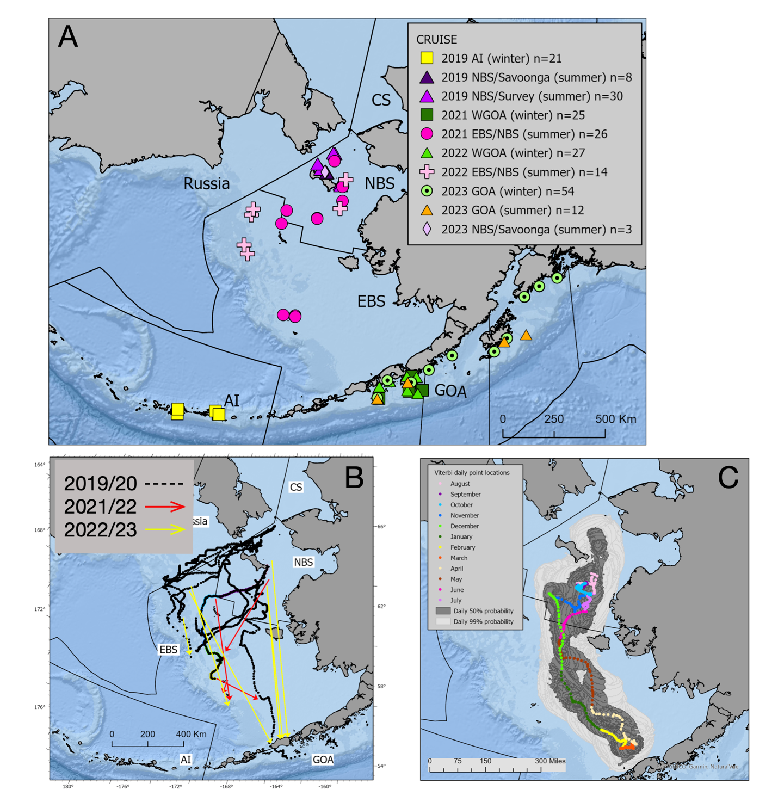

##### Figure 2.. A) Release locations for satellite-tagged Pacific cod in Alaska through 2023. B) Movement from summer to winter (February and March) locations in the Bering Sea. Dotted lines indicate pathways reconstructed using PSAT data (2019-2020) and solid arrows indicate straight line distance moved between release and pop-up locations (2021-2022 and 2022-2023). C) A reconstructed pathway for a fish tagged in the NBS during the summer of 2021 demonstrates a long-distance spawning migration followed by return to the NBS the summer of 2022. Daily point estimates are color coded by month and geolocation uncertainty is indicated polygons that encompass the highest 50% and 99% probability for each day.

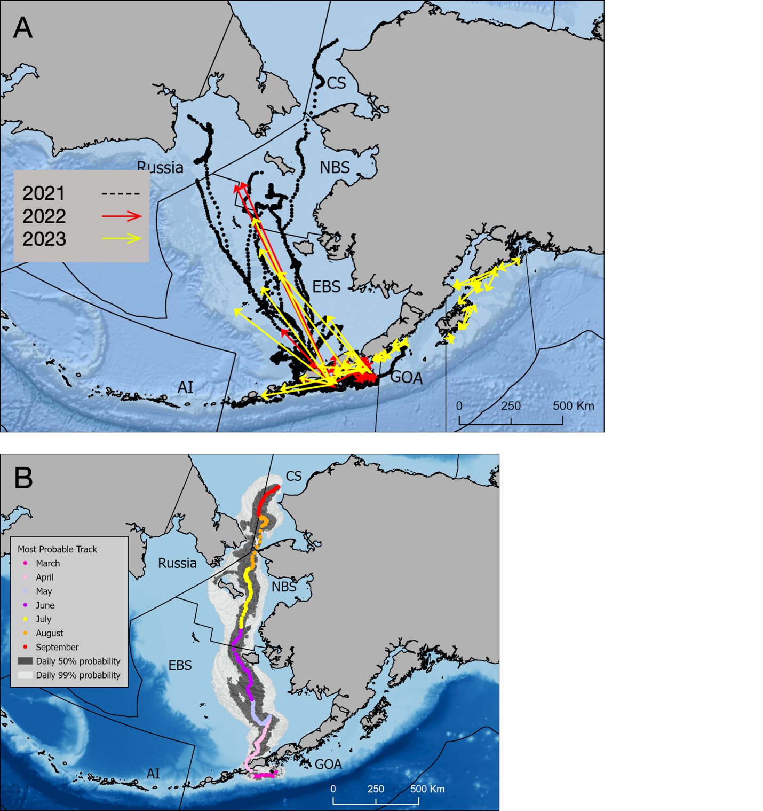

##### Figure 2.. A) Movement from winter spawning locations in the GOA to summer foraging areas. Dotted lines indicate pathways reconstructed using PSAT data (2021) and solid arrows indicate straight line distance moved between release and pop-up locations (2022 and 2023). B) A reconstructed pathway for a fish tagged in the western GOA during the winter of 2021 demonstrates a long-distance migration to a summer foraging area in the Chukchi Sea. Daily point estimates are color coded by month and geolocation uncertainty is indicated polygons that encompass the highest 50% and 99% probability for each day.

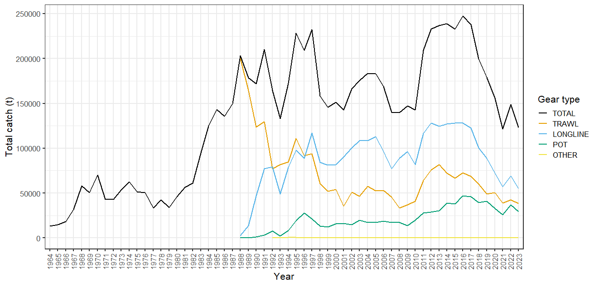

##### Figure 2.. Total catch and catch by gear type. Catch for 2023 is through October 3.

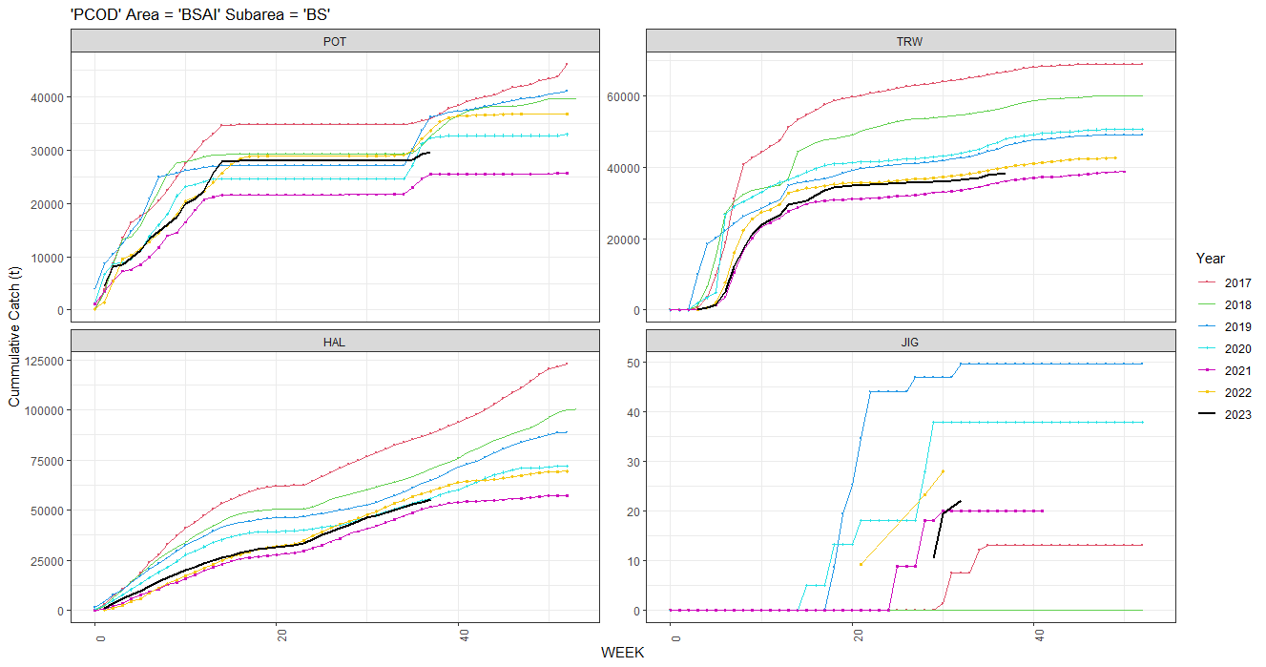

##### Figure 2.. Cumulative Pacific cod catch by gear type for 2017-2023. Data for 2023 are current through October 3.



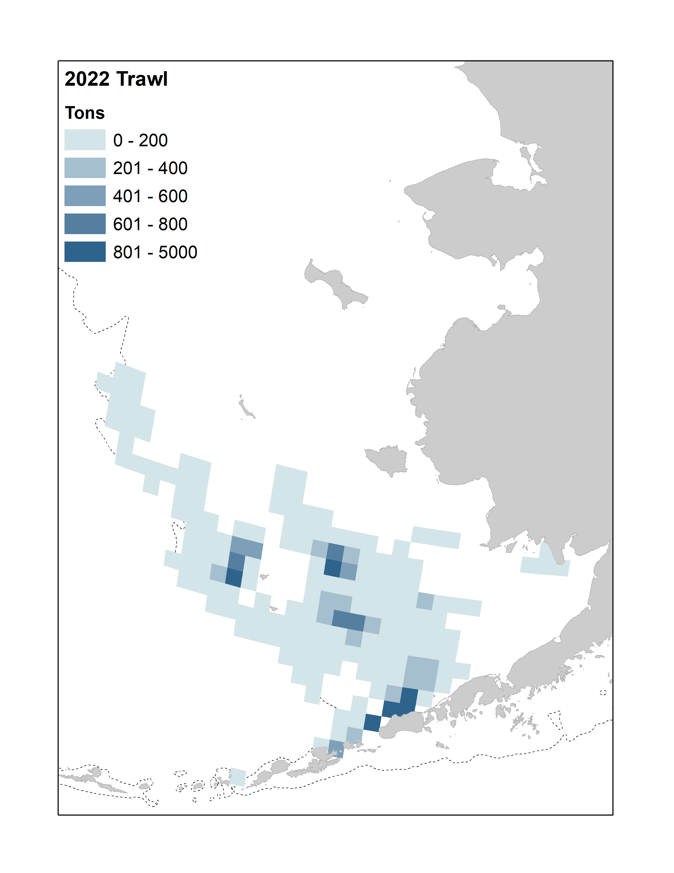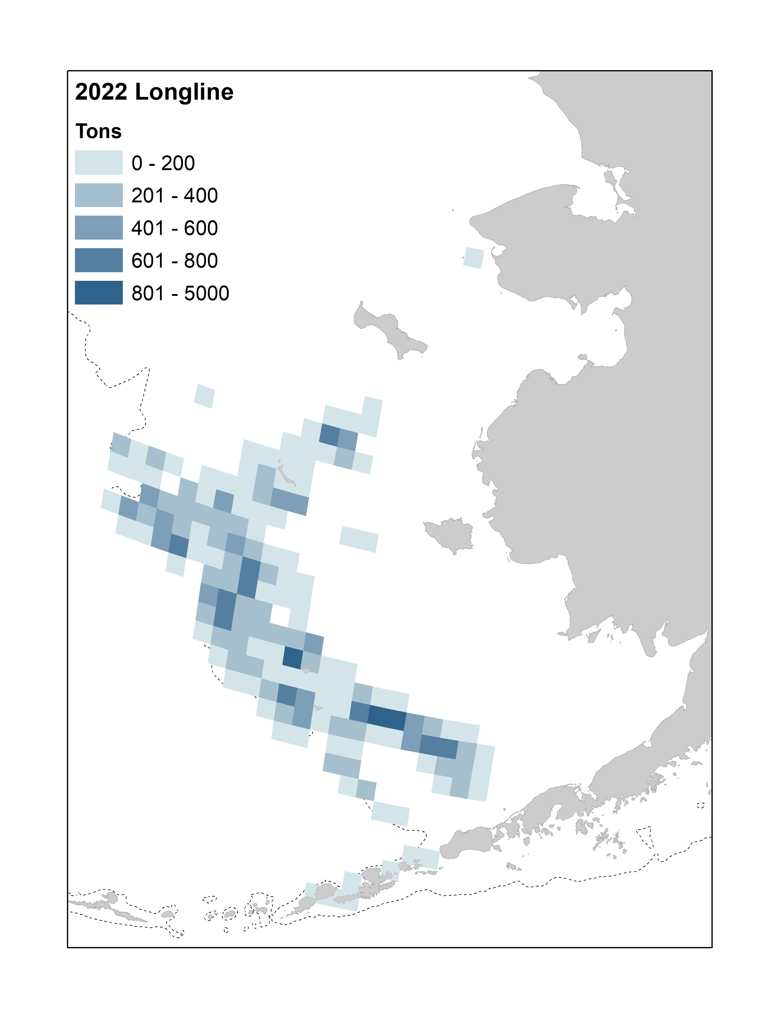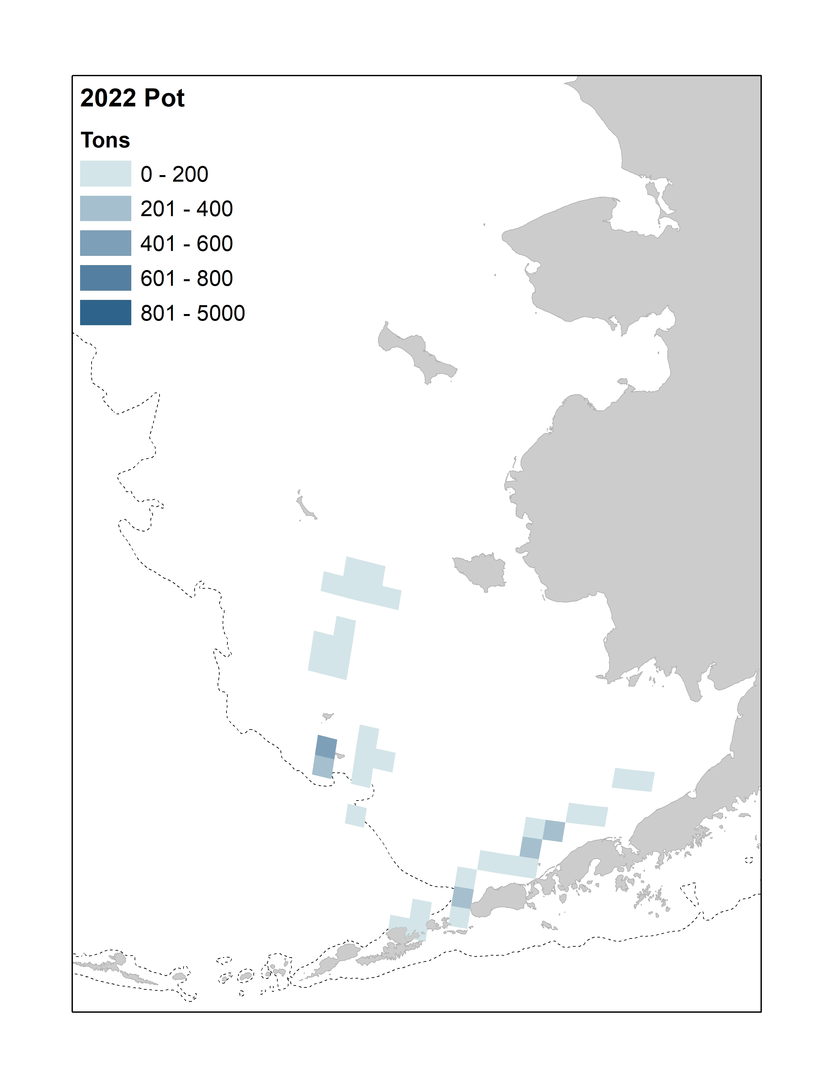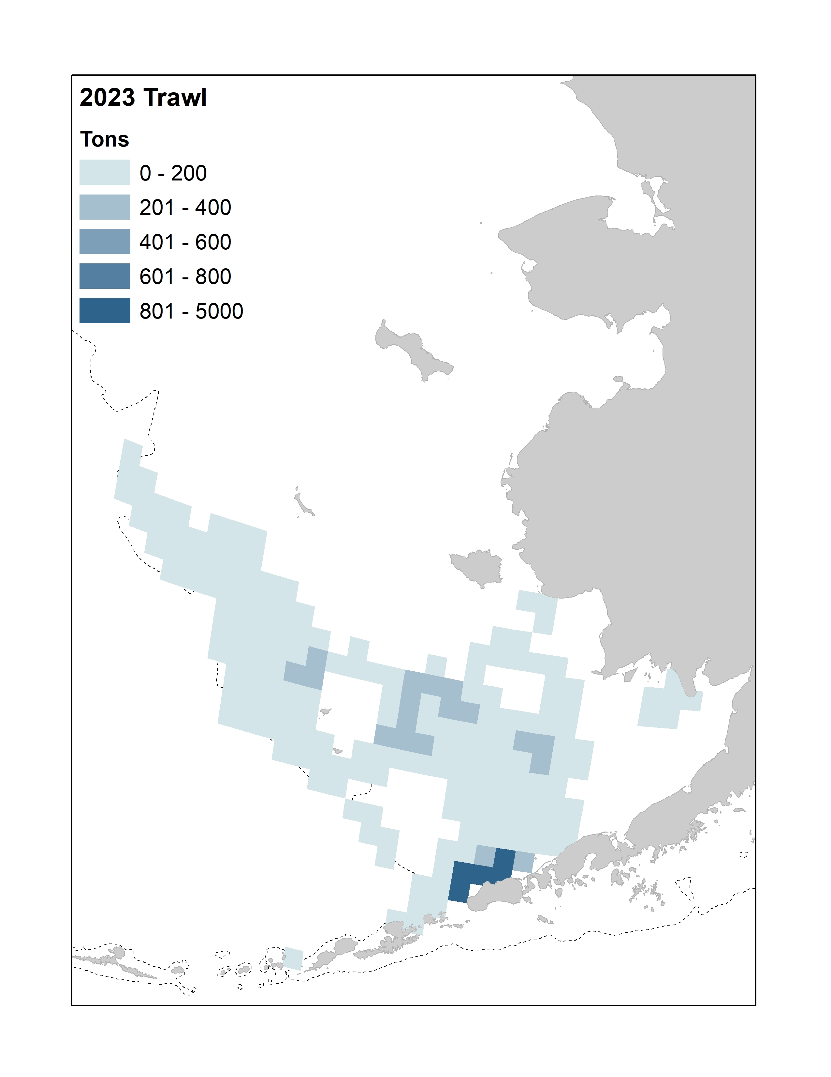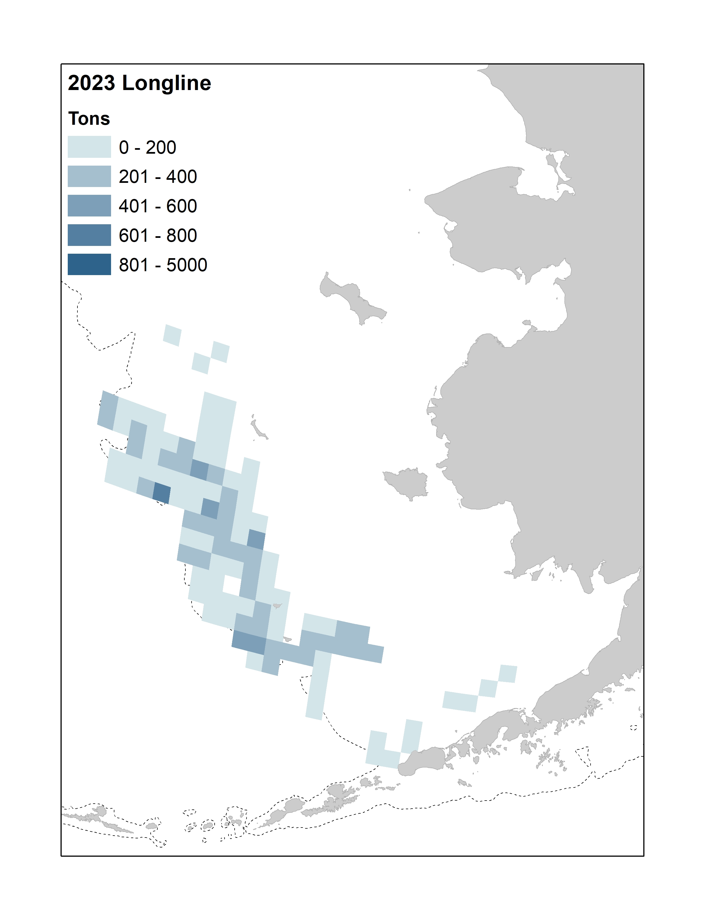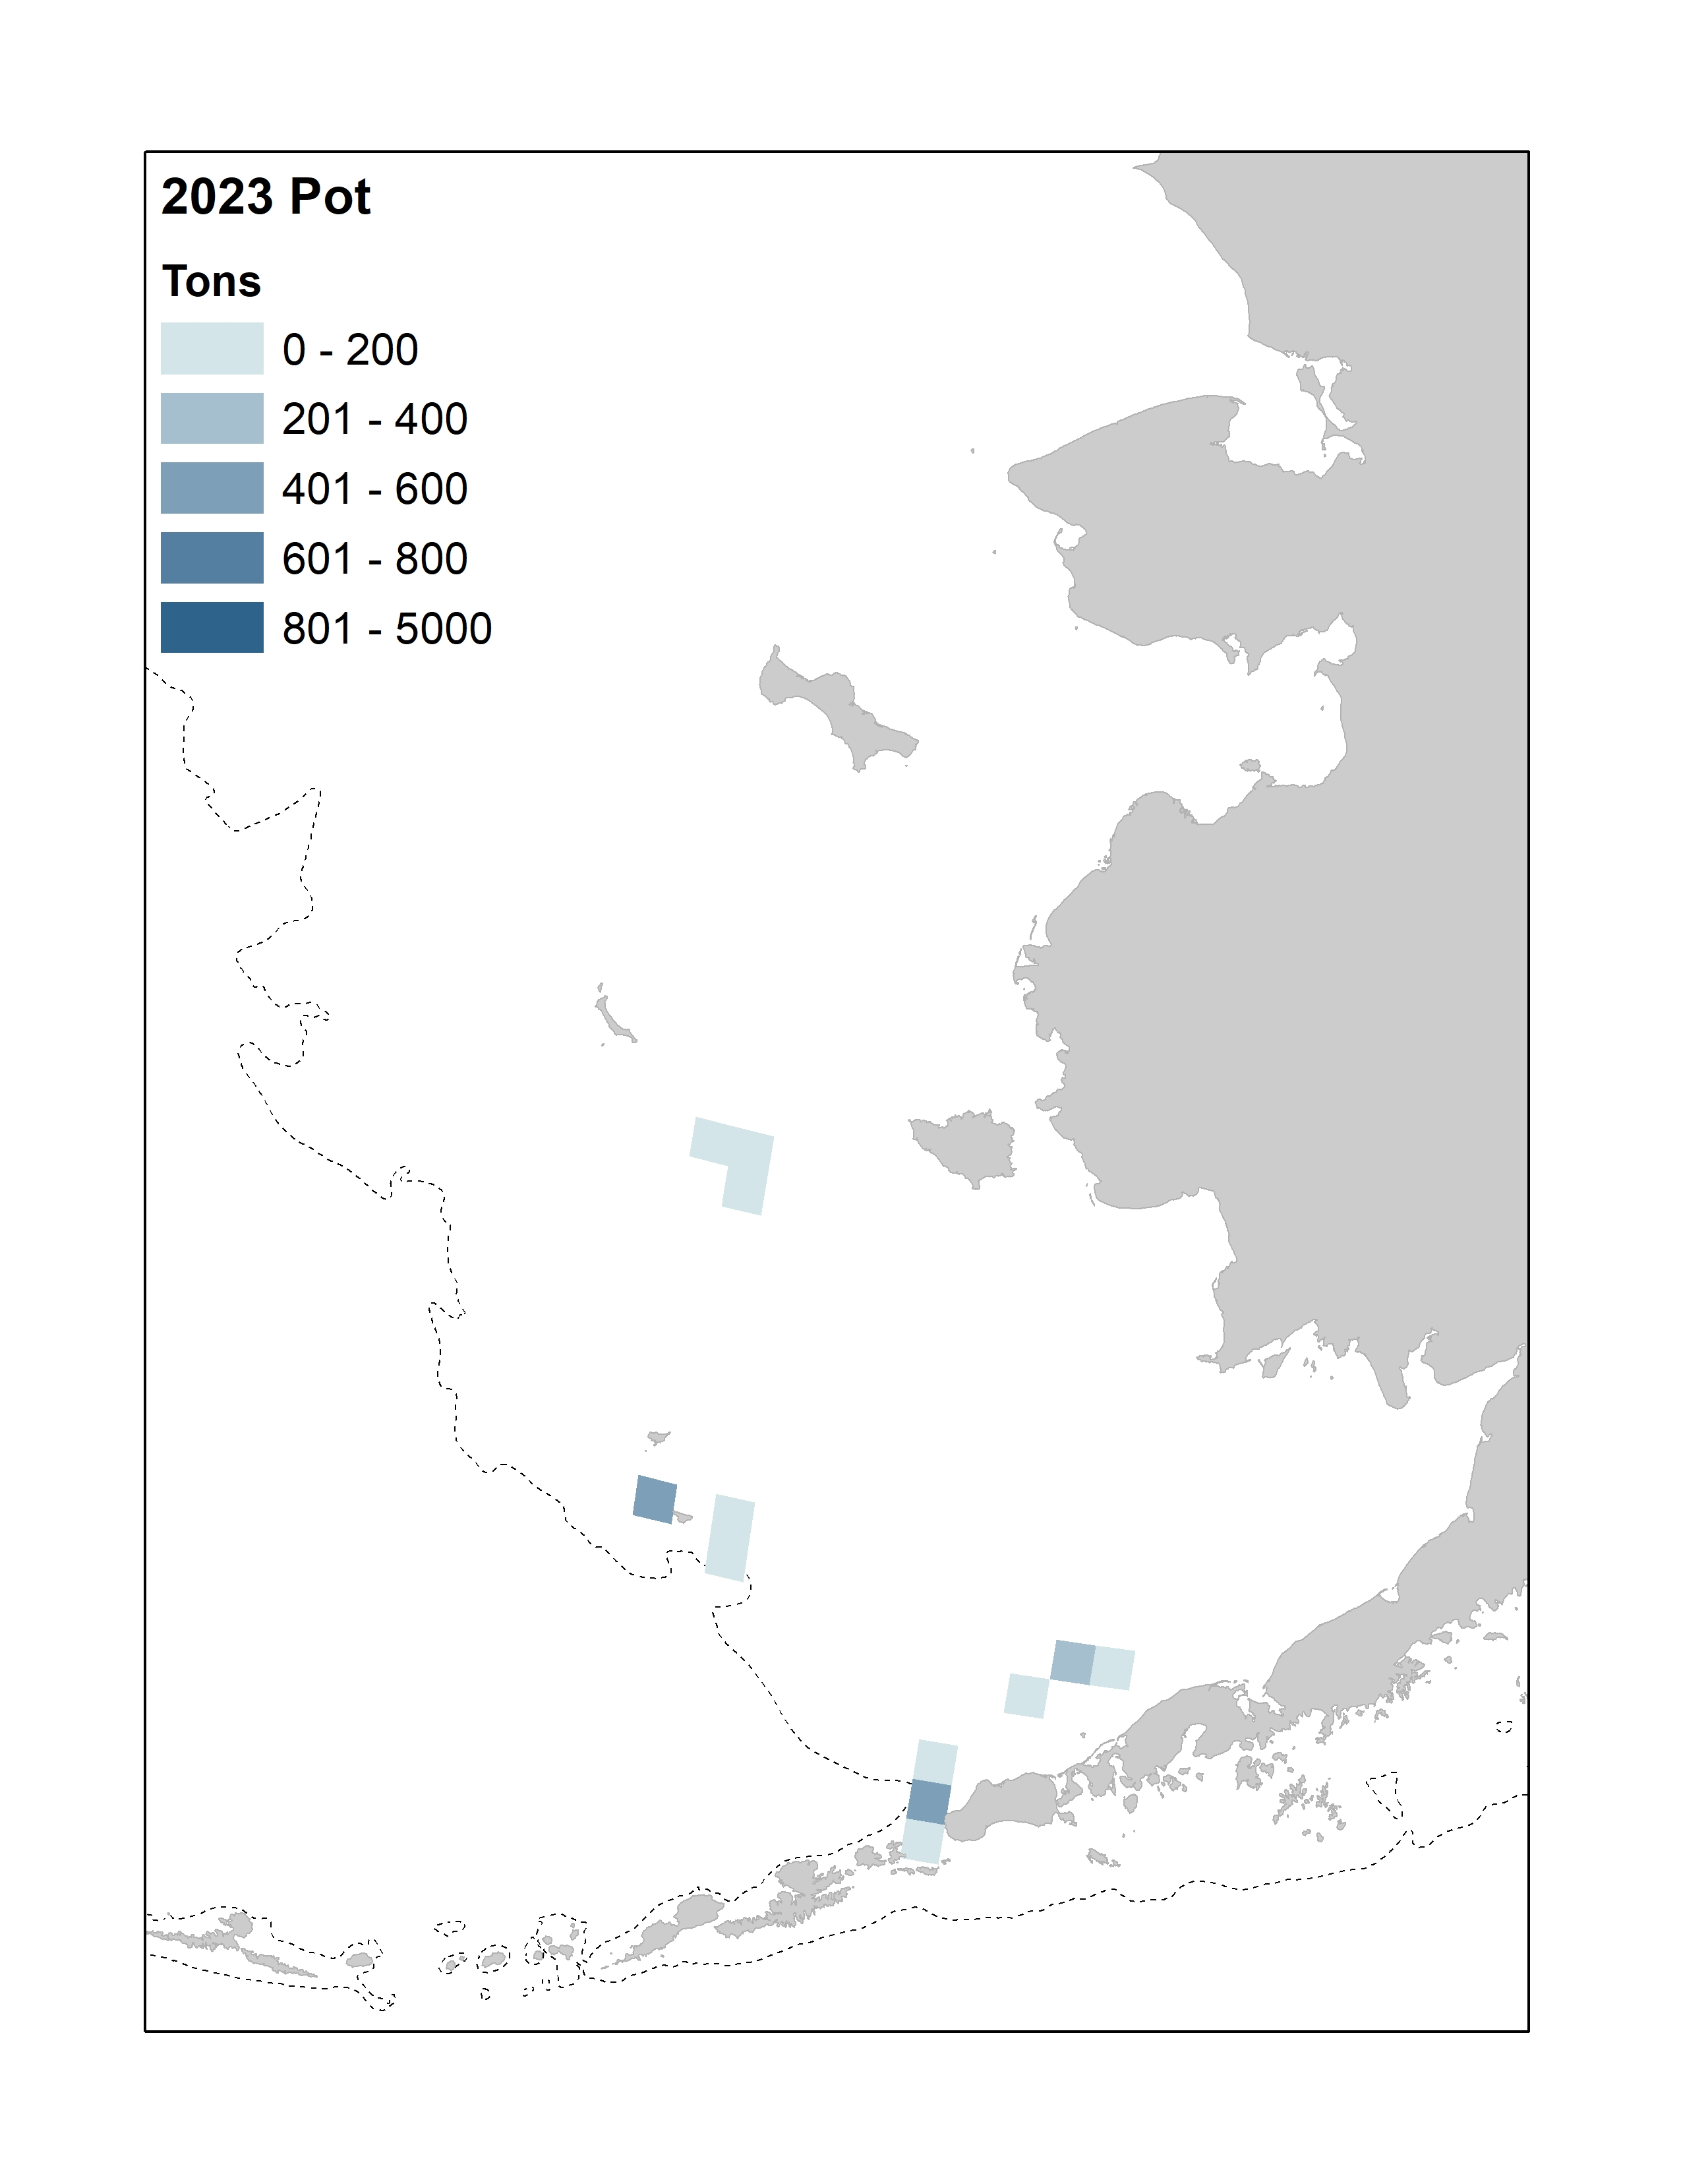

##### Figure 2.. Observed catch by gear type for 2021-2023. Data are aggregated by bottom trawl survey grid cells (20nm2) and all cells with fewer than 3 vessels fishing have been removed. Data for 2023 are through October 3. Bathymetry line (dotted gray) shown is at 200 m.

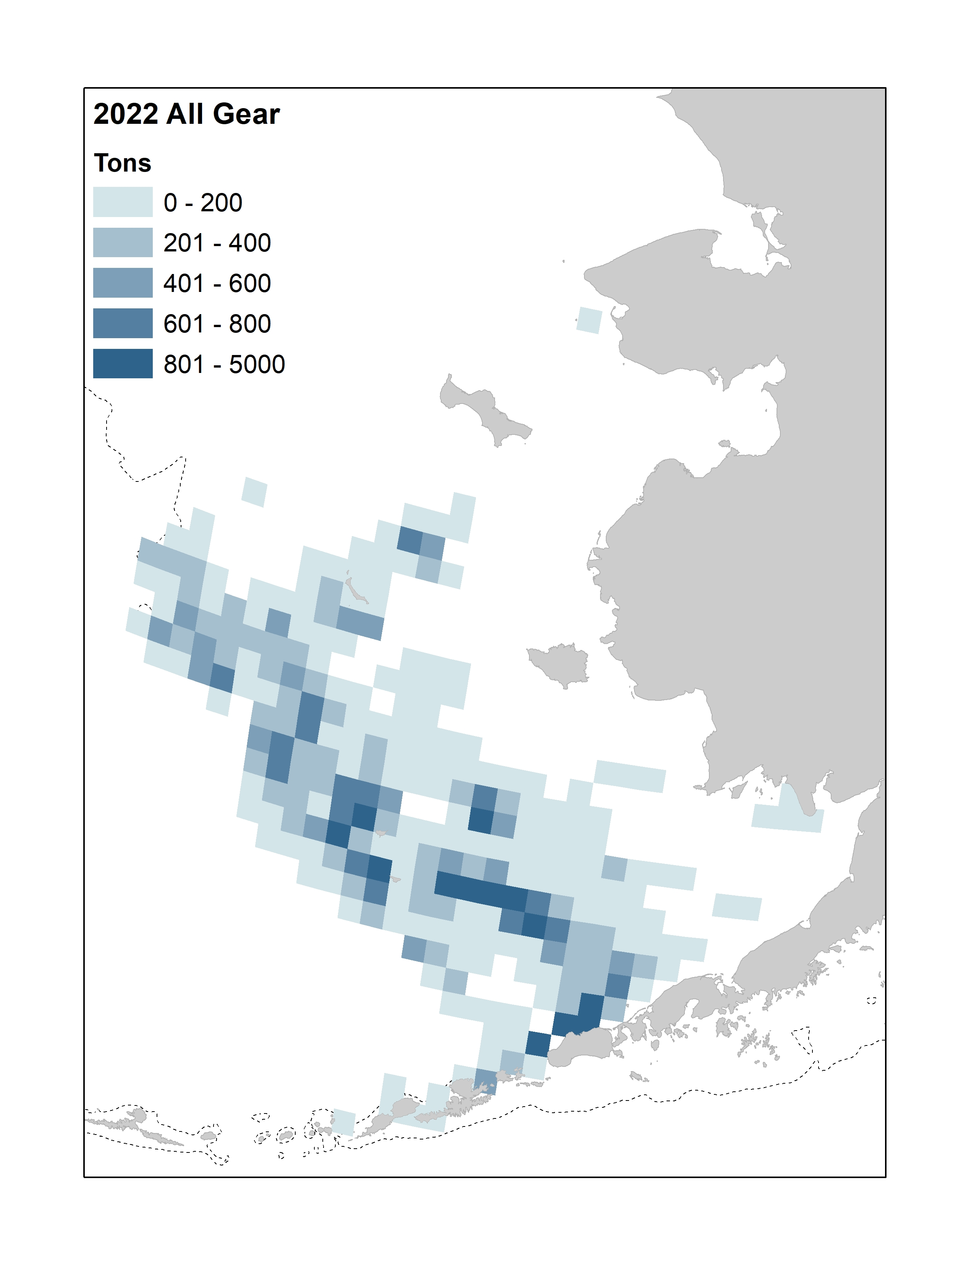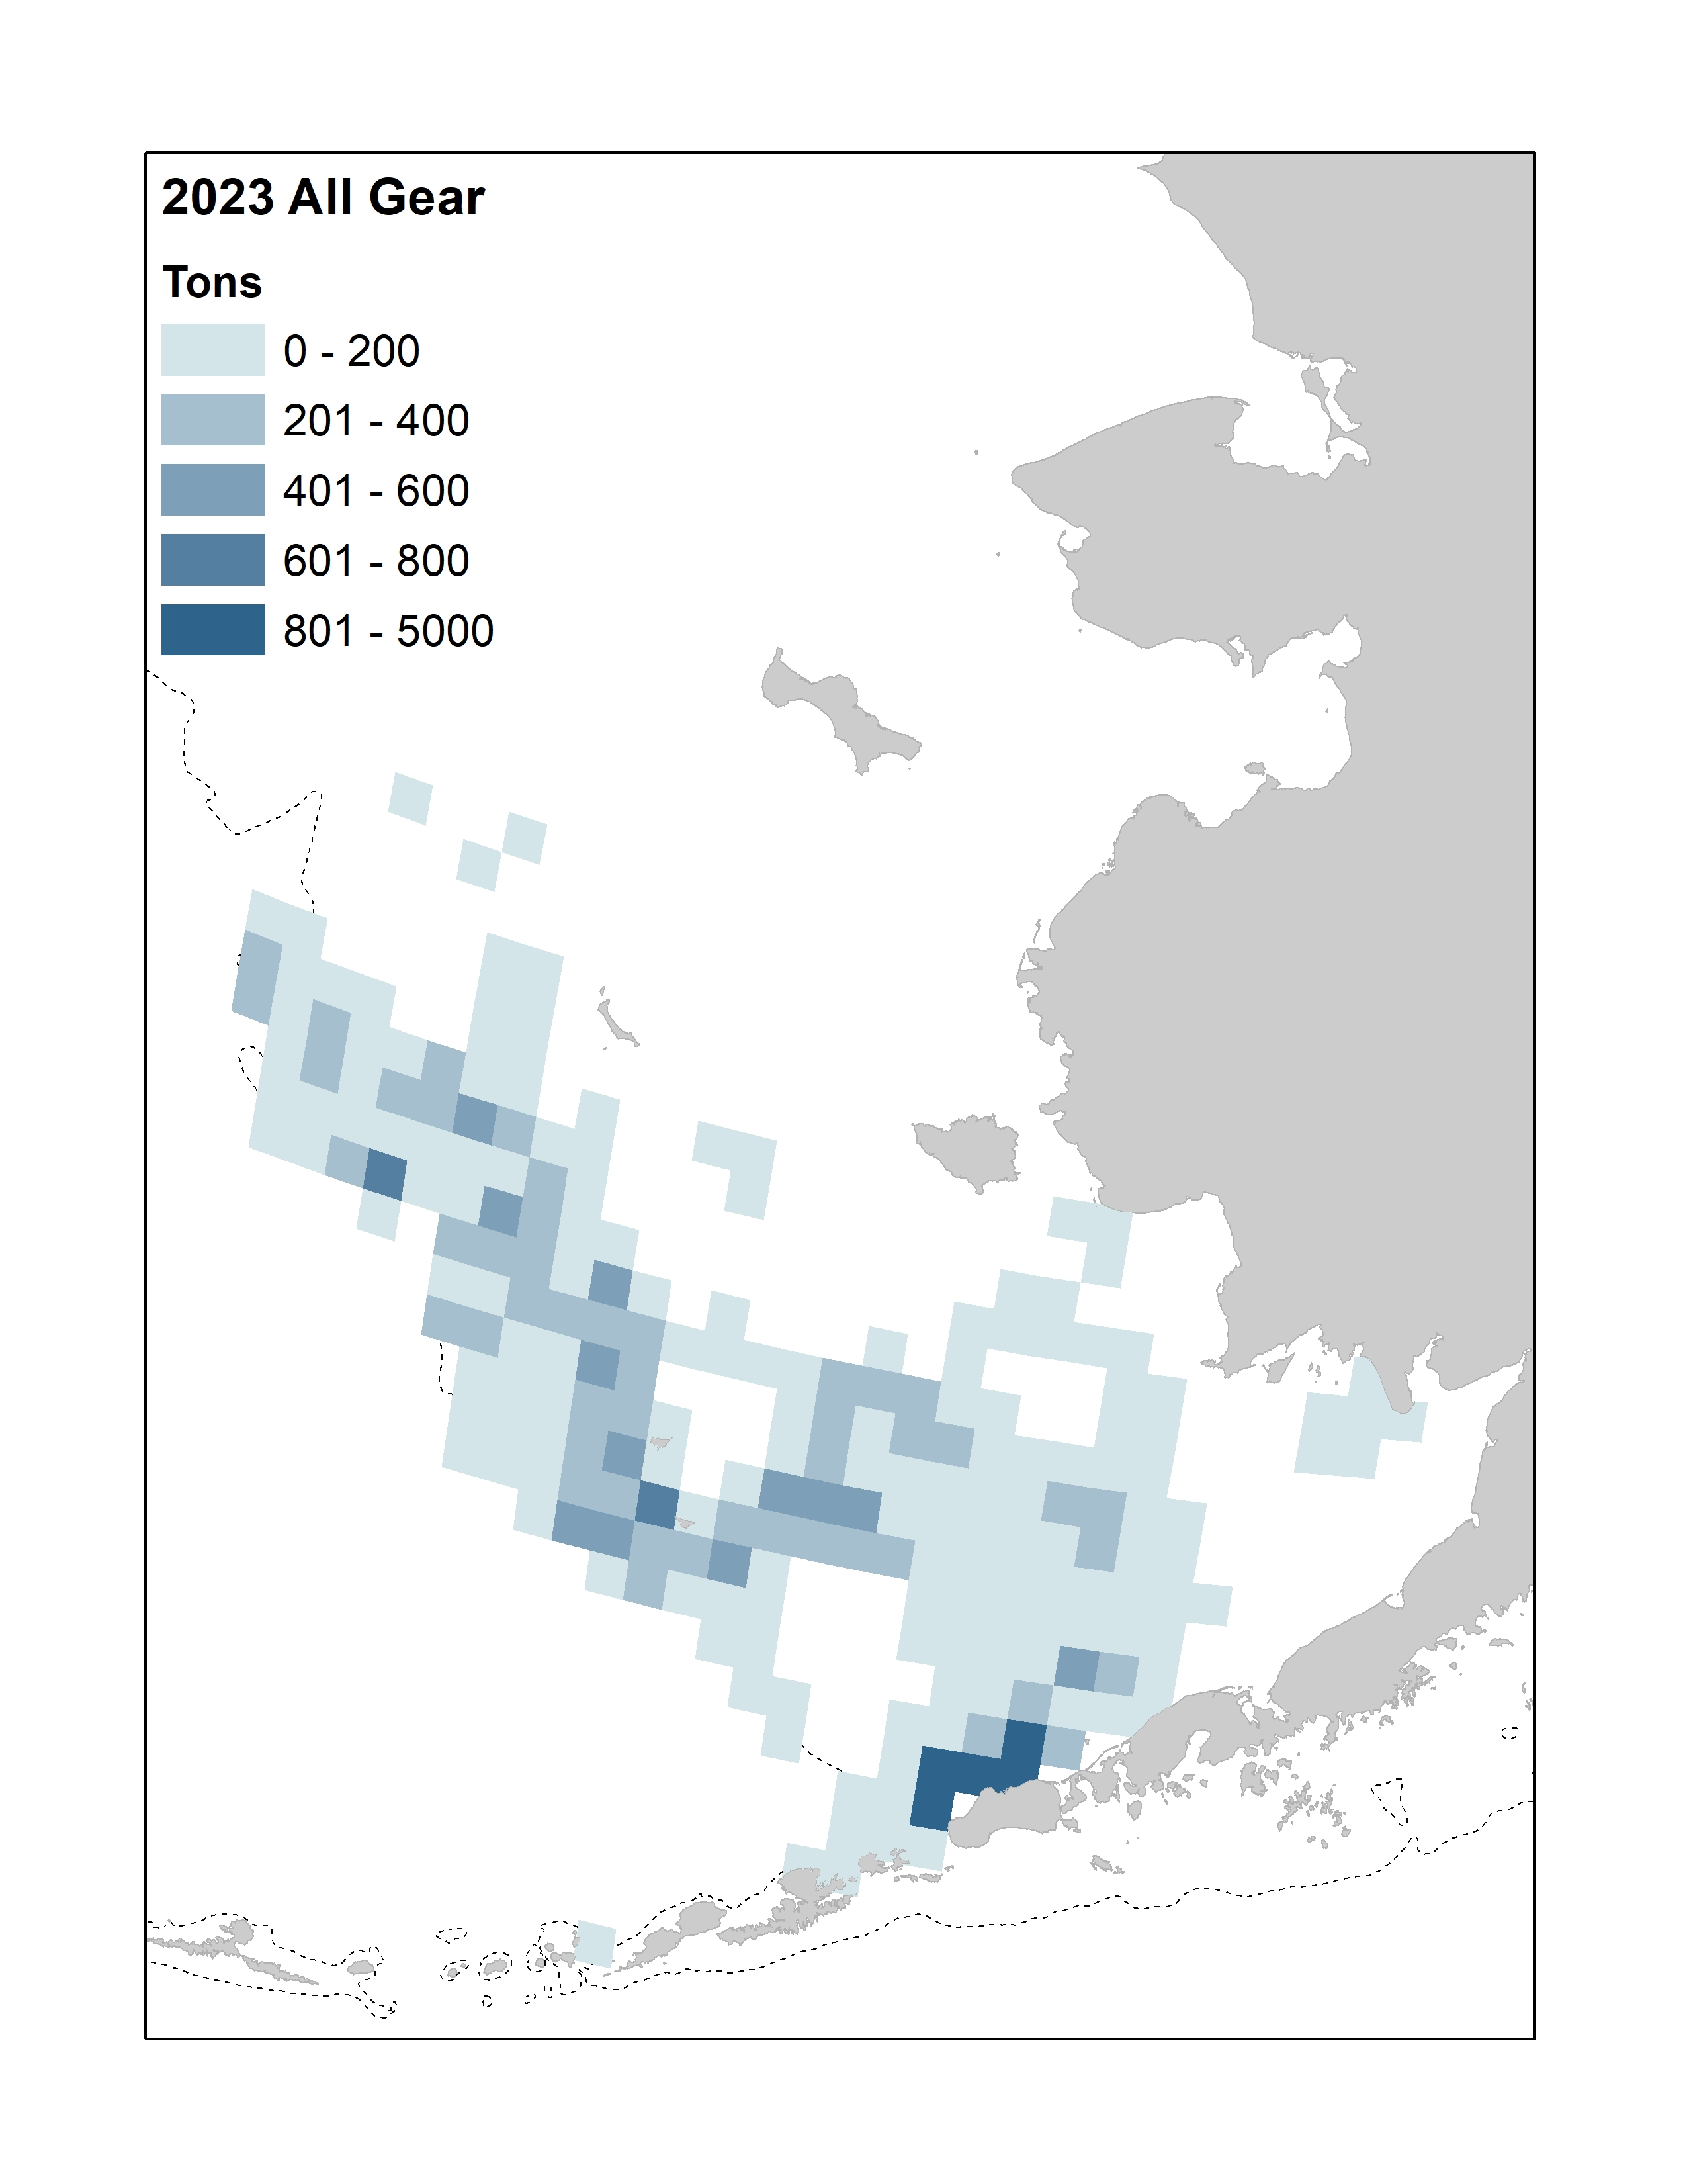

##### Figure 2.. Total observed catch for 2021-2023. Data are aggregated by bottom trawl survey grid cells (20nm2) and all cells with fewer than 3 vessels fishing have been removed. Data for 2023 are through October 3. Bathymetry line (dotted gray) shown is at 200 m.

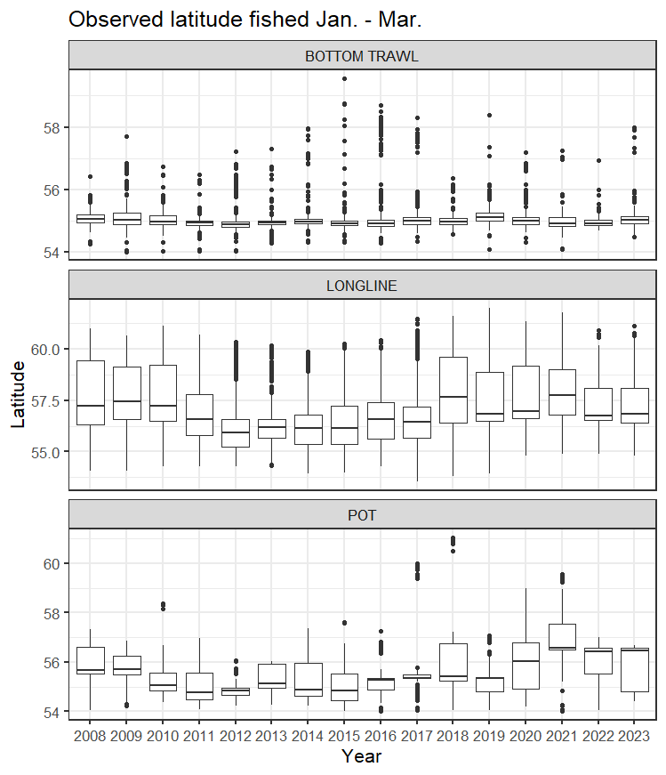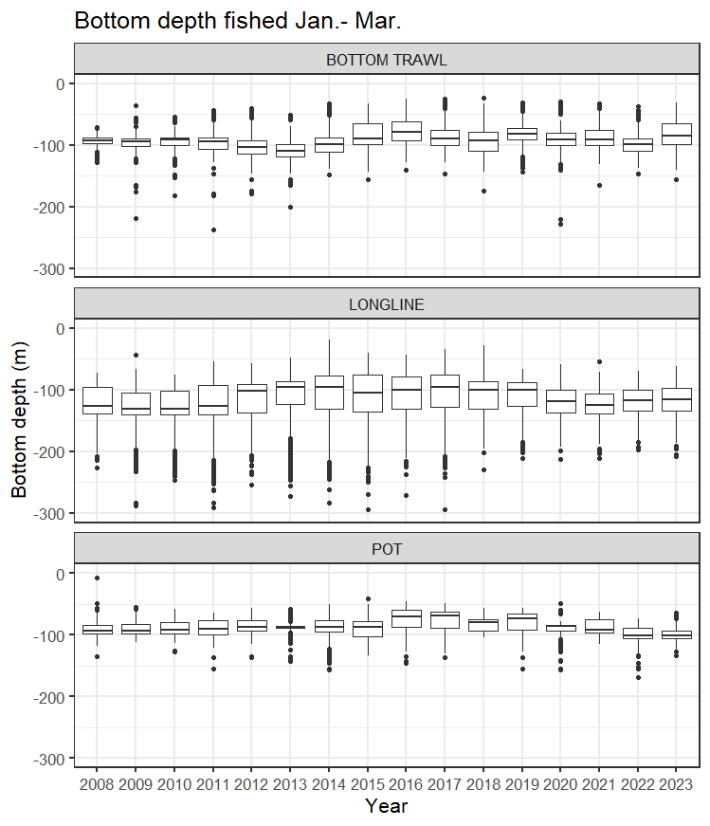

##### Figure 2.. Distribution of Pacific cod hauls or sets by gear type for 2008-2023 for January-March by (left) Latitude and (right) bottom depth in meters.

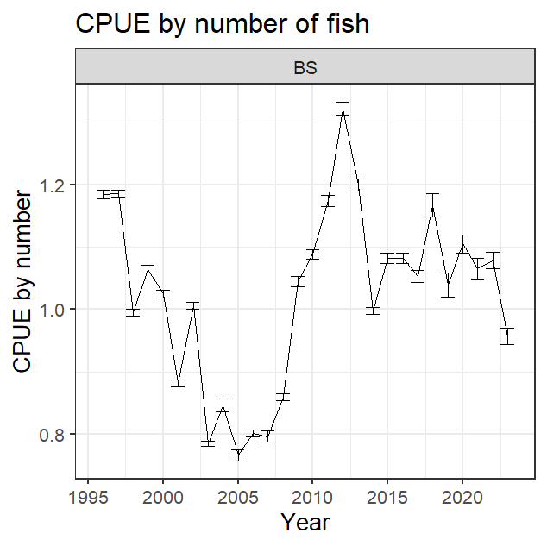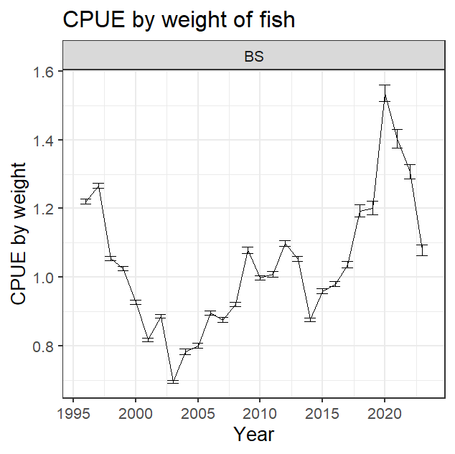

##### Figure 2.. Thompson et al. (2021) combined fishery CPUE index estimates for 1996-2023 by (left) number and (right) weight of fish.

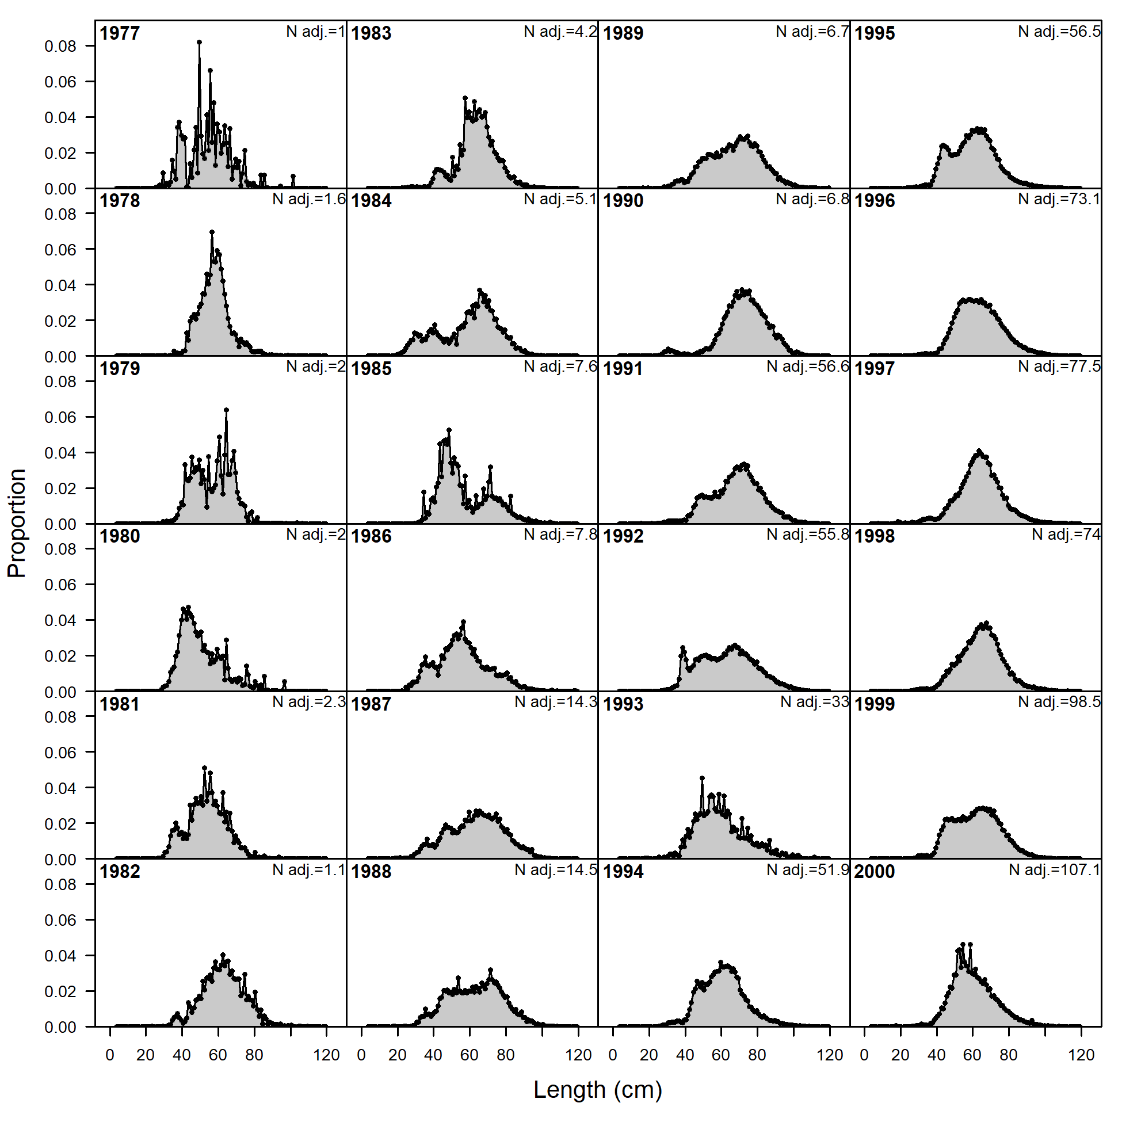 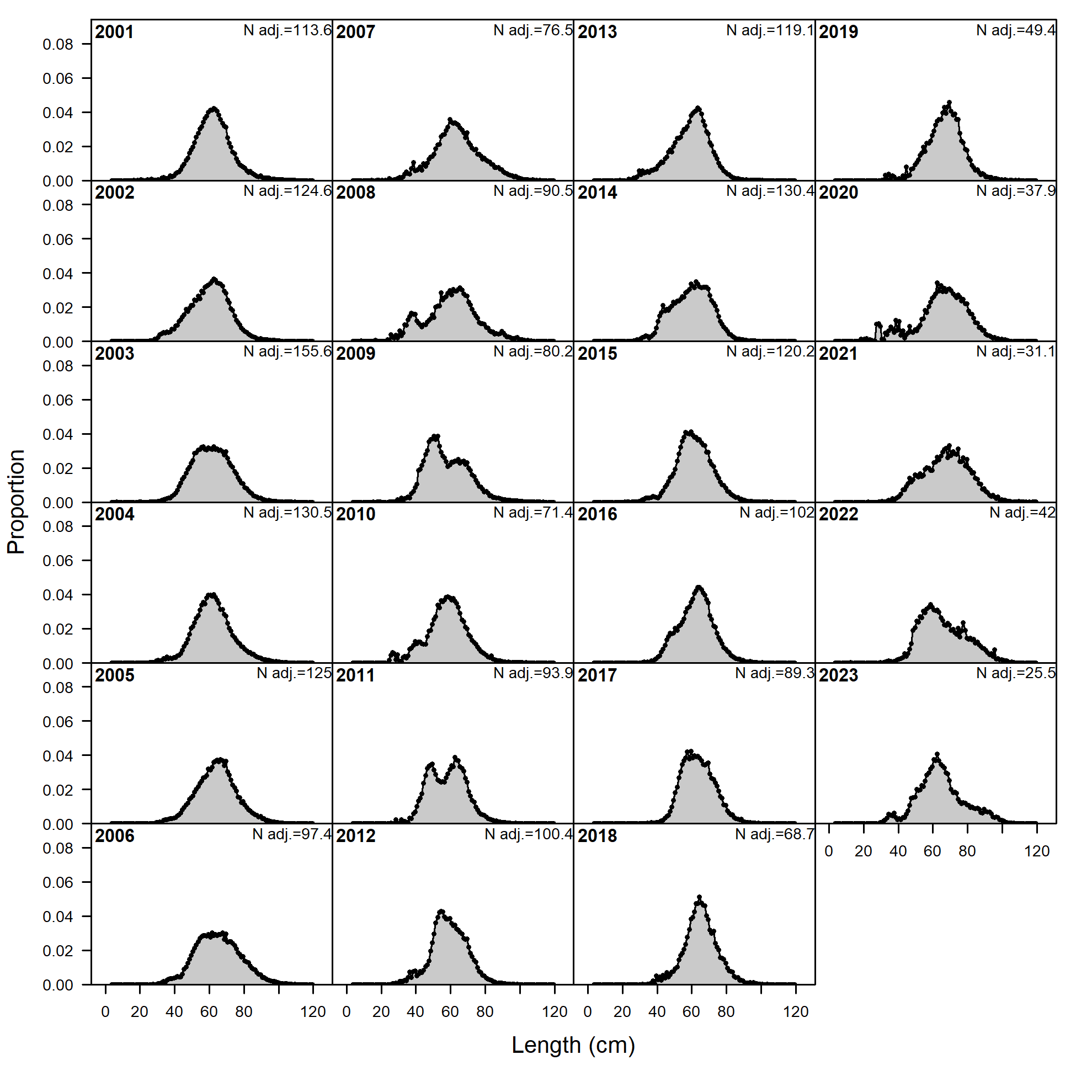

##### Figure 2.. Combined fishery length composition distributions by year.

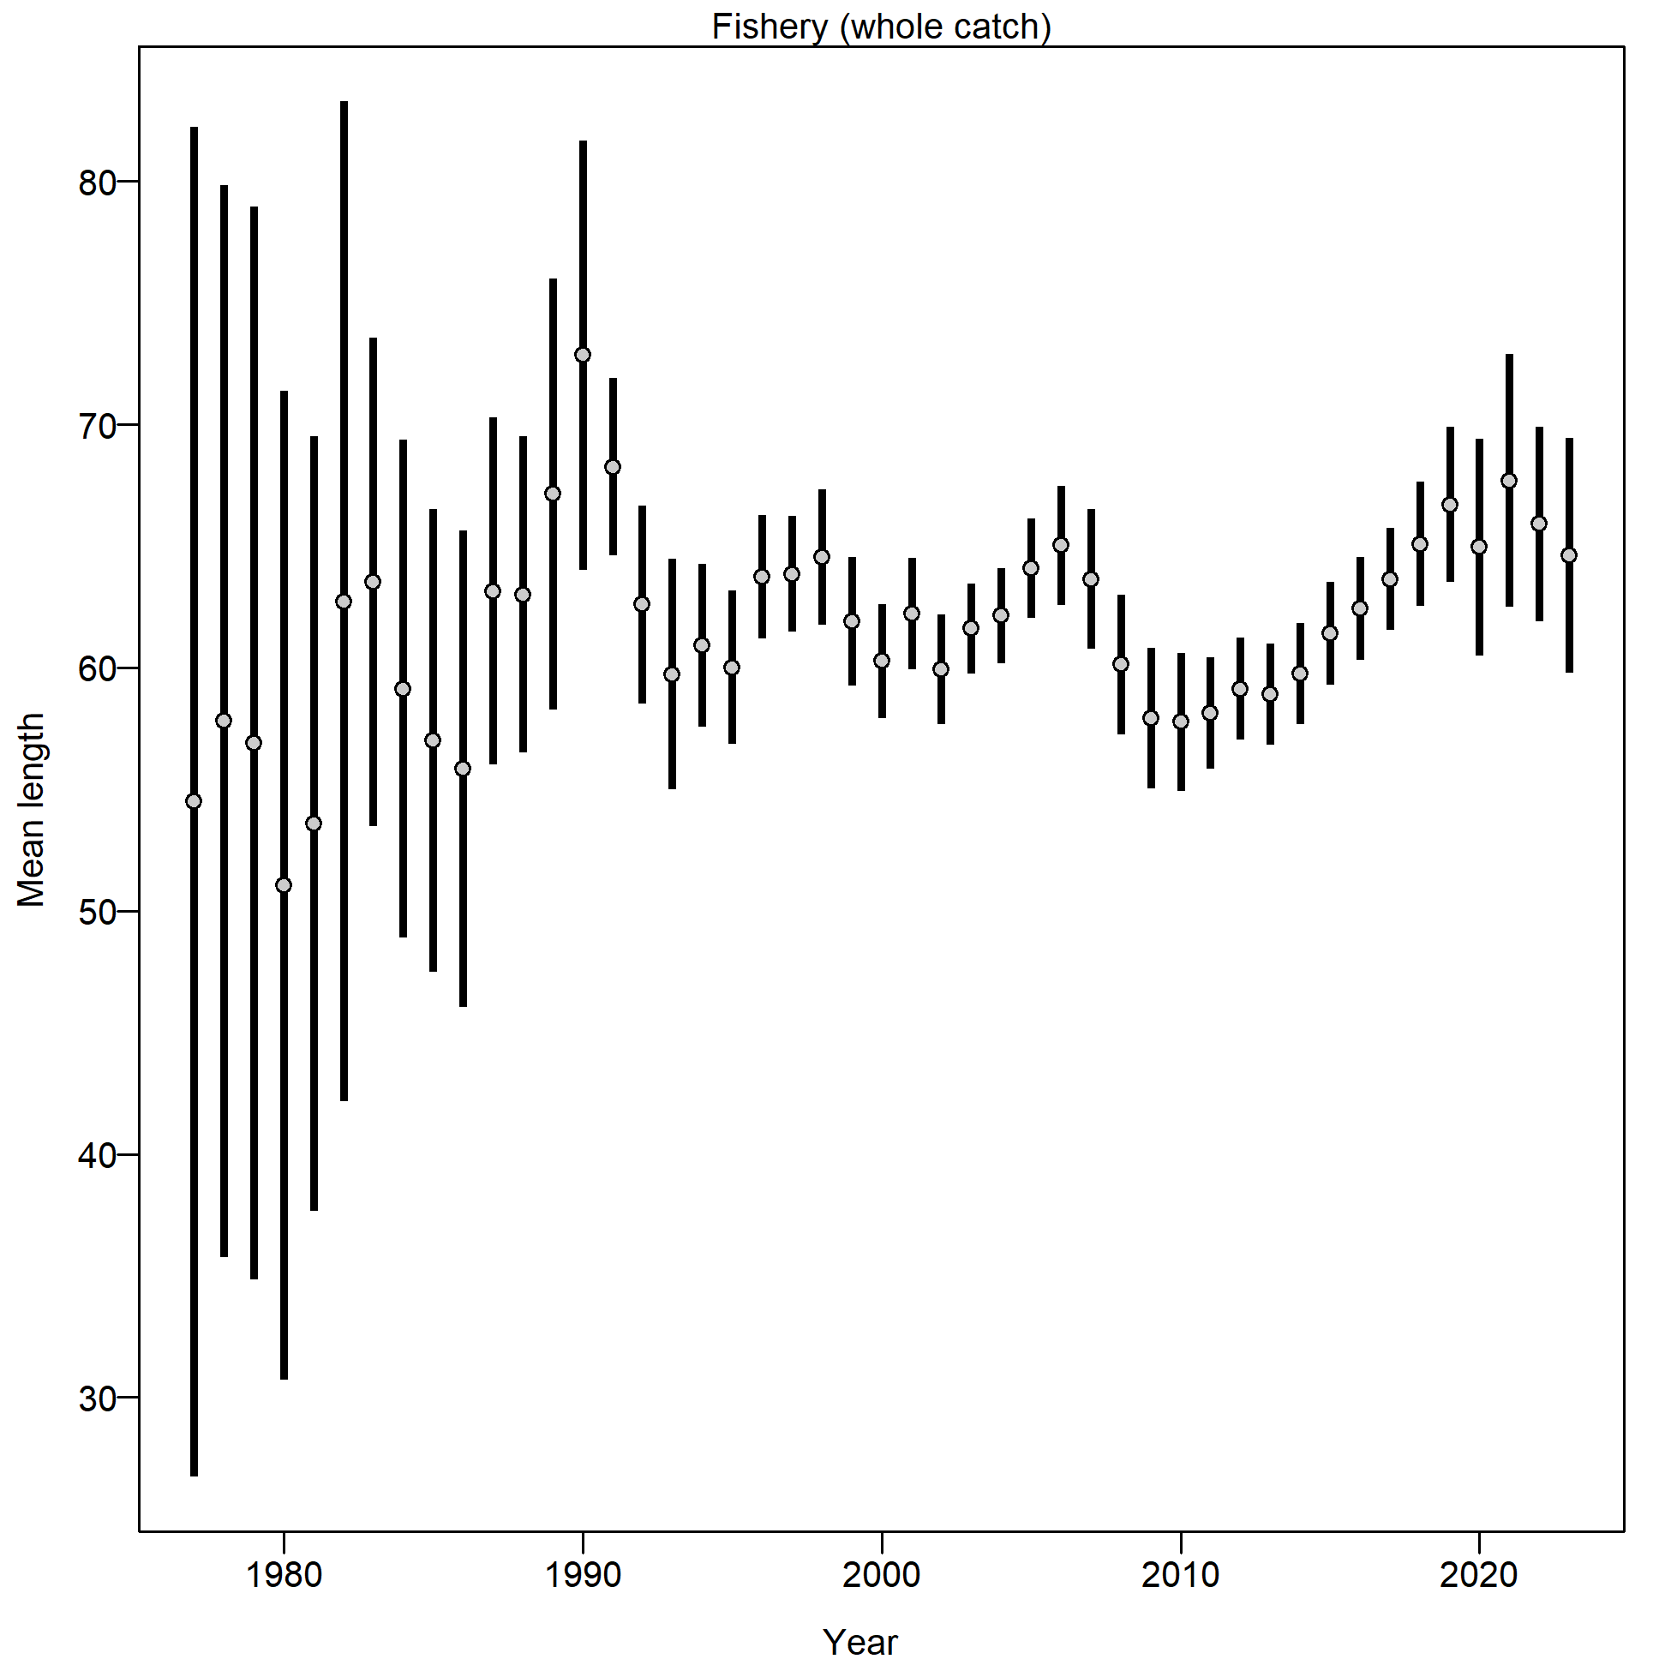

##### Figure 2.. Combined fishery mean length (cm) by year.

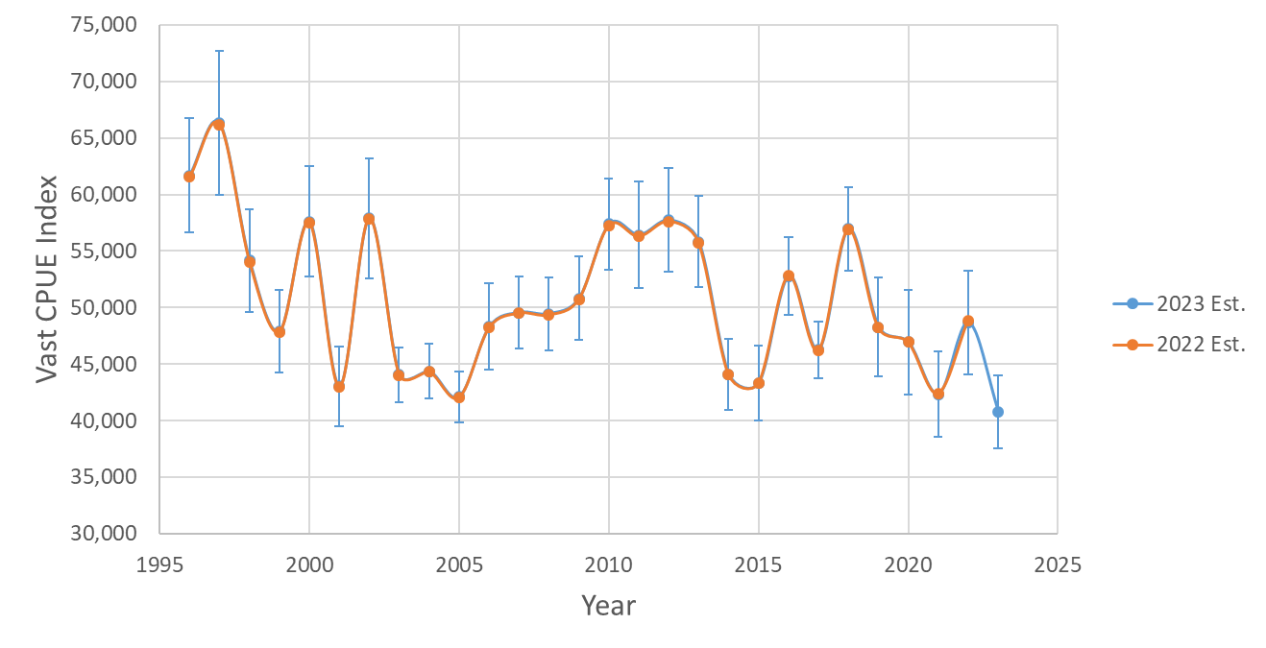

##### Figure 2.. VAST derived winter (January-February) longline fishery CPUE index estimates from 2021 and 2022 for 1996-2022.

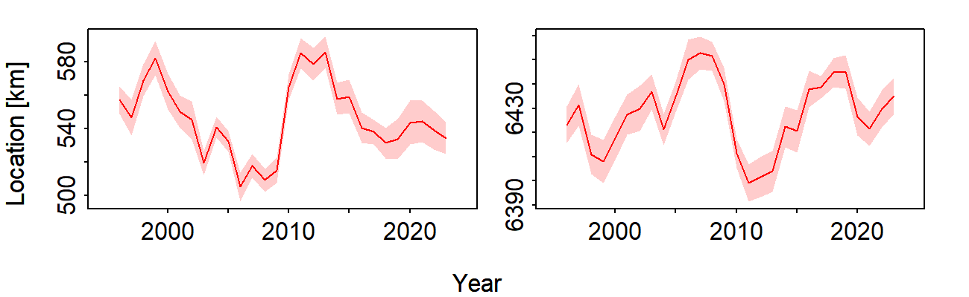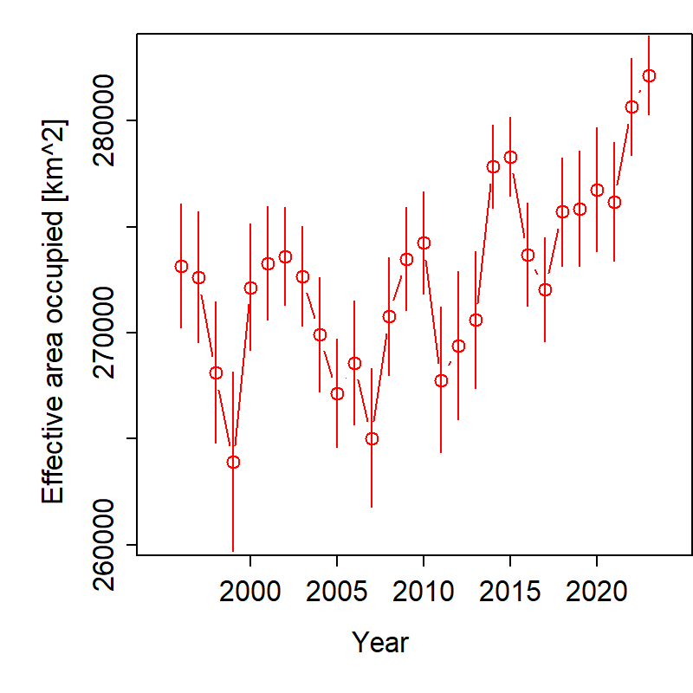

Northings

Eastings

Figure 2.. VAST winter (January- February) longline fishery CPUE index (top left) eastings where larger values indicate further east, (top right) northings where larger values indicate further north, and (bottom) effective area occupied.

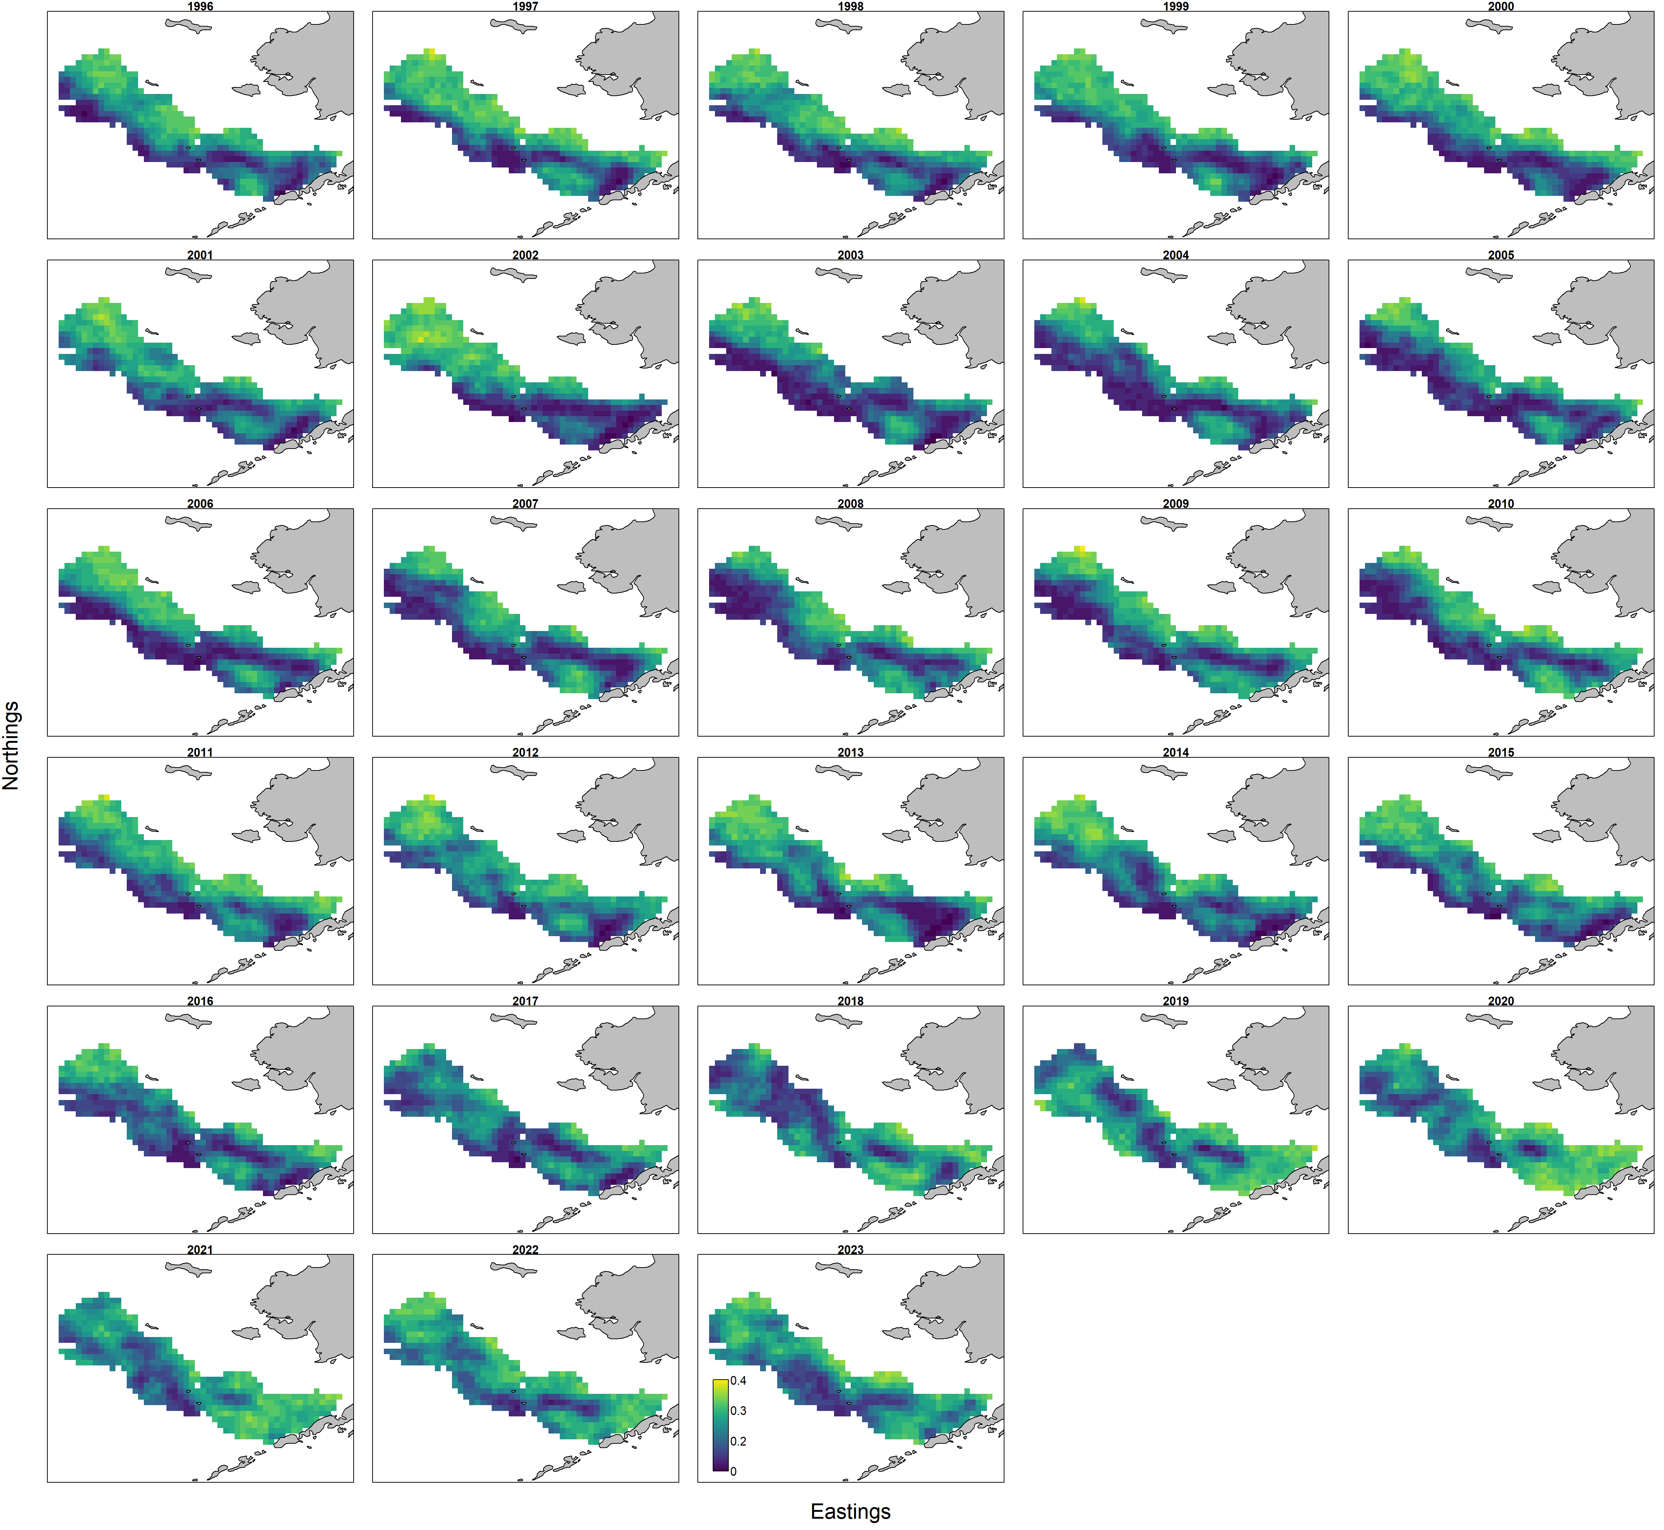

##### Figure 2.. VAST winter longline fishery index CPUE log density maps by year.



##### Figure 2.. AFSC bottom trawl survey strata where crosses represent station locations.



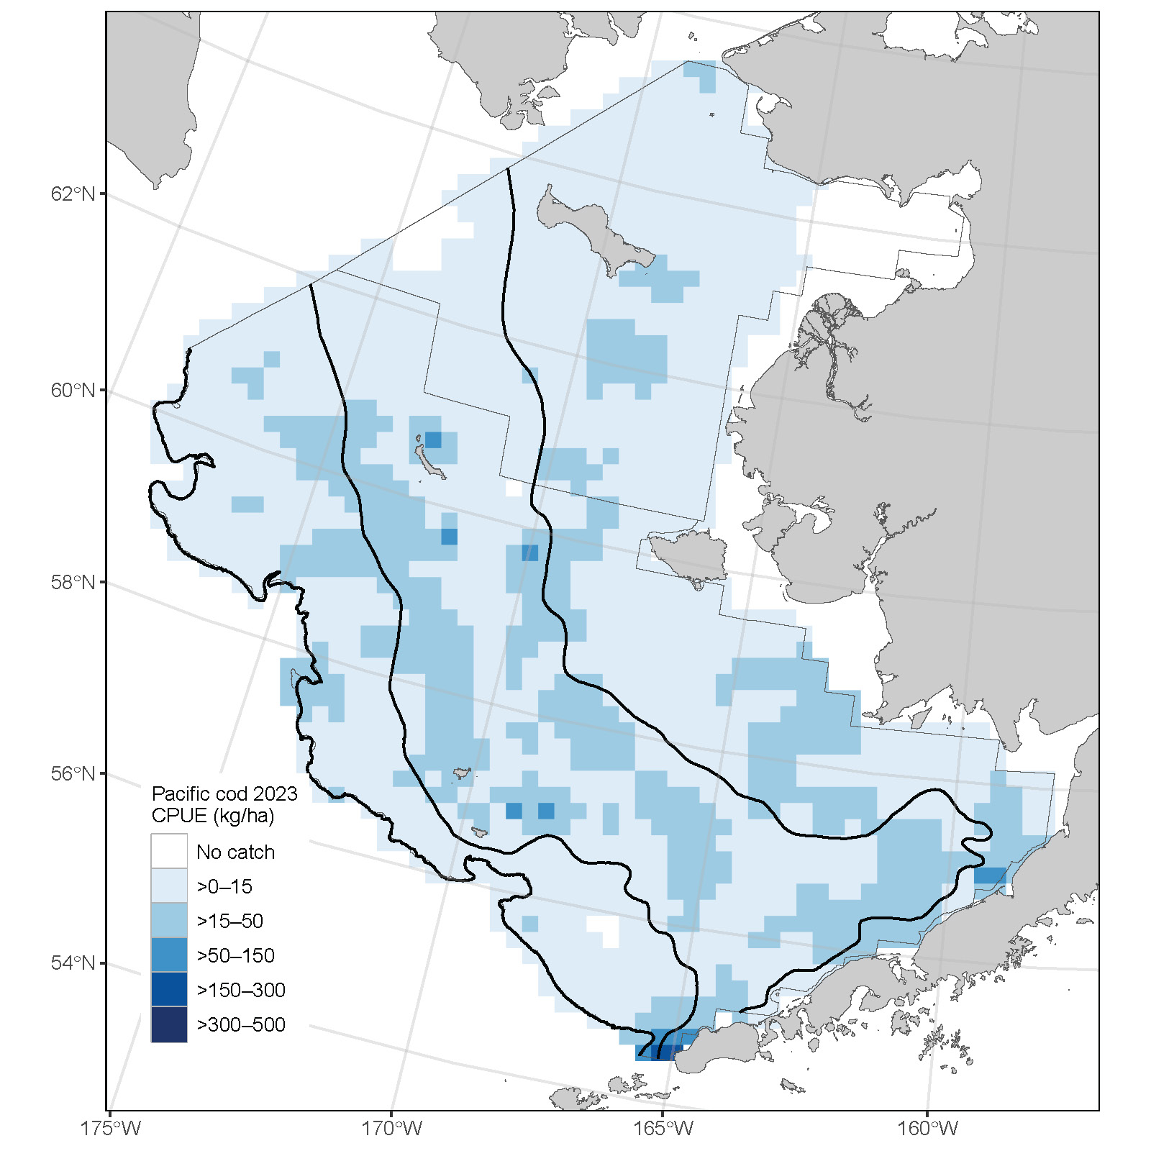

##### Figure 2.. AFSC bottom trawl survey Pacific cod catch per unit effort for 2011-2023 (from top left to bottom right). Maps for 2017, 2019, and 2021-2023 include the northern Bering Sea. There was no survey in 2020. The 50m, 100m, and 200m bathymetry lines are shown.

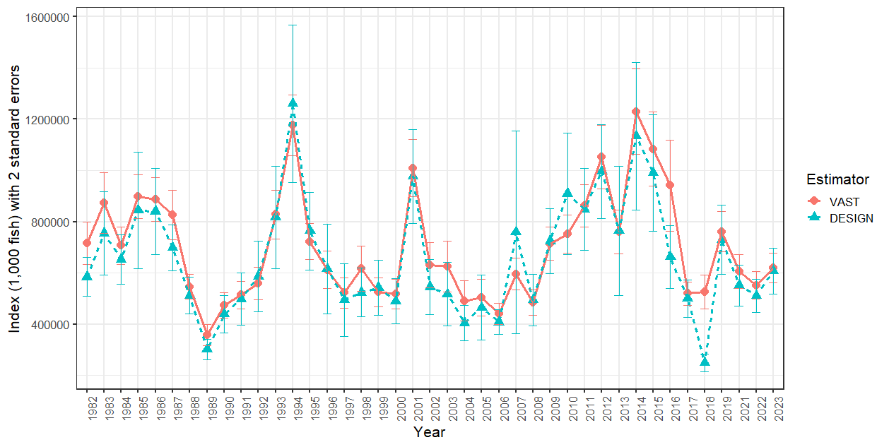

##### Figure 2.. Pacific cod abundance estimates (1000s of fish) for design-based and 2023 VAST Bottom trawl survey time series.

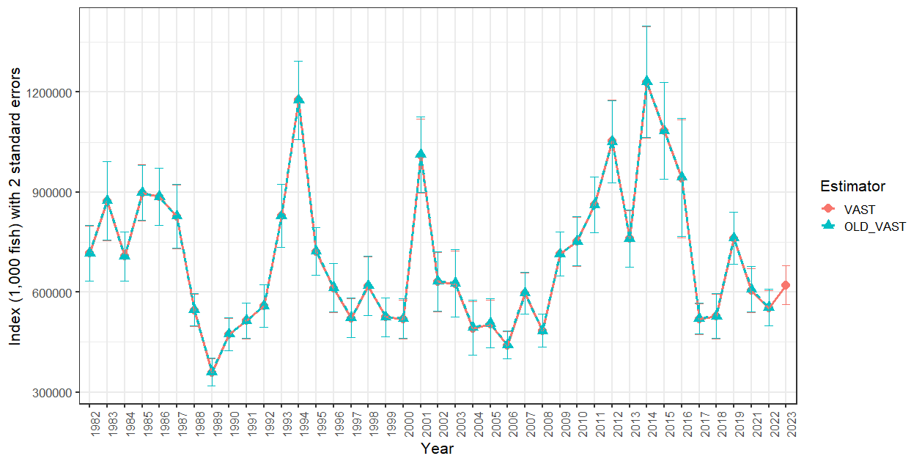

##### Figure 2.. The 2022 (OLD_VAST) and 2023 (VAST) Bering Sea bottom trawl survey Pacific cod abundance (1000s of fish) estimates with confidence intervals (2 standard errors).

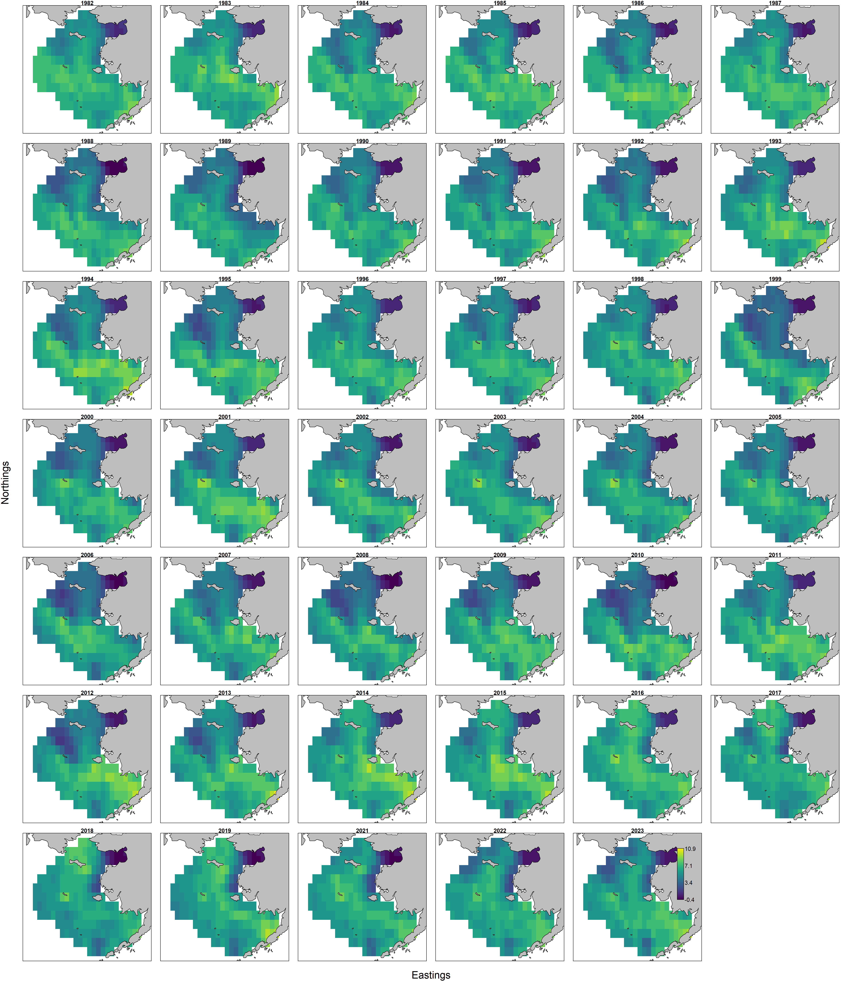

##### Figure 2.. Bering Sea shelf bottom trawl survey Pacific cod abundance log density maps by year from 2023 VAST.

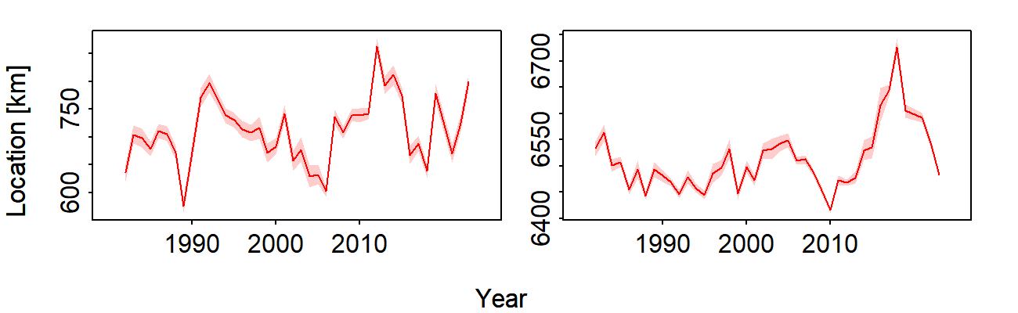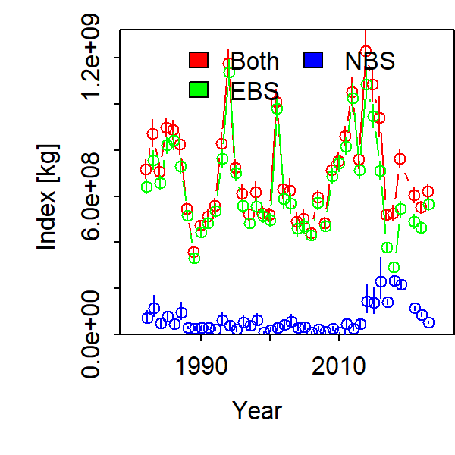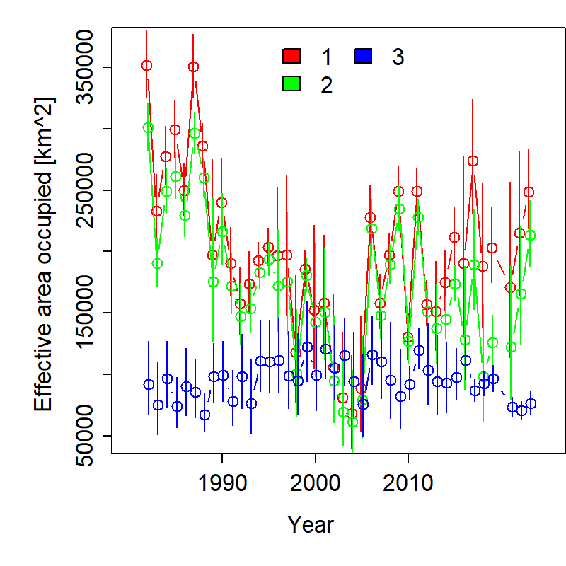

Northings

Eastings

##### Figure 2.. Bering Sea shelf bottom trawl survey index center of gravity (top left) eastings, (top right) northings, (bottom left) abundance index by area, and (bottom right) effective area occupied 1982-2023 for Pacific cod from 2023 VAST.

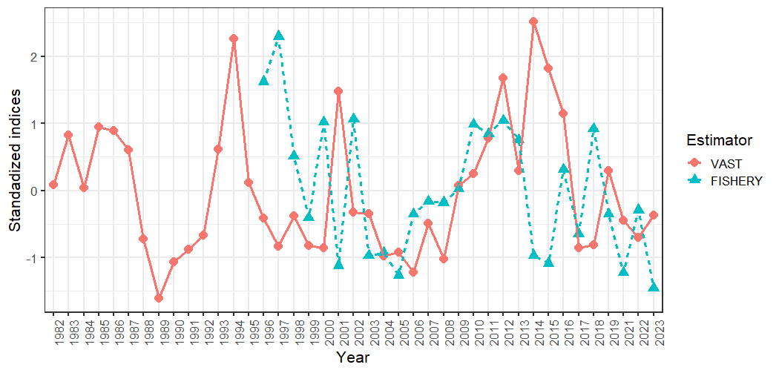

##### Figure 2.. Standardized values of the 2023 VAST bottom trawl survey index and (Fishery) winter longline fishery CPUE index for Bering Sea Pacific cod.

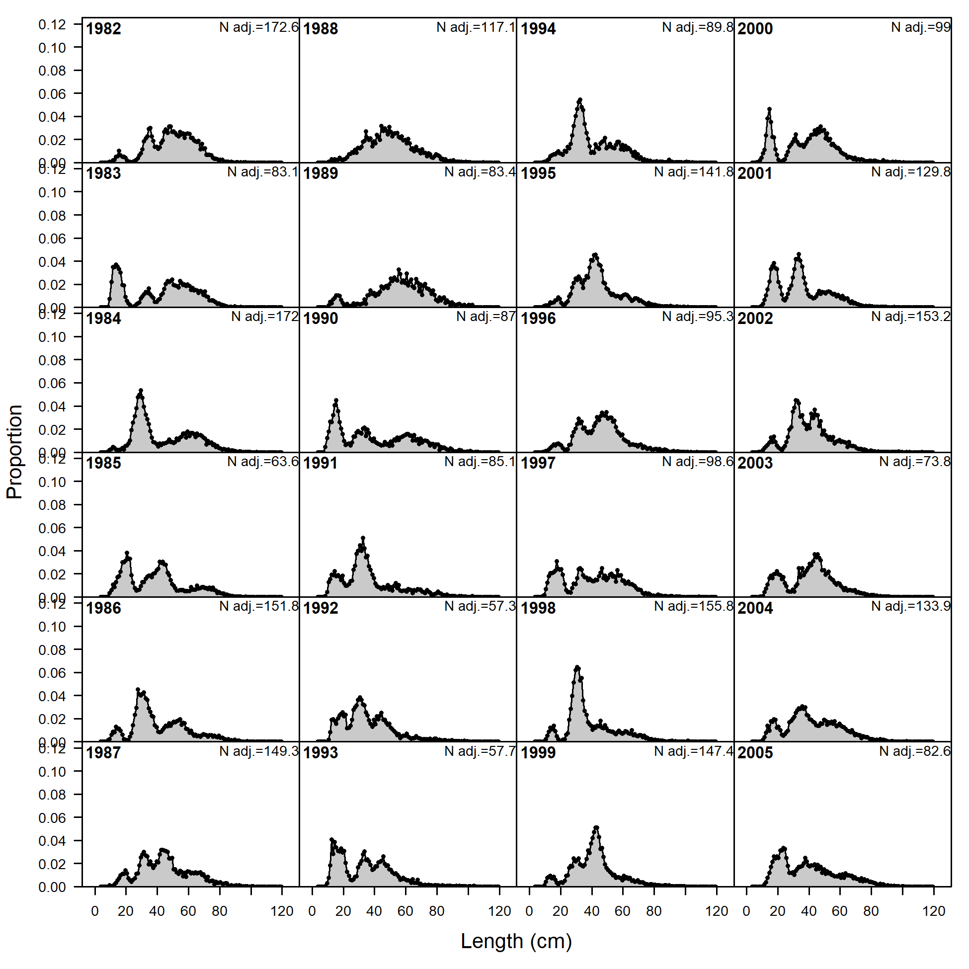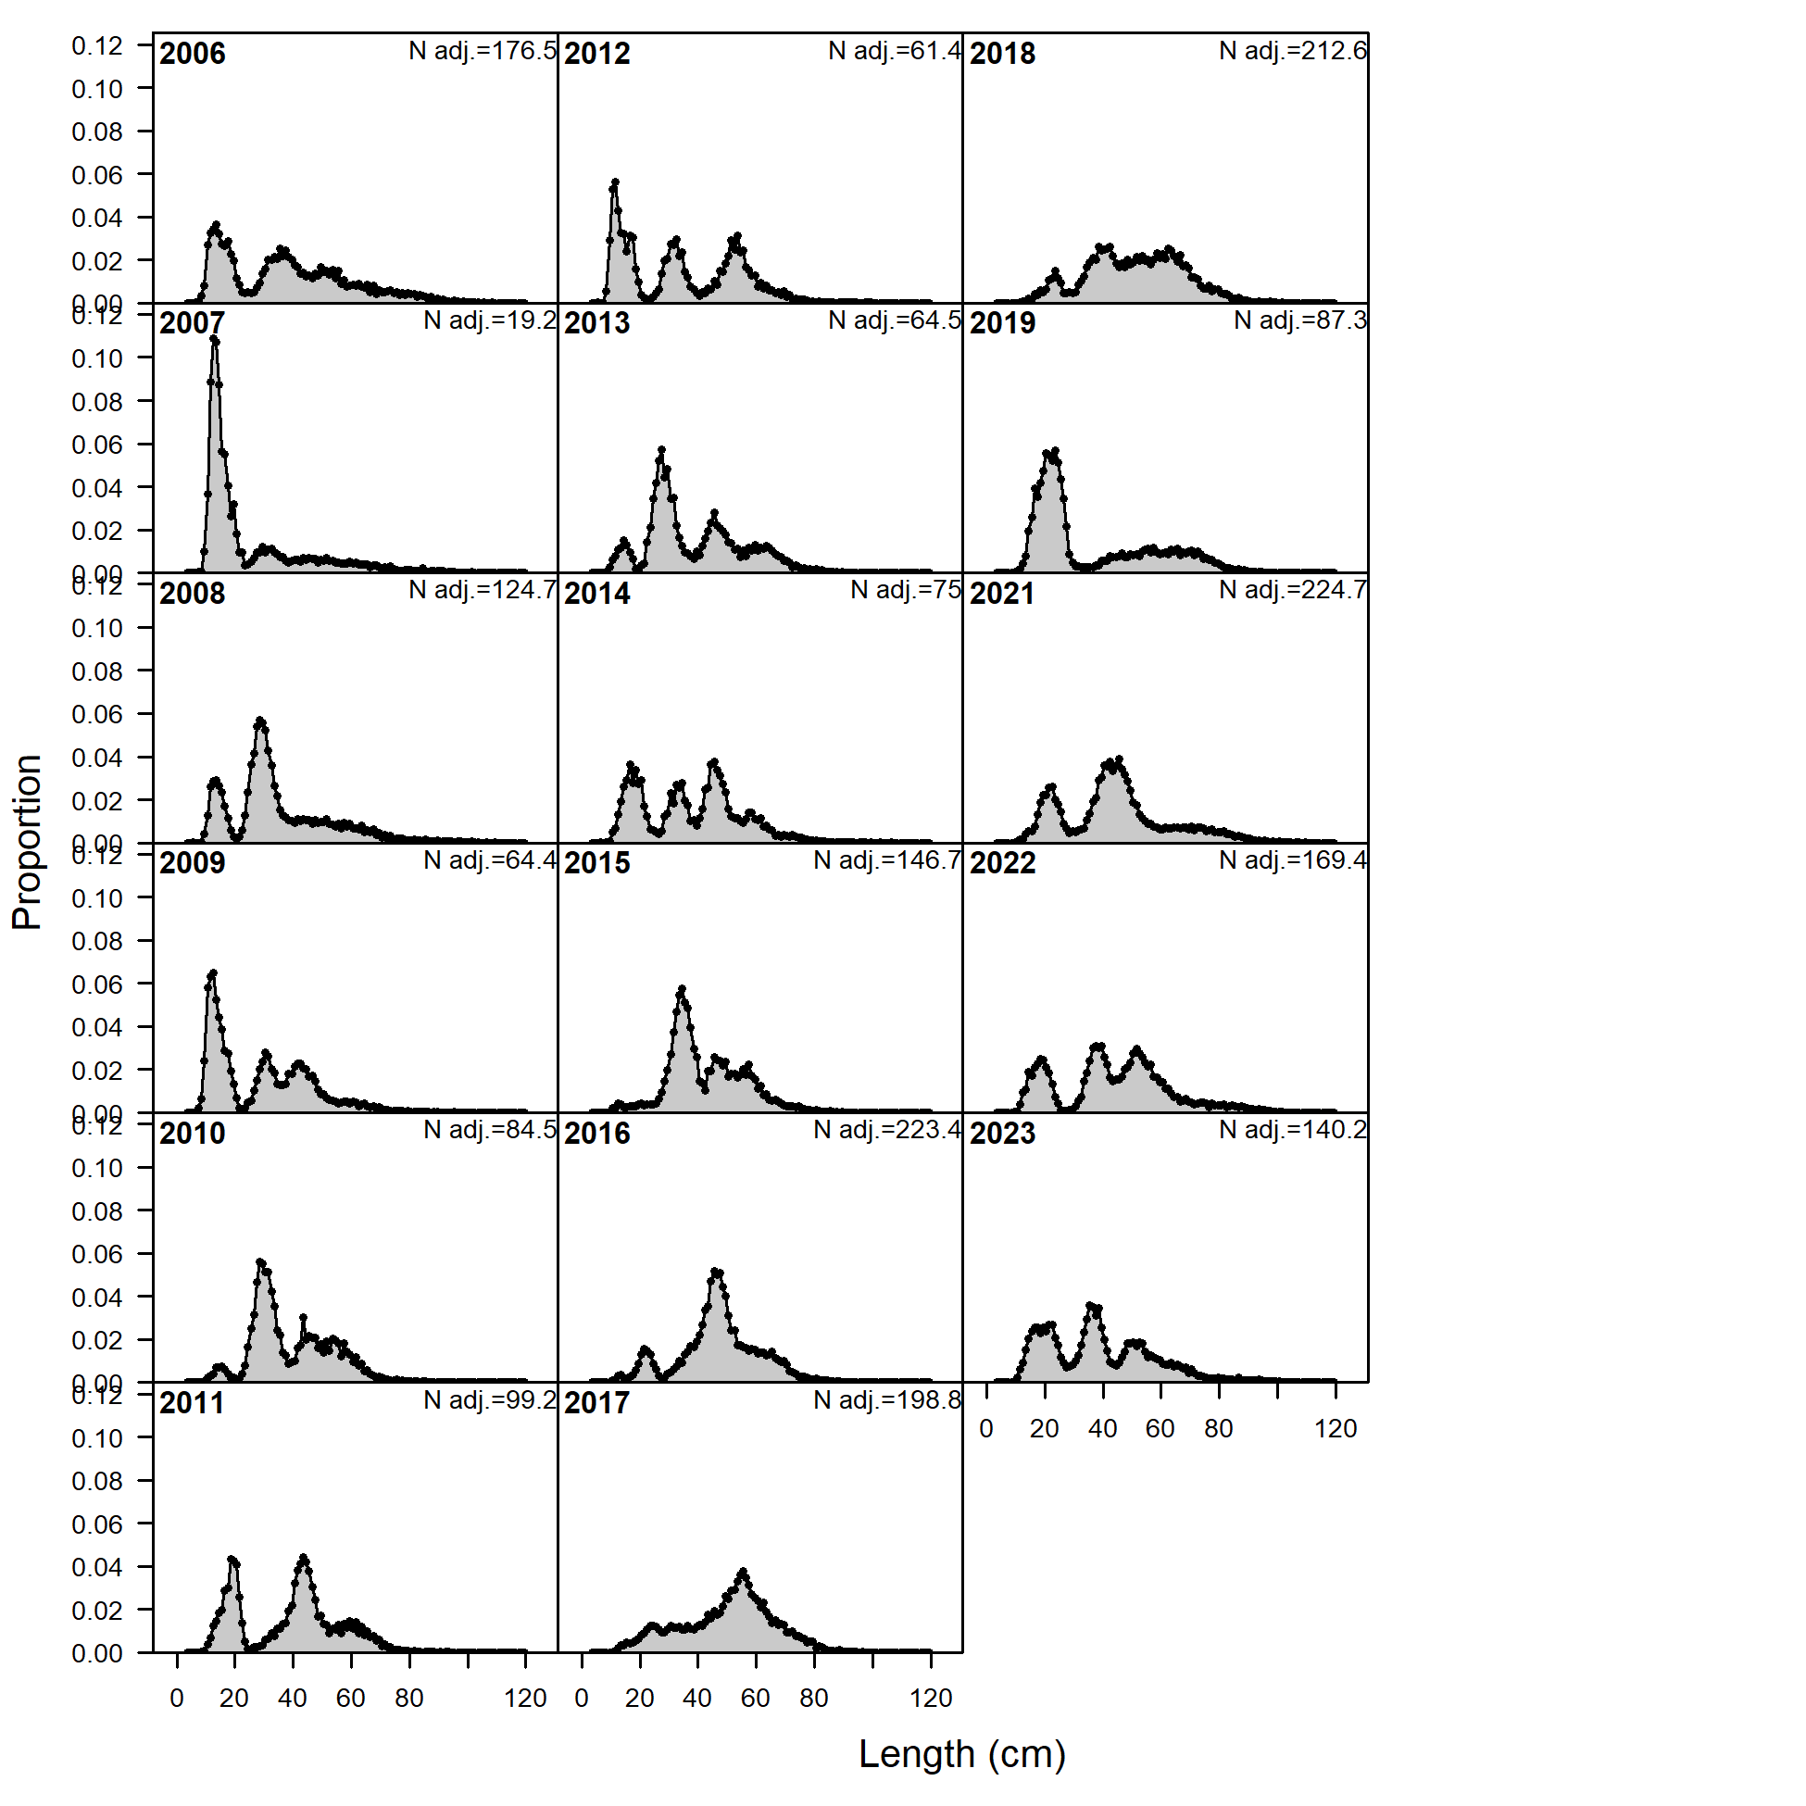

##### Figure 2.. Bottom trawl survey length composition distributions by year.

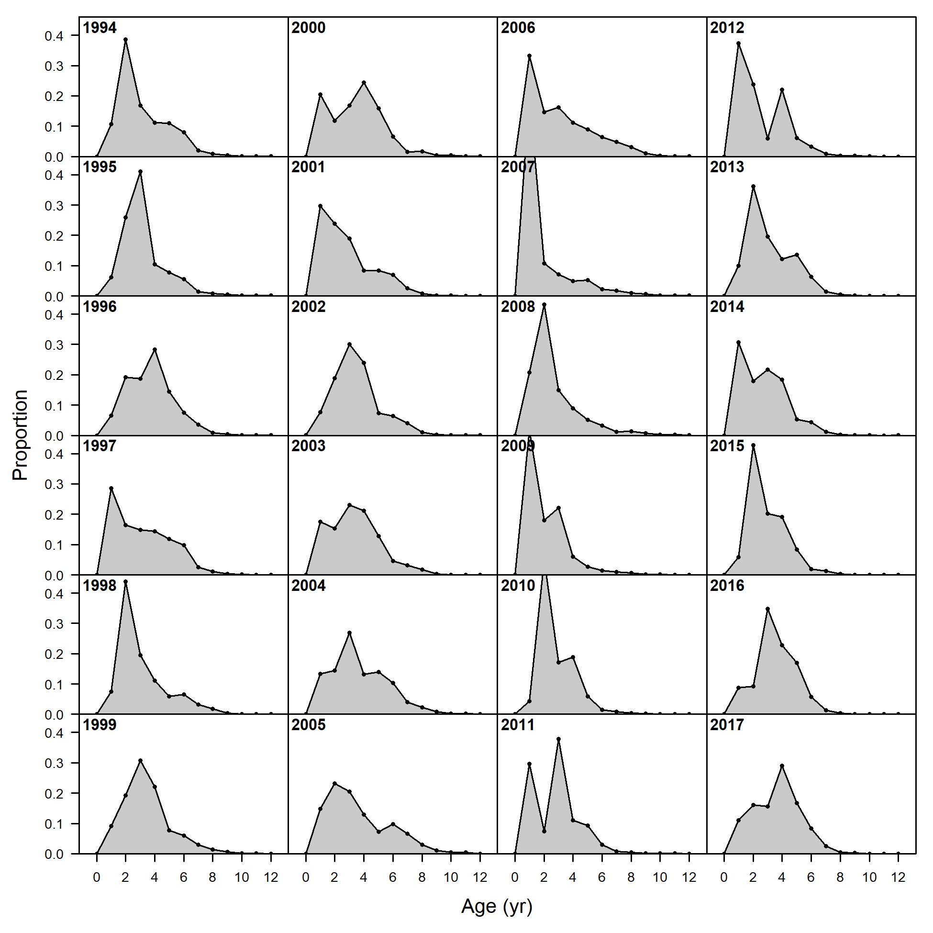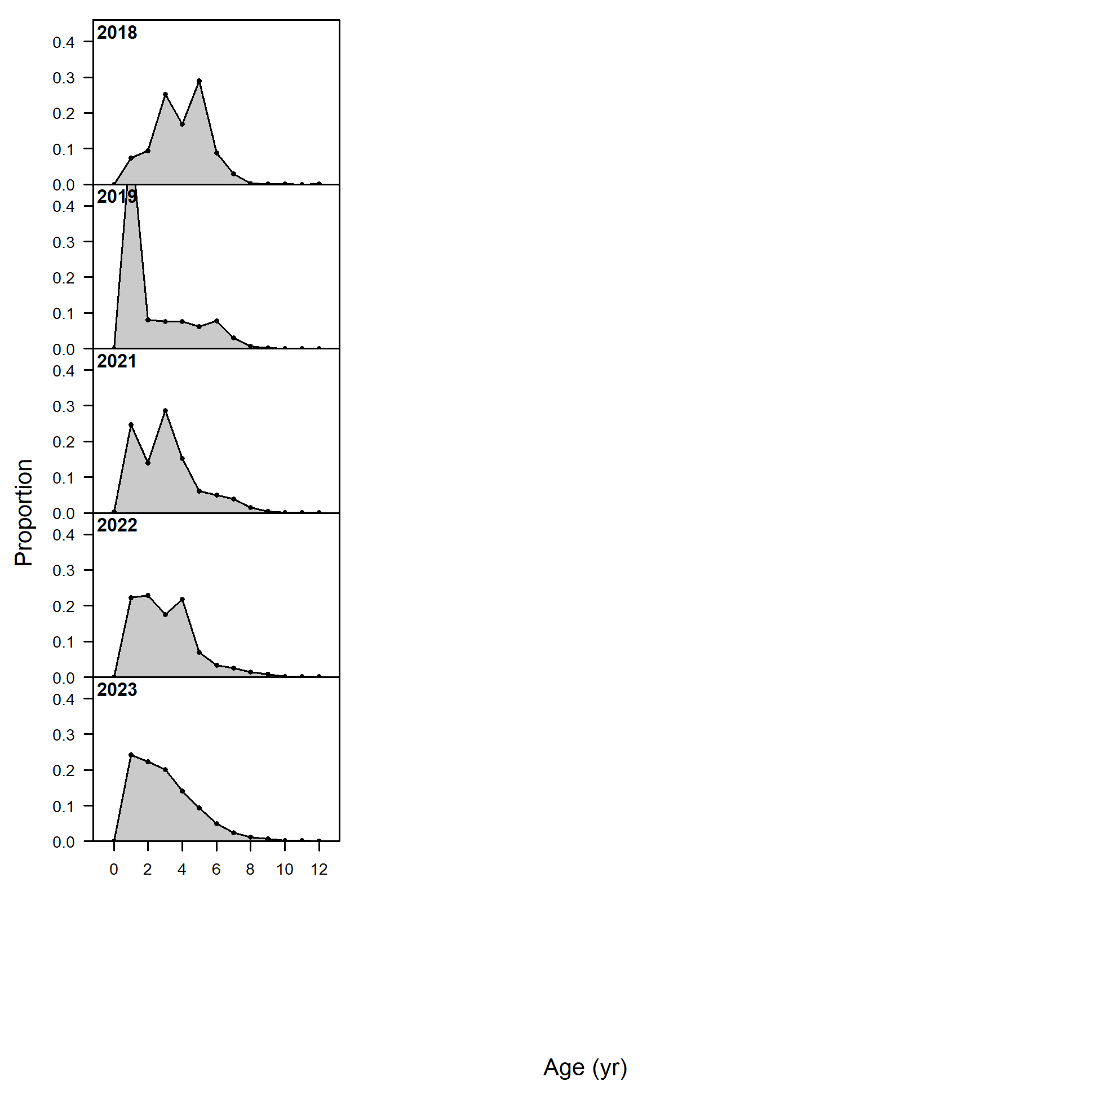

##### Figure 2.. Bottom trawl survey age composition distributions by year.

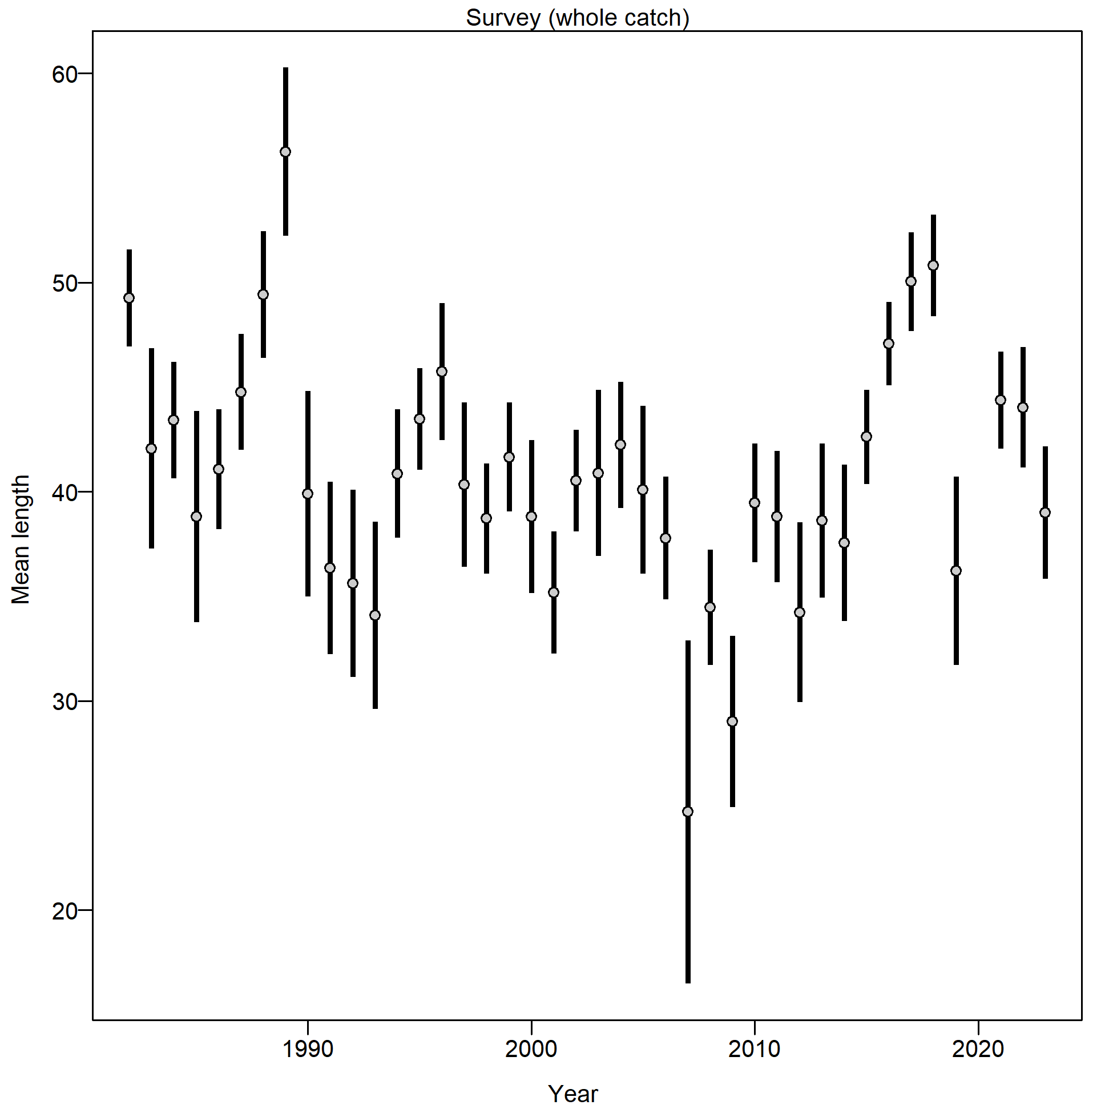

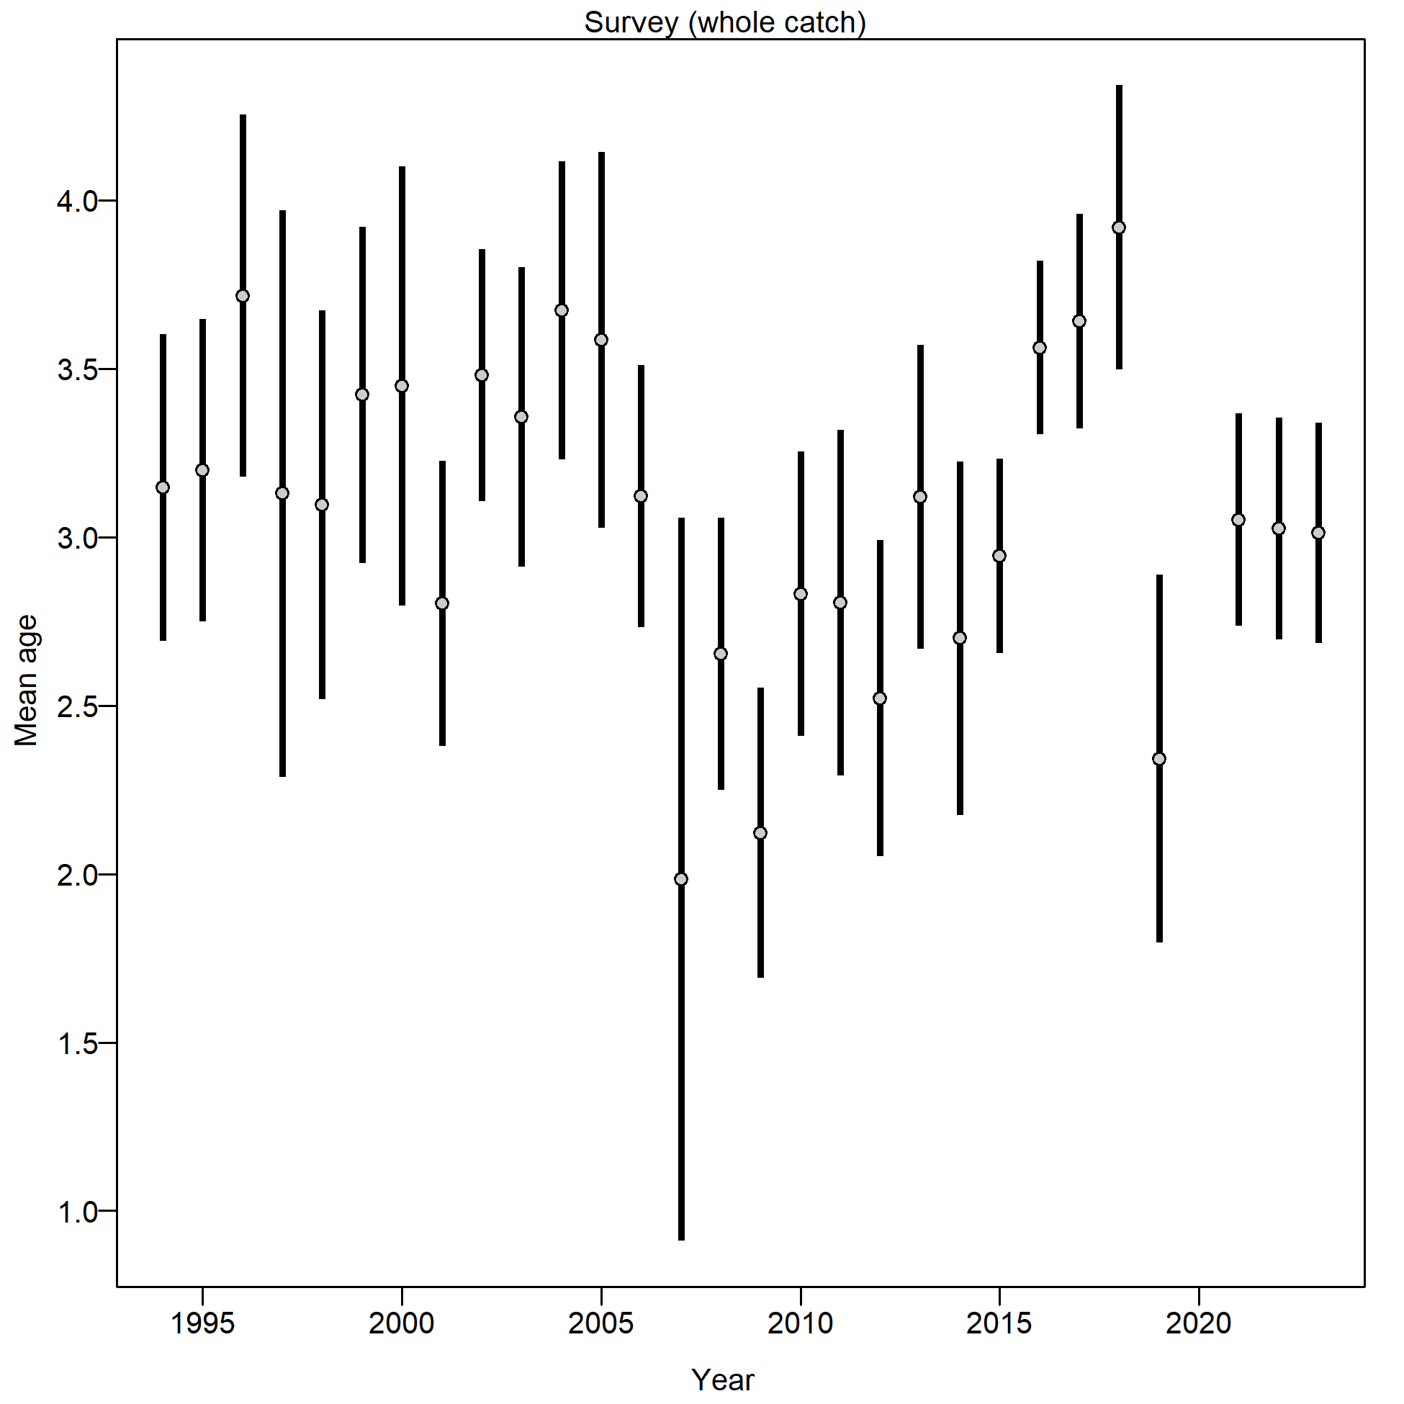

##### Figure 2.. AFSC bottom trawl survey (left) mean length (cm) and (right) mean age by year.

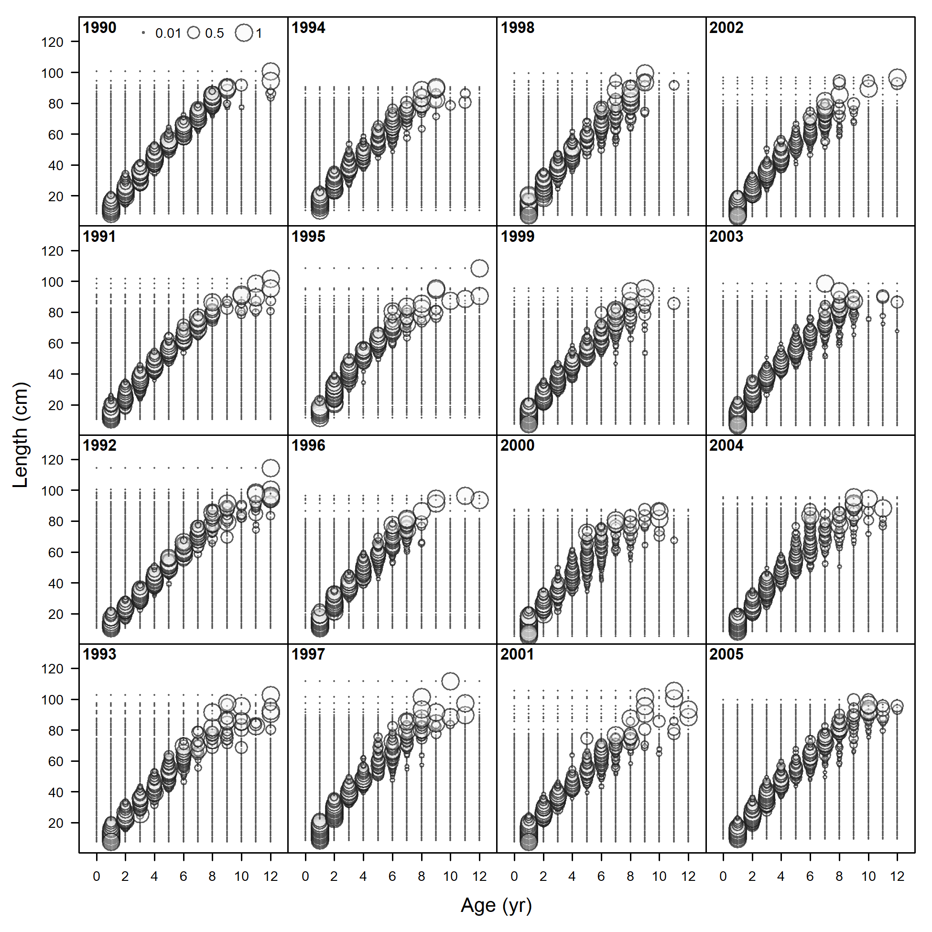 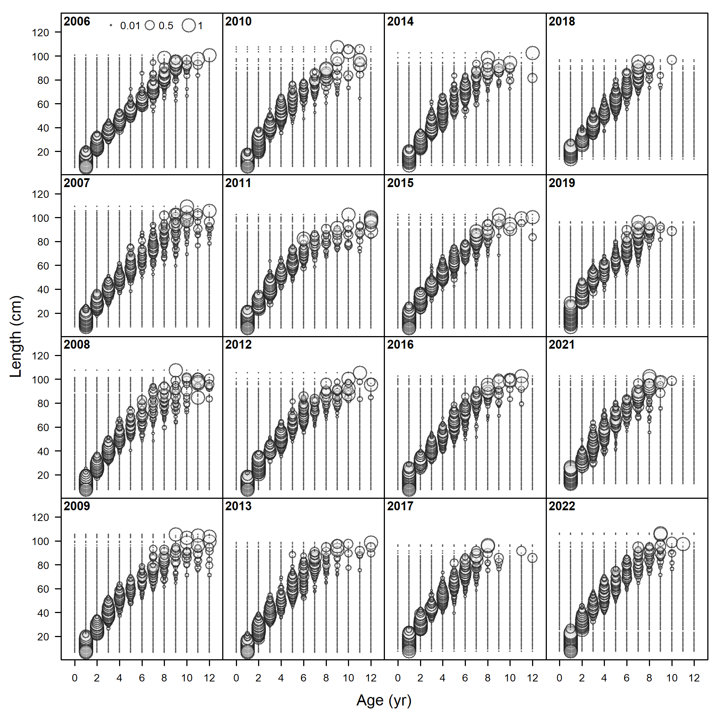

##### Figure 2.. Bottom trawl survey conditional age at length (CAAL) by year.



##### Figure 2.. Locations of AFSC longline survey stations in the EBS region.

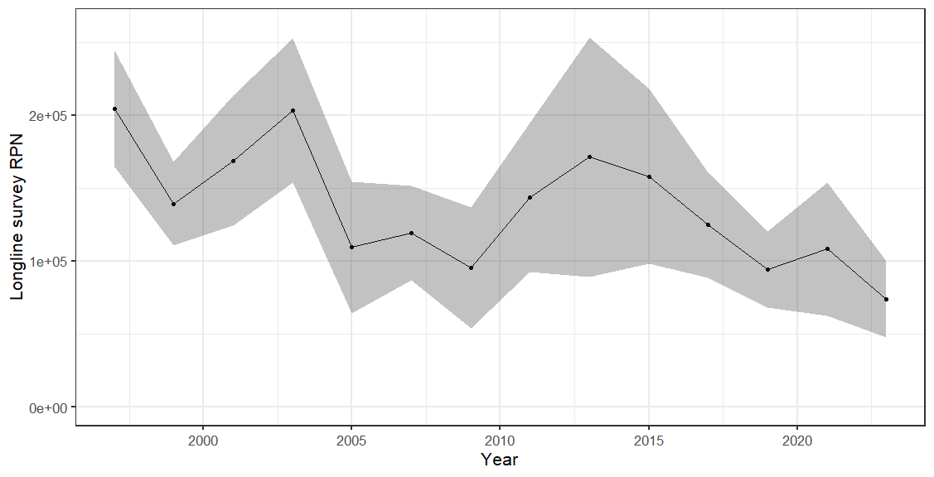

##### Figure 2.. AFSC longline survey relative population numbers (RPN) for EBS region.

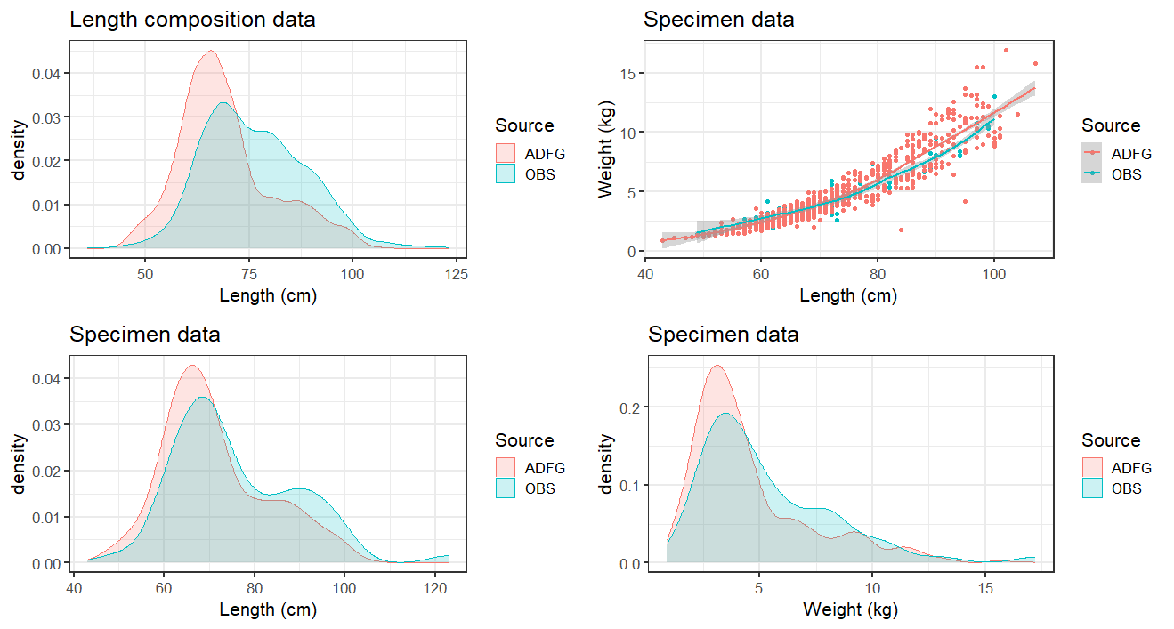

Figure 2. Pacific cod size and weight distribution comparisons for samples collected in the Dutch Harbor Subdistrict (DHS) pot fishery and Federal Bering Sea pot fisheries in the first trimester of 2023. All of the samples collected in the federal fishery were from NMFS Area 517. (Top left) length compostion data, and (top left, bottom) length and weight from individually weighed specimen collections.

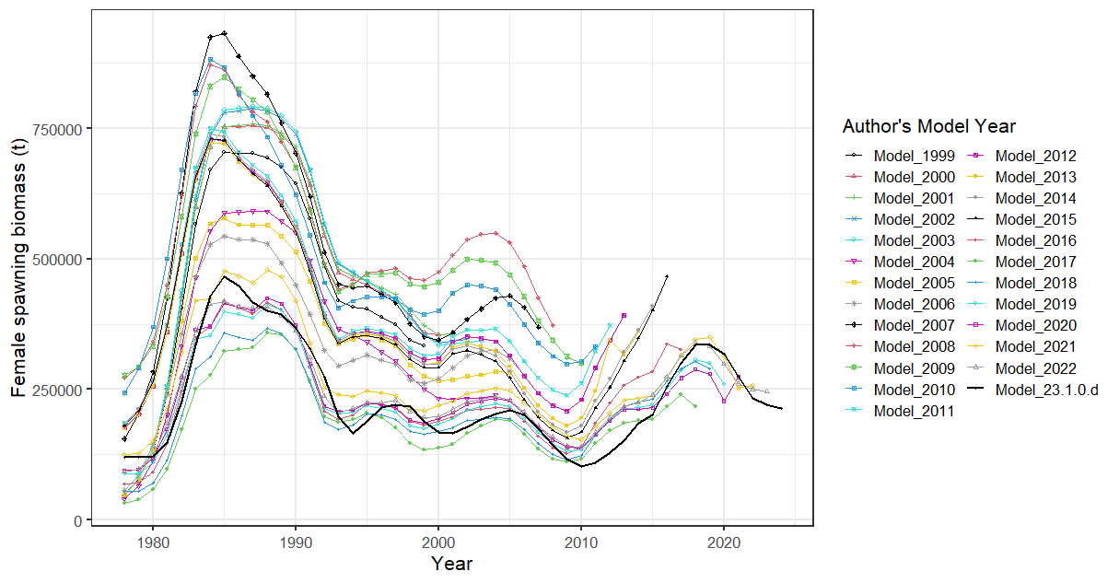

##### Figure 2.. History of model estimated female spawning biomass from 1999-2023 accepted models and the 2023 Model 23.1.0.d.

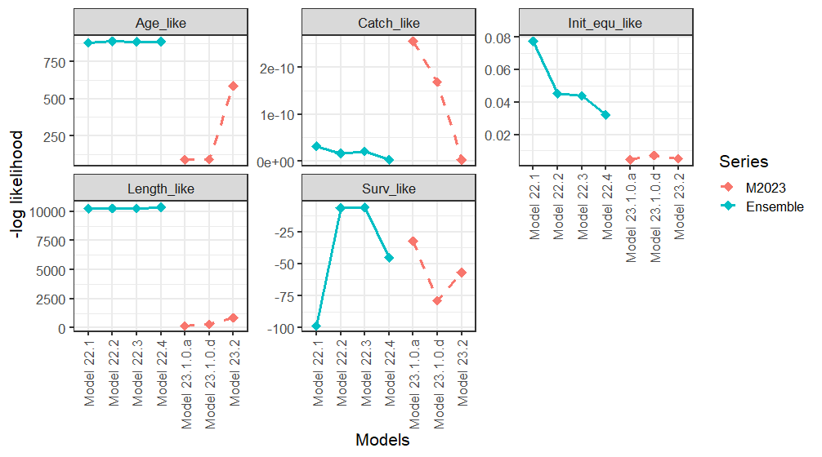

##### Figure 2.. Objective function by likelihood component and total for all models comparing 2022 and 2023 series of models. Note that the age and length composition likelihoods are not comparable between series as the 2022 series employs the Dirichlet multinomial while the 2023 series employs the simple multinomial.

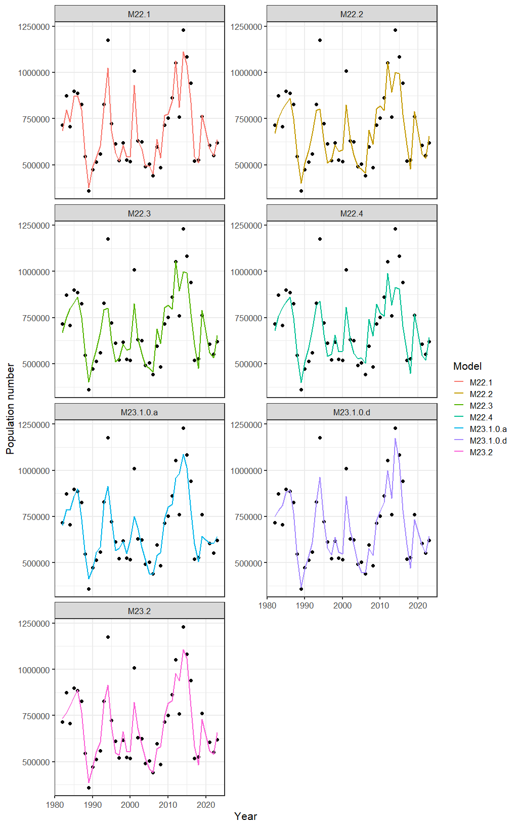

##### Figure 2.. Fits to the bottom trawl survey data (population numbers) for all models. Black dots are the observed values.

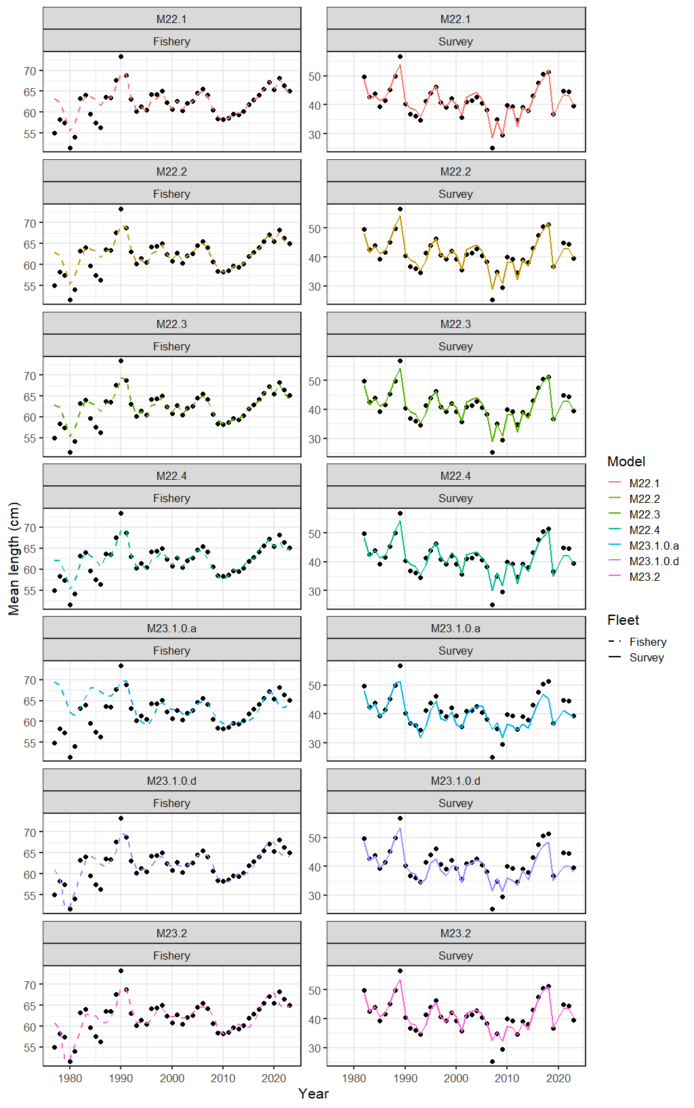

##### Figure 2.. Mean length and fits to mean length by model for all models. Black dots are the observed values.

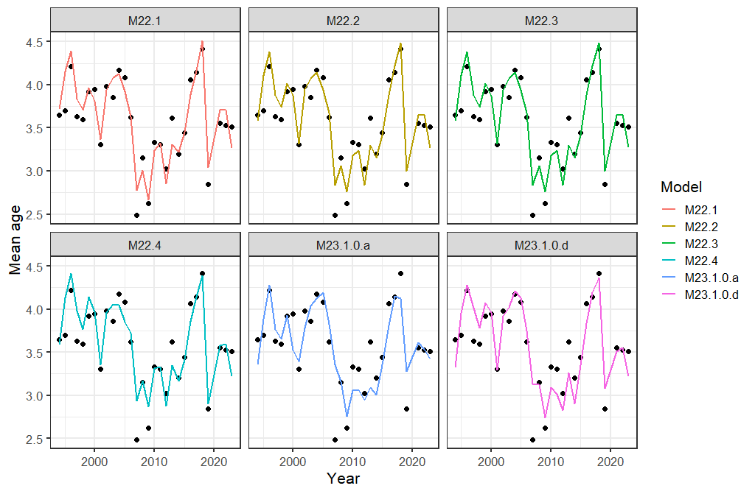

##### Figure 2.. Mean age and fits to mean age by model for all models. Black dots are the observed values.

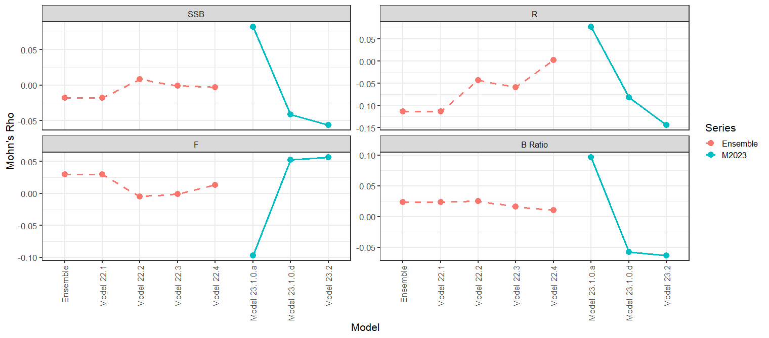

##### Figure 2.. Mohn’s Rho values for all models for spawning stock biomass (SSB), full selection fishing mortatlity (F), age-0 recruitment (R), and Spawning biomass to unfished biomass ratio (B Ratio) by model series (Ensemble=2022 Ensemble series, M2023=2023 Models).

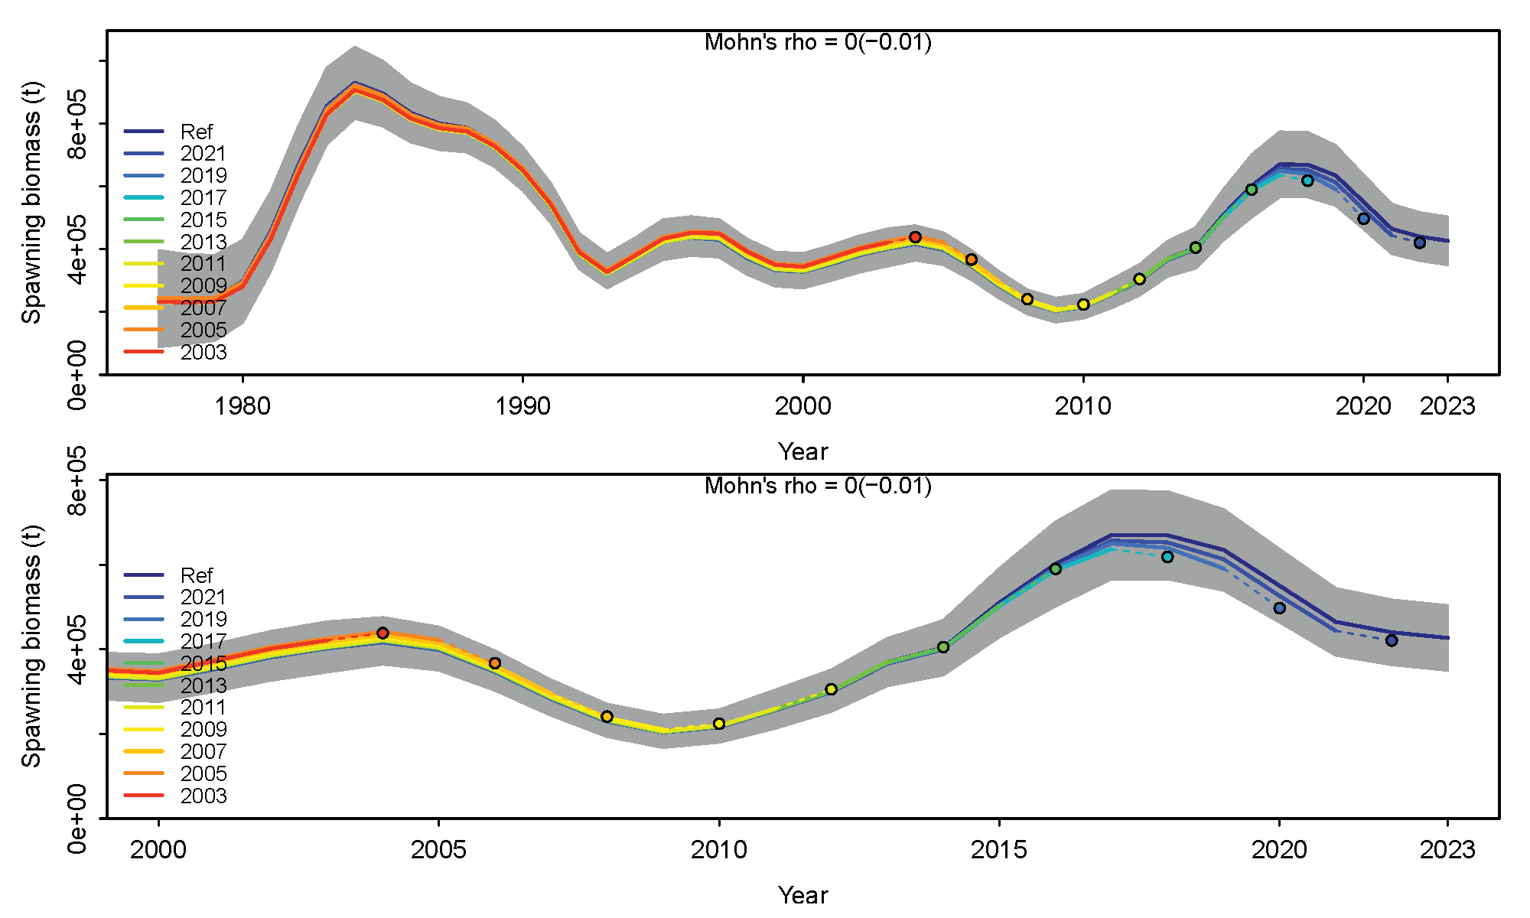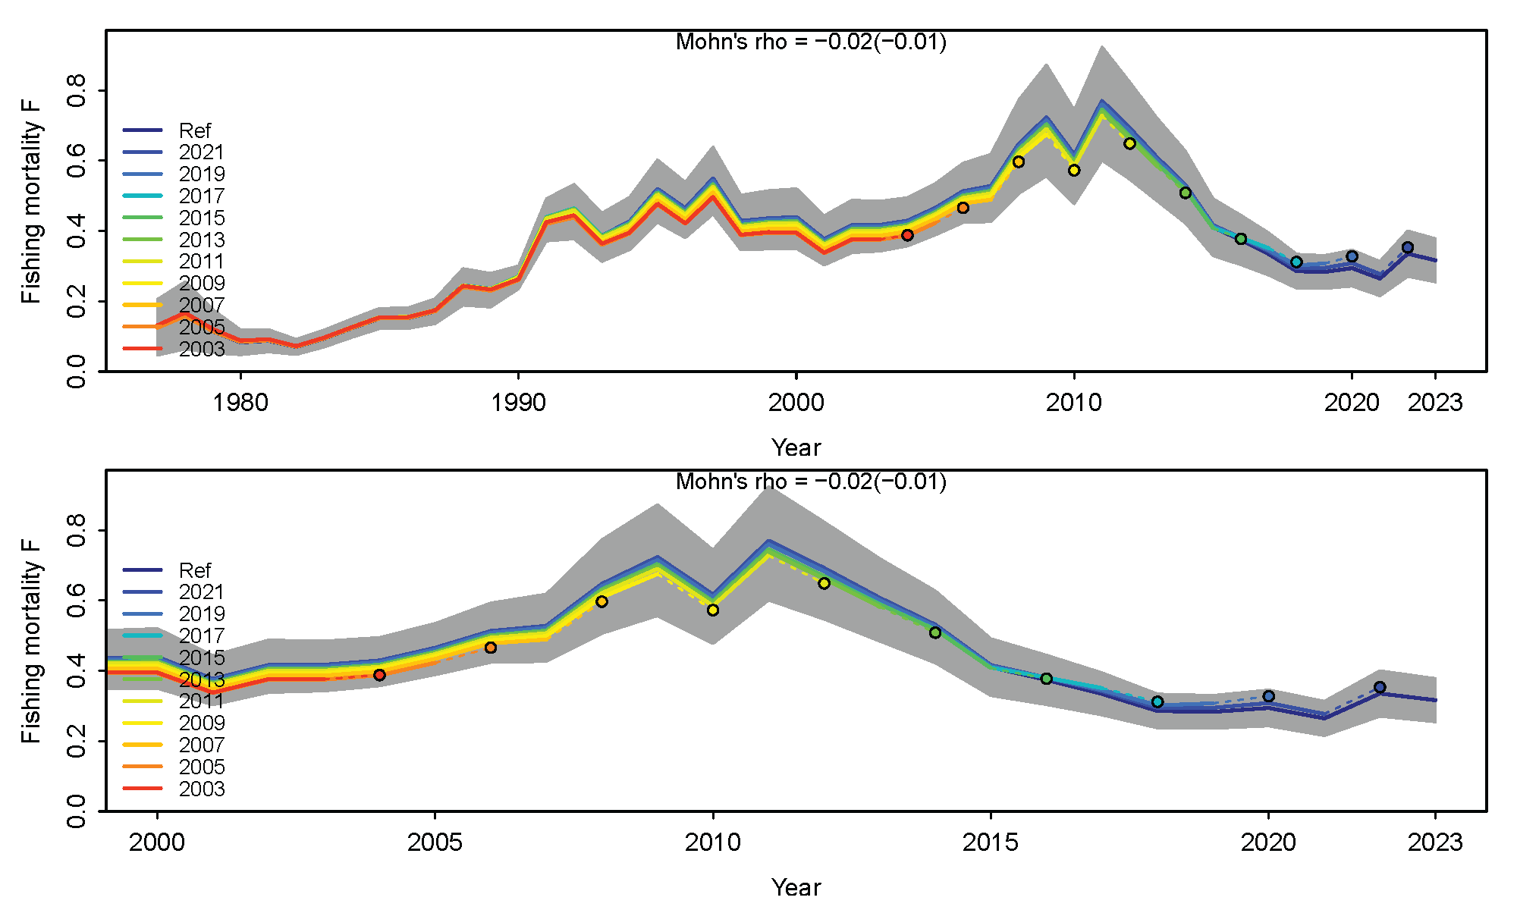

##### Figure 2.. Retrospective plots of (left) spawning stock biomass and (right) fishing mortality for Model 23.1.0.d. Upper figures are the full time series, bottom are the most recent 10 years and includes the Mohn’s rho and in parenthesis the Predictive rho values. Plots from the ss3diags R library (Winker et al. 2022) and described in Carvalho et al. (2021).

**Fishery Selectivity**

2022 Ensemble Models

2023 Models

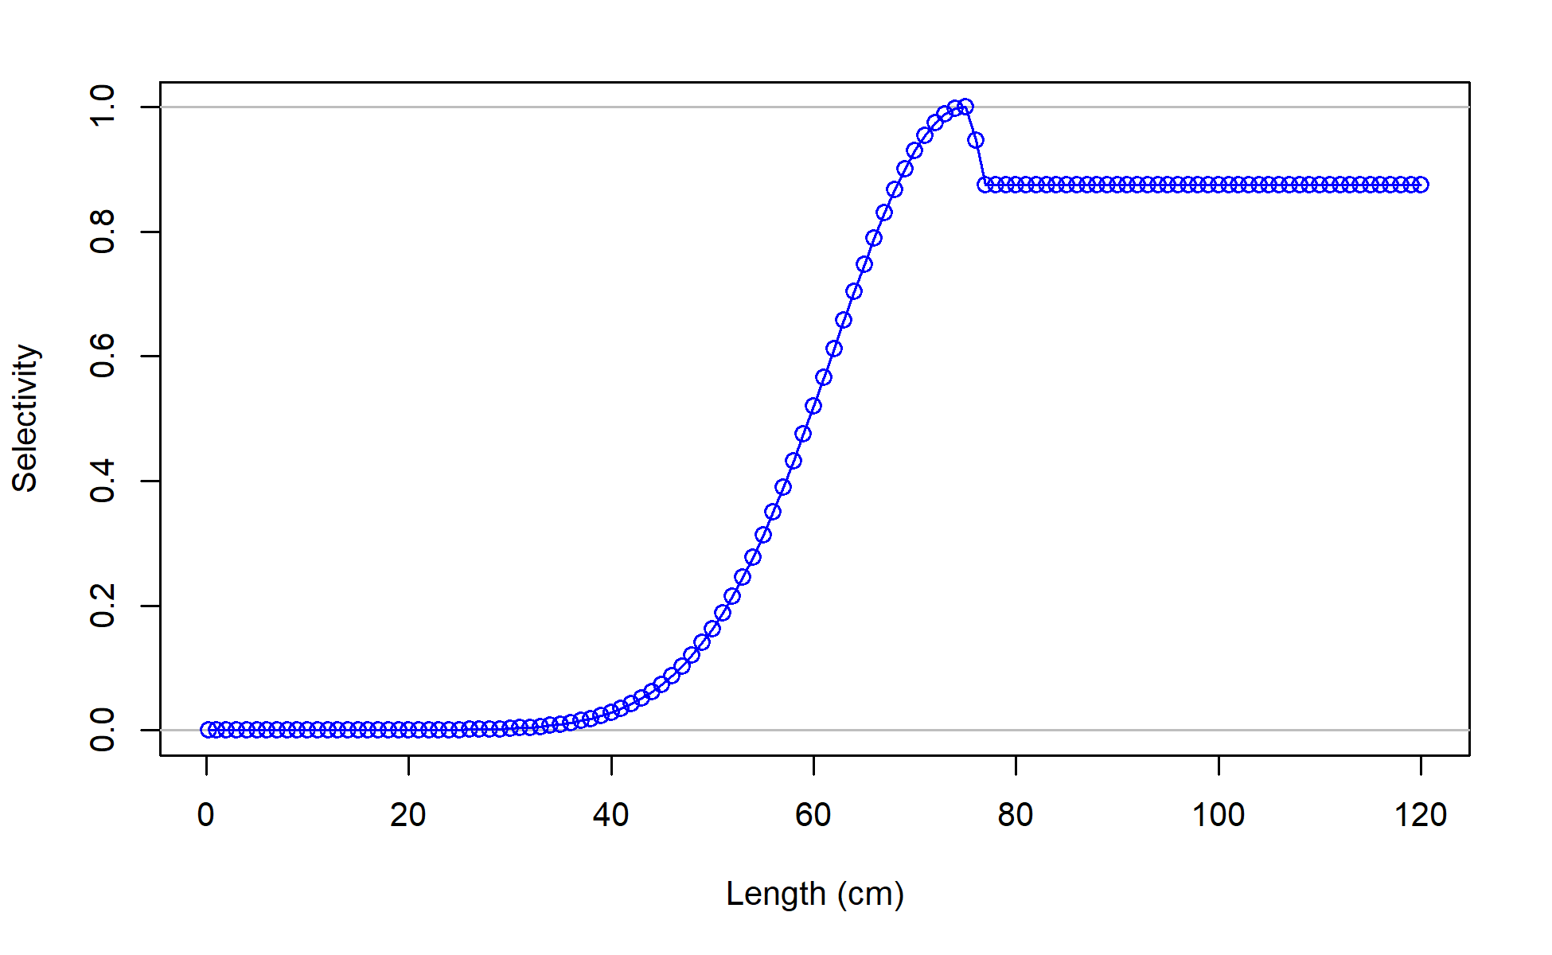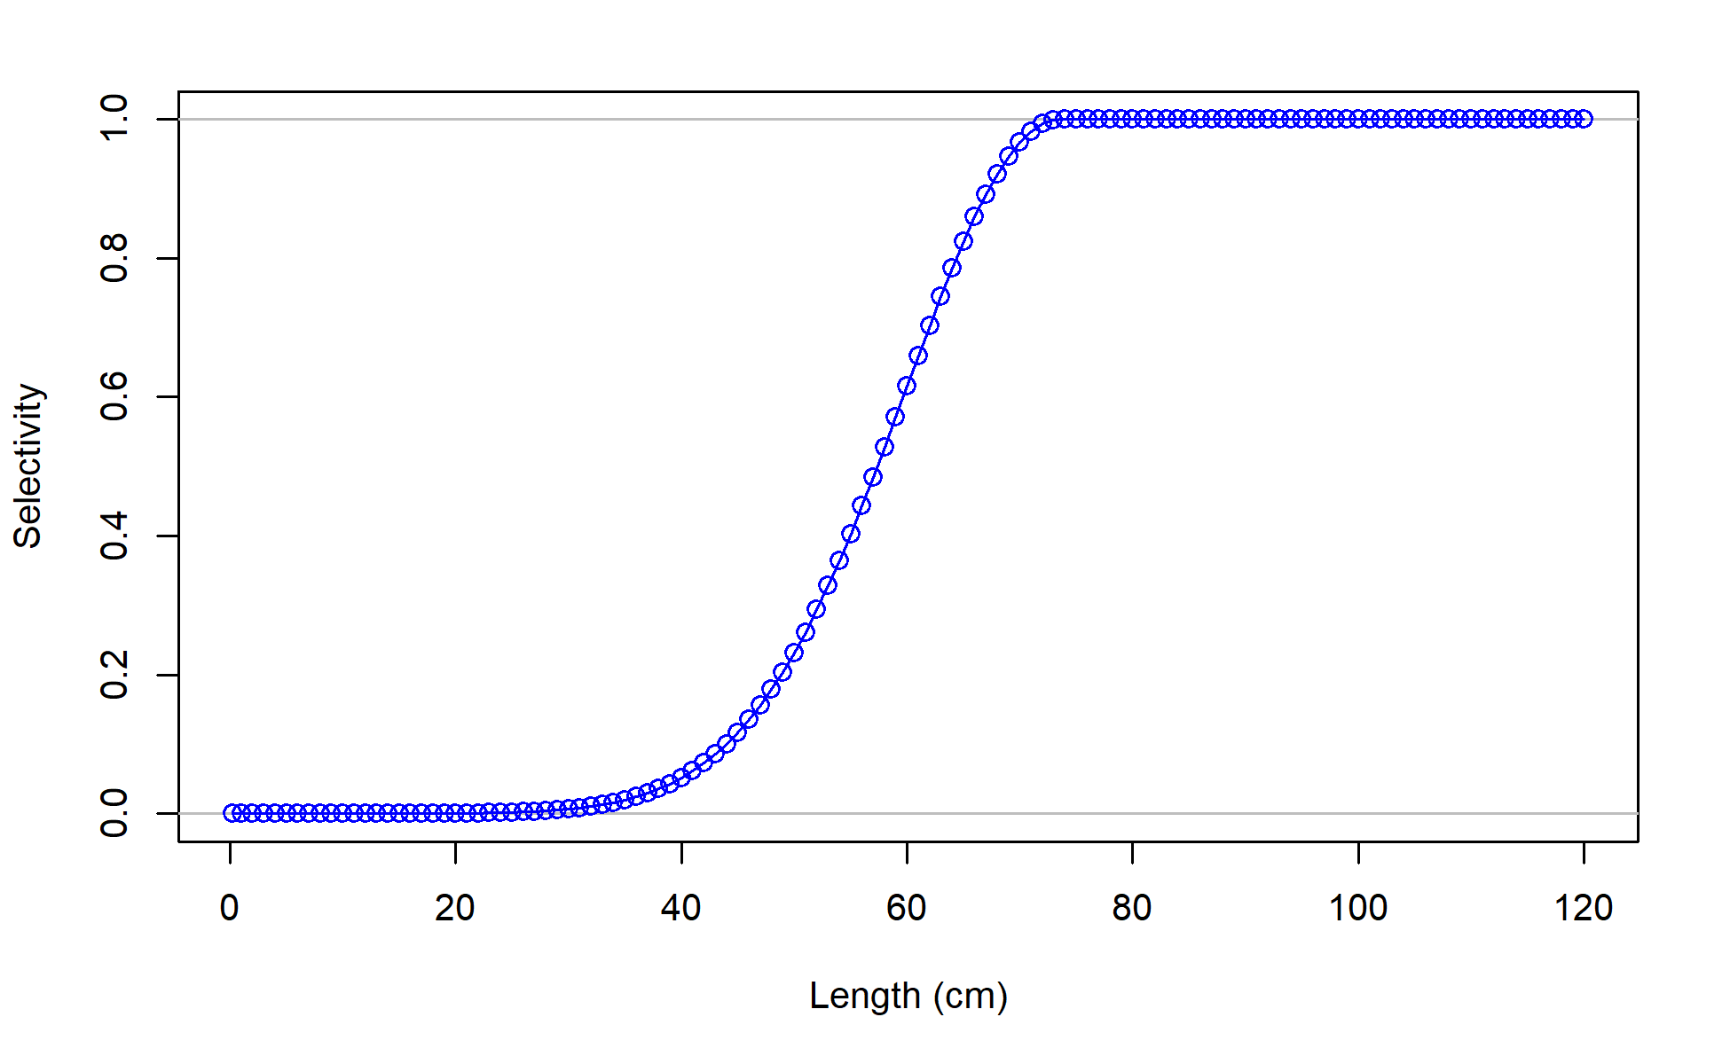

**Survey Selectivity**

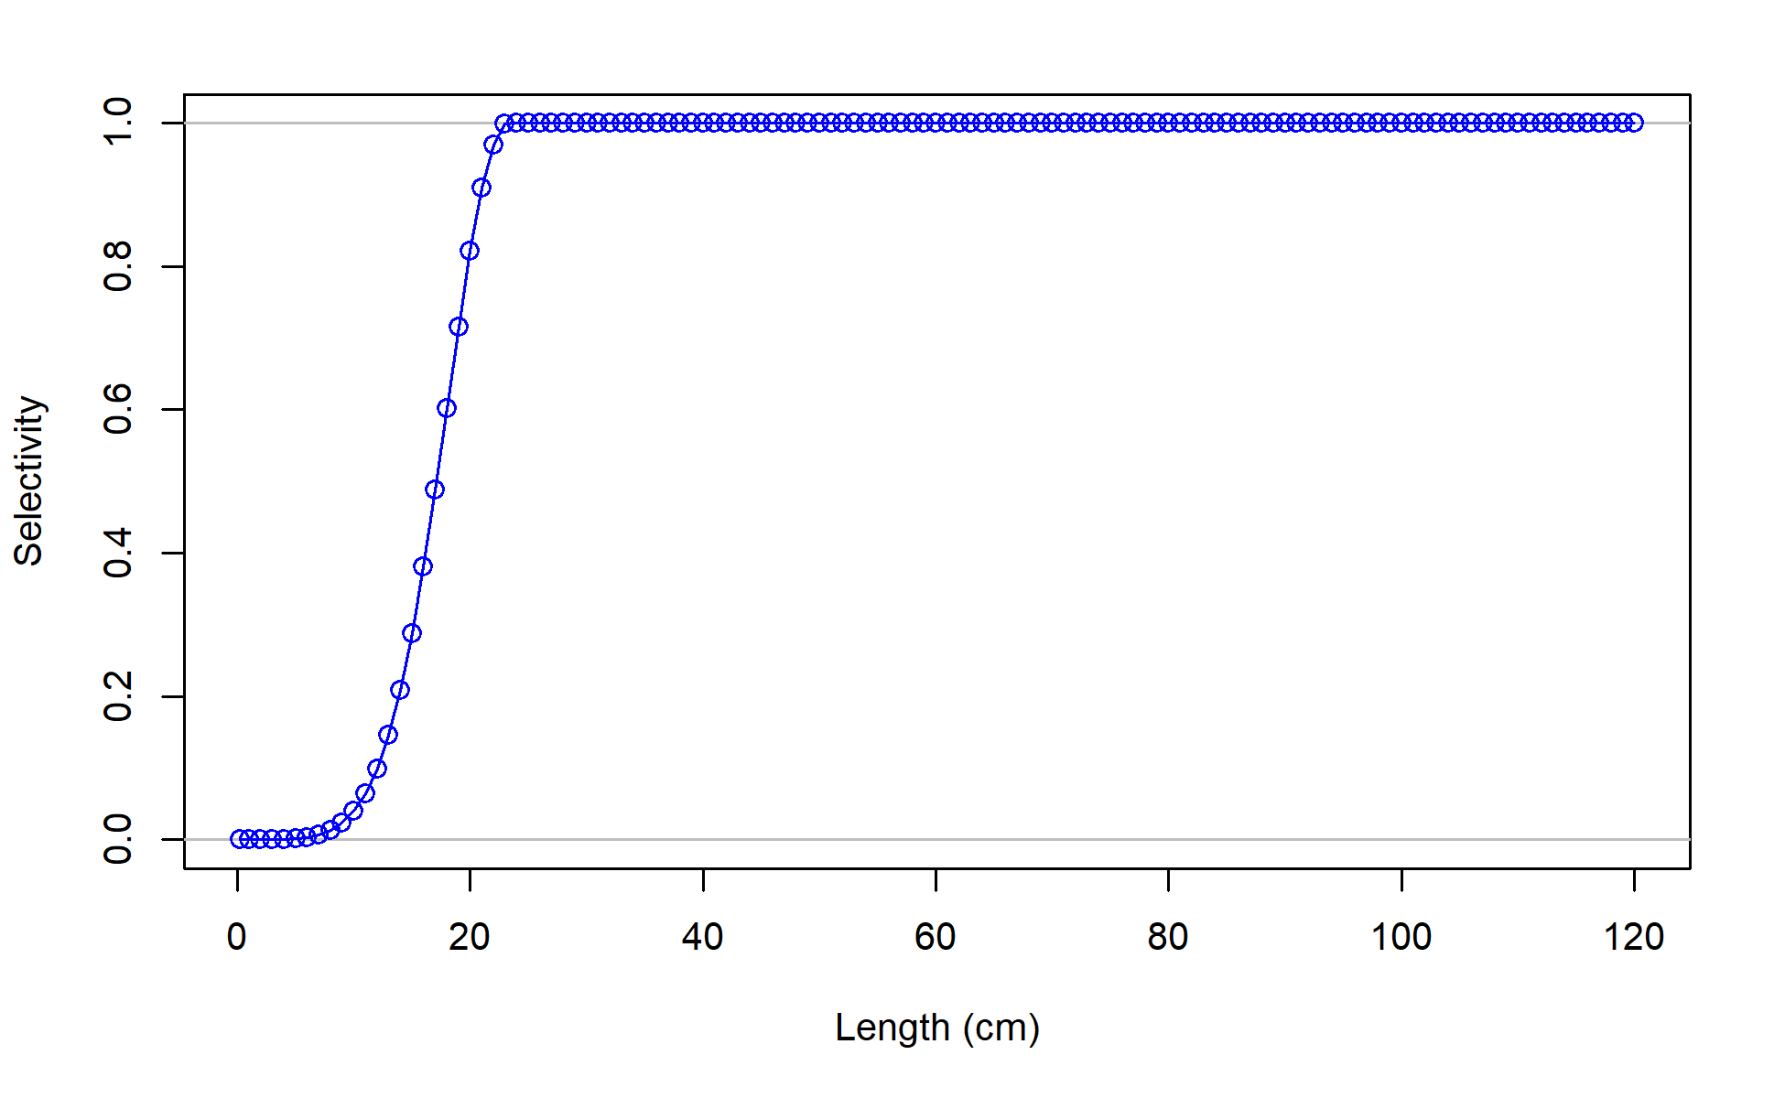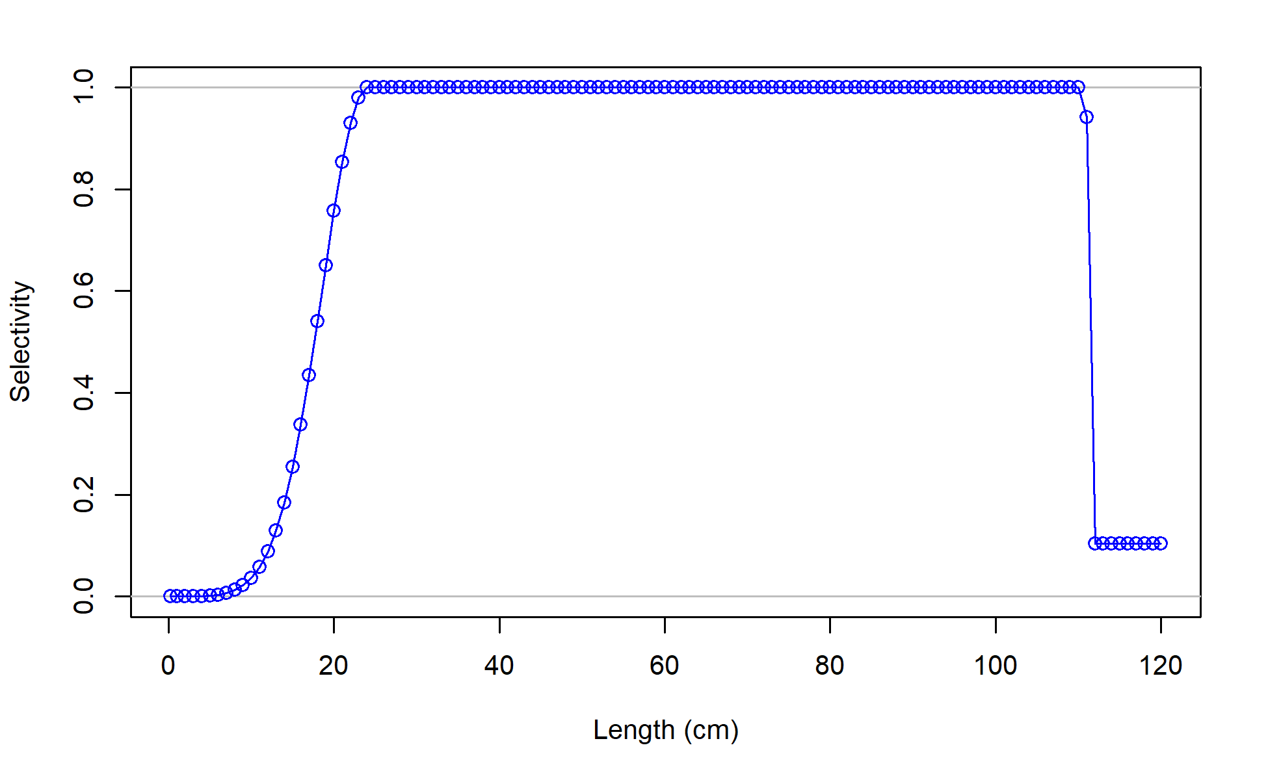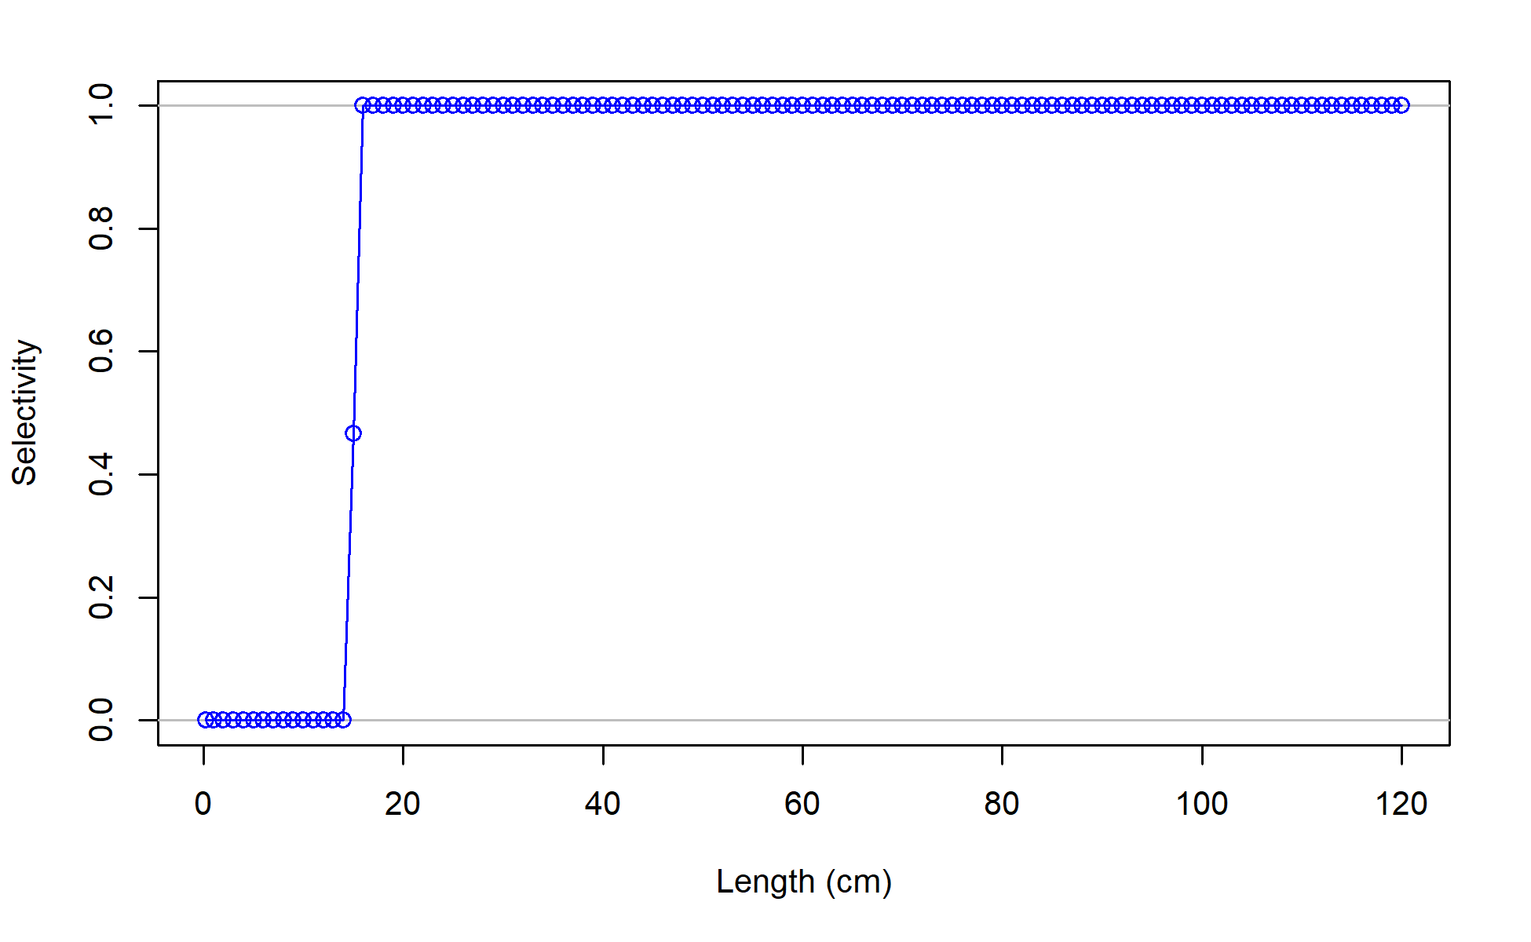

M23.1.0.a

M22.1, M22.2, M22.4 , M23.1.0.d and M23.2

M22.3

Figure 2.37. Basic shapes for fishery and survey selectivities for all models. Note that for all the models with time varying selectivities although the parameters change slightly the basic shape remains the same over time. This figure demonstrates the basic shape fit for each.

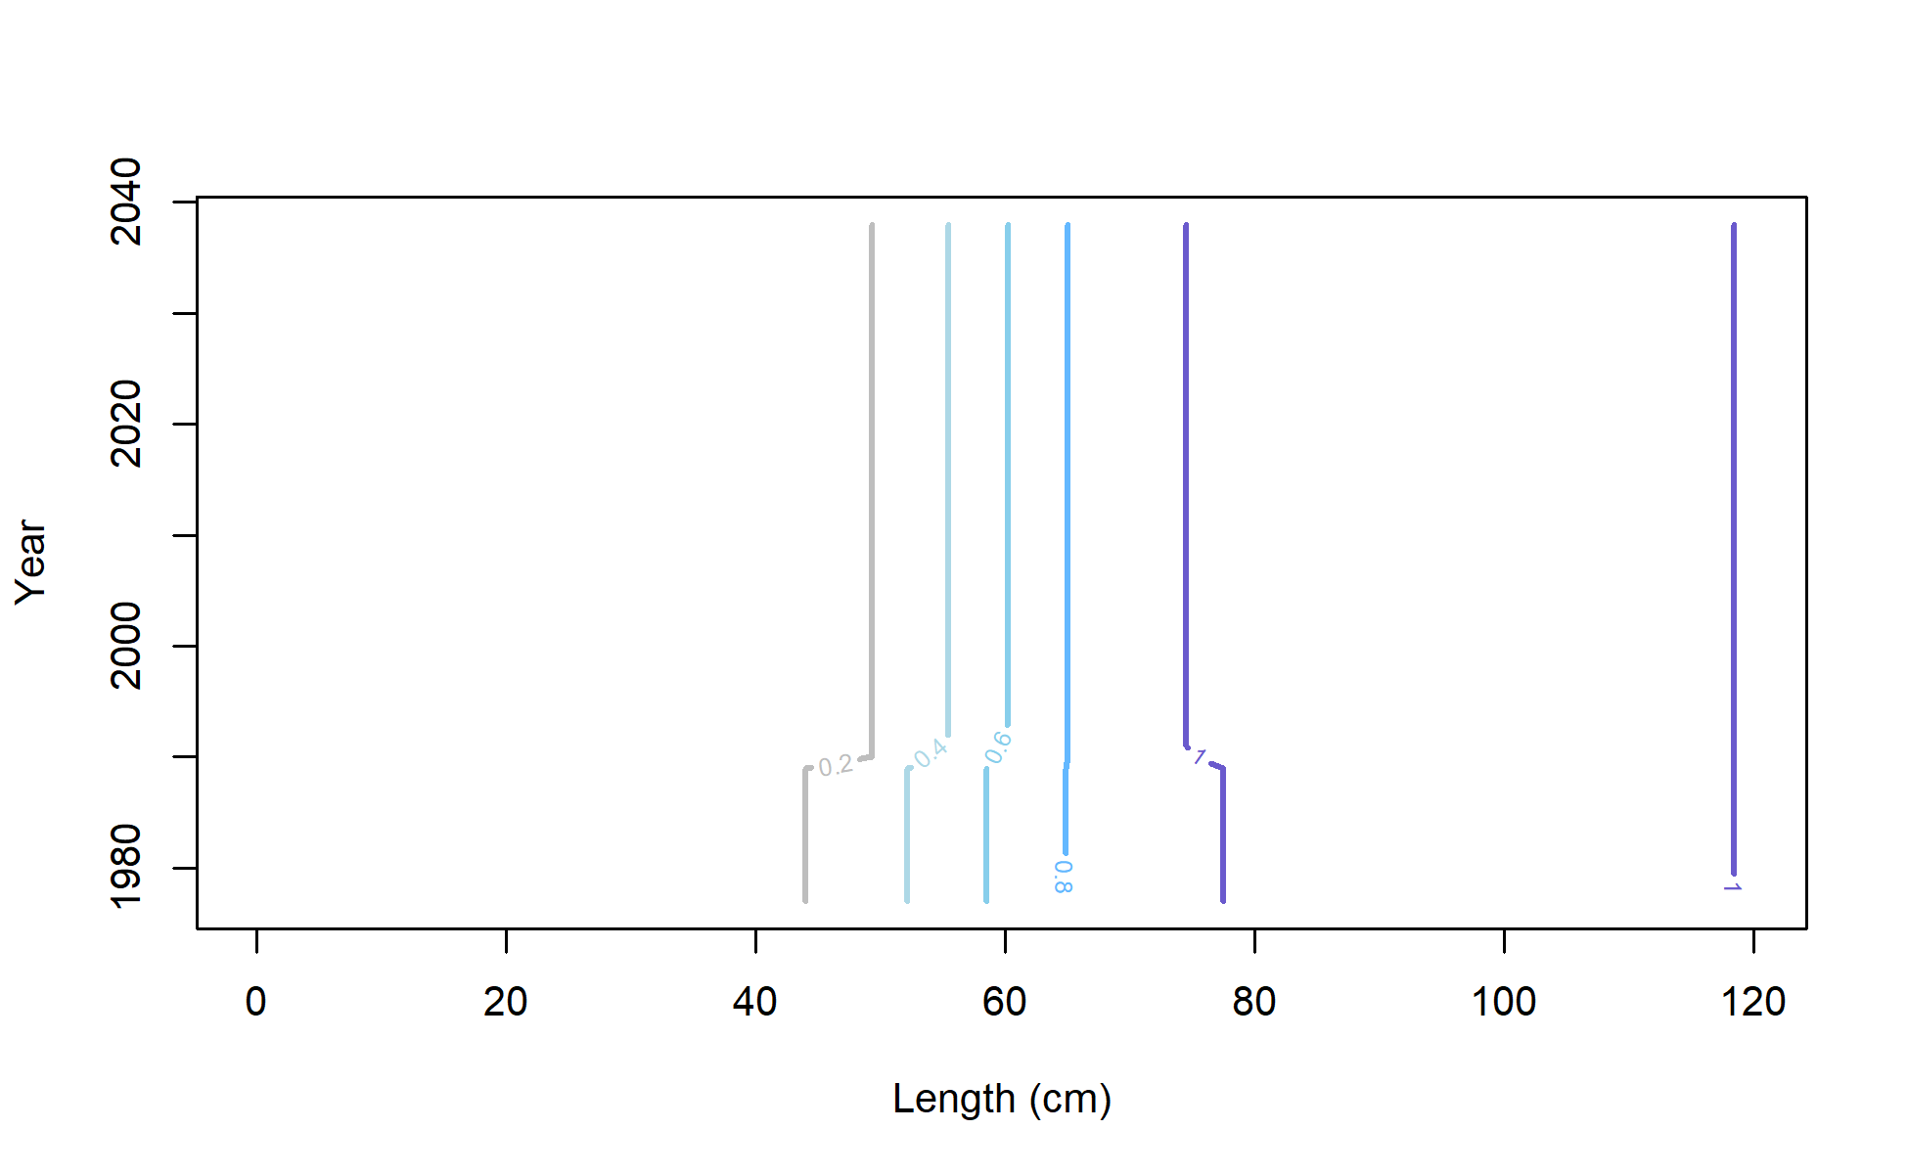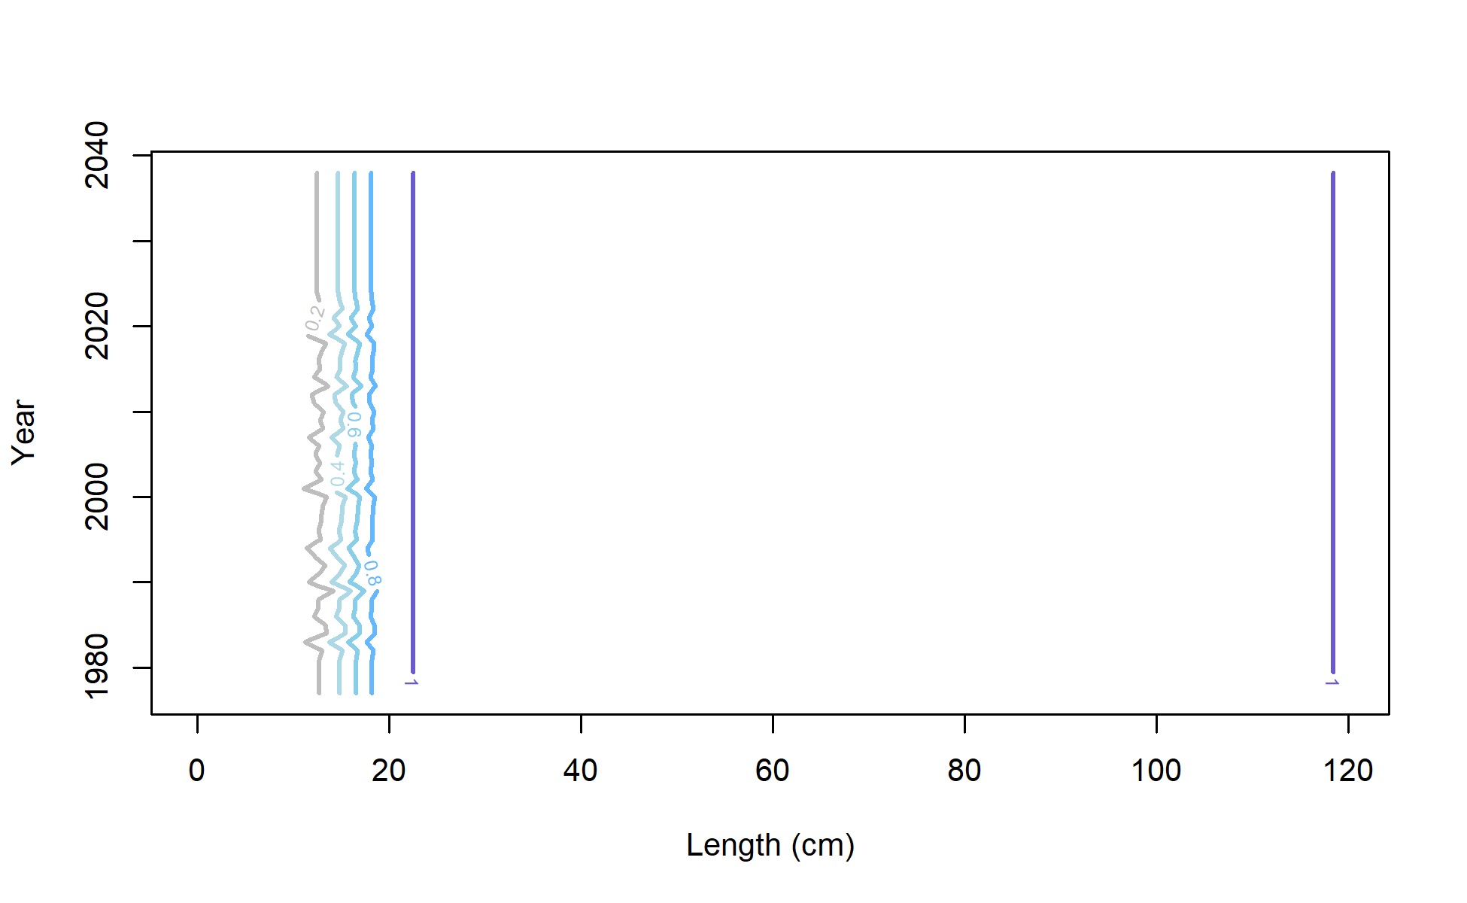

M23.1.0.d Fishery

M23.1.0.d Survey

Figure 2. Time varying selectivity for Model 23.1.0.d showing blocks for the (left) fishery selectivity and (right) annual deviations in the survey selectivity.

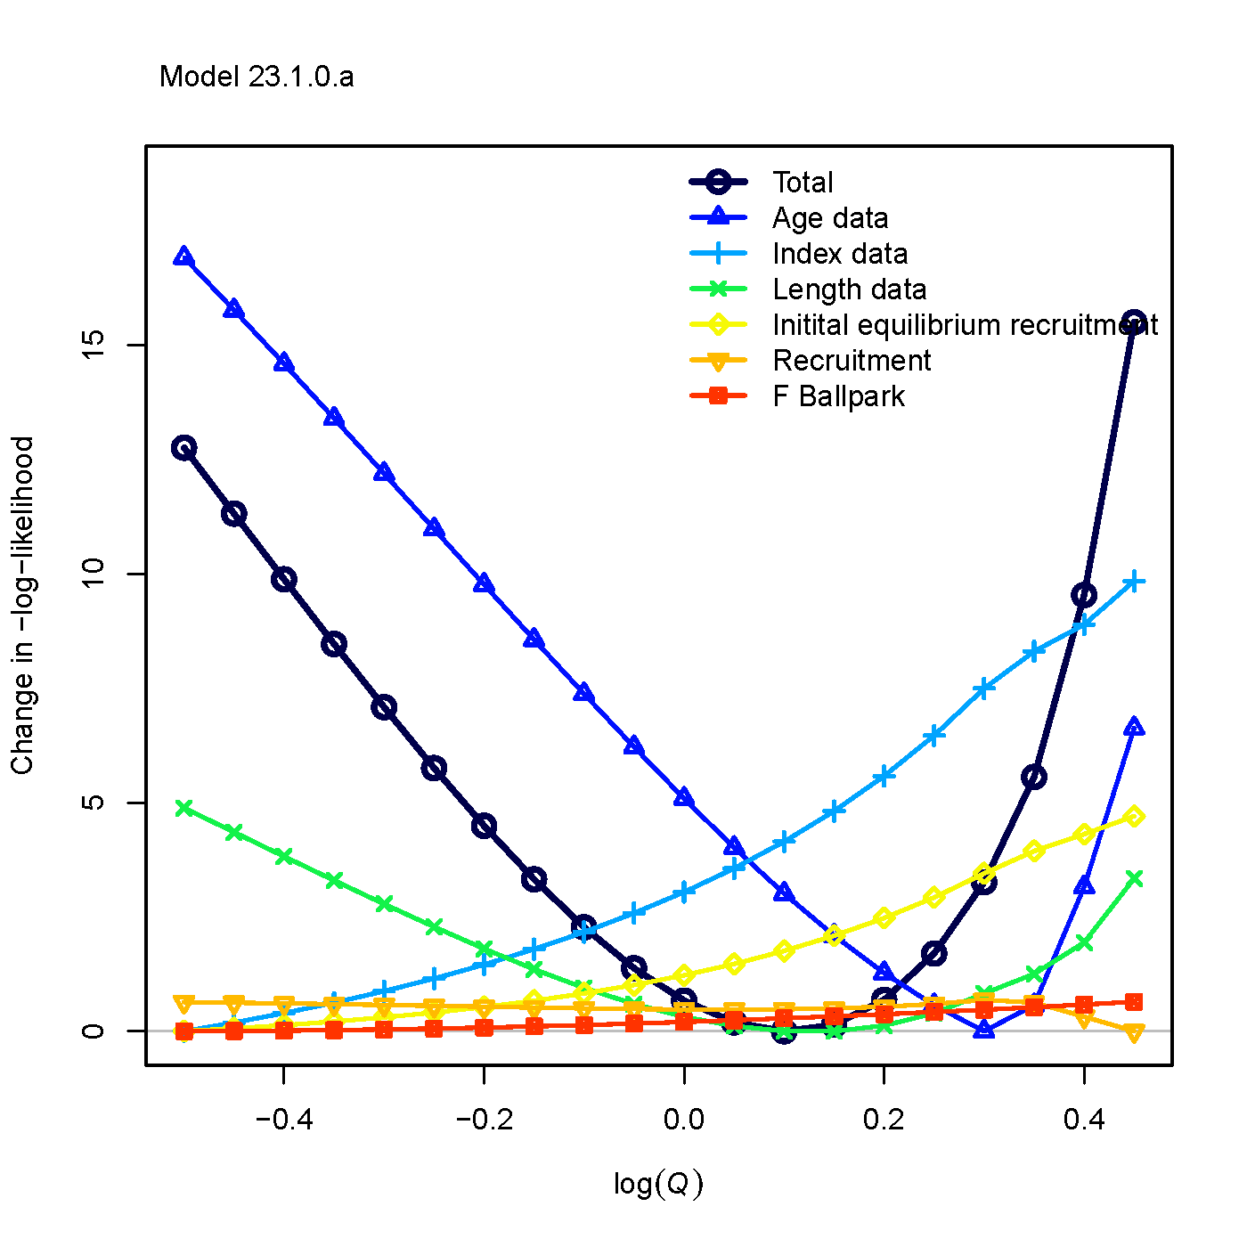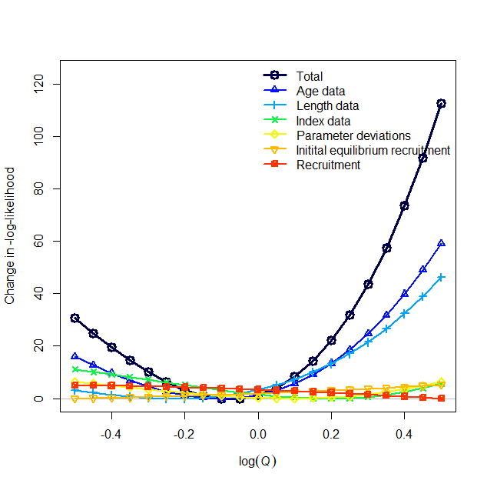

Model 23.1.0.d

Model 23.1.0.a

##### Figure 2.39. Likelihood profiles over survey catchability by model component for (left) Model 23.1.0.a and (right) Model 23.1.0.d.

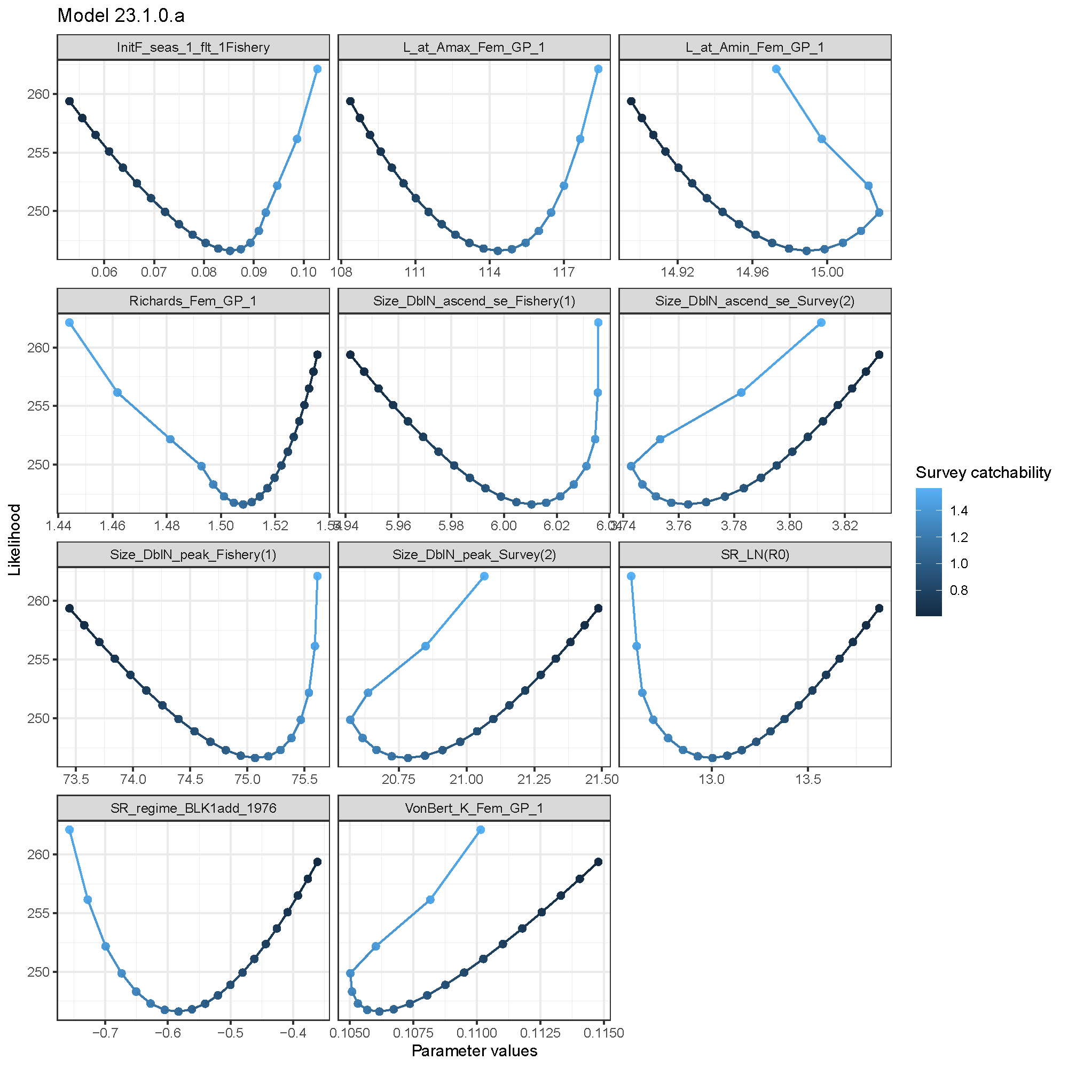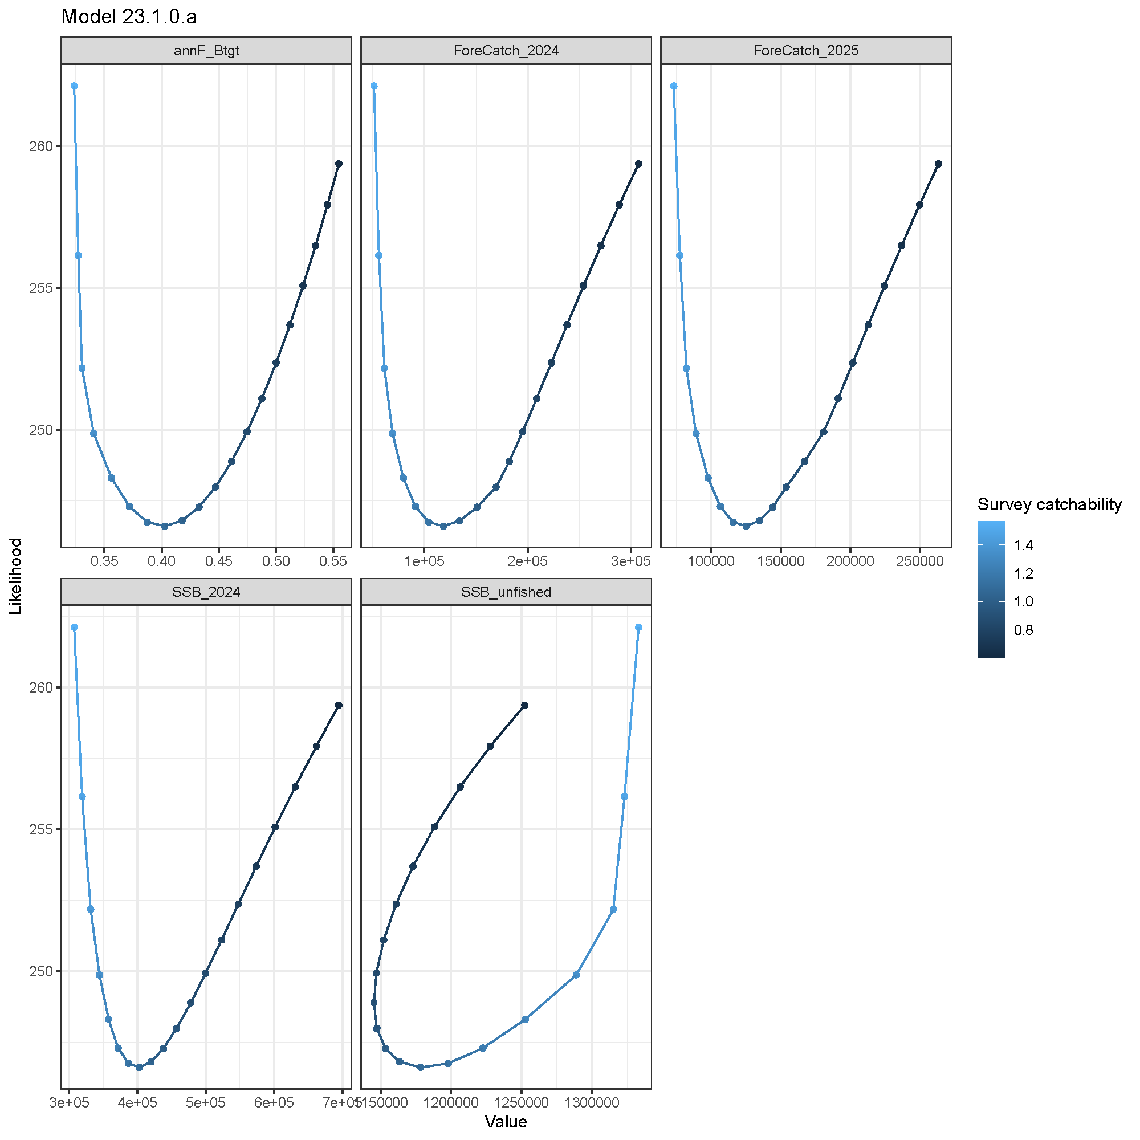

##### Figure 2.40. Likelihood profile over survey catchability for Model 23.1.0.a for (left) key parameters and (right) derived quantities. Forecatch_* is the maxABC for each year, SSB is the TOTAL spawning biomass (males and females), and SSB_unfished is the total unfished spawning biomass (males and females).

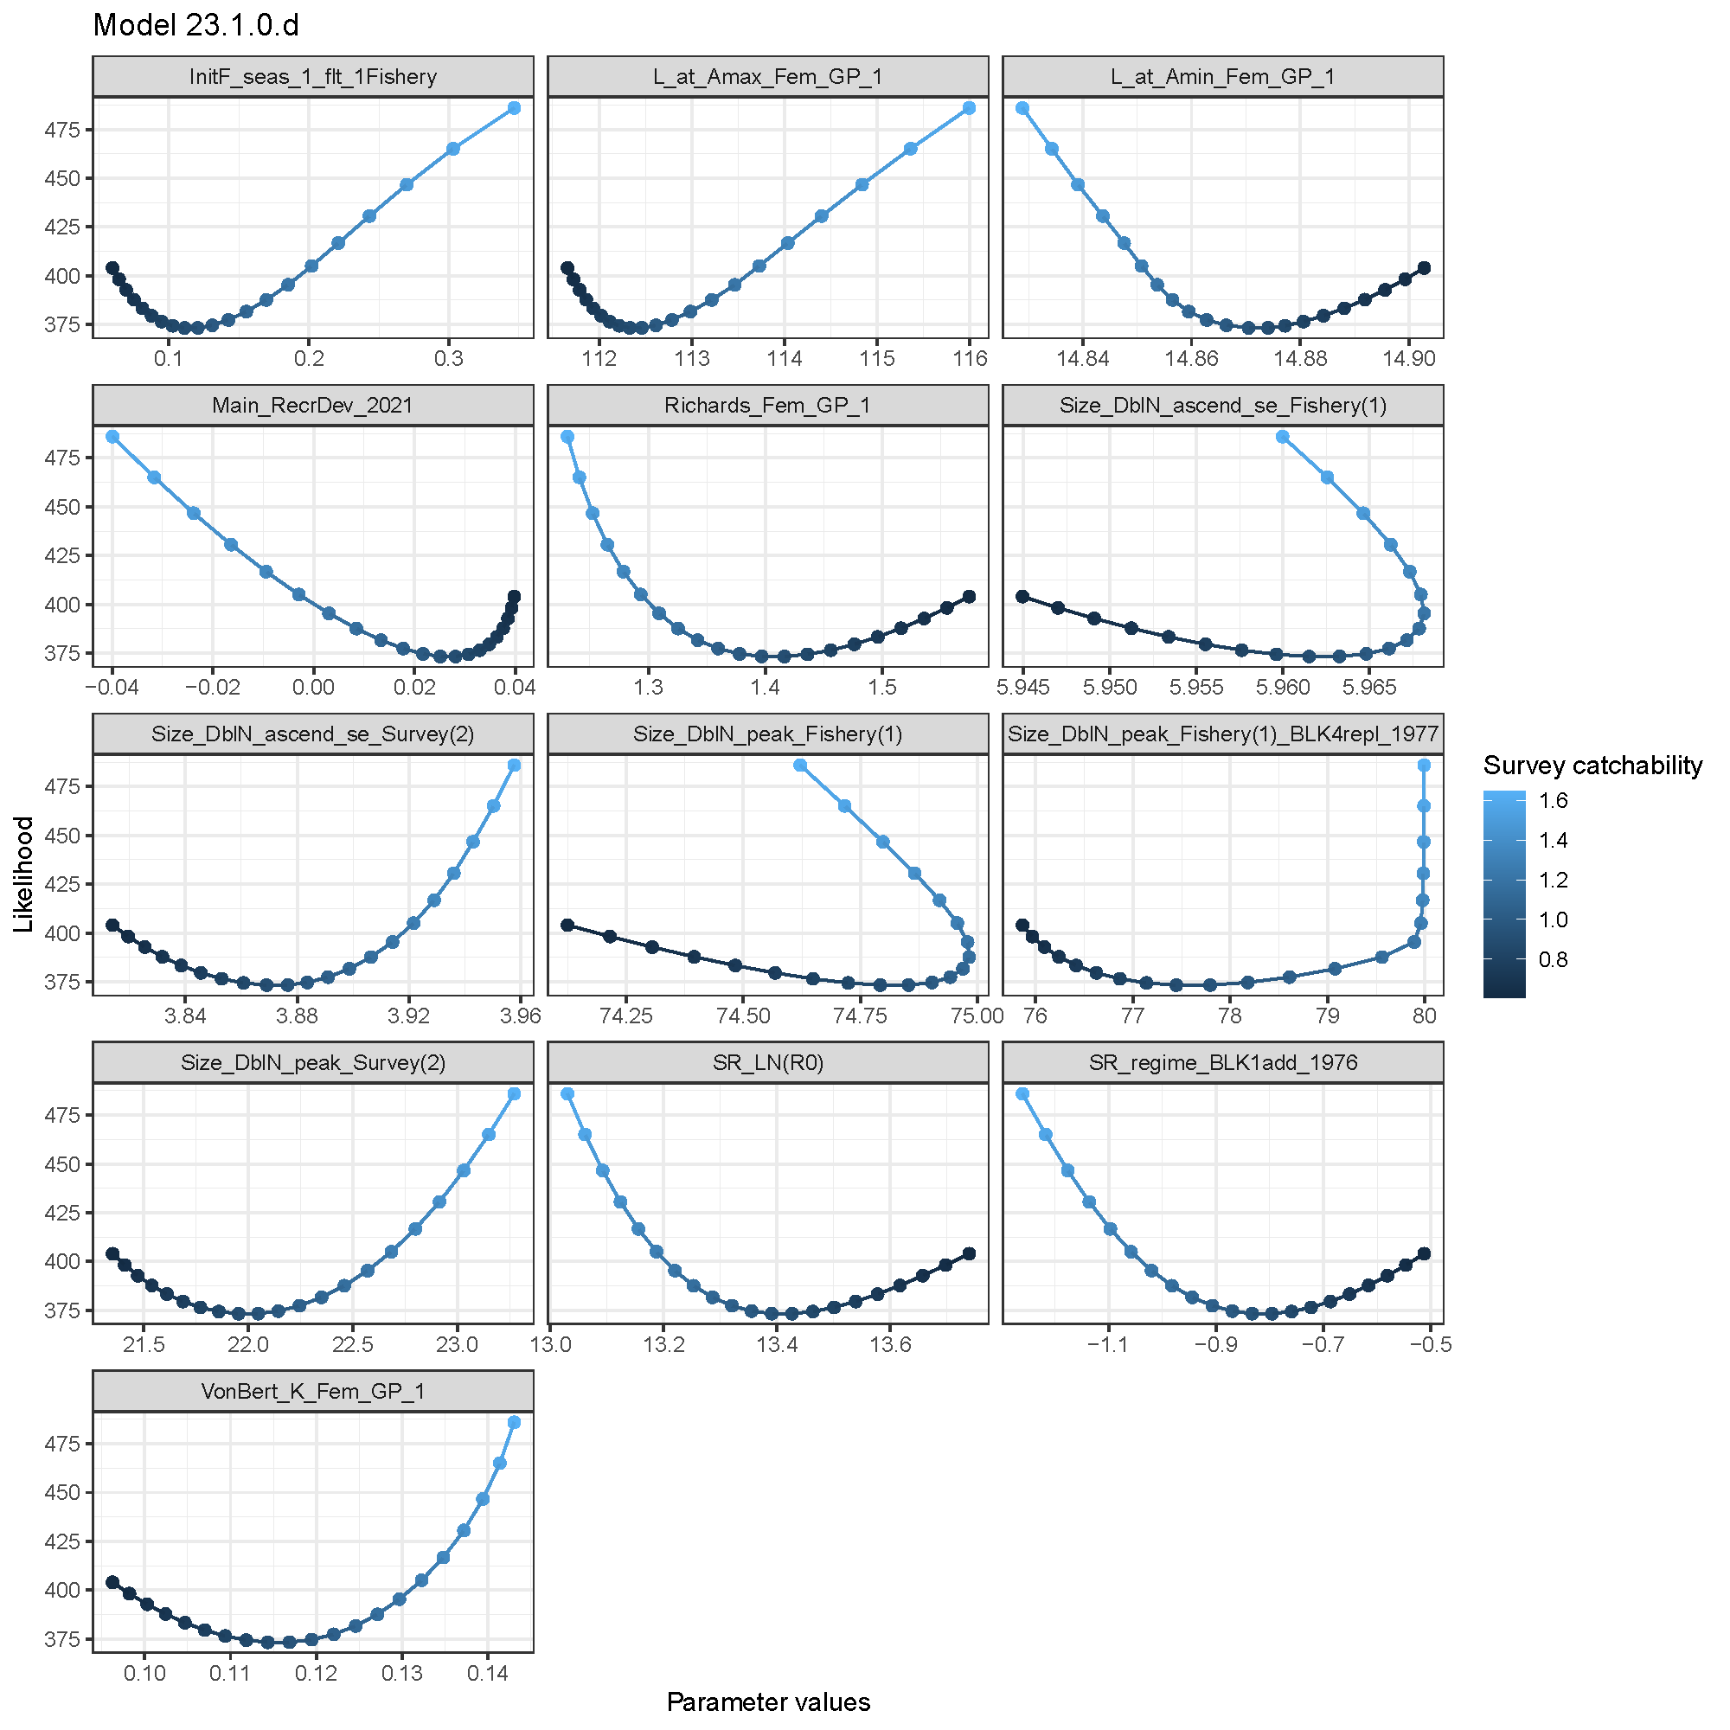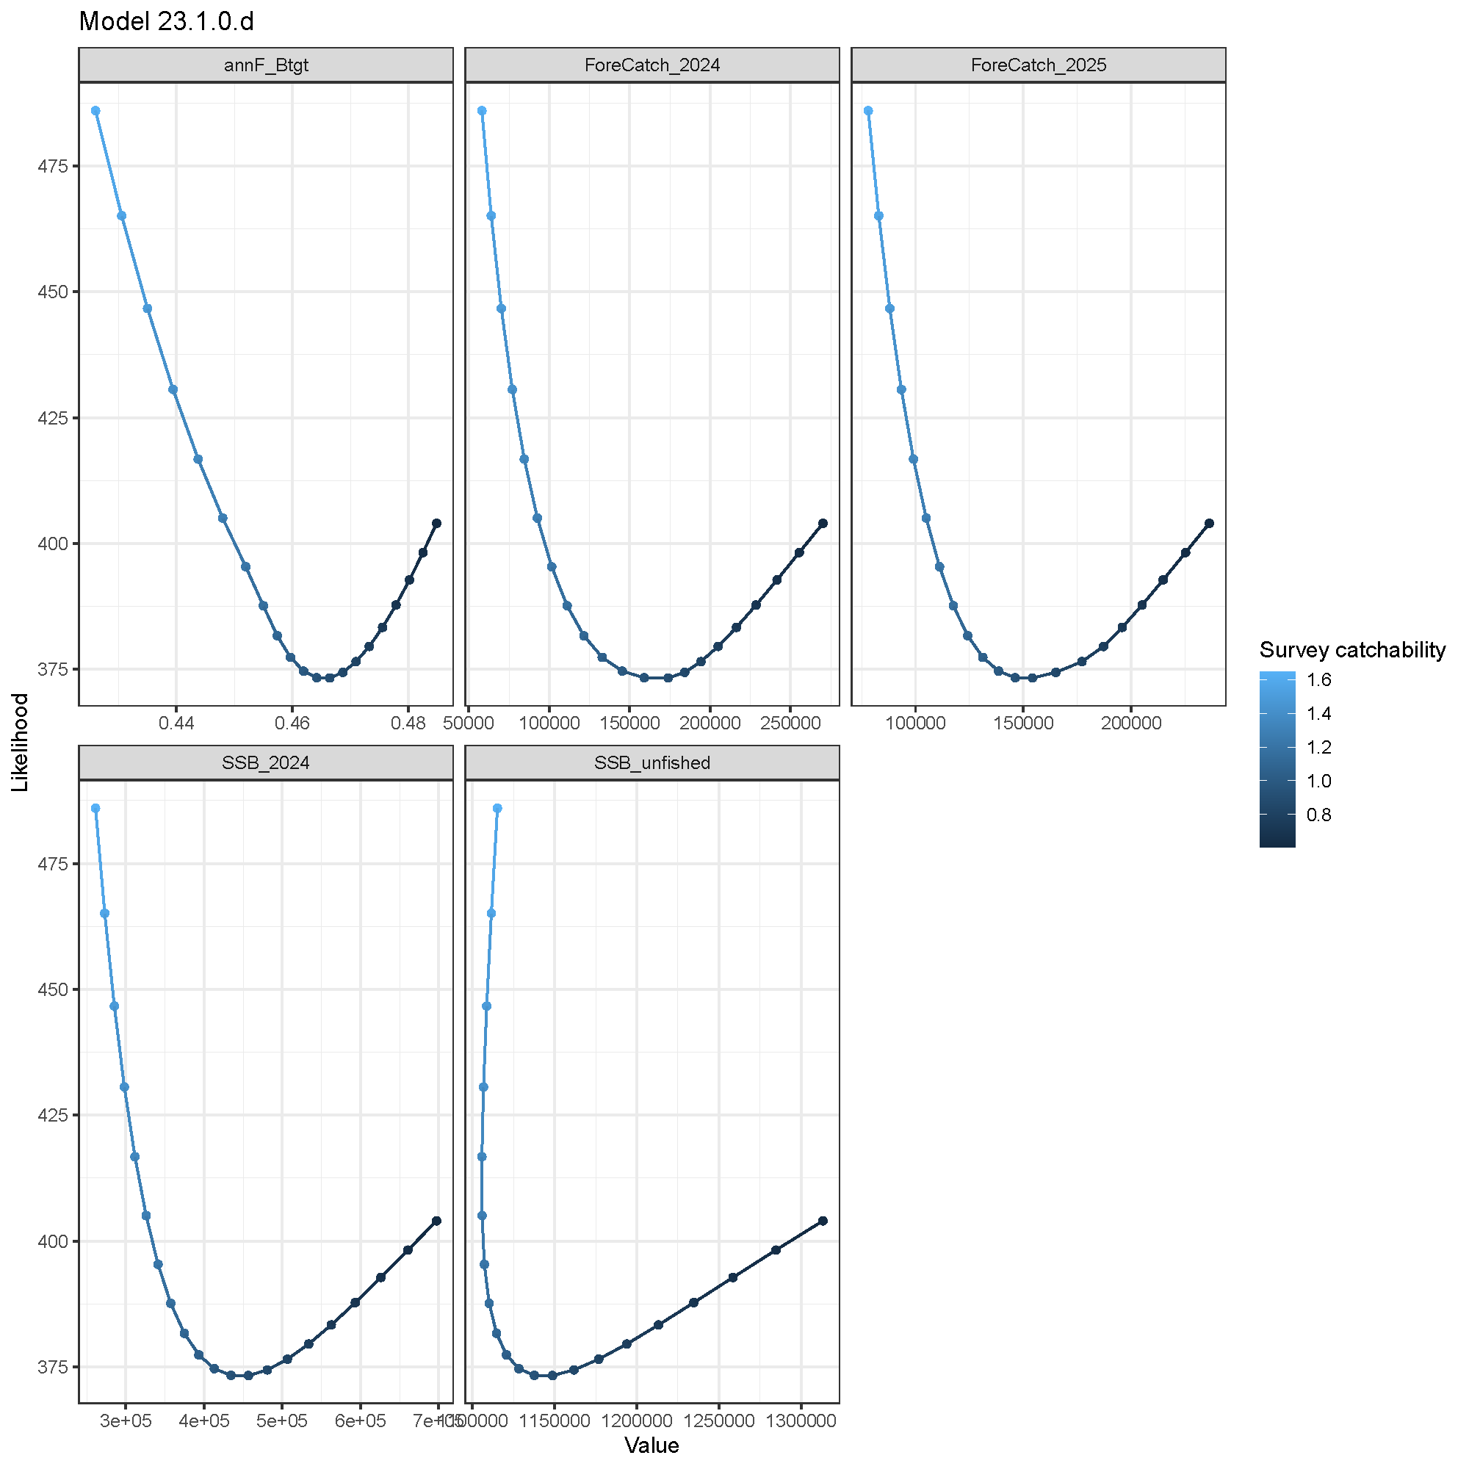

##### Figure 2.41. Likelihood profile over survey catchability for Model 23.1.0.d for (left) key parameters and (right) derived quantities. Forecatch_* is the maxABC for each year, SSB is the TOTAL spawning biomass (males and females), and SSB_unfished is the total unfished spawning biomass (males and females).

##### 

##### Figure 2.42. Likelihood profile over natural mortality where the standard error of the log natural mortality is changed from 0.99, 0.4 to 0.05 by 0.05, and 0.001 to examine the impact of standard error of the prior on the likelihood and natural mortality fit.

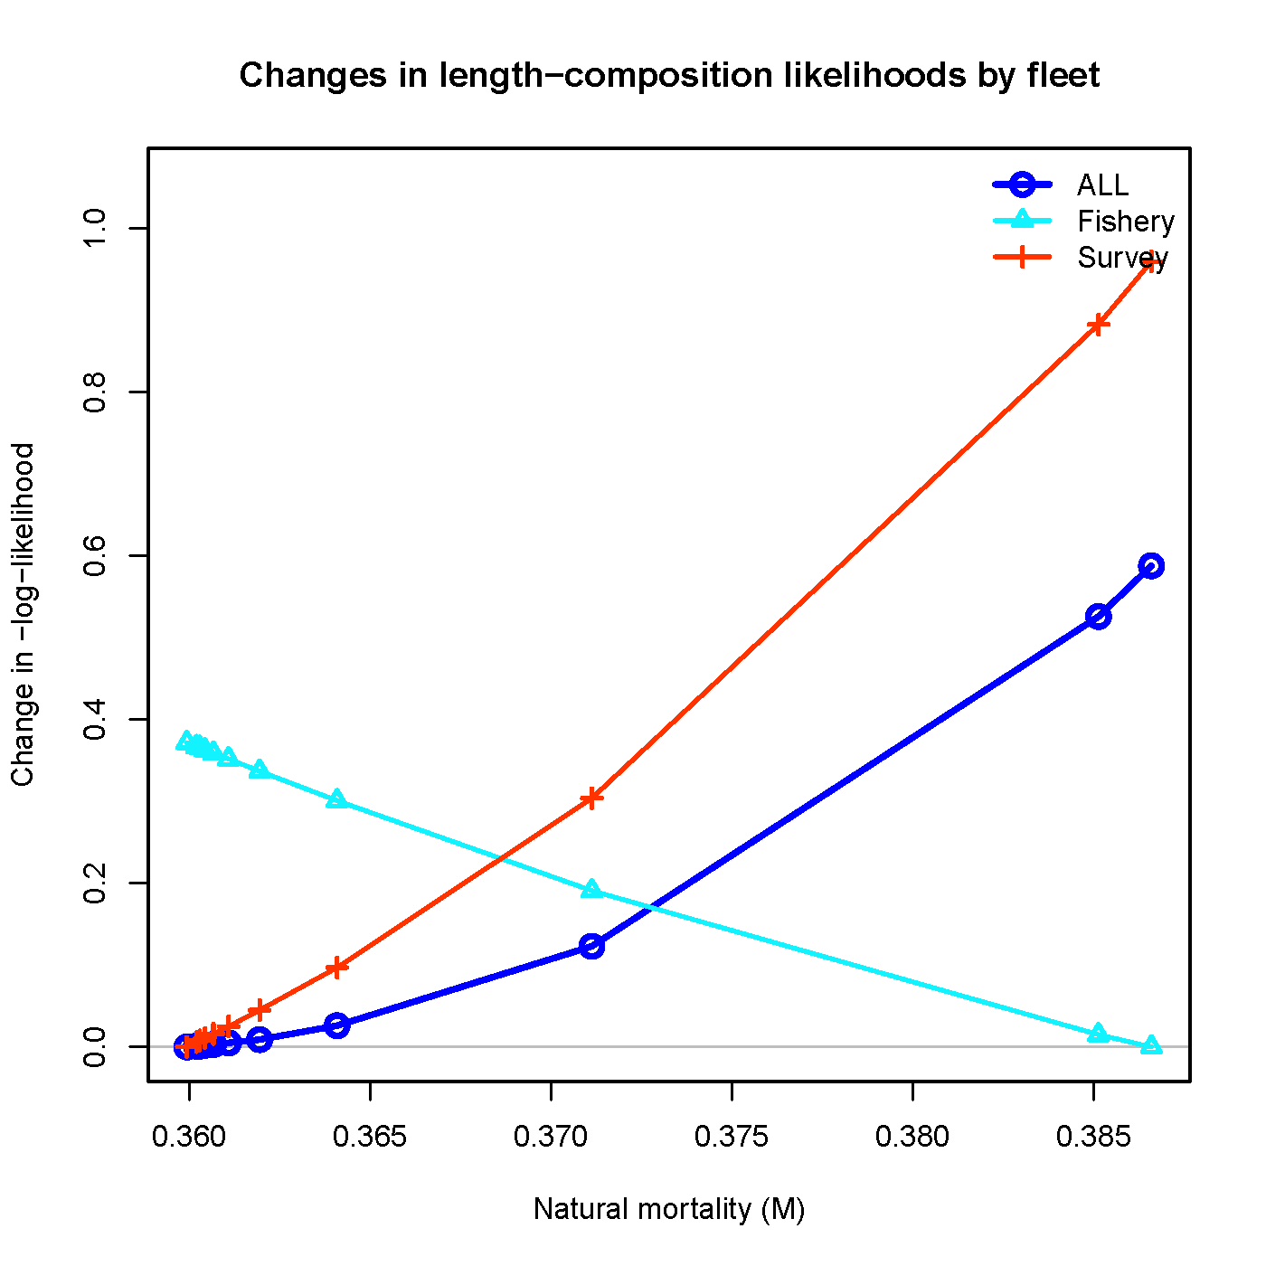

##### Figure 2. Changes in length-composition likelihoods by fleet over natural mortality where the standard error of the log natural mortality is changed from 0.99, 0.4 to 0.05 by 0.05, and 0.001 to examine the impact of standard error of the prior on the likelihood and natural mortality fit.

##### 

##### Figure 2.44. Parameter profiles over the standard error of the log natural mortality to examine impact of the standard error of the prior on the parameter values.

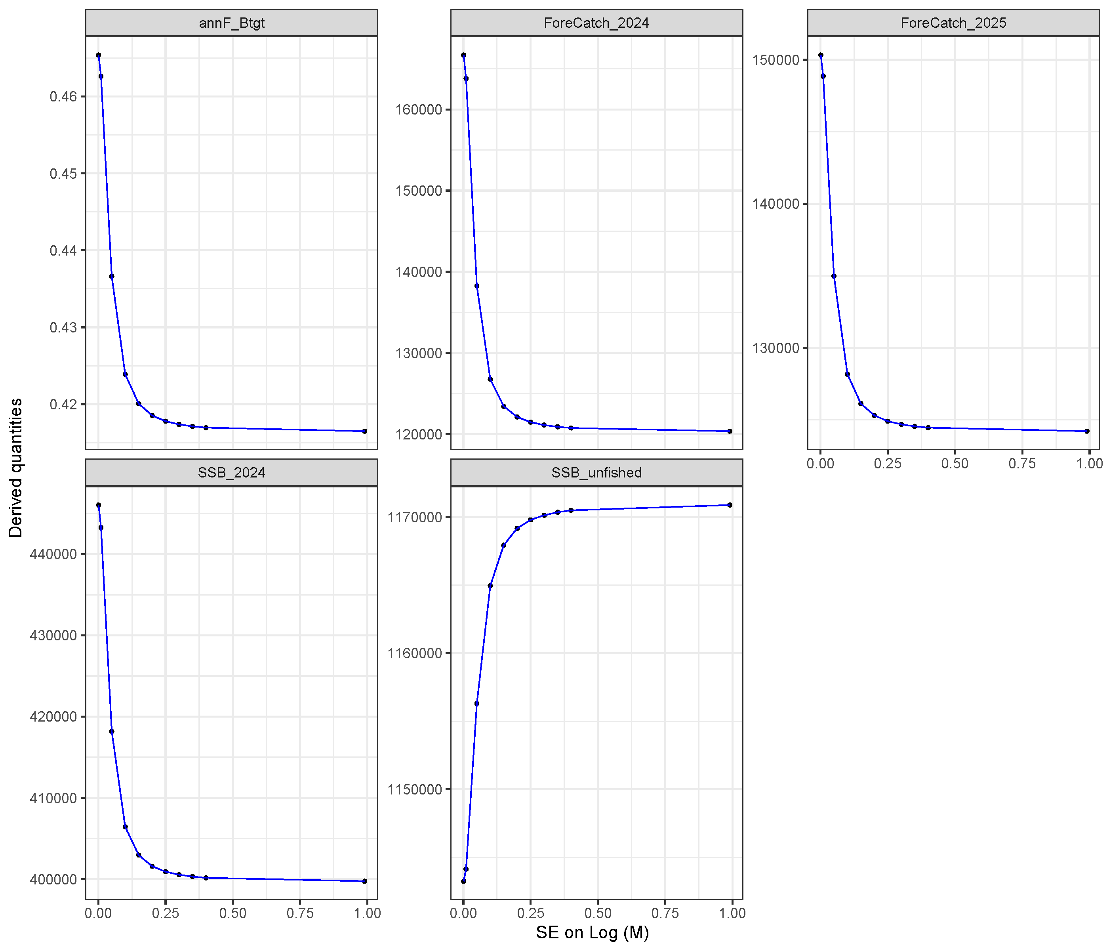

##### Figure 2.45. Profiles of derived quantities over the standard error of the log natural mortality to examine impact of standard error of the prior on the derived quantity values. Forecatch_* is the maxABC for each year, SSB is the TOTAL spawning biomass (males and females), and SSB_unfished is the total unfished spawning biomass (males and females).

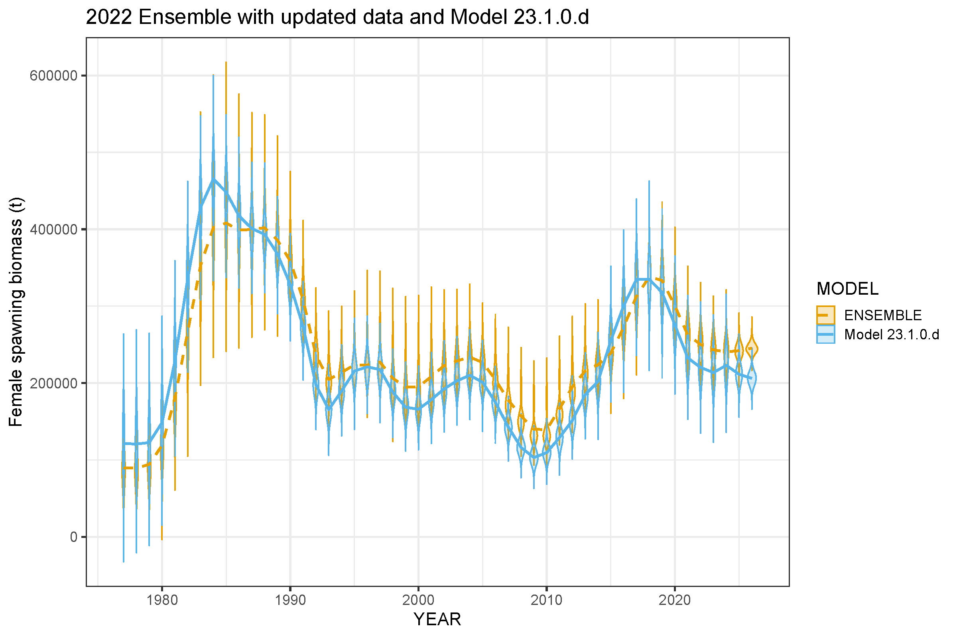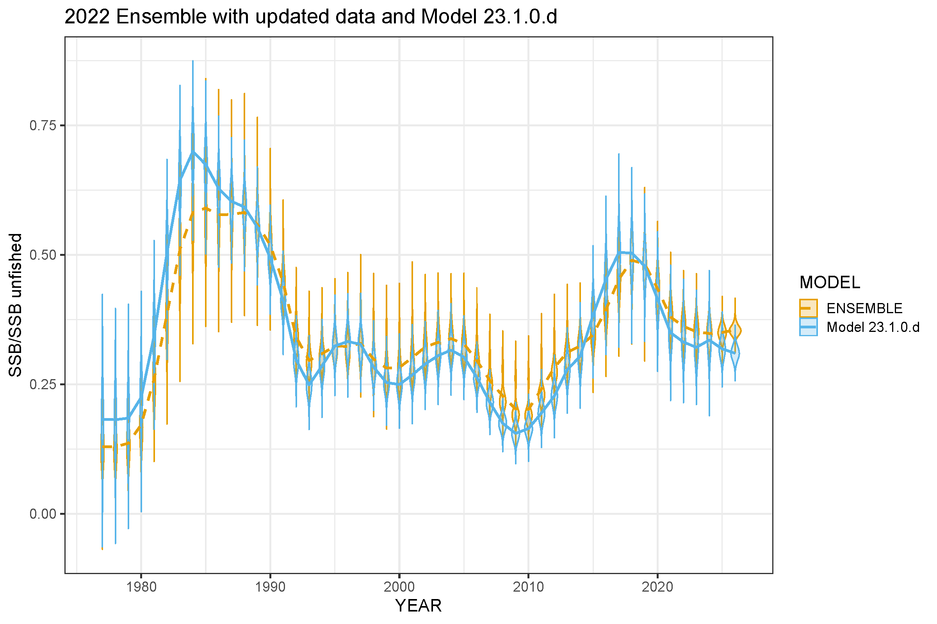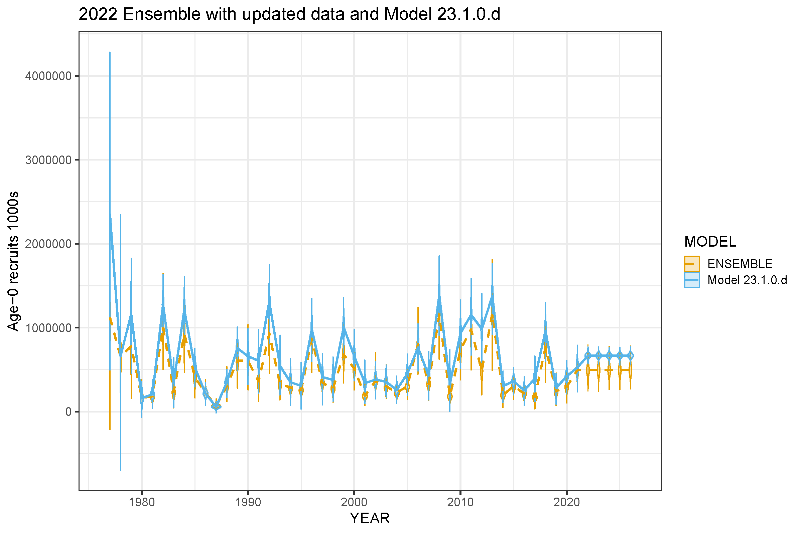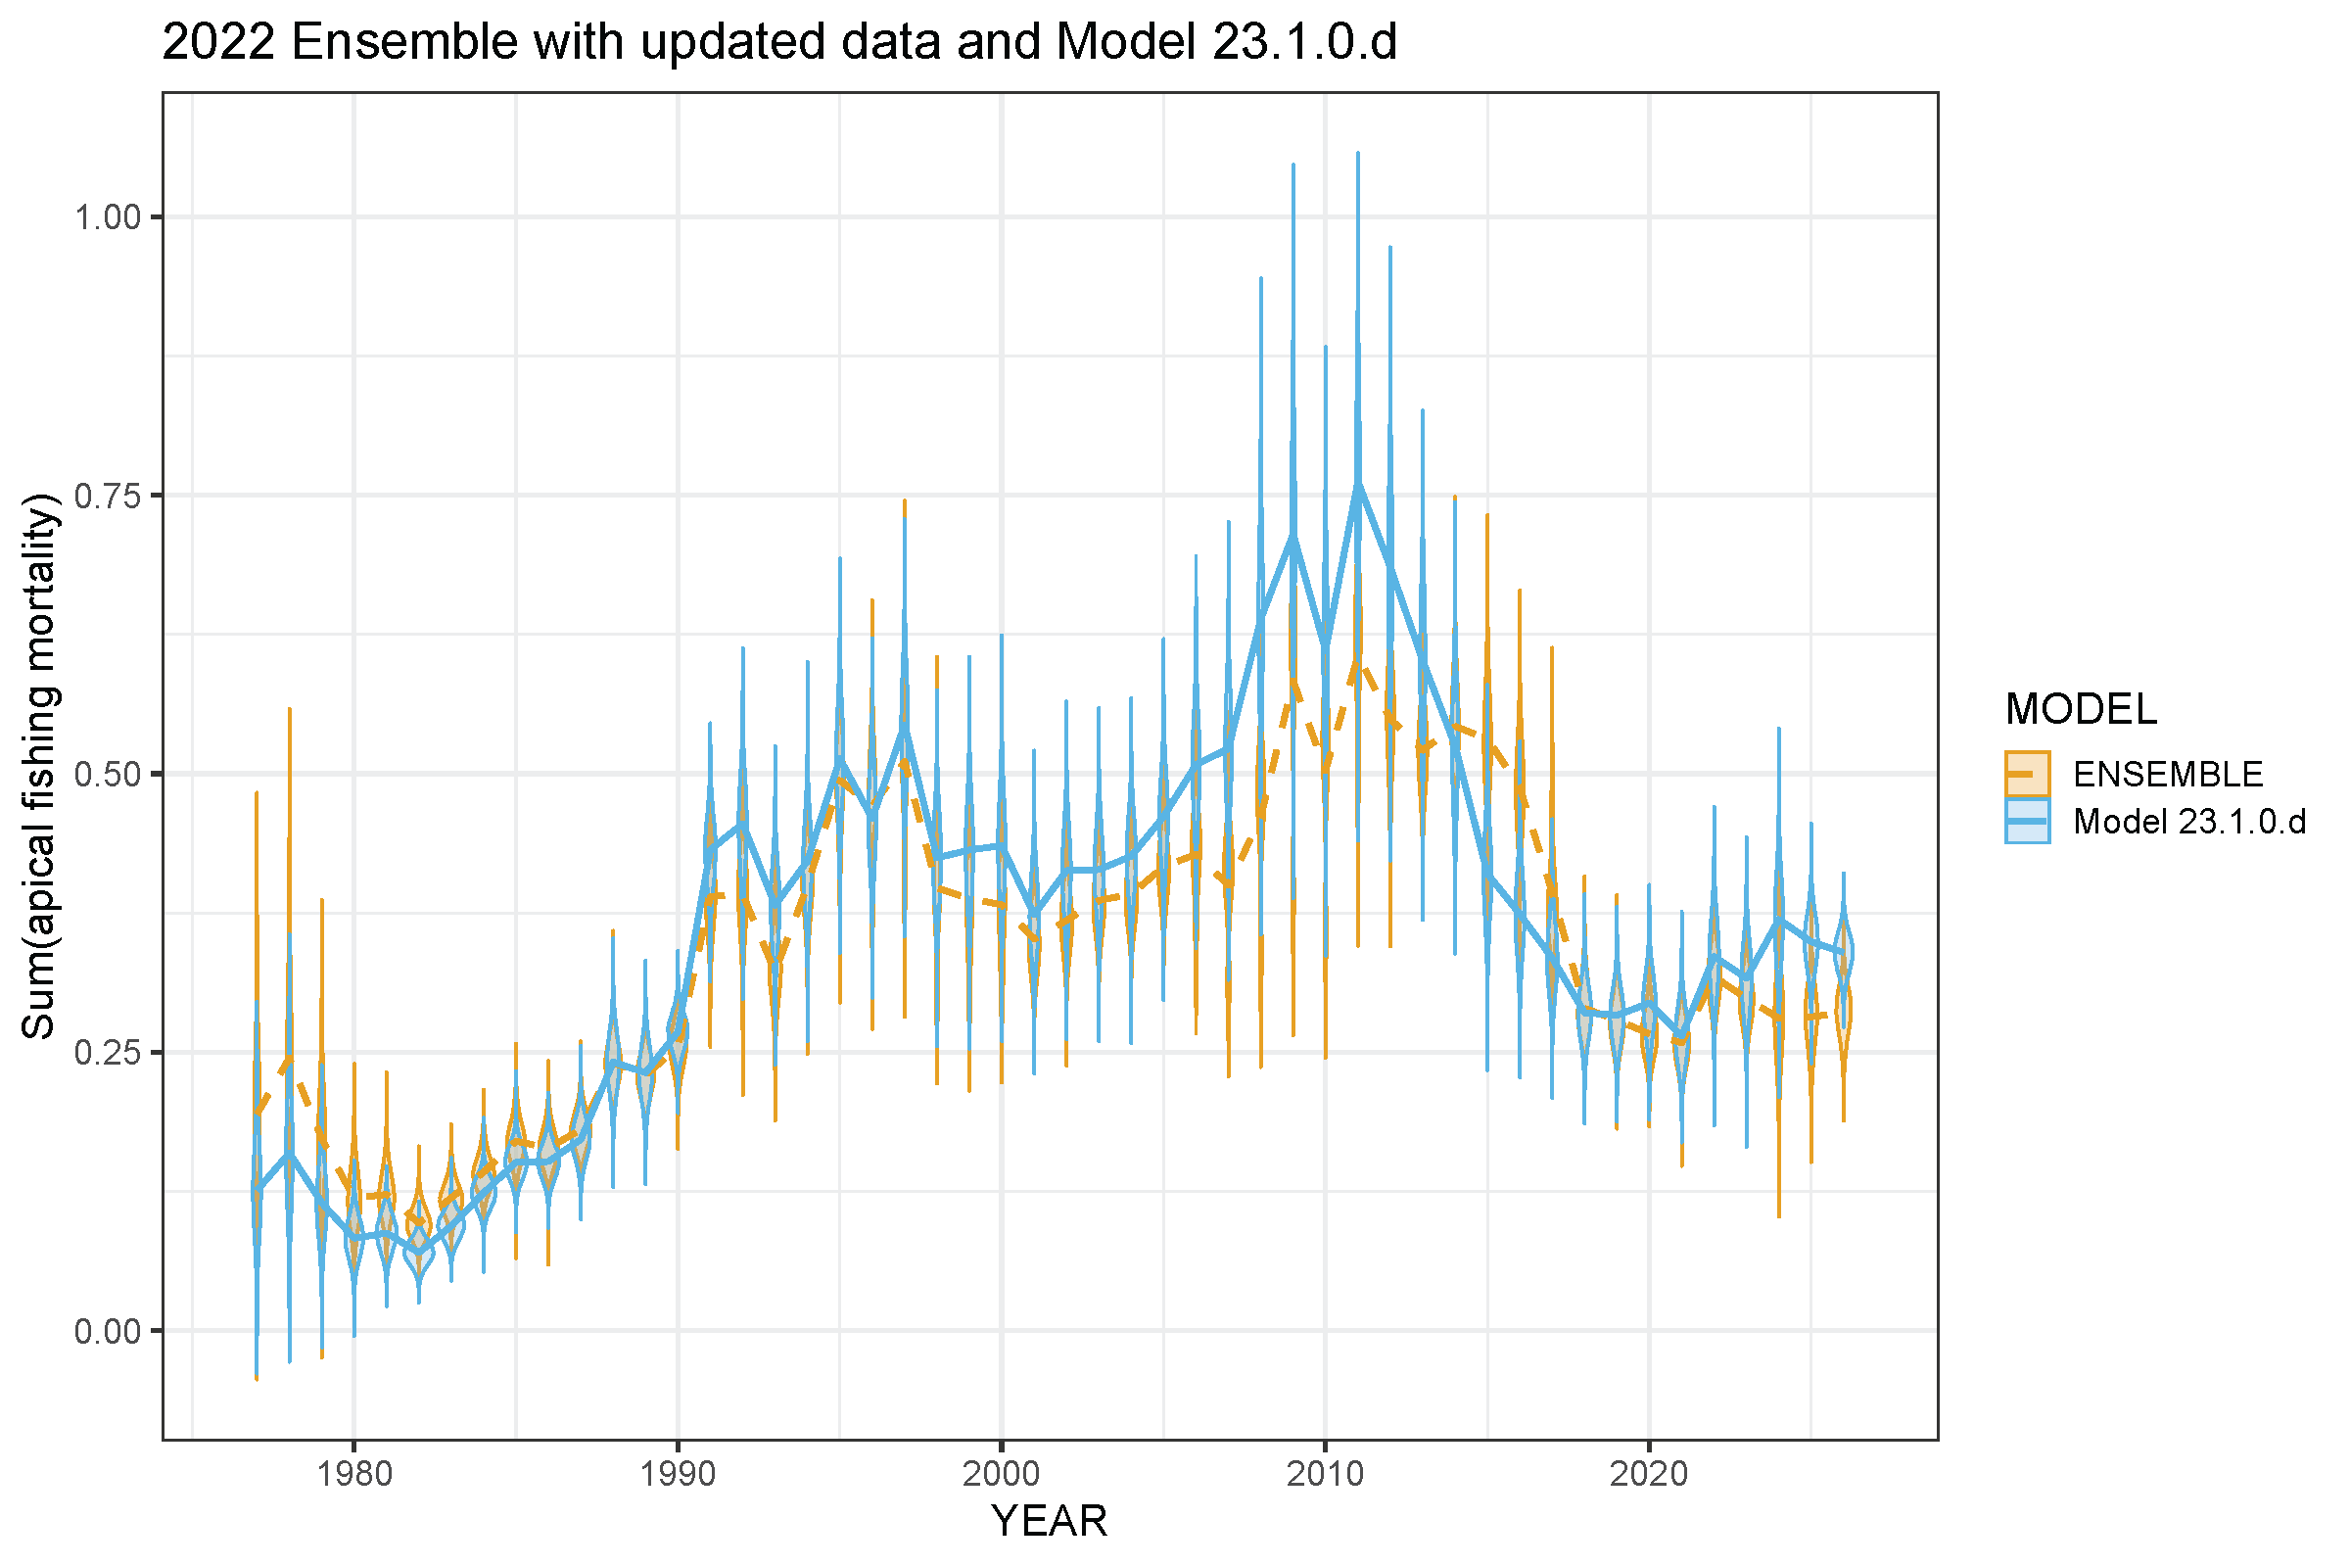

Figure 2.. (Top left) Total spawning biomass (t), (top right) spawning biomass/unfished biomass, (bottom left) Age-o recruits, and (bottom right) F (sum of the apical fishing mortality) for the (yellow, dashed) 2022 ensemble and (blue solid) Model 23.1.0.d.

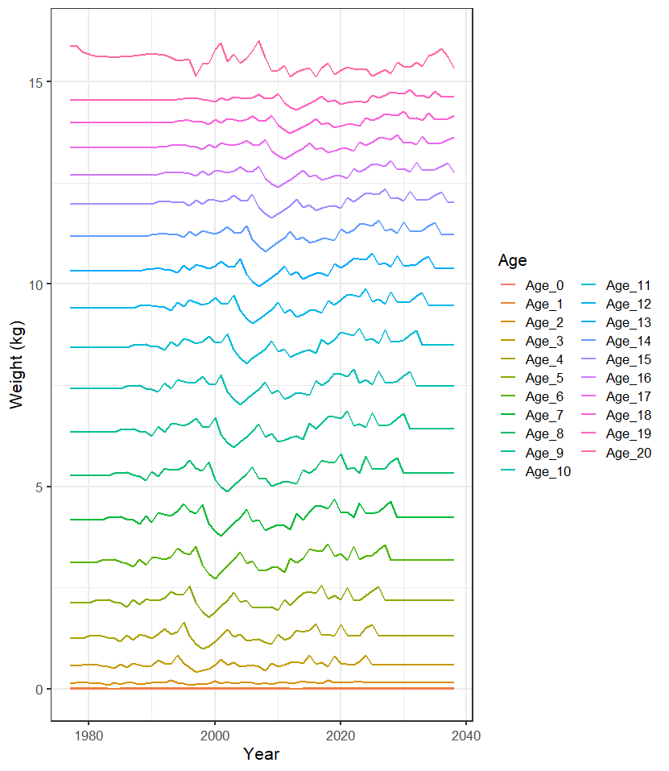

Figure 2. Model 23.1.0.d weight at age (kg).

##### 

##### Figure 2.. Female spawning biomass (t) for Model23.1.0.d.

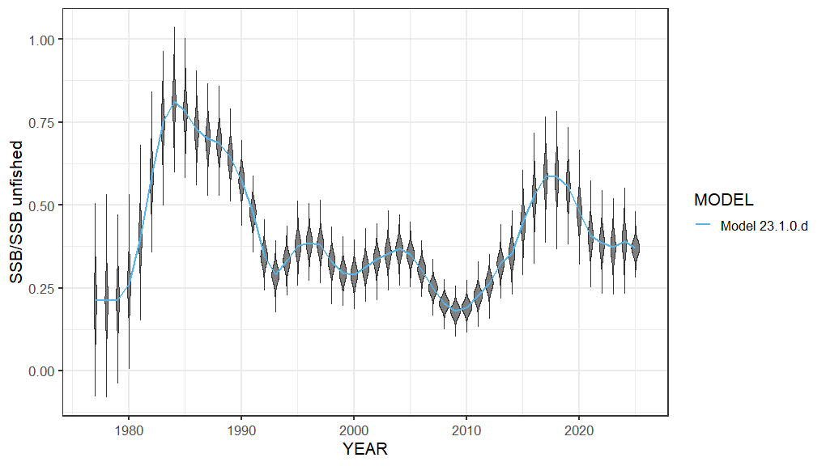

##### Figure 2.. Ratio of spawning stock biomass to unfished spawning biomass Model 23.1.0.d.

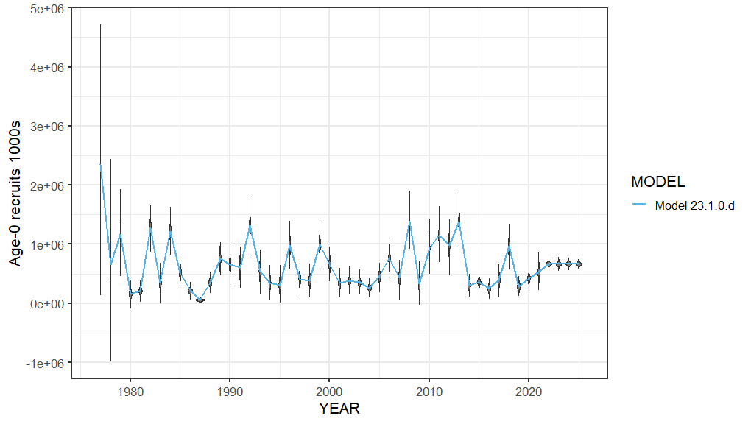

##### Figure 2.. Recruitment (1,000s at age-0) for Model 23.1.0.d.

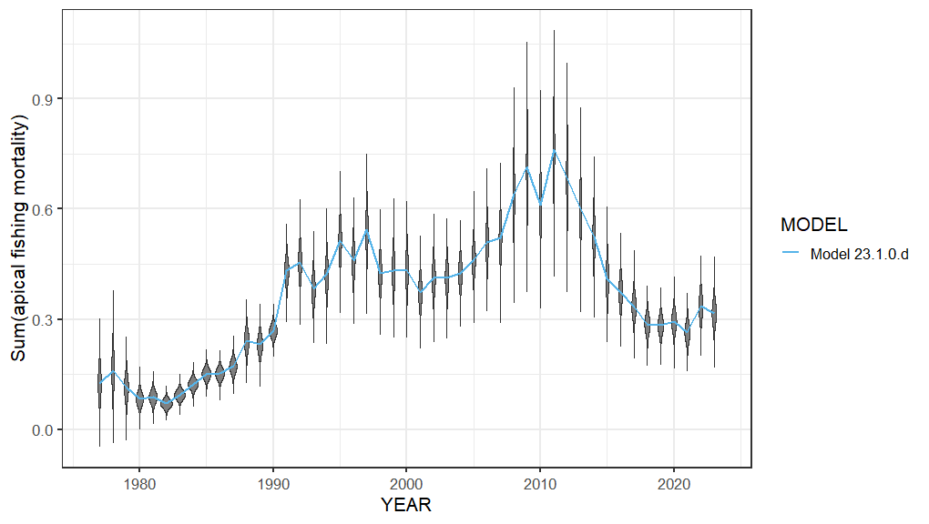

##### Figure 2.. Instantaneous apical fishing mortality (F) for Model 23.1.0.d.

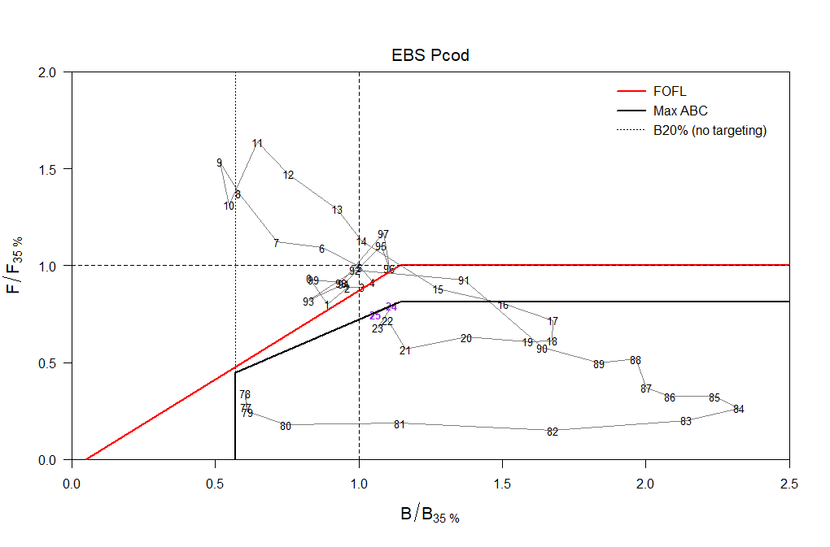

##### Figure 2.. Phase plane plot for Model 23.1.0.d.

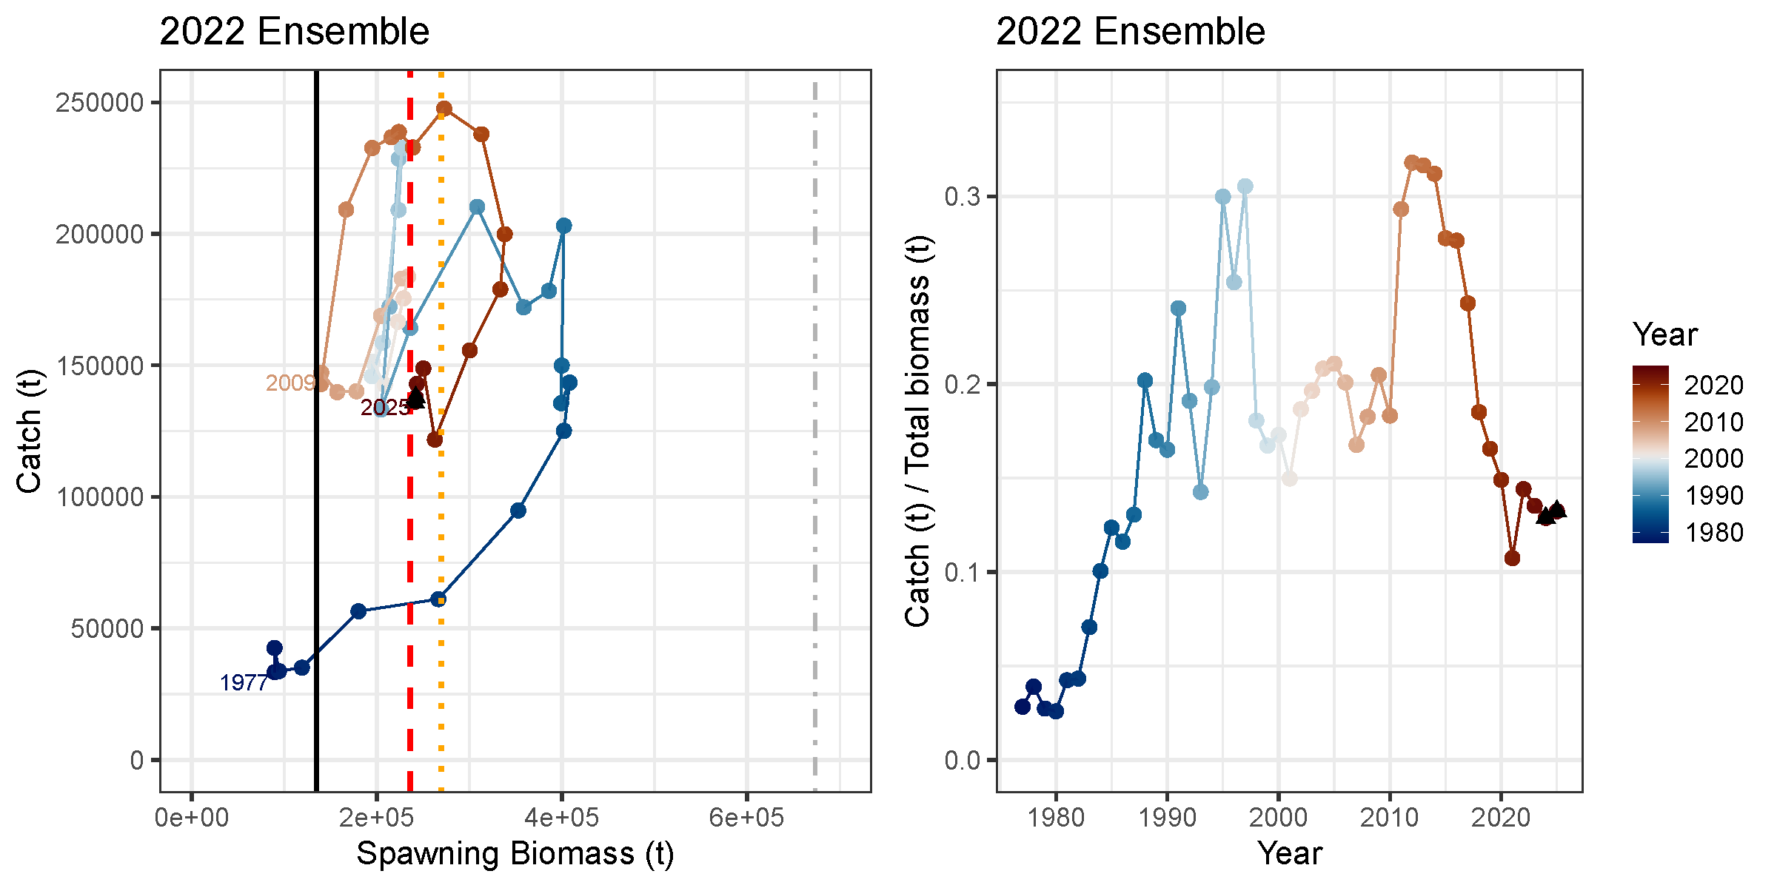

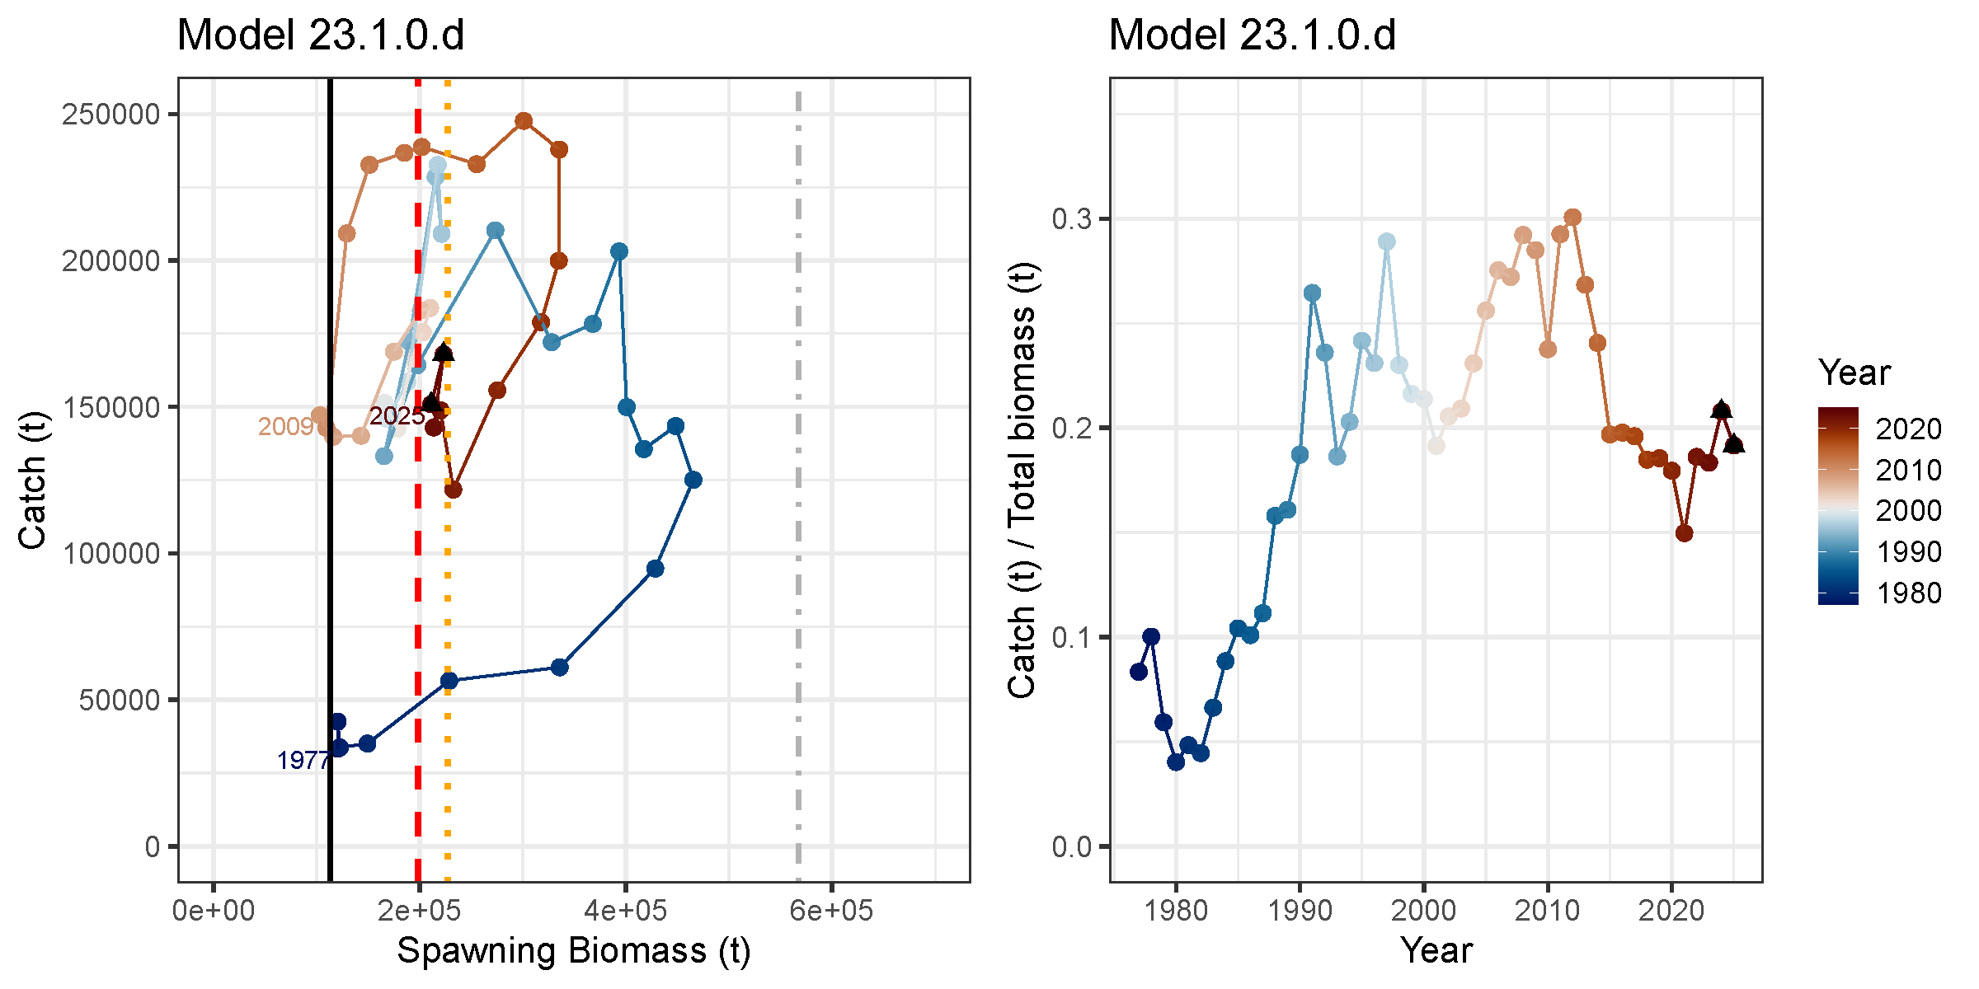

Figure 2. Plots of (left) catch (t) by spawning biomass (t) and (left) catch/total biomass for the 2022 Ensemble and Model 23.1.0.d with (black line) B20%, (red dashed line) B35%, (orange dotted line) B40%, and (grey dash-dot line) B100% for all years with (black triangles) projections for 2024 and 2025.

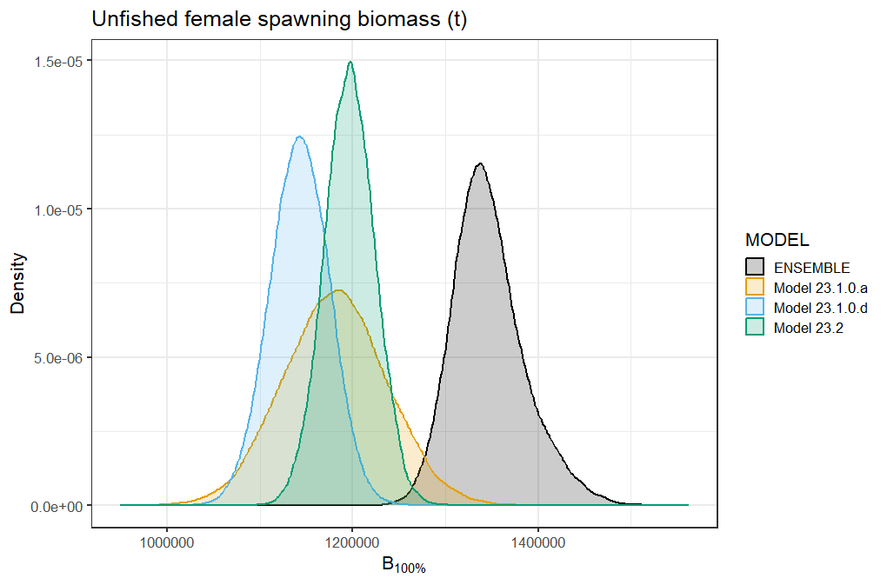

Figure 2.. Distribution of female unfished spawning biomass (SSB100%) for 2023 models and 2022 ensemble.

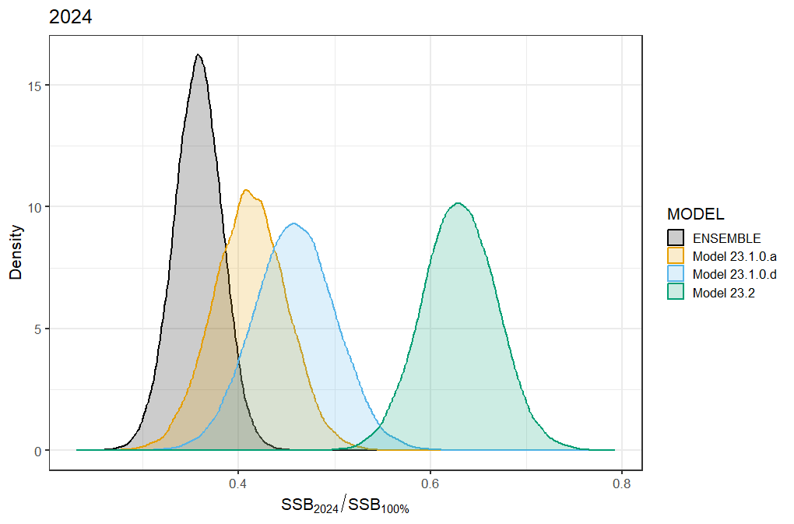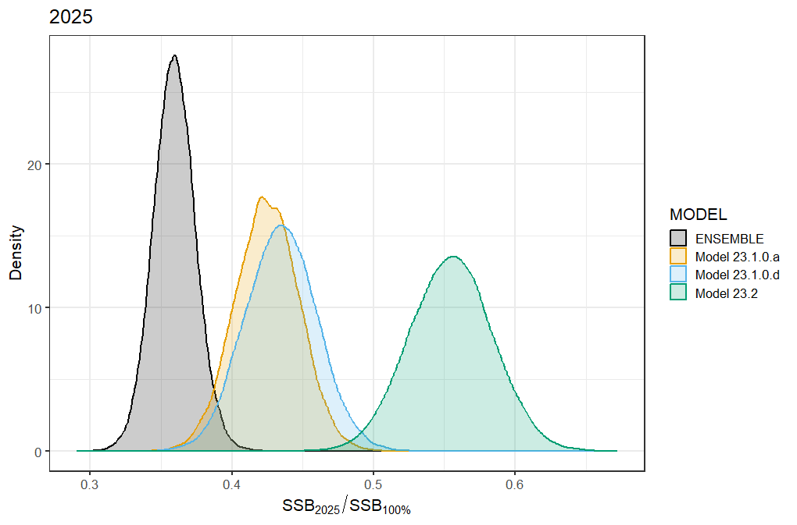

##### Figure 2.. Ratio of spawning stock biomass to unfished spawning biomass distributions for (top) 2024 and (bottom) 2025 for 2022 ensemble and 2023 models.

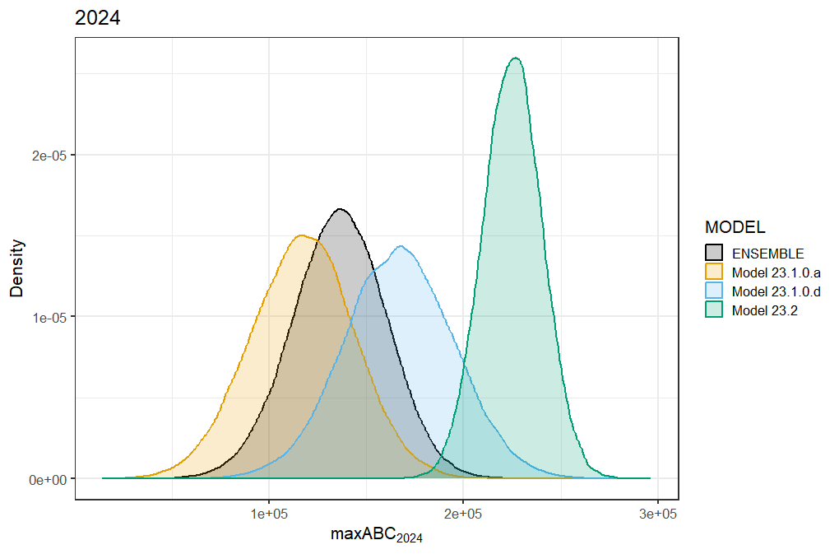

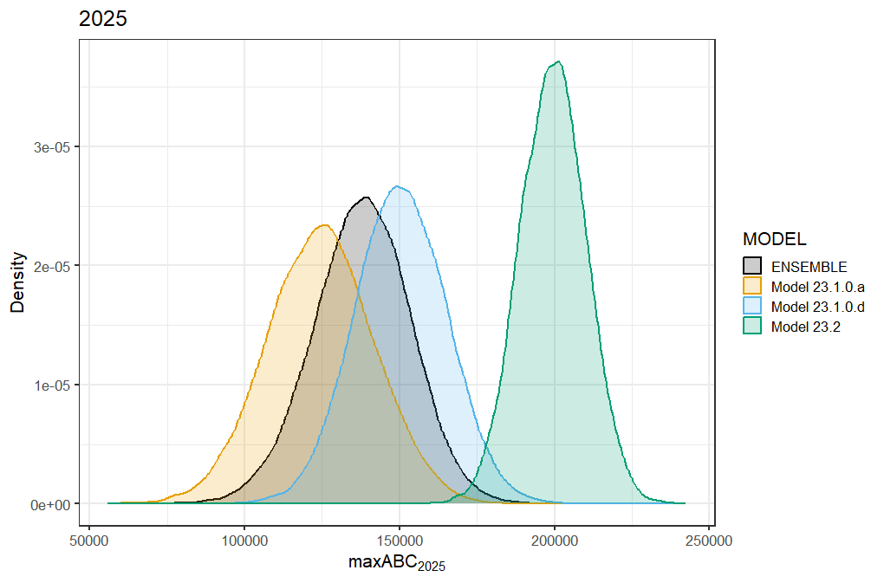

##### Figure 2.. Forecasted maximum ABC for (top) 2024 and (bottom) 2025 for 2023 models and 2022 ensemble distributions.

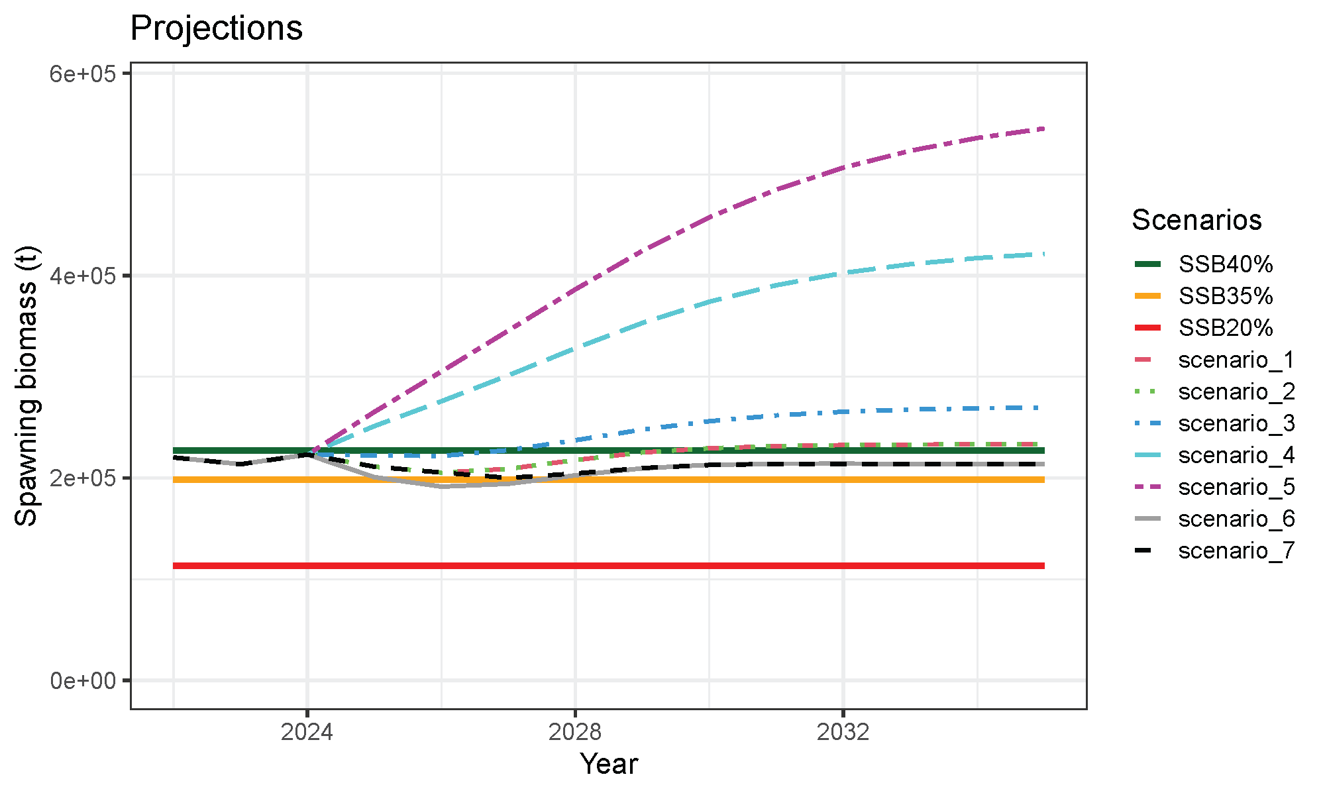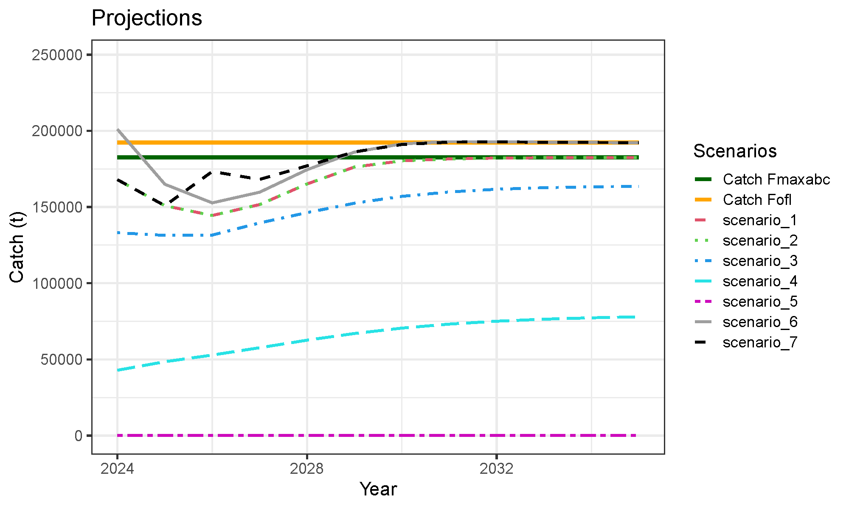

##### Figure 2.. (Top) Female spawning biomass (t) and (bottom) projected catch (t) for the seven North Pacific [projection scenarios](https://afsc-assessments.github.io/EBS_PCOD/2023_ASSESSMENT/NOVEMBER_MODELS/FIGURES/PROJECTIONS/PROJ_23.1.0.d.pdf) from Model 23.1.0.d.

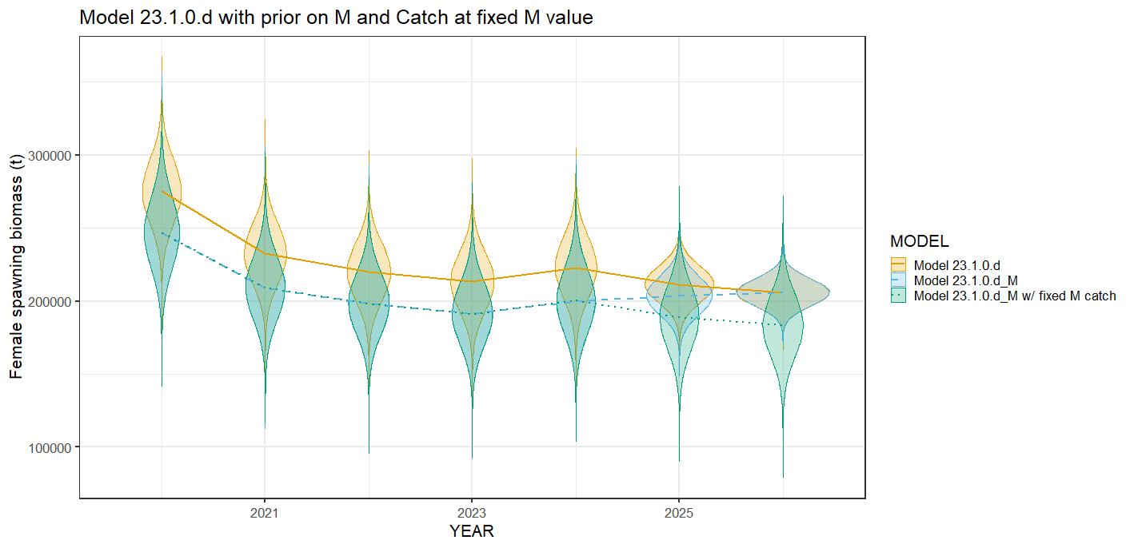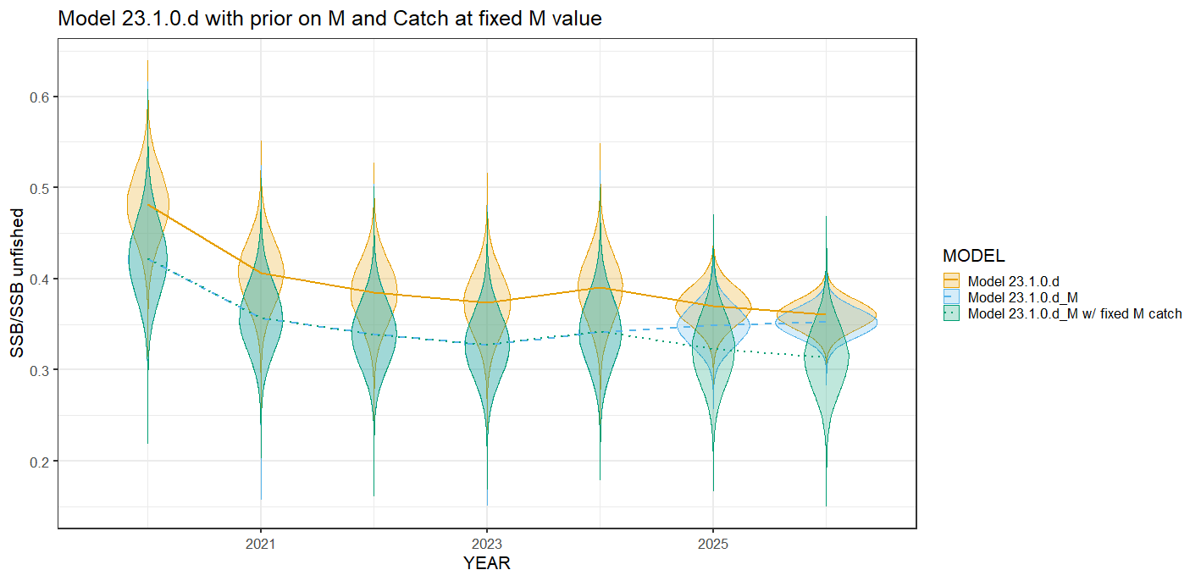

Figure 2. Female spawning biomass and ratio of spawning stock biomass over unfished spawning stock biomass for Model 23.1.0.d, (Model 23.1.0.d_M) Model 23.1.0.d fit with a prior on natural mortality (ln(M)~Ɲ(-0.950365, 0.4)) and Model 23.1.0.d fit with a prior on M but with maxABC set at the fixed M Model 23.1.0.d recommended values through 2026. 2024 and 2025 maxABC for the fixed M Model 23.1.0.d would be 167,952 t and 150,876 t and for Model 23.1.0.d with a prior on M maxABC would be 120,757 and 124,466 t.